Assignment 02
Roll Number: 23K-0038

Section 1: Colorization as Regression

Q1: How Many Convolution Layers?
The regression-based CNN model contains a total of 6 convolution layers:

Layer | Type
Conv1 | Conv2D
Conv2 | Conv2D
Conv3 | Conv2D
Conv4 | Conv2D
Conv5 | Conv2D
Conv6 | Conv2D

Total of 6 convolution layers.

Q2: Filter Sizes and Number of Filters
The architecture used in the regression notebook is as follows:

Layer | Filters | Kernel Size
Conv1 | 32 | 3×3
Conv2 | 64 | 3×3
Conv3 | 128 | 3×3
Conv4 | 64 | 3×3
Conv5 | 32 | 3×3
Conv6 | 3 | 1×1

Figure 1.1 — CNN Architecture Diagram:

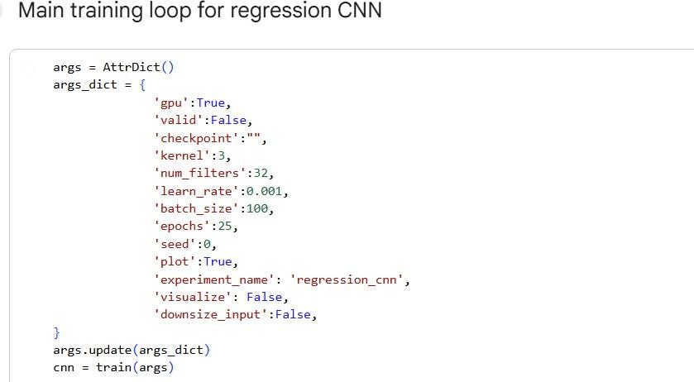
Fig 1.1: Regression CNN Architecture

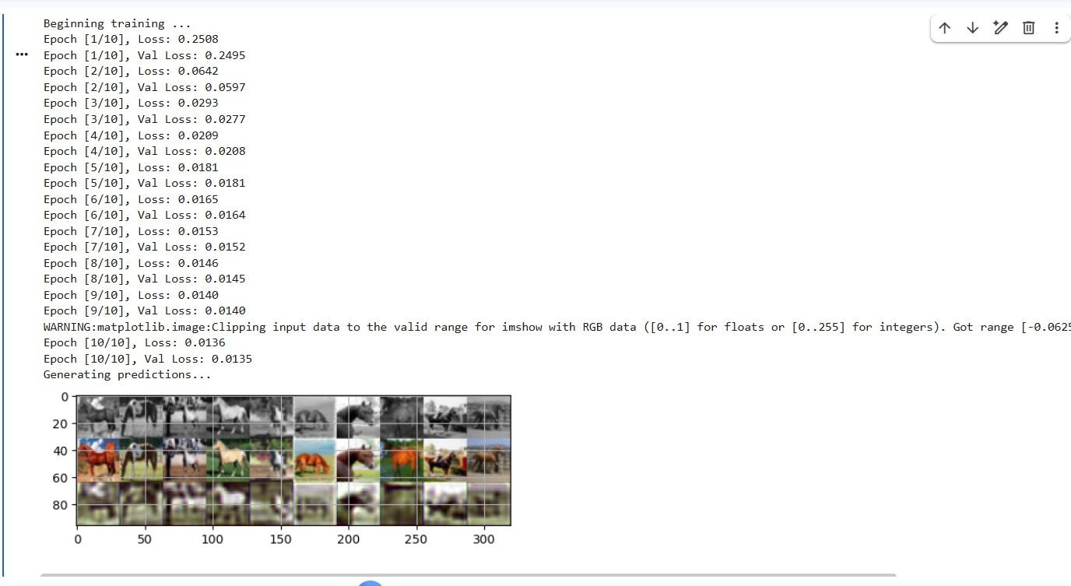
Fig 1.2: Detailed Network Architecture

Q3: Training Epochs — Effect of Training Duration
The model was trained for different numbers of epochs to evaluate the effect of training duration on performance. Figures below show the output images and training loss at each epoch count.

10 Epochs
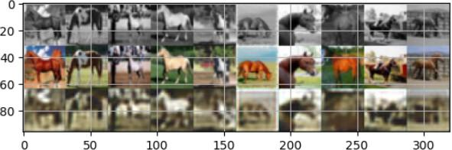
Fig 1.3: Output at 10 Epochs

20 Epochs
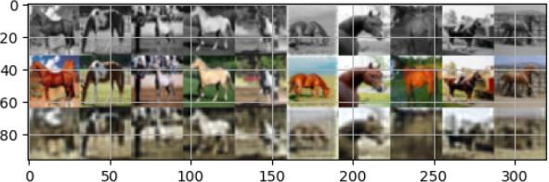
Fig 1.4: Output at 20 Epochs

50 Epochs
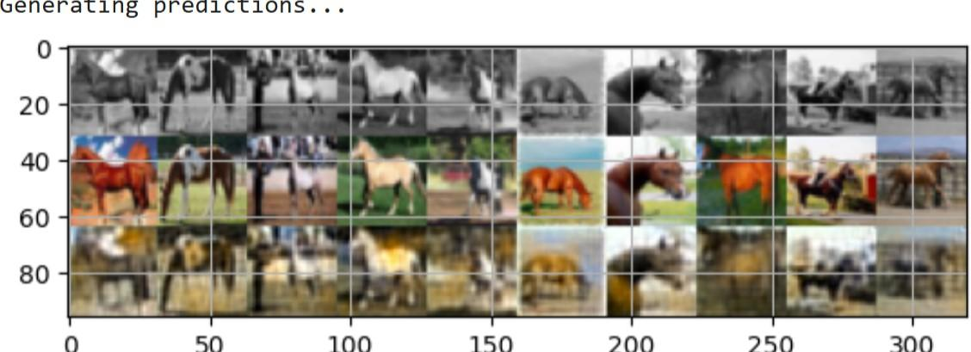
Fig 1.5: Output at 50 Epochs

500 Epochs
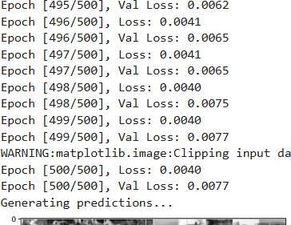
Fig 1.6: Output at 500 Epochs

Summary — Effect of Training Duration:

Epochs | Training Loss | Validation Loss | Observation
10 | High | High | Colors inaccurate, blurry outputs
20 | Lower | Lower | Colors improving, more structure visible
50 | Much lower | Stable | Good colorization, stable outputs
500 | Very low | Very stable | Best results but diminishing improvement

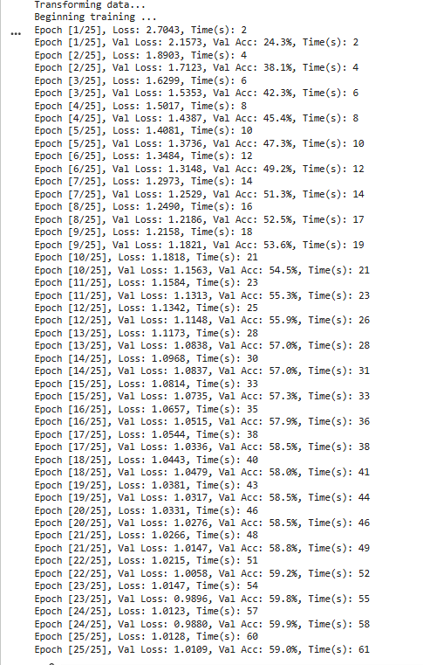
Fig 1.7: Loss Curves for Different Epoch Counts

With only 10 epochs, the predicted images appeared blurry and the model struggled to accurately reproduce colors. Increasing training to 20 epochs improved predictions; the model began capturing more realistic color patterns. At 50 epochs, predictions became significantly better with more stable colors and reduced loss values. Training for 500 epochs resulted in the lowest training and validation losses, producing the most stable color outputs. However, improvements beyond 50 epochs were relatively small, indicating diminishing returns from additional training.

Section 2: Colorization as Classification
In the classification-based approach, image colorization is treated as a pixel-wise classification problem. Instead of predicting continuous RGB values, each pixel is assigned to one of 24 predefined color categories obtained using k-means clustering. The model predicts a probability distribution over these 24 color classes for each pixel, and the final colorized image is obtained by mapping the predicted classes to their corresponding RGB values.

We implemented convolutional neural networks to perform image colorization on grayscale images from the CIFAR-10 dataset. The objective was to predict the color of each pixel in a grayscale image. We experimented with two approaches: treating colorization as regression and as classification. Additionally, we implemented a CNN model and a UNet model with skip connections and compared their performance.

Dataset Description
The CIFAR-10 dataset consists of 32×32 color images belonging to 10 categories. For this assignment, only the horse category was used. Each color image was converted into grayscale and used as input to the neural network. The goal of the model is to predict the color of each pixel in the grayscale image.

CNN Results
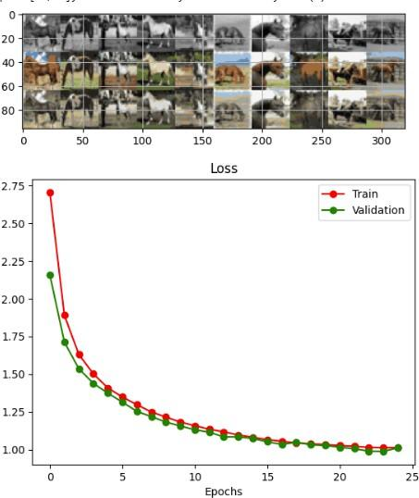
Fig 2.0: CNN Model Colorization Outputs

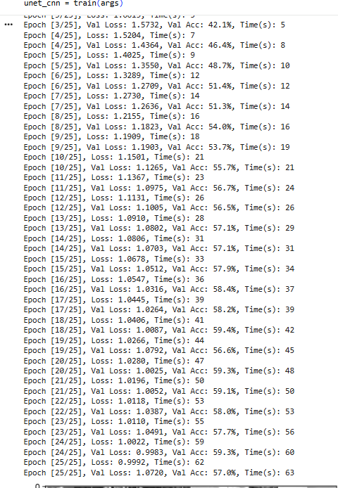
Fig 2.1: CNN Training Loss Curve

UNet with Skip Connections Results
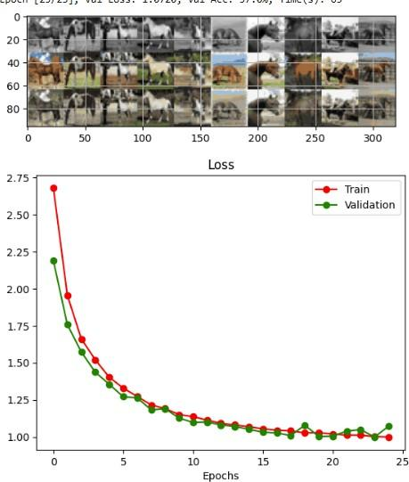
Fig 2.2: UNet Model Colorization Outputs & Training Curve

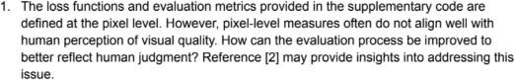
Fig 2.3: Additional Training Metrics

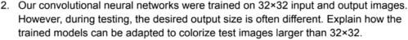
Fig 2.4: Validation Accuracy Comparison

CNN vs UNet Comparison
The CNN model produces reasonable colorization results, but the outputs are slightly blurred and lack fine spatial details. In contrast, the UNet model produces sharper and more consistent outputs, because UNet skip connections help preserve spatial information from earlier layers. Overall, UNet performs better than the standard CNN in terms of visual quality.

Section 3: Skip Connections
Skip connections allow information from earlier layers to be directly passed to later layers in the network. This helps preserve important spatial details that may be lost in deeper layers. They also improve gradient flow during training, making the network easier to train and more stable.

Q: Did Skip Connections Improve Validation Loss and Accuracy?
Yes, skip connections improved validation performance as shown in Fig 2.2. The UNet model achieved slightly lower validation loss compared to the CNN model, indicating better performance and generalization.

Q: Did Skip Connections Lead to Qualitatively Better Outputs?
Yes, skip connections resulted in quality improvement as shown in Fig 2.2. The colorized images from UNet are sharper and preserve more structural details compared to the CNN outputs (Fig 2.1).

Skip connections help because:
- They preserve spatial information from early layers.
- They improve gradient flow during backpropagation.

Section 4: Visualizing Intermediate Activations

CNN Activation Analysis
The activation maps of the CNN show that early layers capture simple features such as edges and textures, while deeper layers capture more complex features such as shapes and object structures. Early layer activations are spatially detailed but semantically shallow, while deeper layers are semantically rich but spatially coarse. This pattern is consistent with the general behavior of deep convolutional networks.

UNet Activation Analysis
In the UNet model, activation maps retain more spatial information due to skip connections, which combine both shallow and deep features. The UNet's decoder layers receive concatenated feature maps from both the encoder path and skip connections, resulting in activations that are both semantically meaningful and spatially precise. This is in contrast to the CNN, where spatial information is progressively lost in deeper layers. The UNet activations show that skip connections allow the network to reconstruct fine details that would otherwise be lost.

Section 5: Theoretical Questions

Q1: Improving Evaluation Beyond Pixel-Level Metrics
Pixel-wise loss functions evaluate predictions at an individual pixel level, which does not always align with human perception of image quality. Humans perceive images based on overall structure, texture, and context rather than individual pixel accuracy.

To improve evaluation, perceptual loss functions can be used. Perceptual losses compare high-level feature representations extracted from a pre-trained network (such as VGG) rather than raw pixel values. This approach, proposed by Johnson et al. [2], computes loss in the feature space of a pre-trained image classification network, resulting in outputs that are more perceptually similar to the target. Other improvements include using Structural Similarity Index (SSIM), Frechet Inception Distance (FID), or human evaluation studies.

Q2: Adapting the Model for Images Larger Than 32×32
Since convolutional neural networks use local filters and do not depend on a fixed input size, they can process images larger than 32×32 without architectural changes. The trained model can be applied to larger images because:
- Convolutional layers are spatially invariant and apply the same learned filters at every position regardless of image size.
- The fully convolutional architecture (no fully connected layers) allows variable-sized inputs and outputs.
- The model can be applied in a sliding window fashion or directly on a larger image to produce a correspondingly larger output.

References
[1] Ronneberger, O., Fischer, P., and Brox, T. (2015, October). U-net: Convolutional networks for biomedical image segmentation. In International Conference on Medical Image Computing and Computer-Assisted Intervention (pp. 234-241). Springer, Cham.
[2] Johnson, Justin, Alexandre Alahi, and Li Fei-Fei. "Perceptual losses for real-time style transfer and super-resolution." In European conference on computer vision, pp. 694-711. Springer, Cham, 2016.

