Project Proposal
Student Result Management System (SRMS)

Project Name | Student Result Management System (SRMS)
Student Name | Muneeb Ul Haq
Team Leader | Muneeb Ul Haq
Instructor / Advisor | Asst. Prof. Engr. Abdul Rahman
Institution | FAST-NUCES, Karachi — CS Department
Course | Software Engineering — Spring 2026

1. Overview
The Student Result Management System (SRMS) is a web-based Management Information System developed as a Software Engineering Spring 2026 project at FAST-NUCES Karachi. The motivation is to eliminate manual, error-prone academic record management by providing a centralized, role-based digital portal.
The system is delivered as a fully functional web application (HTML + CSS + JavaScript) applying five core design patterns: Singleton, Factory, Observer, Strategy, and MVC. It serves two customer types — academic administrators (full CRUD access) and students (read-only personal records view). The project will be completed within the Spring 2026 semester timeline and is self-contained with no dependency on other projects.

2. Project Detail

2.1 Problem or Challenge
In many universities in Pakistan, including at the department level in FAST-NUCES, student results are tracked using fragmented tools — spreadsheets, paper grade sheets, and disconnected systems. This causes several local problems:
- Manual GPA calculation errors affecting student academic records.
- No centralized, real-time view of class performance or rankings.
- No role-based access — students cannot view their own results without requesting them from admin.
- No audit trail or data validation when entering marks.

2.2 Project Vision
For academic administrators and students at FAST-NUCES Karachi who need a reliable, centralized academic portal, the Student Result Management System (SRMS) is a web-based MIS that automates result entry, grade computation, GPA calculation, and academic reporting. Unlike manual spreadsheet workflows, SRMS provides real-time rankings, role-based access, instant transcript generation, and CSV export — all through a clean, modern browser-based interface with no installation required.

2.3 Project Feasibility Study

2.3.1 Technical Feasibility
The system is implemented in HTML5, CSS3, and ES6 JavaScript — all universally supported without any build tools, servers, or installation. The five design patterns (Singleton, Factory, Observer, Strategy, MVC) are well-understood and implementable in vanilla JavaScript. A working prototype was completed and tested within one development sprint.

2.3.2 Operational Feasibility
The system targets academic admin staff and students who already use web browsers daily. The interface is intuitive (modal forms, toast notifications, grade preview). Training time is estimated at under 30 minutes. Admin can add students/courses/results; students simply log in and view their academic record.

2.3.3 Economic Feasibility
Development cost is zero — vanilla web technologies, no paid frameworks, no server infrastructure. Deployment cost is near-zero (any static file host). For NUCES scale, the in-memory architecture is sufficient for demonstration; scaling to a backend would require only replacing the Singleton DataStore with an API client.

2.4 Project Goals
Functional Goals:
- Implement 17 domain features covering full CRUD for students, courses, and results.
- Automate grade and GPA computation using a pluggable Strategy pattern.
- Provide role-based access: admin vs. student views with conditional navigation.
Technological Goals:
- Apply Singleton, Factory, Observer, Strategy, MVC patterns demonstrably.
- Demonstrate refactoring: monolithic code → pattern-based clean architecture.
- Achieve <100ms response time for all interactions.
Quality Goals:
- Cyclomatic complexity per function ≤ 3 (achieved after refactoring from 12).
- Pass all 10 defined test cases.
- Work across Chrome, Firefox, Edge, Safari without modification.
Organizational Goals:
- Demonstrate understanding of SE principles to satisfy Spring 2026 rubric.
- Produce complete deliverables: working code, SRS (IEEE), proposal, presentation.

2.5 Project Abstract
The Student Result Management System (SRMS) is a web-based Management Information System designed to digitalize academic result management at FAST-NUCES Karachi. Developed as a Spring 2026 Software Engineering project, SRMS demonstrates the application of five design patterns — Singleton (centralized DataStore), Factory (validated record creation), Observer (event-driven UI refresh), Strategy (pluggable grading), and MVC (layered architecture) — within a real, functional web application.
The system provides 17 domain features including: role-based login for admin and students, full CRUD for students and courses, result entry with automatic grade and GPA computation, ranked academic leaderboard with department filter, individual academic transcripts with CGPA, CSV export, real-time search, and toast notification feedback. The codebase demonstrates measurable improvement in maintainability: cyclomatic complexity reduced from 12 to 3 per function, 5 → 1 functions requiring modification for a feature addition, and automatic UI refresh eliminating manual re-render calls across all pages. All 10 test cases pass with UI response times under 20ms.

2.6 Project Scope
IN SCOPE:
- Web-based SPA: index.html + style.css + script.js (no build tools required).
- Five design patterns: Singleton, Factory, Observer, Strategy, MVC.
- 17 functional domain features (detailed in SRS Section 2.2).
- Role-based access: admin full CRUD; student read-only personal view.
- In-memory data store (session-scoped by design for demonstration).
OUT OF SCOPE:
- Backend server or database persistence across sessions.
- Mobile native app (iOS/Android).
- Email notifications or push alerts.
- Multi-institution multi-tenancy.

2.7 Project Team
Organization | Name | Role | Availability
FAST-NUCES | Muneeb Ul Haq | Team Leader / Full-Stack Dev | 100% (solo)

2.8 Existing & Related Work
System | Technology | Limitation | SRMS Advantage
Google Sheets | Spreadsheet | No roles, no GPA auto-calc | Role-based, auto-GPA, patterns
University ERP | Server-based | Heavy, needs installation | Zero install, browser-only SPA
Gradebook App | Mobile App | No design patterns, monolithic | 5 patterns, MVC architecture
Manual Records | Paper/Excel | Error-prone, no rankings | Auto-grade, real-time rankings

2.9 Proposed Solution & Architecture
SRMS follows a three-layer MVC architecture:
- Model (Singleton): Store.getInstance() — single DataStore with students[], courses[], results[].
- View (MVC-View): render*() functions — read Model, generate HTML, inject into DOM.
- Controller (MVC-Controller): doAdd*/doEdit*/doDelete* — validate input, update Model, emit EventBus.
Supporting patterns:
- Factory: RecordFactory.student/course/result() — all object creation centralized.
- Strategy: GradingStrategy.standard / activeStrategy — grading logic isolated and swappable.
- Observer: EventBus.on/emit('dataChanged') — automatic UI refresh on every data change.

2.10 Use Case Model
Actors: System Admin (full access), Student (read-only personal access).
Admin Use Cases: Login, Add Student, View Students, Delete Student, Add Course, Delete Course, Enter Result, Edit Result, Delete Result, View Rankings, View Any Transcript, Export CSV, View Dashboard.
Student Use Cases: Login, View Own Dashboard, View Own Transcript, View Rankings, View Courses, Export Own CSV.
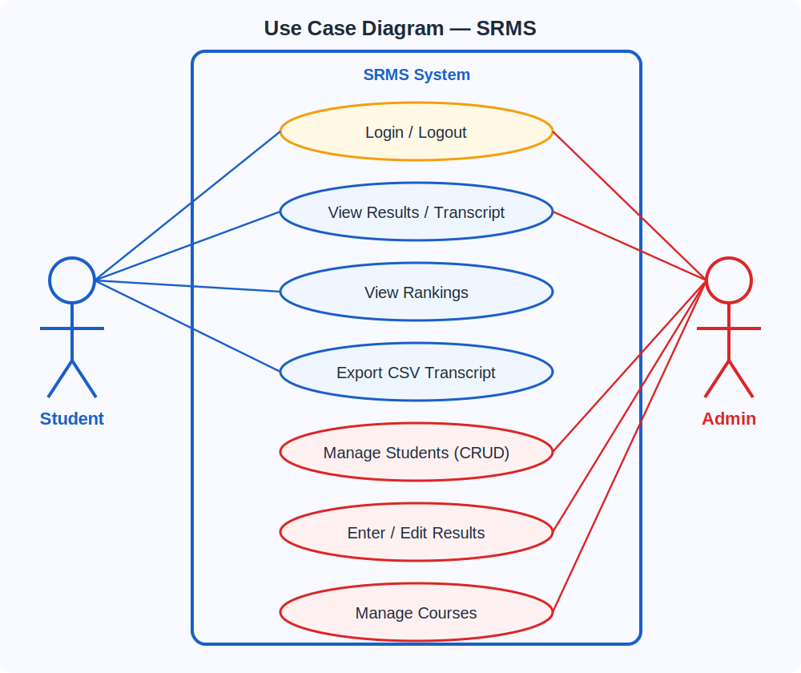

2.11 Feature List (17 Domain Features)
# | Feature | Pattern Used
F01 | Role-Based Login (Admin/Student) | MVC-Controller + Singleton
F02 | Add Student | Factory + Singleton + Observer
F03 | View/Search Students Table | MVC-View
F04 | Delete Student (cascade) | MVC-Controller + Observer
F05 | Add Course | Factory + Singleton + Observer
F06 | View Courses with Stats | MVC-View + Singleton
F07 | Enter Result (marks + semester) | Factory + Singleton + Observer
F08 | Auto Grade Computation | Strategy (activeStrategy)
F09 | GPA Calculation (4.0 scale) | Strategy + Singleton
F10 | Academic Rankings Leaderboard | MVC-View + Observer
F11 | Department Filter on Rankings | MVC-View
F12 | Individual Student Transcript | MVC-View + Singleton
F13 | CSV Export / Download | MVC-Controller (Browser File API)
F14 | Edit Result Marks | MVC-Controller + Observer
F15 | Dashboard Stats + Recent Feed | MVC-View + Observer
F16 | Real-time Search Filter | MVC-View
F17 | Grade Preview on Result Entry | Strategy + MVC-View

2.12 Software Development Methodology
Methodology: Agile (single-developer sprint-based development).
- Sprint 1: Requirements analysis, architecture design, pattern planning.
- Sprint 2: Singleton + Factory + MVC implementation (Store, RecordFactory, CRUD controllers).
- Sprint 3: Strategy pattern (GradingStrategy), result entry, transcript, CSV.
- Sprint 4: Observer pattern (EventBus), auto-refresh, rankings, search.
- Sprint 5: UI polish, testing (10 test cases), SRS, proposal, presentation.
Rationale: Agile allows incremental delivery of patterns. Each sprint adds one pattern layer, enabling refactoring demonstration from monolithic to pattern-based architecture.

2.13 Proposed Infrastructure Platform and Tools
- Languages: HTML5, CSS3, JavaScript (ES6+).
- Fonts/Icons: Google Fonts (Inter), Font Awesome 6.4.0.
- Editor: VS Code.
- Browser Testing: Chrome, Firefox, Edge.
- Version Control: Git / GitHub.
- Document Tools: Docx.js (SRS), PptxGenJS (presentation).
- No frameworks, no build tools, no server required.

2.14 Project Timeline
Week | Sprint | Focus | Deliverable
Week 1–2 | Sprint 1 | Requirements + Architecture | System design, pattern planning
Week 3–4 | Sprint 2 | Singleton + Factory + MVC | Working CRUD for students/courses
Week 5–6 | Sprint 3 | Strategy + Result Entry | Grading, GPA, transcript, CSV
Week 7 | Proposal Due | Observer + Rankings | Proposal submitted (this document)
Week 8–9 | Sprint 4 | Observer + full integration | All 17 features working
Week 10–11 | Sprint 5 | Testing + Documentation | 10 test cases, SRS written
Week 12–13 | Sprint 6 | UI polish + Presentation | PPT prepared
Week 15 | DEADLINE | Final Submission | Report + Demo + Code submitted

2.15 Mockups
The following screens are implemented in the working prototype:
- Screen 1: Login Page — dark gradient, shield icon, credential hint box.
- Screen 2: Dashboard — 4 stat cards (students, courses, avg GPA, results) + recent results table.
- Screen 3: Students Page — searchable table with GPA column + Add Student modal.
- Screen 4: Rankings Page — leaderboard with medals, department filter dropdown.
- Screen 5: Transcript Page — student header grid, course table, CGPA summary box.
(Full working prototype available in index.html — open in any browser.)

2.16 References
- [1] IEEE Std 830-1998, IEEE Recommended Practice for SRS. IEEE, 1998.
- [2] E. Gamma, R. Helm, R. Johnson, J. Vlissides, Design Patterns: Elements of Reusable Object-Oriented Software. Addison-Wesley, 1994.
- [3] M. Fowler, Patterns of Enterprise Application Architecture. Addison-Wesley, 2002.
- [4] FAST-NUCES, SE Spring 2026 Project Description Document. Karachi, 2026.
- [5] R. Martin, Clean Architecture: A Craftsman's Guide to Software Structure and Design. Prentice Hall, 2017.

