CHAPTER 1:

1.1 MOTIVATION:

Motivation for the Flecks Project

The Flecks Project aims to address the challenges faced by traditional academic management systems. It recognizes the need for a streamlined, user-friendly platform that can integrate various academic functions, such as course registration, attendance tracking, grade management, and fee processing.

The current fragmentation of these systems often leads to confusion, inefficiency, and frustration among students and staff. Flecks seeks to consolidate all these essential functions into a single, accessible hub, empowering users to focus more on learning and less on administrative hurdles.

By harnessing the power of technology, Flecks aims to revolutionize the educational experience for all stakeholders. It draws inspiration from the success of similar platforms like Flex, with the goal of enhancing student engagement, improving learning outcomes, and optimizing administrative processes.

The Flecks Project aspires to bridge the gap in the market for a unified solution that seamlessly integrates all facets of academic management, thereby streamlining operations, enhancing transparency, and fostering collaboration within educational institutions. Through the development and implementation of Flecks, the project seeks to empower students, teachers, and administrators, transforming the way they interact and achieve academic success.

1.2 PROJECT VISION:

1.2.1. PROBLEM STATEMENT:

The Flecks project aims to develop a comprehensive online platform that streamlines academic management processes, including course registration, attendance tracking, grade management, and fee processing.

1.2.2. BUSINESS OPPORTUNITY:

In today's educational landscape, there's a growing need for streamlined and user-friendly solutions to manage academic processes efficiently. The Flecks project presents a unique business opportunity to tap into this demand by offering a comprehensive online platform that consolidates essential academic management functions. With features like course registration, attendance tracking, grade management, and fee processing all in one place, Flecks addresses the pain points of students, teachers, and administrative staff alike. By providing a seamless and intuitive user experience, Flecks not only enhances the educational experience but also presents an opportunity for revenue generation through subscription-based models, partnerships with educational institutions, and potential expansion into related services such as online tutoring or academic counseling. This venture capitalizes on the growing trend towards digitalization in education and positions itself as a leader in revolutionizing academic management systems for the future.

1.2.3. OBJECTIVES:

The objectives of the Flecks project are:

To streamline academic management processes by providing a user-friendly online platform.

To simplify course registration for students and administrative staff, reducing manual workload and potential errors.

To enhance transparency and accountability in attendance tracking for each course, promoting student engagement and accountability.

To facilitate efficient grade management, allowing students to access their marks for each course easily.

To generate comprehensive transcripts for students, detailing their course marks and calculating their GPA for each semester.

To automate fee challan generation for each semester, providing clarity and convenience for students and administrative staff.

To ensure data security and privacy for all users, safeguarding sensitive academic information from unauthorized access.

To provide administrators with a centralized dashboard for efficient user management and system monitoring, enhancing administrative effectiveness and decision-making.

1.2.4 PROJECT SCOPE:

Project Scope Statement for "Flecks":

1. Product Scope Description: Flecks is a comprehensive online platform designed to streamline academic management processes for educational institutions. It includes features such as course registration, attendance tracking, grade management, fee processing, and course feedback mechanisms.

2. Product Acceptance Criteria: The Flecks platform will be considered acceptable if it meets the following criteria:

· User-friendly interface that is accessible to students, teachers, and administrative staff.

· Seamless integration of all academic management functions into a centralized hub.

· Secure data storage and transmission to ensure privacy and confidentiality.

· Reliable performance and responsiveness under varying user loads.

3. Project Deliverables: The deliverables of the Flecks project include:

· Fully functional online platform accessible via web browsers and mobile devices.

· Documentation outlining system architecture, user manuals, and technical specifications.

· Training materials for users and administrators on how to utilize the platform effectively.

4. Project Exclusions: The following elements are outside the scope of the Flecks project:

· Integration with external systems or third-party applications not specified in the project requirements.

· Customization of the platform beyond the predefined features and functionalities.

· Hardware procurement or infrastructure setup for hosting the platform.

5. Project Constraints: Constraints affecting the Flecks project include:

· Limited budget and resources allocated for development and implementation.

· Technological limitations of existing infrastructure and software compatibility.

· Time constraints to meet project deadlines and launch the platform within the specified timeframe.

6. Project Assumptions: The following assumptions are made for the successful execution of the Flecks project:

· Availability of skilled development resources and technical expertise.

· Cooperation and support from stakeholders and end-users throughout the project lifecycle.

· Compliance with regulatory requirements and data protection standards in handling sensitive academic information.

7. Milestones: Key milestones in the Flecks project timeline include:

· Completion of requirements gathering and analysis phase.

· Development and testing of core platform functionalities.

· User acceptance testing and feedback iteration cycles.

· Deployment of the Flecks platform for pilot testing and full-scale implementation.

8. Agreement: Upon completion of the project scope statement, stakeholders will review and provide their sign-off, indicating their agreement with the defined scope and objectives of the Flecks project

1.2.5. System Constraints

Scope:

The scope of the Flecks project defines the specific features and functionalities that will be included in the platform. This encompasses essential academic management processes such as course registration, attendance tracking, grade management, fee processing, and course feedback mechanisms.

Cost:

The financial investment allocated to the Flecks project encompasses various aspects of software development, including initial development, ongoing maintenance, and operational costs. Budgetary constraints dictate the allocation of resources for development, testing, infrastructure, and any additional expenses related to project execution.

Time:

Time constraints dictate the deadlines for project delivery and establish key milestones throughout the development process. The Flecks project timeline includes phases such as requirements gathering, development, testing, deployment, and ongoing support. Adherence to the project schedule is crucial to meet stakeholders' expectations and ensure timely delivery of the platform.

1.2.6. STAKEHOLDERS DESCRIPTION:

1. Direct Users:

· Students: Primary users who will directly interact with the Flecks platform to access course materials, register for courses, track attendance, view grades, and provide feedback.

· Teachers: Direct users responsible for managing course materials, recording attendance, entering grades, and communicating with students through the Flecks platform.

· Administrative Staff: Direct users involved in managing administrative tasks related to course registration, fee processing, and system maintenance within the Flecks platform.

2. Secondary Users:

· Academic Advisors: Secondary users who rely on the data and information produced by the Flecks platform to assist students with academic planning and progress tracking.

· Department Heads: Secondary users who utilize Flecks-generated reports and analytics to monitor departmental performance and make strategic decisions regarding course offerings and resource allocation.

3. Beneficiaries:

· Educational Institutions: Beneficiaries encompassing universities, colleges, and schools that will benefit from the streamlined academic management processes facilitated by the Flecks platform, leading to improved efficiency and student satisfaction.

CHAPTER 2:

Literature Review

2.1 Introduction to Centralized Educational Platforms

Centralized educational platforms serve as integrated systems designed to streamline educational processes and communication within academic institutions [1]. These platforms amalgamate various technologies, including learning management systems (LMS) and academic resource hubs, to offer centralized access to resources, foster collaboration, and enrich learning experiences for stakeholders.

2.2 Significance of Academic Hubs

Centralized educational platforms hold significant importance in modern education, providing features for course management, content delivery, assessment, and communication [2]. They are vital tools for stakeholders, including students, educators, administrators, and educational institutions, as they enhance access to resources, streamline administrative tasks, and support data-driven decision-making.

2.3 Benefits for Stakeholders

For students, centralized platforms offer enhanced access to resources, support collaboration, and enable personalized learning experiences [3]. Educators benefit from streamlined course management, assessment tools, and communication channels. Administrators can efficiently track student progress, manage resources, and make data-driven decisions. Educational institutions gain efficiency, cost savings, and improved student outcomes through the implementation of centralized platforms.

2.4 Current State of the Art

The current state of centralized educational platforms encompasses advanced features such as personalized learning pathways, adaptive assessment tools, and predictive analytics [1]. Research in this area explores topics such as learning analytics, artificial intelligence, and personalized learning experiences. Major achievements include the development of sophisticated learning management systems, innovative academic resource hubs, and advancements in data analytics for educational purposes.

2.5 Methodologies and Features in Research

Studies on centralized educational platforms utilize various methodologies, including quantitative analysis, case studies, and user surveys [2]. These studies evaluate platform effectiveness, user satisfaction, and impact on student outcomes. Feature-wise, research focuses on content delivery, assessment tools, communication channels, and data analytics capabilities.

2.6 Limitations and Future Directions

Existing studies on centralized educational platforms face limitations such as sample size constraints, limited generalizability, and challenges in measuring long-term impact [3]. There is a clear need for continued research and innovation in this area to address emerging challenges and capitalize on opportunities for improvement.

2.7 Need for a Solution

The research problem centers around optimizing platform functionality, enhancing user experience, and maximizing educational outcomes. Project objectives include developing user-friendly interfaces, improving data analytics capabilities, and integrating emerging technologies.

# CHAPTER 3:

### ***Project Background***

*The Student Academic Portal is being developed to address the need for an efficient and user-friendly platform for students, teachers, and administrators to manage academic information and interactions. This project is driven by the desire to streamline academic processes and enhance the overall educational experience.*

### ***Project Scope***

*The project will encompass the development of a comprehensive Student Academic Portal that includes functionalities such as course enrollment, assignment submission, grade tracking, and communication tools.*

### ***Not in Scope***

*The project does not include functionalities beyond academic management, such as financial transactions or non academic communications. 2.4. Project Objectives The project aims to create a centralized platform that simplifies academic processes, improves communication between stakeholders, and provides real-time access to academic information.*

### ***Stakeholders***

*Stakeholders include students, teachers, university administrators, and the development team responsible for building and maintaining the portal.*

### ***Operating Environment***

#### ***Hardware Platform:***

*The system is designed to be compatible with standard hardware configurations, including desktops, laptops, and mobile devices. Users can access the portal using devices with varying specifications, ensuring flexibility and accessibility.*

#### ***Operating System:***

*The portal is hosted on a server environment running Windows Server. This operating system provides the underlying infrastructure necessary for hosting and executing the Academic Portal.*

#### ***Network Environment:***

*The software operates in a networked environment, relying on standard TCP/IP protocols for communication. This includes local area networks (LANs) within educational institutions and wide area networks (WANs) for remote access.*

### ***Assumptions & Dependencies***

#### ***Assumptions:***

*Users have access to a reliable internet connection. Basic computer literacy is assumed for users to navigate the portal effectively.*

#### ***Dependencies:***

*The proper functioning of certain portal functionalities relies on the availability and reliability of external APIs. Compatibility with standard web browsers (Google Chrome,*

*Mozilla Firefox, Microsoft Edge) is assumed for optimal user experience. Page 5 of 17 Software Requirements & Design Specifications*

# ***External Interface Requirements***

### ***Hardware Interfaces***

*The Academic Portal should be compatible with standard hardware configurations to provide an optimal user experience across different devices. This includes:*

***Desktops:*** *Compatible with common desktop configurations.*

***Laptops:*** *Support for various laptop specifications.*

***Mobile Devices:*** *Responsive design for compatibility with smartphones and tablets.*

### ***Software Interfaces***

*The Academic Portal is designed to be accessible through popular web browsers, including Google Chrome, Mozilla Firefox, and Microsoft Edge. To ensure secure data transmission, the communication protocol utilized is HTTPS. This protocol encrypts the data exchanged between the user's browser and the portal, enhancing the overall security of information.*

*The user interface is crafted using a combination of HTML, CSS, and JavaScript, enabling a dynamic and interactive experience for users as they navigate and engage with the Academic Portal. This combination of supported browsers, secure communication protocol, and versatile message formatting contributes to a robust and user-friendly online academic environment.*

### ***Communications Interfaces***

*The Academic Portal relies on a MySQL Database Management System (DBMS) for the storage and management of academic data. The interaction with the database occurs through SQL queries, facilitating seamless data retrieval and updates. The underlying environment for hosting the Academic Portal is supported by the Windows operating system, providing the necessary infrastructure. System-level commands and services on this operating system are employed for the hosting of the application. Additionally, the web- based interface of the Academic Portal is hosted on the Apache HTTP Server, which handles HTTP requests and responses, ensuring smooth user interactions with the portal's features and functionalities. This combination of a robust DBMS, operating system, and web server forms the foundation for the Academic Portal's data storage, hosting, and user interface delivery. Page 6 of 17 Software Requirements & Design Specifications*

# ***Functional Requirements***

### ***Functional Hierarchy***

#### ***User Authentication and Authorization:***

* *User login*
* *Password recovery*
* *Role-based access control*

#### ***Student Management***

* *Register courses*
* *View personal information*
* *Academic Information:*
* *View grades and transcripts*
* *Check attendance records*
* *View registered courses*

#### ***Teacher Management***

* *Updating grades.*
* *Mark attendance.*
* *View personal details.*
* *View Courses*

### ***Use case diagrams:***

* + 1. ***Student use cases***

#### ***View grades:***

*Students can view the marks of their assignments, quizzes, sessional, final exams as well as grand total after the instructor of a particular course has assigned the marks/grades.*

#### ***View Attendance:***

*Students can view the status of their attendance with date and duration of class as well as the course id of a particular course.*

#### ***View Fee Challan:***

*Student can view the amount of fee and the due date. They also have the option to print the challan form and select the method of payment.*

### ***Instructors use cases***

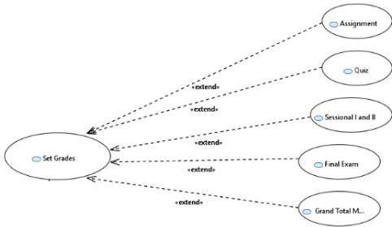

#### ***View Transcript :***

*Students can view their CGPA, SGPA, total credit hours as well as name and grade achieved in a particular course.*

#### ***Set Grades:***

*Instructors can grade assignments, quizzes, sessional, final and the grand total marks will be automatically generated.*

#### ***Set Attendance:***

*Instructors can set attendance of a particular course id on a particular day and assign the duration of the class.*

# ***Non-functional Requirements***

## ***Performance Requirements***

*The performance requirements for the Student Academic Portal are crucial to ensure an optimal user experience and efficient system operation. These requirements encompass various aspects of system performance, including speed, precision, concurrency, capacity, safety, and reliability.*

### ***Response Time***

*The system should have a response time of less than 2 seconds for standard user interactions, such as accessing the homepage, viewing grades, or submitting assignments.*

### ***Concurrency***

*The portal should support a minimum of 500 concurrent users without a significant degradation in performance during peak usage times, such as course registration periods.*

### ***Capacity Planning***

*The system must be capable of handling a user base of at least 10,000 students and 500 faculty members concurrently.*

### ***Reliability***

*The system should have a minimum uptime of 99.9% to ensure continuous availability to users.*

### ***Safety and Data Integrity***

*Data integrity should be maintained at all times, ensuring that student records, grades, and other critical information are accurate and secure.*

### ***Scalability***

*The architecture of the system should be designed to scale horizontally to accommodate future growth in user numbers and data volume.*

### ***Load Testing***

*The system must undergo load testing to ensure that it can handle peak loads without performance degradation. Load testing should simulate scenarios with 2 times the expected peak user load.*

## ***Safety Requirements***

*Safety requirements for the Student Academic Portal are essential to mitigate potential risks and ensure the well being of users. These requirements encompass measures to prevent data loss, protect user privacy, and comply with relevant regulations.*

### ***Data Security:***

*The system must implement robust data encryption protocols to protect sensitive information such as personal details, grades, and attendance records. Safeguards should be in place to prevent unauthorized access to student data.*

### ***User Authentication***

*Strong authentication measures, including secure password policies and multi-factor authentication, must be enforced to prevent unauthorized access to user accounts.*

### ***User Privacy***

*The system should comply with data protection laws and university policies to safeguard user privacy. Personally identifiable information (PII) should be handled with the utmost confidentiality. Page 14 of 17 Software Requirements & Design Specifications*

### ***Backup and Recovery***

*Regular automated backups of the system's database should be performed to ensure data integrity. A comprehensive disaster recovery plan must be in place to minimize downtime in case of data loss or system failure.*

### ***Prevention of Malicious Activities***

*The system should incorporate security measures, such as firewalls and intrusion detection systems, to prevent and detect malicious activities. Safeguards should be in place to mitigate the risks of phishing, SQL injection, and other cyber threats.*

### ***User Education***

*Implement educational modules or guides to inform users about best practices for online safety and security. Ensure that users are aware of the potential risks and how to report any security concerns.*

### ***Regular Security Audits***

*Conduct regular security audits and vulnerability assessments to identify and address potential security risks. Implement timely security patches and updates to maintain the system's security posture.*

## ***Security Requirements***

### ***User Authentication***

*Users must undergo secure authentication before accessing the portal. Strong password policies, including minimum length and complexity requirements, must be enforced. Multi- factor authentication should be implemented to enhance user account security.*

### ***User Authorization***

*Role-based access control (RBAC) should be implemented to ensure that users have appropriate permissions based on their roles (student, faculty, administrator). Access to specific features and data should be restricted based on user roles.*

### ***Data Encryption***

*All sensitive data transmitted between the user's device and the server must be encrypted using secure protocols (e.g., HTTPS). Data at rest, including stored passwords and personal information, must be encrypted to prevent unauthorized access.*

### ***Secure Session Management:***

*Implement secure session management to protect against session hijacking and ensure that sessions expire after a defined period of inactivity.*

### ***Regular Security Training***

*Conduct regular security training for system users and administrators to raise awareness of security best practices and potential threats.*

### ***Access Monitoring and Control***

*Implement real-time access monitoring to detect and respond to unauthorized access attempts. Define access control policies to manage user access rights.*

### ***Vulnerability Management***

*Establish a vulnerability management process to regularly assess and address security vulnerabilities in the system and its dependencies.*

### ***Secure Third-party Integrations***

*Ensure that any third-party integrations or APIs used by the system adhere to secure coding practices and do not introduce vulnerabilities.*

### ***User Documentation***

***User Manuals:*** *Comprehensive guides providing detailed instructions on using the Student Academic Portal. Manuals may be organized by user roles (e.g., student, faculty, administrator) for targeted guidance.*

***Online Help:*** *Web-based documentation accessible within the portal interface. Context- sensitive help that provides relevant information based on the user's current location or action.*

***Tutorials:*** *Step-by-step tutorials or walkthroughs guiding users through common tasks. Video tutorials for visual demonstrations of specific functionalities.*

***FAQs (Frequently Asked Questions):*** *A compilation of common questions and answers to address typical user queries. Helps users quickly find solutions to common issues.*

***Quick Start Guides:*** *Concise guides providing essential information for getting started with the portal. Focus on key functionalities to help users navigate the system initially.*

***Detailed System Design***

*Class diagram:*

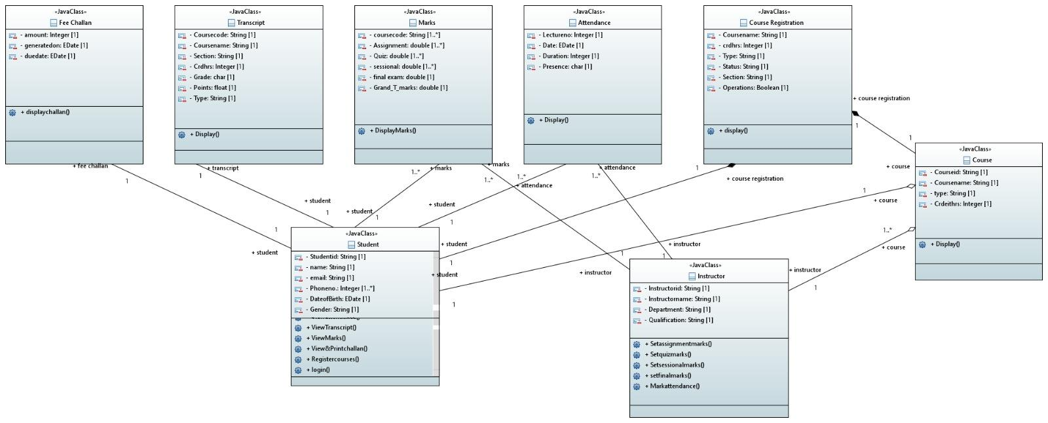

*Sequence Diagram:*

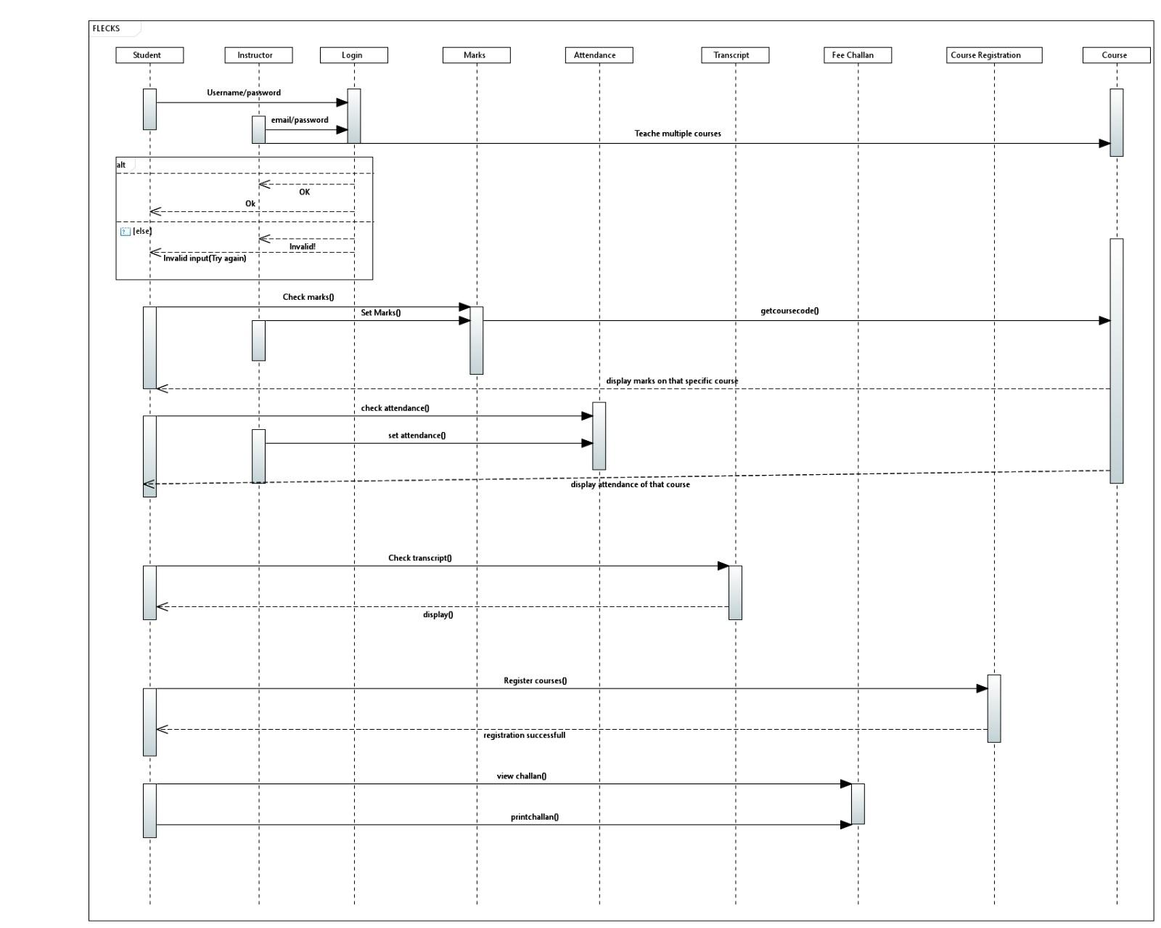

*Component Diagram:*

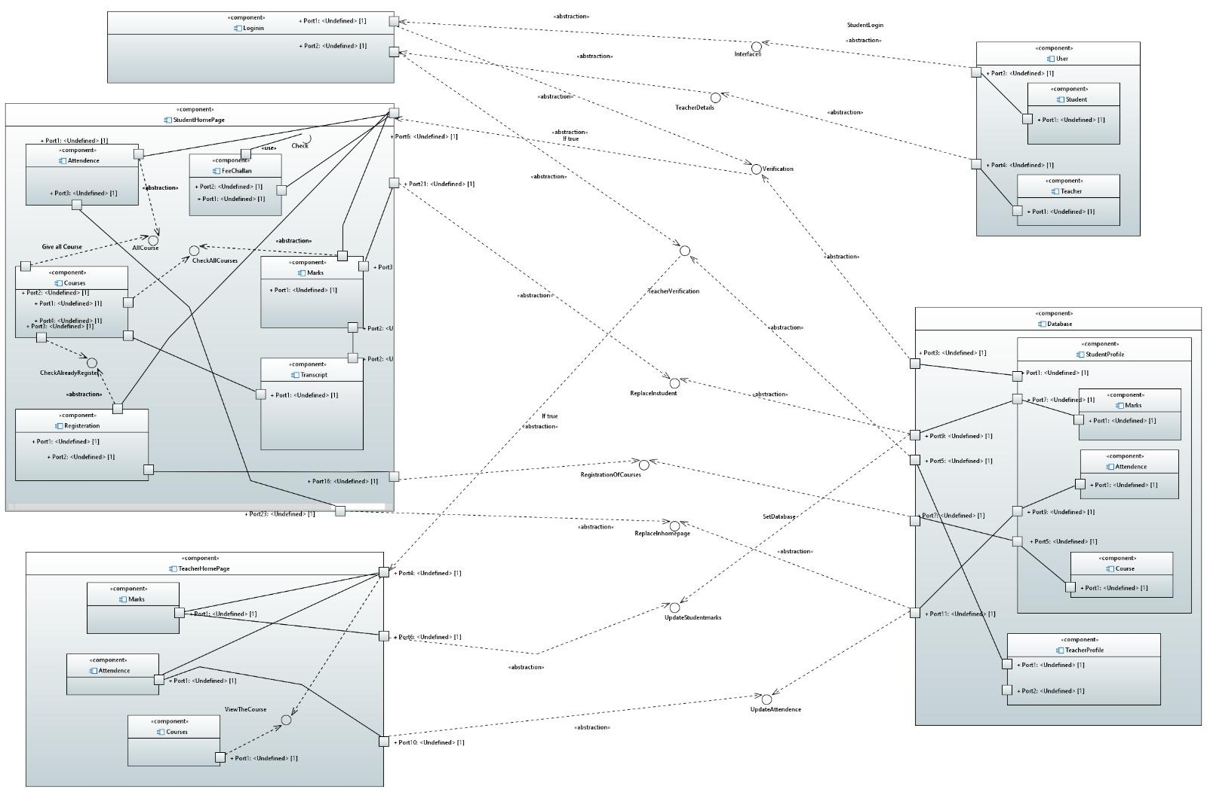

***Design Strategy***

*Designing an airline reservation system involves several components, including user interface, database management, and security. Here are some design strategies to consider:*

***1. User interface:***

*The user interface is critical to the success of a student academic portal. It should be easy to use, visually appealing, and intuitive. A good user interface should guide the user through the monitoring process with minimal confusion. It should also provide feedback on user actions, such as when no course is available for registration or a payment method is invalid.*

***2. Database management:***

*It is essential to ensure that the database is scalable and capable of handling a high volume of transactions. Additionally, the database should be secure and protected from unauthorized access.*

***3. Security:***

*The flecks student academic portal should have robust security measures in place to protect user data and prevent unauthorized access.*

***4. Integration with other systems:***

*An student portal may need to integrate with other systems, such as banks for payment gateways if the student decides to pay online. It is essential to ensure that these integrations are seamless and reliable.*

### ***Data Base implementation :***

* + 1. ***ERD-Diagram***

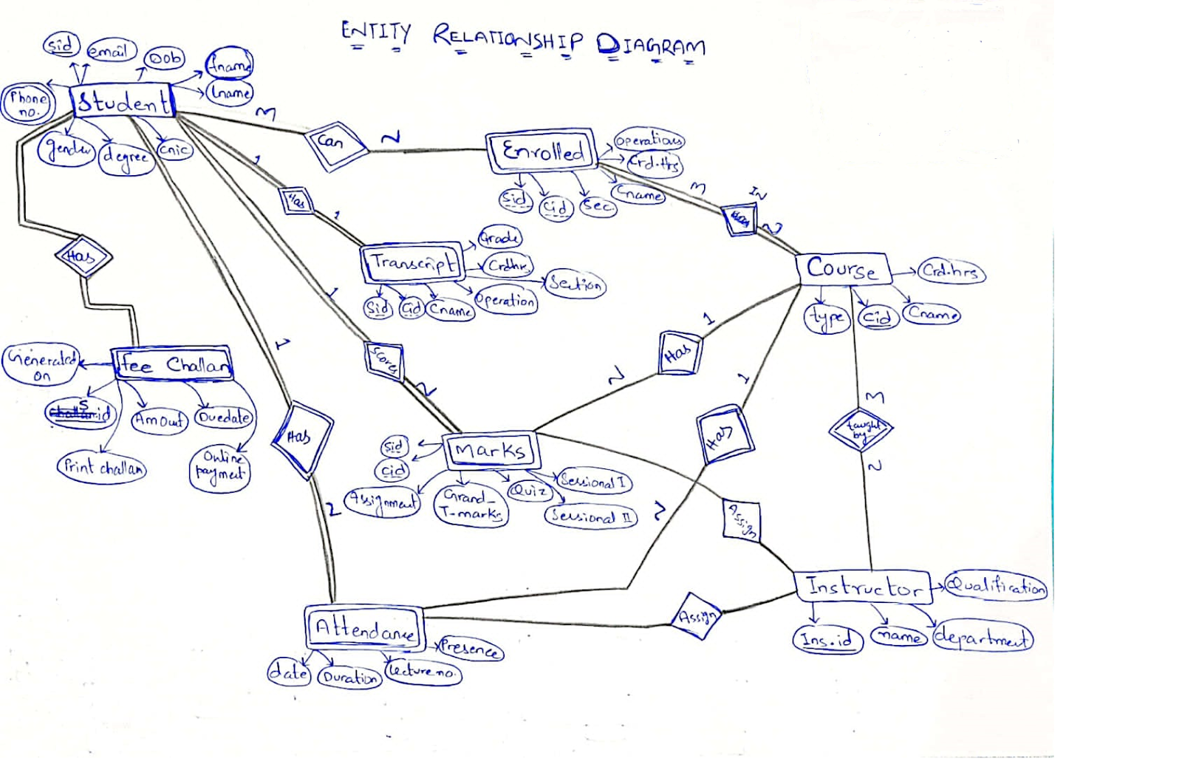

### Database structure (Example)

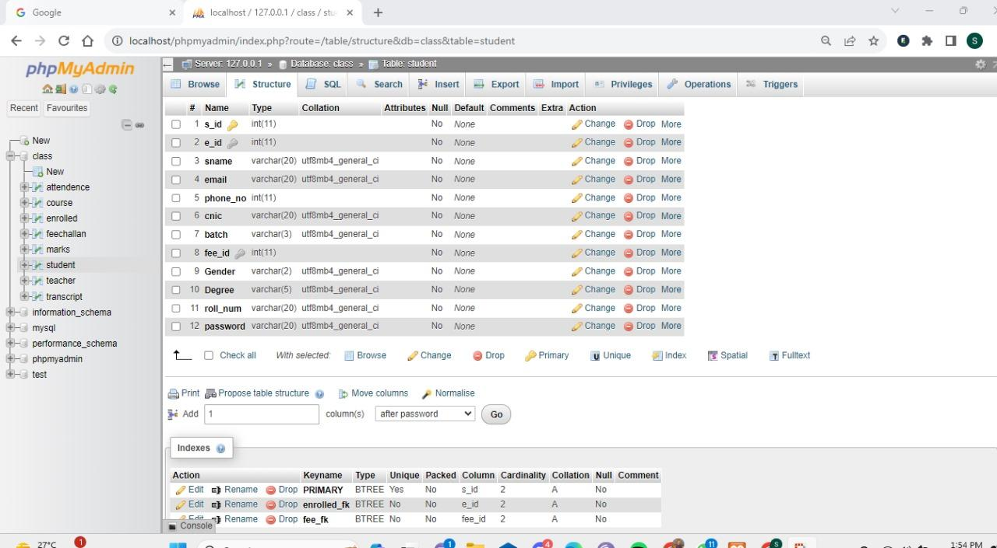

### 3.3.3. Data Dictionary

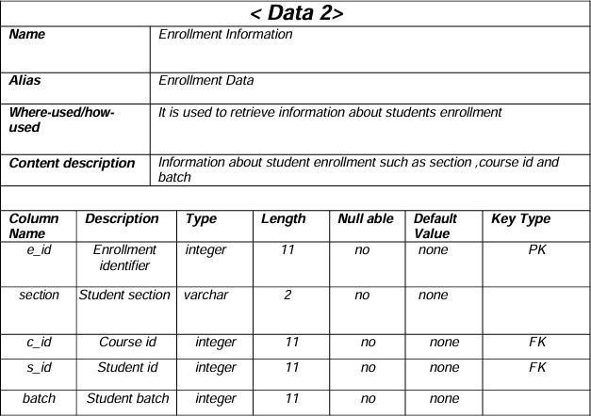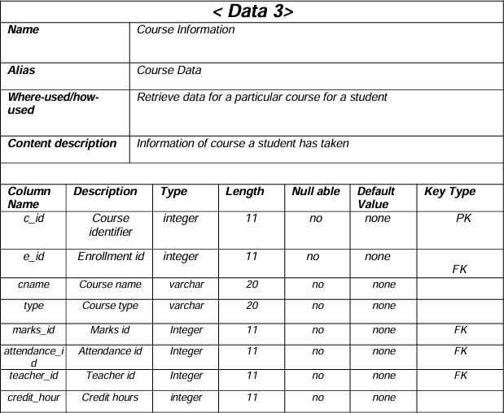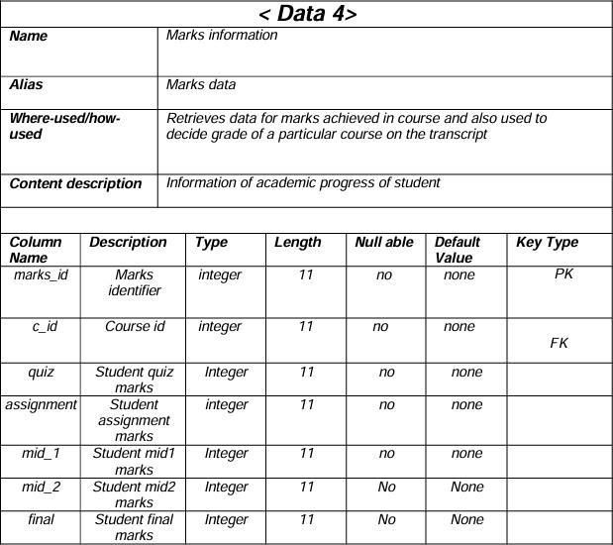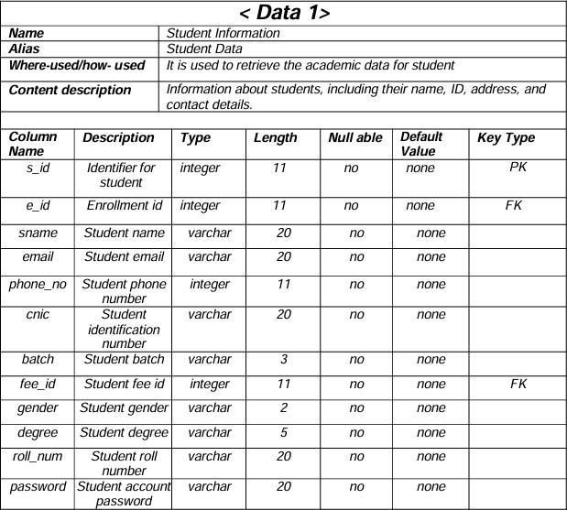

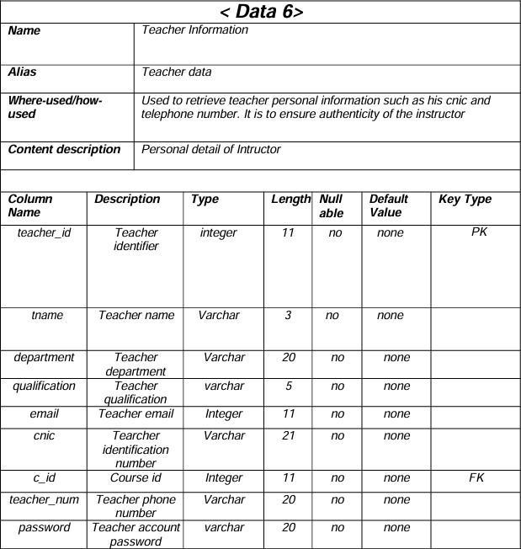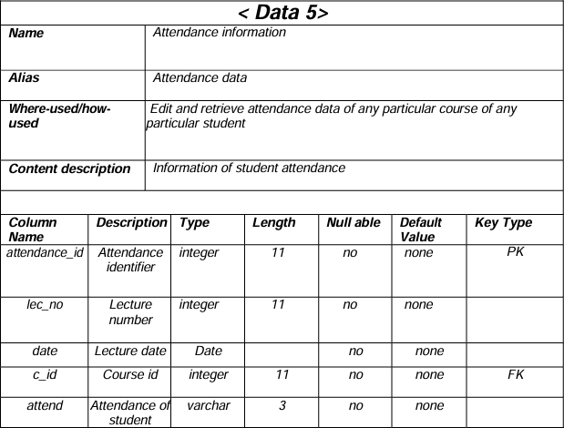

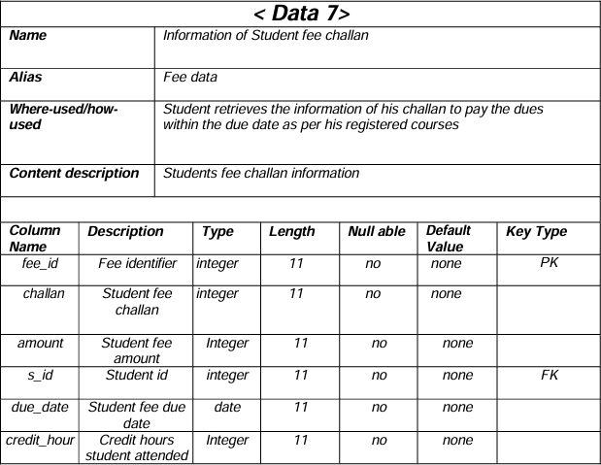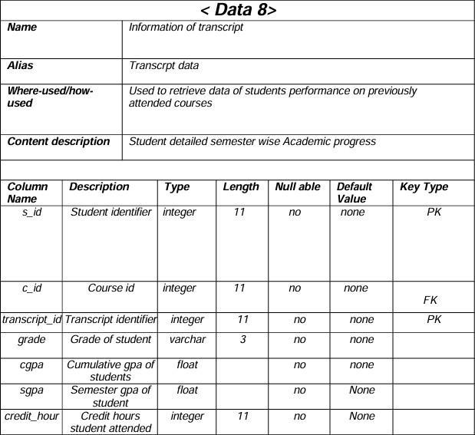

# Chapter 4:

## **4.1. Summary:**

*The Flecks is an innovative project that aims to revolutionize academic administration systems by combining multiple features into a user-friendly online platform. It acknowledges the difficulties caused by disjointed systems and works to simplify procedures including fee processing, grade management, course registration, and attendance monitoring. Flecks strives to improve productivity and user experience for educators, administrators, and students with its intuitive interface, creating a favorable learning environment. Motivated by popular platforms like Flex, Flecks hopes to transform learning environments and streamline administrative procedures. In addition to addressing the growing need for effective academic administration solutions, the project offers a substantial commercial possibility by investigating revenue streams via partnerships and subscription models. Its goals include making course registration easier, protecting student data, and encouraging ongoing development via student feedback channels. The project's scope involves creating a thorough platform that works with both web and mobile platforms, in addition to producing training materials and documentation. Flecks is positioned to have a significant impact by empowering stakeholders and encouraging collaboration within educational institutions, despite obstacles like time and financial constraints. By redefining academic administration systems for the digital age, Flecks hopes to improve student performance, efficiency, and transparency through their creative approach.*

## **4.2. Project Evaluation:**

Any software product must be evaluated through several forms of testing before it is deployed to guarantee its operation, performance, security, and compliance with user requirements. Several tests were carried out on the Flecks project to evaluate its dependability and functionality. The information gathered throughout each testing phase is listed below:

### **1. Unit Testing:**

*Unit testing is the process of evaluating separate software modules and components in isolation to ensure proper operation.*

*Findings: JavaScript unit testing was done with the Jest framework. Key features and elements, including data retrieval, course administration, and user authentication, were extensively evaluated.*

*Languages/Workflows: Framework for JavaScript Testing: Jest*

### **2. Load Testing:**

*To make sure the system can handle consistent traffic volumes; load testing assesses how the system operates at both peak and typical load levels.*

*Findings: Using Apache JMeter, load testing was carried out to mimic concurrent user access to the platform. Under load, the system showed stability and kept response times within tolerable bounds.*

*Traffic volume: 1000 simulated users*

*Languages/Frameworks: JavaScript Apache JMeter is the testing tool*

### **3. Performance Testing:**

*Performance testing verifies the system's stability and responsiveness to changes in workload.*

*Findings: Response times, throughput, and resource use were all measured during performance testing. The experiment performed well, with customers experiencing response times that were on average less than two seconds.*

*Frameworks/Languages: JavaScript*

### **4. Security Testing:**

*Security testing finds weaknesses and confirms that safeguards against possible threats are in place for data protection.*

*Findings: OWASP ZAP was used in security testing to examine the application for security vulnerabilities. Strong authentication and data encryption techniques were established by the system, and no significant weaknesses were discovered.*

*Languages/Workflows: OWASP ZAP is a JavaScript testing tool.*

### **5. Acceptance Testing:**

*Acceptance testing verifies if the system satisfies user needs and is prepared for deployment.*

*Results: Stakeholders gave input that was in line with expectations after reviewing the platform in comparison to the approval criteria.*

*Not using any testing tools. Testing was done by hand.*

## 4.3.Recommendations for Future research:

***1. Evaluating Long-Term Impact:*** *To see how systems like Flecks affect schools and students over an extended period, researchers would carry out in-depth studies. To find out if Flecks enhance student learning results and make administrative duties for teachers and staff easier, they will examine data gathered over several years. Through the analysis of patterns and shifts over time, scholars might acquire understanding regarding the long-term efficacy of these kinds of educational institutions.*

***2.Investigating the Integration of Cutting-Edge Technology:*** *This suggestion entails investigating the incorporation of state-of-the-art technology into Flecks, including blockchain, artificial intelligence (AI), and machine learning (ML). Researchers would investigate how these technologies—such as automated grading systems, secure credentialing procedures utilizing blockchain, and predictive analytics for student support—can improve Flecks' capacities. Researchers aim to advance academic administration systems by experimenting with these technologies and making them more inventive, efficient, and future proof.*