**IST 230**

**Spring, 2024**

1. You and your friends want to tour the southwest by car. You will visit the nine states below, with the following rather odd rule: you must cross each border between neighboring states exactly once (so, for example, you must cross the Colorado-Utah border exactly once). Can you do it? Using an appropriate algorithm, develop the tour for the network shown. What modifications must you make to the graph (if any)?

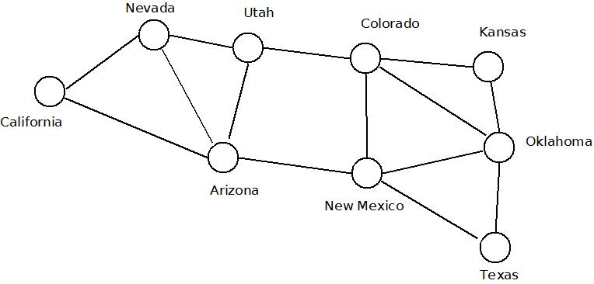

2. Consider the following business situation and **formulate a solution approach** (you do not have to solve it).

A mining company produces 100 tons of red ore and 80 tons of black ore each week. These can be treated in different ways to produce three different alloys, Soft, Hard or Strong. To produce 1 ton of Soft alloy requires 5 tons of red ore and 3 tons of black. For the Hard alloy the requirements are 3 tons of red and 5 tons of black, whilst for the Strong alloy they are 5 tons of red and 5 tons of black. The profit per ton from selling the alloys (after allowing for production but not mining costs, which are regarded as fixed) are £250, £300 and £400 for Soft, Hard and Strong respectively. Formulate the problem of deciding how much of each alloy to make each week.

3. Find the **minimum** weight collection of arcs that **span** the following network. (Note: the numbers on the arcs represent the weight of the arc).

