Shortest Path Finder with Traffic Management
Project Documentation

Introduction
This project implements a Smart City Navigation System that finds the shortest path between cities while considering real-world constraints like traffic conditions and road blockages. The system is built using Dijkstra's Algorithm and provides an interactive interface for managing a weighted graph of cities and routes.
The project addresses common urban transportation challenges including finding optimal routes between locations, adapting to dynamic traffic conditions, handling road closures, and calculating travel costs that reflect real-world delays.
Unlike basic pathfinding systems, this implementation incorporates dynamic edge weights that change based on traffic levels, making it more realistic for navigation applications. The system automatically blocks routes when traffic becomes severe and recalculates paths accordingly.

Project Features
Dynamic Graph Management
- Add cities dynamically with unique identifiers
- Create bidirectional or one-way routes between cities
- Automatic duplicate detection and prevention
- Comprehensive input validation for all operations
Traffic Management System
- Traffic levels ranging from 0 to 10
- Dynamic cost calculation based on both distance and traffic
- Automatic route blocking when traffic reaches critical levels
- Manual route blocking and unblocking for emergencies
Intelligent Pathfinding
- Dijkstra's algorithm for shortest path computation
- Considers both distance and traffic in path calculation
- Automatically skips blocked routes
- Handles disconnected graph components appropriately
User Interface
- Interactive menu-driven system
- Clear error messages and comprehensive validation
- Visual display of graph structure
- Detailed path results with complete route information
Testing Capabilities
- Pre-configured sample network for demonstration
- Multiple test cases including disconnected components

Methodology
Problem-Solving Approach
The project addresses three fundamental challenges: efficient graph representation with multiple edge attributes, optimal path computation considering traffic conditions, and handling real-time changes in route availability.
Data Structures Used
Unordered Map (Hash Table)
Used for storing cities and adjacency lists. This structure was chosen because it provides constant-time average lookup for city retrieval by identifier and allows direct access to adjacency lists without iteration. The dynamic sizing capability means it grows automatically as cities are added.
The alternative of using vectors or arrays would waste memory with non-sequential identifiers and require pre-allocation of fixed sizes. Hash maps handle sparse identifier spaces efficiently.
Linked List (Adjacency List)
Used for storing connections from each city. Linked lists provide dynamic sizing where each city can have any number of connections. They offer efficient insertions and deletions when routes need to be modified, use memory proportional only to actual connections, and allow easy iteration through neighbors during pathfinding.
The alternative of adjacency matrices would require space proportional to the square of the number of cities, which is wasteful for sparse graphs where most city pairs are not directly connected. Adjacency matrices also make it difficult to store multiple attributes per edge.
Custom Min Heap (Priority Queue)
A custom implementation combining a vector-based heap with an index map. This structure was necessary because Dijkstra's algorithm requires a min-priority queue for efficient selection of the next node to process. The custom implementation supports efficient decrease-key operations through the index map, which is essential for updating distances during the relaxation step.
The standard library priority queue does not support efficient updates to existing elements. Without decrease-key capability, we would need to insert duplicate entries leading to inefficient processing.
The heap maintains the property that parents have smaller values than children. The index map provides constant-time lookup of node positions in the heap. Operations include bubbling smaller values upward, pushing larger values downward, and efficiently updating distances with re-heapification.
Vector (Dynamic Array)
Used for storing the final computed path. Vectors provide dynamic resizing for paths of unknown length, constant-time random access for reverse iteration during path reconstruction, and efficient appending operations for path construction.
Algorithm Implementation
The project uses Dijkstra's Algorithm, which is optimal for finding shortest paths in graphs with non-negative edge weights. The algorithm works by maintaining tentative distances to all nodes and repeatedly selecting the node with minimum tentative distance for processing.
The initialization phase sets all distances to infinity except the source, which is set to zero. The main loop extracts the minimum distance node from the heap, then examines all its neighbors. For each neighbor, if the route is not blocked and a shorter path is found, the distance and parent are updated.
After processing completes, path reconstruction works backward from the destination using parent pointers, then reverses the result to obtain the source to destination path.
Traffic Integration
The effective cost calculation combines base distance with a traffic penalty. The formula multiplies the base distance by the traffic level as a percentage, making the traffic impact proportional to route length. This causes routes with high traffic to become virtually longer in the algorithm's calculation, naturally guiding Dijkstra's algorithm to avoid congested routes.
Design Decisions
Choice of Dijkstra's Algorithm: Floyd-Warshall algorithm computes all-pairs shortest paths but is inefficient for single-source queries and provides unnecessary information. Bellman-Ford algorithm handles negative weights but is slower when all weights are non-negative. Dijkstra's is optimal for our use case of non-negative weights with on-demand queries.
Separation of Traffic and Blocking: Traffic represents current congestion levels that can change frequently. Blocking represents manual closures like construction or accidents that are independent of traffic flow. Separating these allows independent control of each factor.
Effective Cost vs Direct Distance: Real-world navigation considers travel time, not just physical distance. Traffic can make a shorter route slower than a longer clear route. Dynamic cost calculation reflects actual driving conditions and provides more useful recommendations.
Space Requirements
The cities map stores all city objects. The adjacency list stores vertex lists plus all edge objects. The min heap stores at most all vertices. Distance and parent maps each store one entry per vertex. The total space requirement is proportional to the number of vertices plus edges, which is optimal for sparse graphs.

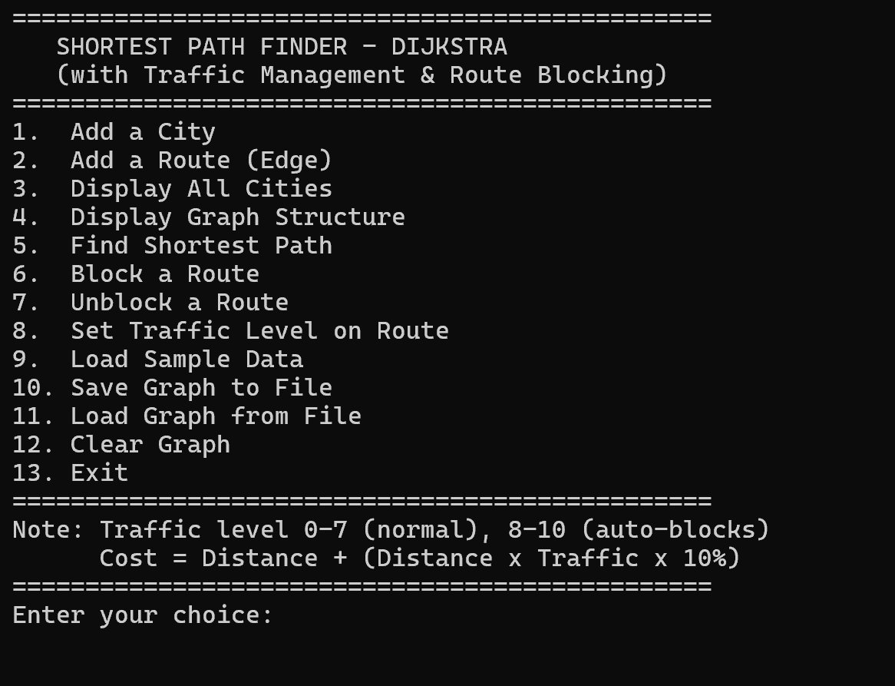
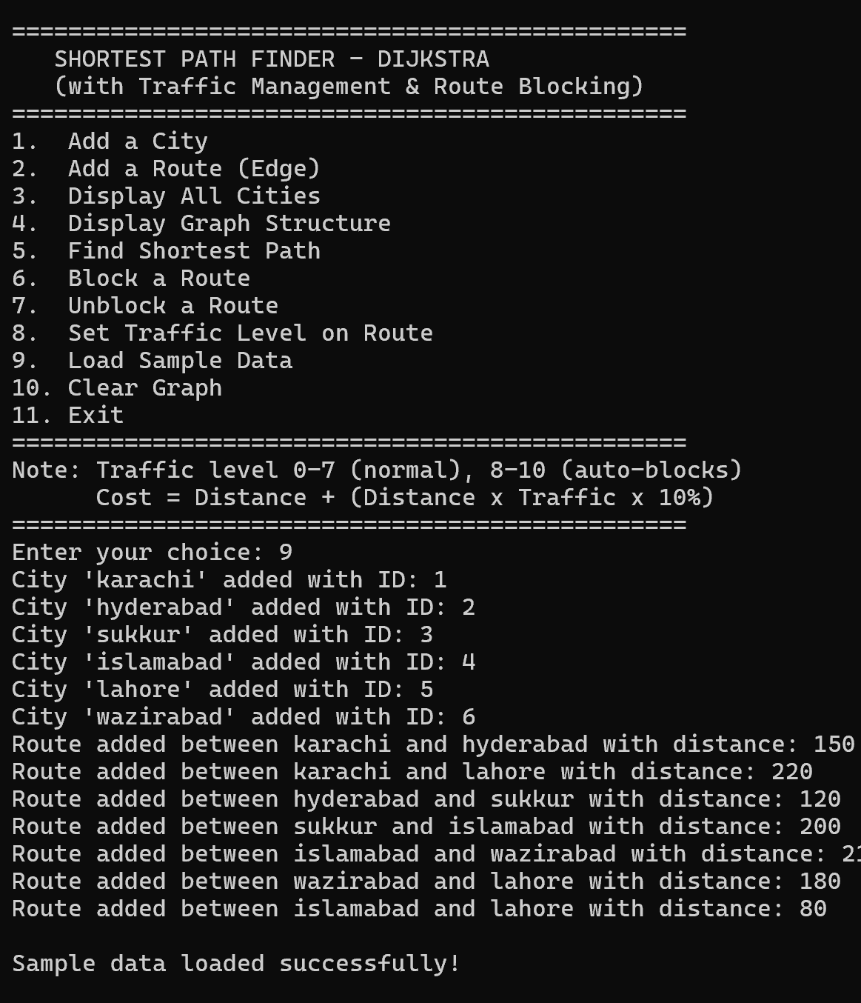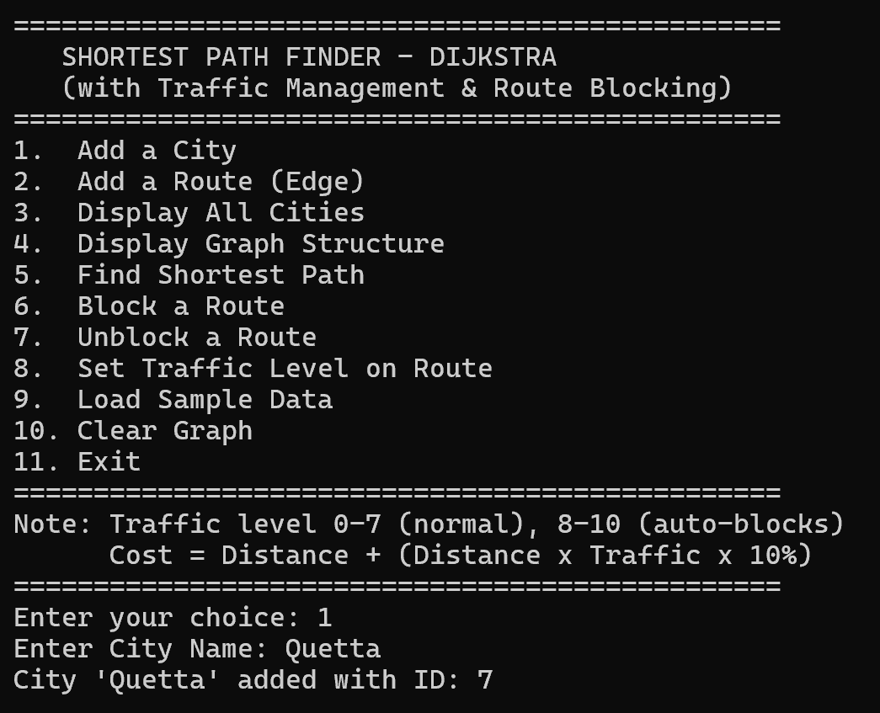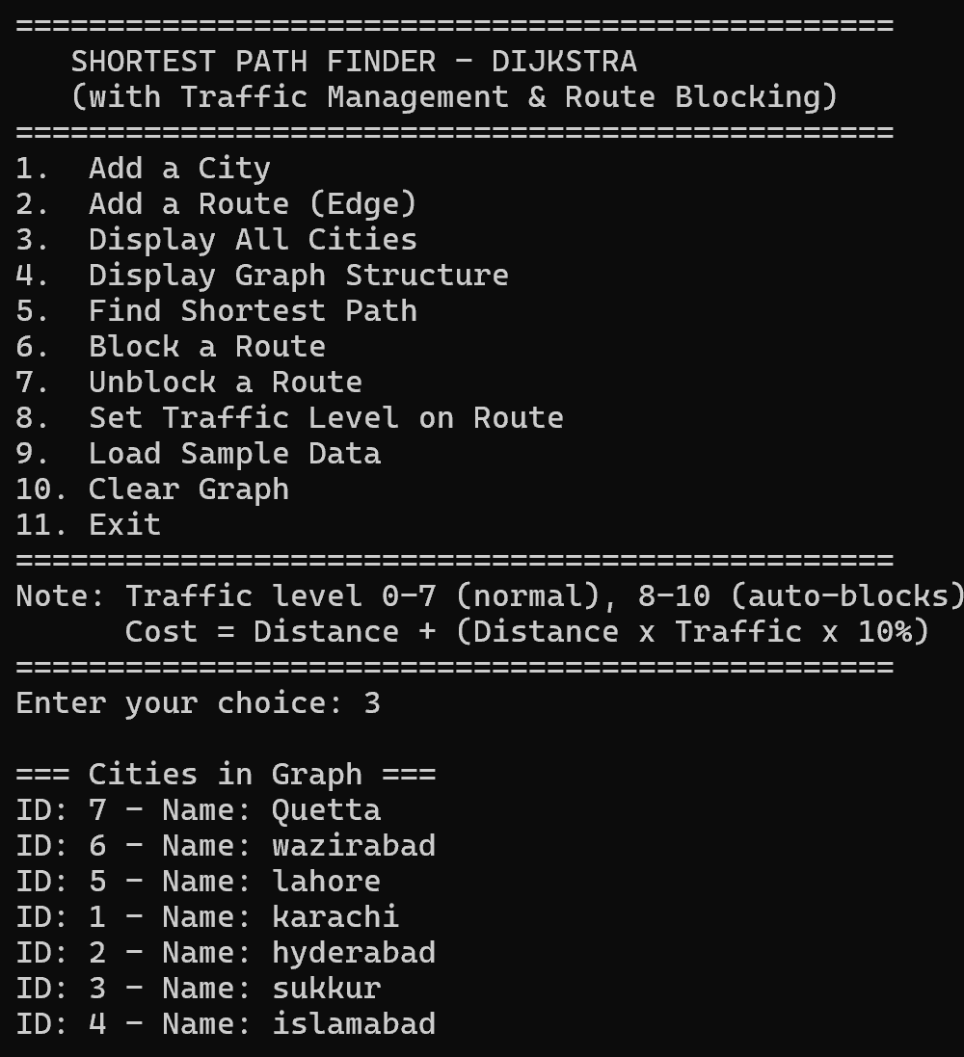
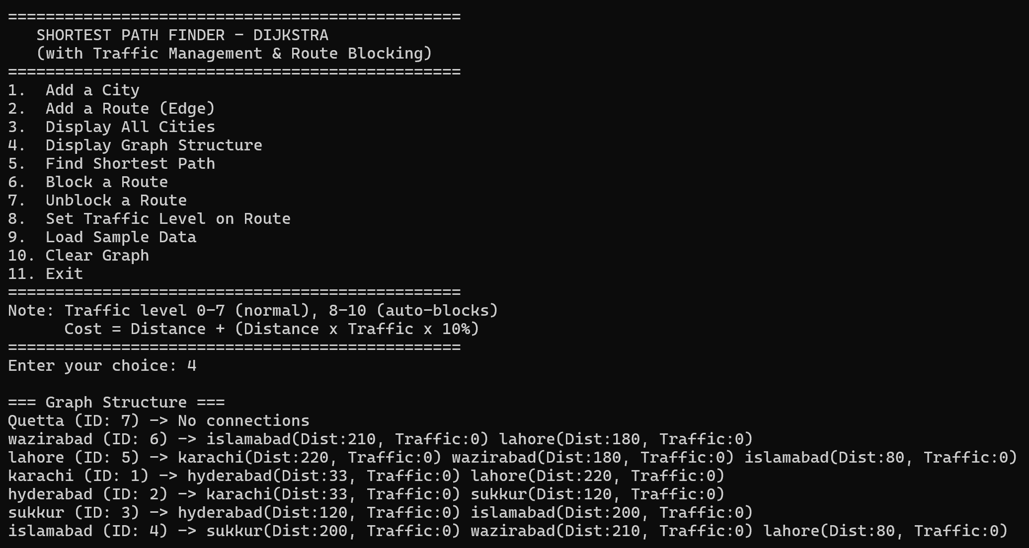
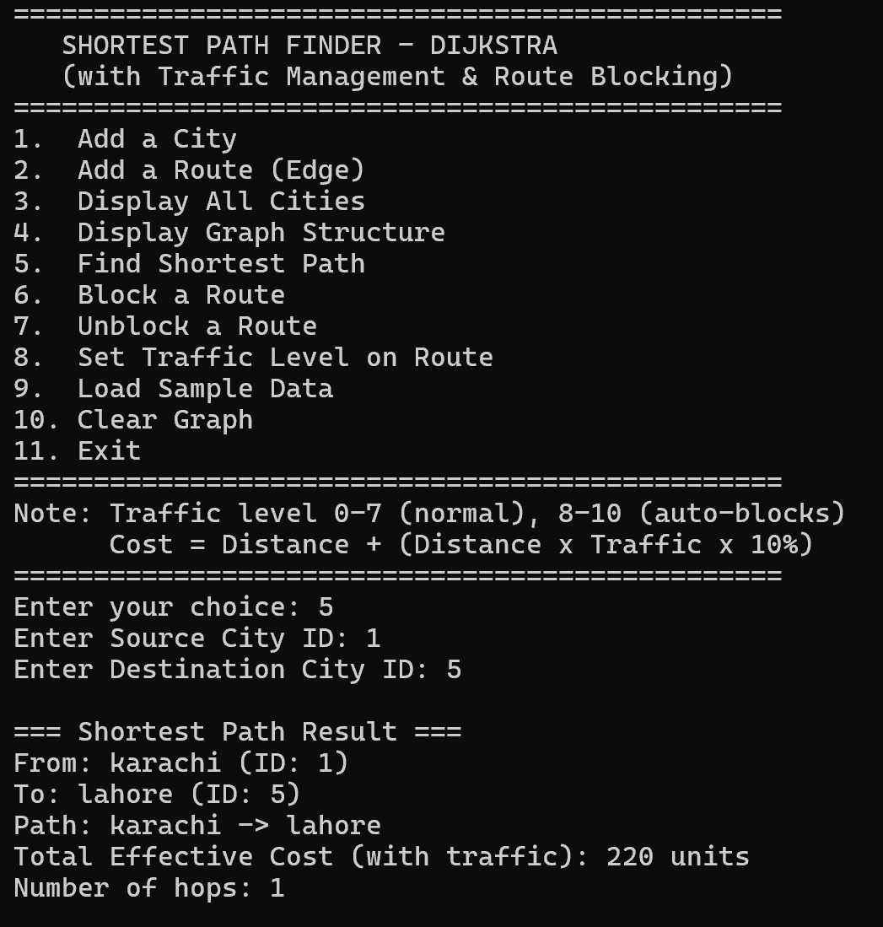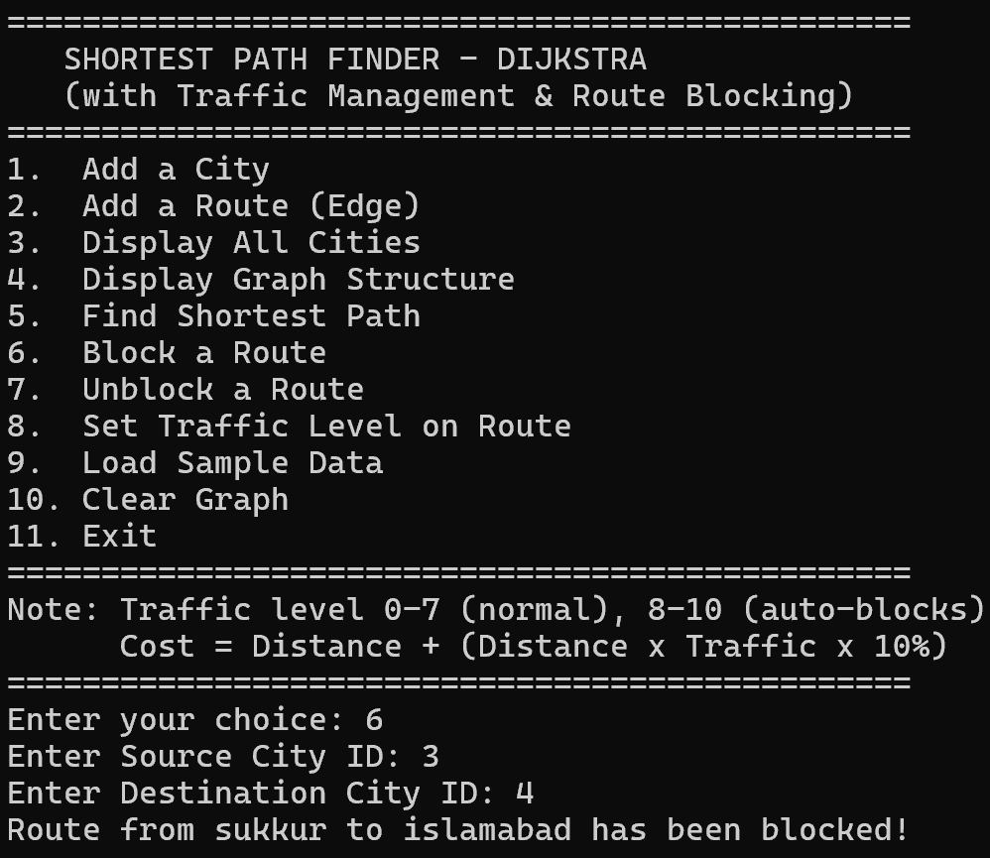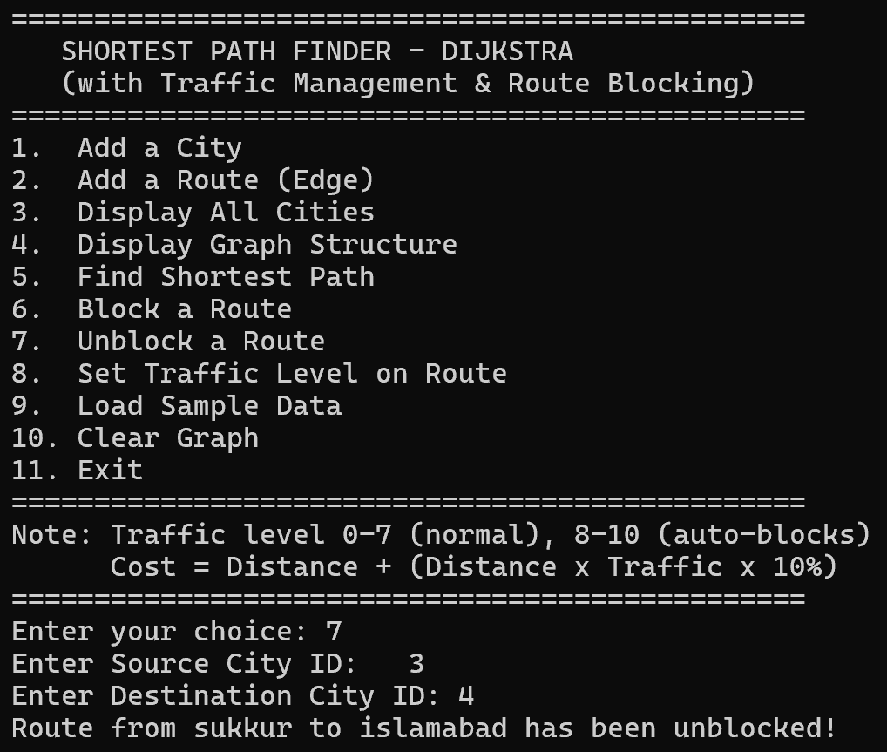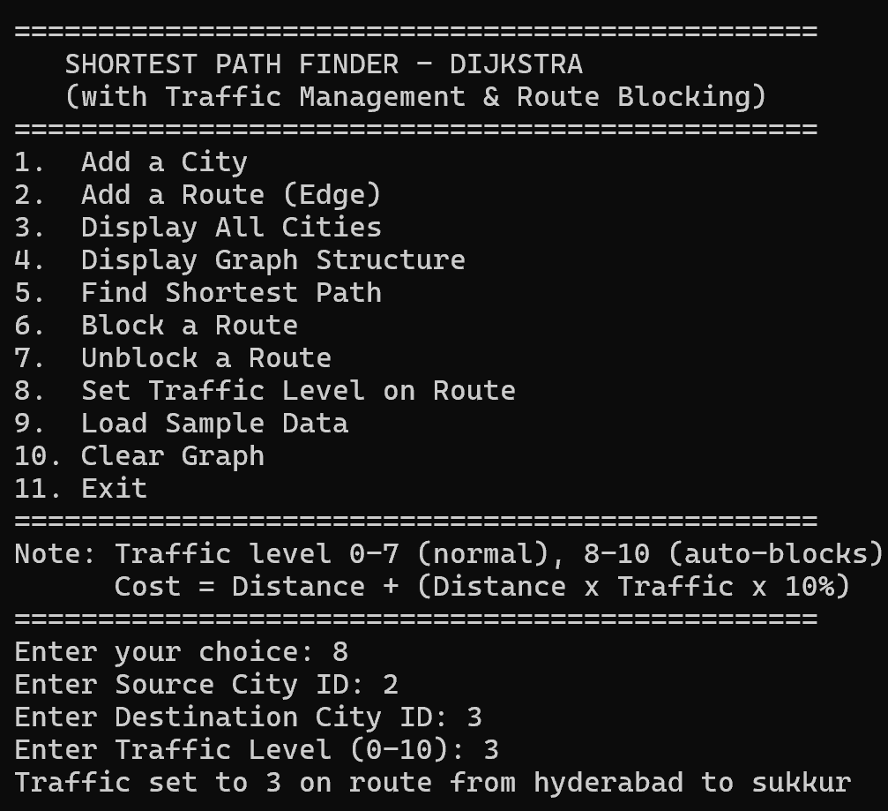

Challenges Faced
Memory Management with Custom Heap
Implementing the custom min heap with an integrated index map required careful handling of pointer invalidation. When heap elements are swapped during heapify operations, the index map must be updated simultaneously to maintain consistency. Any mismatch between the heap vector and index map would cause incorrect node lookups during distance updates.
Handling Bidirectional Edges
When adding bidirectional routes, maintaining consistency between forward and reverse edges proved challenging. If a user updates the distance on one direction, the reverse direction must also be updated. Similarly, blocking or unblocking routes requires checking whether both directions should be affected. The solution required iterating through adjacency lists to find and update corresponding reverse edges.
Integer Overflow in Distance Calculations
Using INT_MAX as the initial distance value created potential overflow issues during relaxation. When checking if a new path is shorter, adding to INT_MAX would cause overflow. This required explicit checks to ensure distances are finite before performing addition operations.
Traffic Auto-Blocking Logic
Determining the appropriate traffic threshold for automatic blocking required balancing safety and usability. Setting it too low would unnecessarily block routes, while setting it too high would allow dangerous conditions. The chosen threshold of 8 out of 10 provides a reasonable balance, but edge cases exist where manually blocked routes might be unintentionally unblocked by setting low traffic levels.
Graph Disconnection Detection
Distinguishing between "no path exists due to blocking" and "cities are in separate components" required additional logic. Simply returning infinity distance could mean either scenario. The solution provides informative messages to help users understand why no path was found.
Input Validation Complexity
Handling all possible invalid inputs from users required extensive validation logic. Empty city names, duplicate cities, self-loops, negative distances, non-existent city IDs, and invalid traffic levels all needed specific error handling. Balancing strict validation with user-friendly error messages added significant complexity to the interface code.

Future Work
Algorithm Enhancements
A-Star Pathfinding: Implementing A-Star algorithm with geographic coordinates as heuristics would significantly improve performance for large graphs. This would allow the system to prioritize exploration toward the destination rather than examining all directions equally.
Multiple Path Options: Rather than showing only the shortest path, the system could display the top three alternative routes with their respective costs. This would give users flexibility to choose based on preferences like avoiding highways or preferring scenic routes.
Time-Dependent Routing: Incorporate time-of-day traffic patterns where edge weights change based on rush hours, weekends, or special events. This would require storing historical traffic data and predicting conditions at the expected travel time.
Data Structure Improvements
Spatial Indexing: Implement a quadtree or R-tree for geographic queries to quickly find nearby cities or routes within a radius. This would enable features like "find routes within 50km of my location."
Graph Compression: For very large networks, use techniques like contraction hierarchies to preprocess the graph and speed up queries. This involves identifying and contracting unimportant nodes while preserving shortest path properties.
Persistent Storage: Add database integration to save and load large graphs efficiently. Currently, the system only operates on in-memory data, limiting scalability for real-world city networks with thousands of nodes.
Feature Additions
Real-Time Updates: Implement a simulation mode where traffic levels change dynamically over time, requiring periodic path recalculation. This would better simulate real navigation systems that adapt to changing conditions.
Multi-Criteria Optimization: Allow users to specify preferences like minimizing distance, minimizing time, avoiding tolls, or preferring highways. This would require multi-objective optimization or weighted combination of criteria.
Visual Interface: Develop a graphical user interface with an interactive map where users can click cities and see routes drawn visually. This would make the system more accessible to non-technical users.
Route Validation: Add checks for route feasibility based on vehicle type, such as weight limits for bridges, height restrictions for tunnels, or vehicle-specific road access rules.
Traffic Management
Machine Learning Integration: Use historical traffic data to predict future traffic patterns and suggest optimal departure times. The system could recommend "leave 15 minutes later to avoid congestion."
Incident Reporting: Allow users to report accidents, construction, or hazards that automatically trigger route blocking and notify other users seeking paths through that area.
Dynamic Rerouting: Implement real-time path recalculation during navigation. If traffic conditions change significantly while traveling, the system would automatically suggest alternate routes.
Performance Optimization
Parallel Processing: For very large graphs, implement parallel Dijkstra's algorithm or bidirectional search that explores from both source and destination simultaneously.
Caching Mechanism: Store frequently requested paths and reuse them when conditions haven't changed, avoiding redundant computation for popular routes.
Approximation Algorithms: For extremely large networks where exact solutions are too slow, implement approximation algorithms that trade slight optimality for significant speed improvements.
User Experience
Natural Language Interface: Allow users to input queries like "fastest route from downtown to airport avoiding highways" rather than using numeric city IDs.
Mobile Application: Develop a mobile version with GPS integration for turn-by-turn navigation and location-based services.
Route History: Maintain a log of previously computed routes for easy reference and comparison of different time periods or traffic conditions.

Conclusion
This implementation demonstrates how classical graph algorithms can be enhanced with real-world constraints. By combining efficient data structures with Dijkstra's algorithm and dynamic edge weights, the system provides a practical solution for urban navigation problems.
The choice of each data structure was driven by performance requirements. Hash maps provide fast lookups, linked lists enable dynamic adjacency management, custom heaps support efficient priority operations, and vectors offer flexible path storage. The result is a scalable and maintainable system that balances theoretical correctness with practical usability.

