MUNEERA BANU ALAMUR  7569665687 | muneerabanualamur@gmail.com | Tadipatri, Andhra Pradesh  LinkedIn: linkedin.com/in/alamur-muneera-banu  GitHub: github.com/muneerabanualamur-droid | 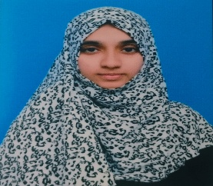
Objective
Motivated Computer Science Engineering student with knowledge in Java, Python, DBMS, and Web Technologies. Passionate about software development, Artificial Intelligence, and problem-solving. Seeking an opportunity to apply technical skills and contribute to organizational growth. .
Education
B.Tech – Computer Science and Engineering 2023 – 2027 (Expected)
Annamacharya Institute of Technology and Sciences, Rajampet, Kadapa | CGPA: 9.25/ 10.0
Intermediate – MPC April 2023
J.C.N.R.M Junior College, Tadipatri, Anantapur | 95.7%
Secondary School Certificate (SSC) March 2021
Padmavani [E.M] High School, Tadipatri | 100%
Skills
- Programming Languages: C, Java, Python
- Web Technologies: HTML,CSS
- Core Subjects: DBMS ,OOPS, Computer Networks
- Tools & Technologies: Basics of DevOps and Cloud Computing
- Soft Skills: Communication, Teamwork, Problem Solving
Certifications & AChievements
- Completed certification in C Programming
- Completed certification in Python Programming
- Participated in AI/ML Workshop
- Completed certification in java in codechef
- Attended training sessions on Cloud Computing and DevOps
- Participated in coding competitions and hackathons

projects
AI Health Risk Prediction System
- Technologies: Python, Flask, Machine Learning
- Developed a web application to predict health risks.
- Integrated Flask backend with frontend.
- Implemented emergency alert functionality.
Workshops
- IgniteX – Entrepreneurship & Startup Awareness Workshop | Wadhwani Foundation
- SkyEd – Python Programming Hands-on Workshop

