Face Recognition Attendance System

A real-time AI-based student attendance system developed using Python and Computer Vision.

Features

- Real-time webcam face detection
- YuNet face detection
- MediaPipe facial landmark detection
- Face recognition
- Student registration
- Automatic attendance marking
- Date and time logging
- CSV-based attendance records
- Duplicate attendance prevention

Technologies Used

- Python
- OpenCV
- MediaPipe
- NumPy
- YuNet
- ONNX
- Computer Vision
- Face Recognition

Project Workflow
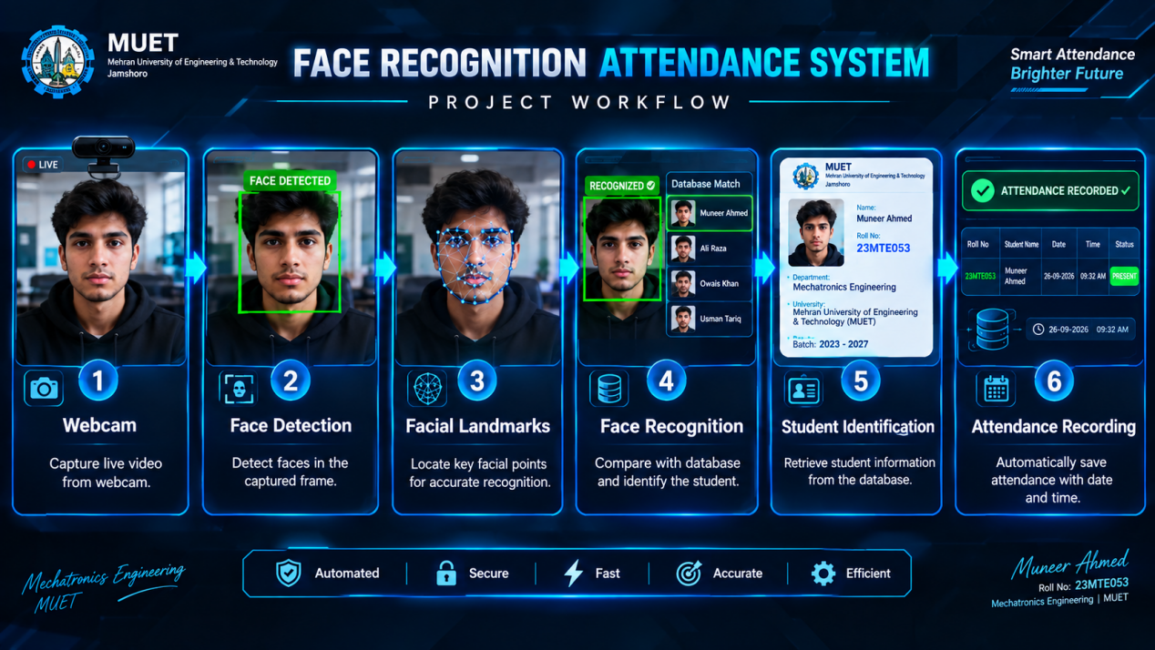

Webcam → Face Detection → Facial Landmarks → Face Recognition → Student Identification → Attendance Recording

Author

Muneer Ahmed Khokhar
BS Mechatronics Engineering
Mehran University of Engineering & Technology (MUET)

