Where we are in place and time
Objective: Inserting an online pictures and formatting a text
Name:

December 9, 2017

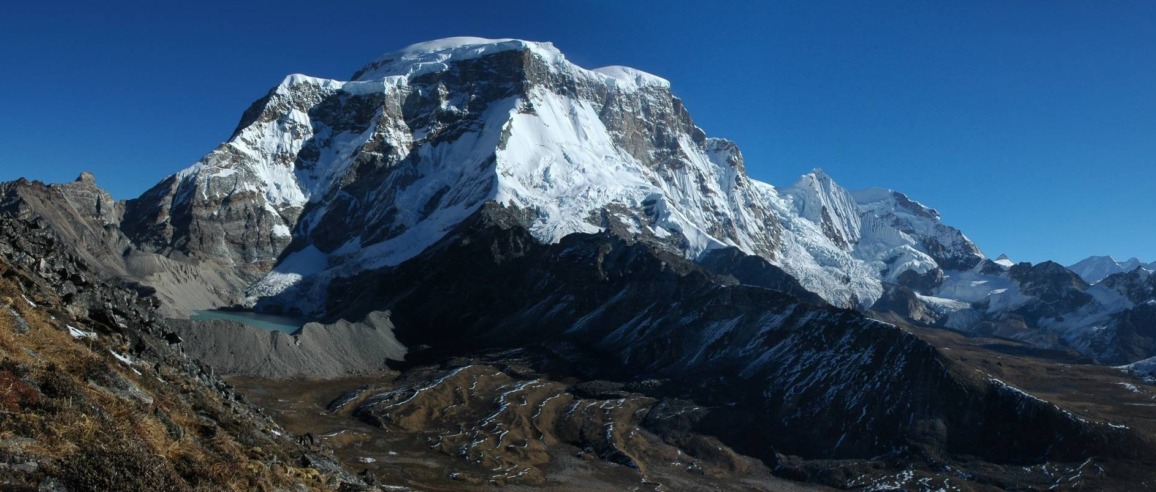

This is a mountain

This is a

This is a

This is a

