This is a subtask of T217577734

Deploy change set to production: "T217577734 - Comarketing POP Project"

Post deployment Instructions

Create Download POP button (1) - Goto Files

Click [Upload Files] button

Download the agreement file here and upload the file.

Click down arrow and click on Public Link

set expiration date 12/31/2035

copy the link

Edit the custom action 'Download POP Agreement'

paste the URL you just copied to the box starting from "/sfc..."

SAVE

Create Download POP Button (2) for Japan file - Goto Files

Click [Upload Files] button

Download the agreement file here and upload the file.

Click down arrow and click on Public Link

set expiration date 12/31/2035

copy the link

Edit the custom action 'Download POP Agreement - Japanese'

paste the URL you just copied to the box starting from "/sfc..."

SAVE

Refer to the screen capture below

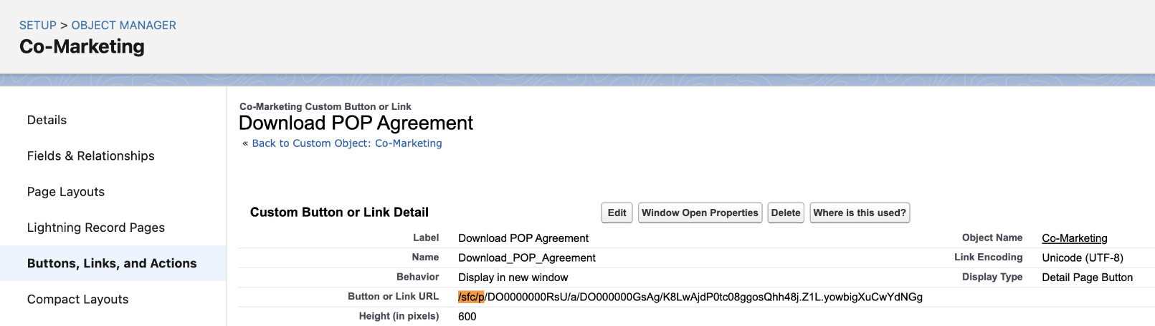

Set FLS for custom fields to visible for all profiles except these

ShowPOPAlert__c

Agreement_Shared_With_Retailer__c

Goals_Validated_by_Demand_Planning__c

Roll_up - Amount (Requested) Summary USD

Estimated_Incremental_Units__c

Business_Rationale__c

On Co-Marketing Record Page

Add [Download POP Agreement] custom button (1) to the highlight panel - on top of [Delete] button and set visibility filters.

Record > Status Equal Draft

Record > GEO Equal NA

Record > Record > Roll_up - Amount (Requested) Summary USD Greater Than or Equal 250000

Record > GEO Equal APAC

Record > GEO Equal EMEA

Record > Roll_up - Amount (Requested) Summary USD Greater Than or Equal 100000

Record > Country Not Equal JP

Record > Plan > Channel (Sales Team) Equal 3P Retail

Show Component When > The filter logic is met.

1 AND 8 AND ((2 AND 3) OR (4 AND 6 AND 7) OR (5 AND 6))

Add [Download POP Agreement ] custom botton (2) to the highlight panel - below the first Download POP Agreemet button (1) and set visibility filters.

Record > Status Equal Draft

Record > Roll_up - Amount (Requested) Summary USD Greater Than or Equal 100000

Record > Country Equal JP

Record > Plan > Channel (Sales Team) Equal 3P Retail

Show Component When

All filters are true

Set visibility filter for [Submit for Approval] button

Record > Record Type > Record Type Name Equal Header

Record>Status Equal Draft

Record>ShowPOPAlert__c Equal False

Show Component When > The filter logic is met.

All filters are true

Refer to the screen capture for settings below

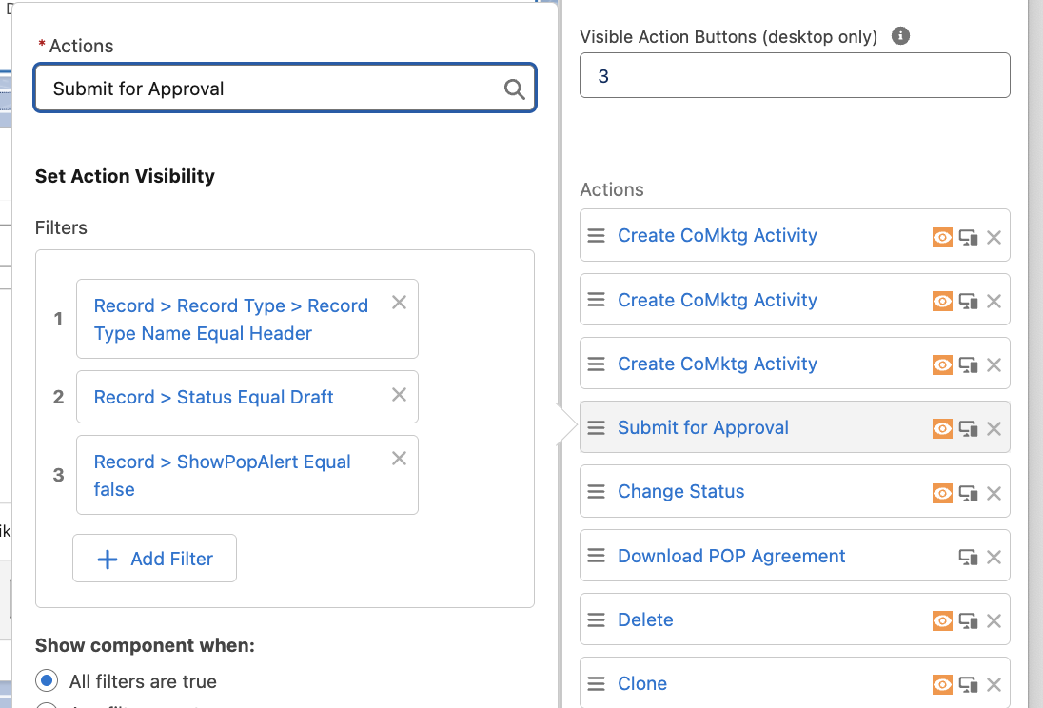

Add custom fields to the Co-Marketing Record Page (header section) after the 'Product Category' field

Business Rationale (BusinessRationale__c)

Estimated Incremental Units (Estimated_Incremental_Units__c)

Goals Validated By Demand Planning (Goals_Validated_by_Demand_Planning__c)

Agreement_Shared_With_Retailer__c

Add Rich Text Component for 'Action Required' (drag it to the page layout above tabs section)

Rich Text message and format

TEXT (refer to screen capture below for format or to SFULL)

"Action Required

The 'Submit for Approval' button will be available once the steps below are completed.

Fill in the 'Business Rationale' field

Fill in the 'Estimated Incremental Units' field

Check the checkbox 'Display as card'

Set rich text component visibility

Record > Status Equal Draft

Record > ShowPopAlert Equal True

Record > Roll_Up - Amount (Requested) Summary USD Less Thank 250000

Record > GEO Equal NA

Record > Roll_Up - Amount (Requested) Summary USD Less Than 100000

Record > GEO Equal EMEA

Record > GEO Equal APAC

Show Component When: The filter logic is met

1 AND 2 AND ((3 AND 4 ) OR (5 AND (6 OR 7)))

Add Rich Text Component for 250K threshold (drag it to the page layout below the 'Action Required' component)

Rich Text message and format

TEXT (refer to screen capture below for format or to SFULL)

"Action Required - Amount (Requested) >= $250K "

The 'Submit for Approval' button will be available once the steps below are completed:

Click on 'Download POP Agreement' button (located on top right of page).

Complete the POP Agreement template and share it with the retailer

After sharing it with the retailer, check the 'Agreement shared with Retailer' checkbox below.

Navigate to the 'Notes and Attachments' tab and click on the 'Upload Files' button to upload the shared agreement

Fill in the 'Business Rationale' field

Fill in the 'Estimated Incremental Units' field

Optionally, check the 'Goals validated by Demand Planning' checkbox

Check the checkbox 'Display as card'

Set 250K Rich Text component visibility filter

Record > ShowPOPAlert__c = true

Record > GEO Equal NA

Record > Roll-up Amount (Requested) Summary USD Greater Than or Equal 250000

Show Component When

All filters are true

Refer to the screen capture

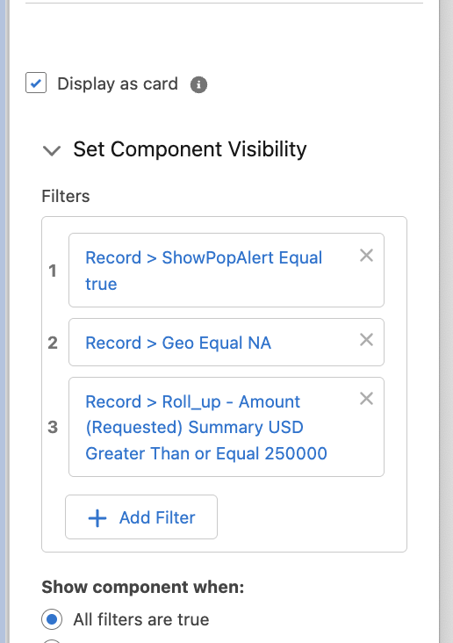

Add Rich Text Component for USD 100K Threshold (drag it under the 250K banner)

Rich Text message and format

TEXT (refer to screen capture below for format or to SFULL)

"Action Required - Amount (Requested) >= USD 100K "

The 'Submit for Approval' button will be available once the steps below are completed:

Click on 'Download POP Agreement' button (located on top right of page).

Complete the POP Agreement template and share it with the retailer

After sharing it with the retailer, check the 'Agreement shared with Retailer' checkbox below.

Navigate to the 'Notes and Attachments' tab and click on the 'Upload Files' button to upload the shared agreement

Fill in the 'Business Rationale' field

Fill in the 'Estimated Incremental Units' field

Optionally, check the 'Goals validated by Demand Planning' checkbox

Check the checkbox 'Display as card'

Set Rich Text visibility filter

Record > ShowPOPAlert__c = true

Record > Roll-up Amount (Requested) Summary USD Greater Than or Equal 250000

Record > GEO Equal APAC

Record > GEO Equal EMEA

Show Component When

The filter logic is met

1 AND 2 AND (3 OR 4)

Refer to the screen capture

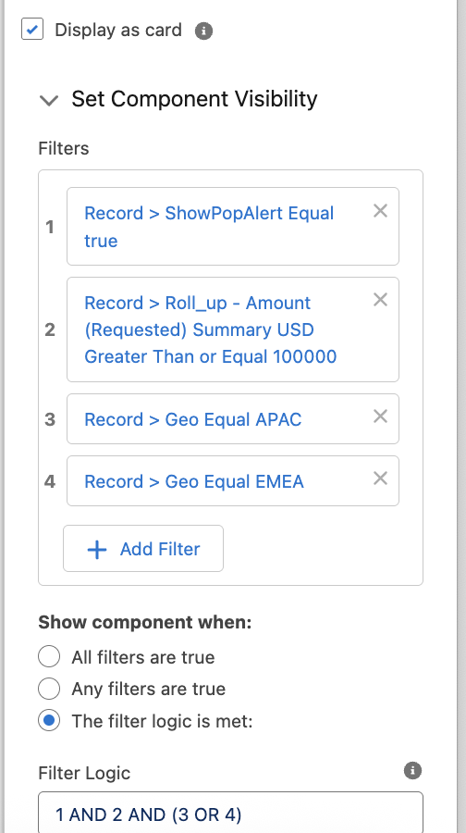

Add Rich Text Component for required fields for approvals (drag it under the 100K banner)

Rich Text message and format

TEXT (refer to screen capture below for format or to SFULL)

"Action Required "

The 'Submit for Approval' button will be available once the steps below are completed:

Fill in the 'Business Rationale' field

Fill in the 'Estimated Incremental Units' field

Optionally, check the 'Goals validated by Demand Planning' checkbox

NOTE:

For Action Required format please refer to the screen capture attached for text and color setting or cut and paste from SFULL

