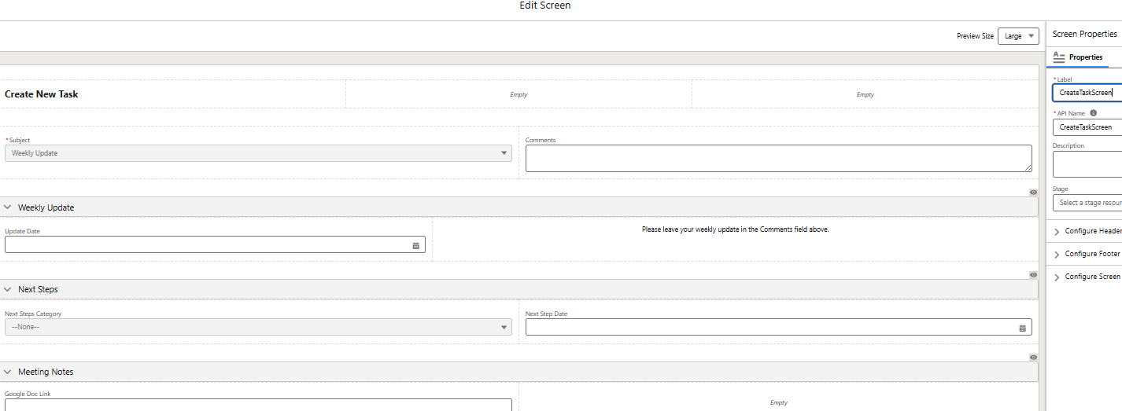

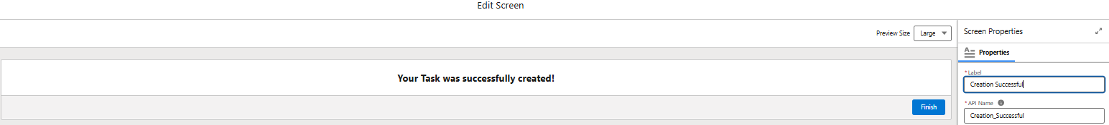

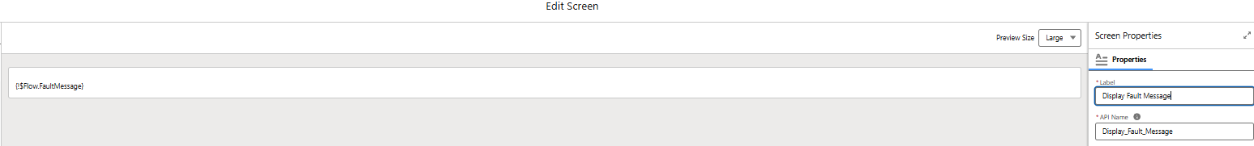

**@Leads - Work Flows - Create Participant, Offering and Fb Object - V**

