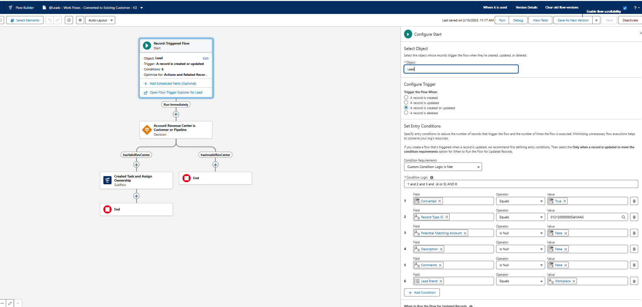

Make sure that converted Contact still exists

