Lead Auto Conversion criteria *(updated as of May 14th 2021)*

Report

**AS OF Q1 2022, THE NEW AUTOCONVERSION CRITERIA IS FOUND IN: ​​ [Lead to contact auto conversion_2022](https://docs.google.com/document/d/1S6MArD6f6DwujFfO6g38ATsKI31CWrGchyTLfARWaKQ/edit)**

The below report link shows the list of leads that would be converted when the next batch runs. If leads are not converted due to any issues, they would be logged in Log__c object

<https://fb.my.salesforce.com/00O1H000007m3Vk>

Per the report, Leads are auto converted to Contacts if below conditions are met

1. Lead’s RecordType = 'FB@Work' , lead_brand__c = ‘Workplace’
2. Status != 'Disqualified'
3. Matching Account is not null
4. Matching Account’s RecordType is 'Standard'
5. Matching Account is Workplace Account
6. OLSD in
   * Web - Blog Subscription
   * Web - Content Download
   * Web - Content Syndication
   * Web - Webinar
   * Event - Marketing
   * Sales Prospecting
   * Message on Social Media
   * Chat on Website
   * Essential
   * Web - Advanced
   * Web - Advanced Trial
   * Mobile - Essential
   * Web - Essential
   * (Matching Account’s priority = 'Marketstar Outbound'

    OR

* Matching Account is a Target Account

OR

* Matching Account’s Workplace Account Status is 'Pipeline' or 'Customer'
  + Client Partner is Active

OR

* Matching Account’s Owner is Active and belong to workplace related profile

Chronos Job

The below chronos job is scheduled to run one hour once to convert leads to contact

<https://www.internalfb.com/intern/chronos/job/?jobname=WP_LeadConversionBatch&smc=chronos_gp_admin_client>

Logs for debugging leads not converted

Leads auto conversion may fail due to data, validations or code issues and these details are logged in the Log__c object for debugging purposes.

select Id, Details__c, Apex_Class__c, Record_ID__c

from log__c

where Apex_Class__c = 'WP_LeadConversionBatch'

and CreatedDate = Today

order by CreatedDate desc

Email Notifications

Custom Label Lead_Conversion_Send_Email_OLSD (<https://fb.my.salesforce.com/1011H0000093f4a>) controls if email notifications should be sent upon Lead Conversion to Contact for the leads that satisfy any of the below conditions

1. Matching Account target Account is true (Converted_Account__r.WP_Target_Account__c = true) OR
2. Original_Lead_Source_Detail__c(OLSD) in Custom Label Lead_Auto_Conversion_Assign_to_Account_OLSD(<https://fb.my.salesforce.com/1011H0000093kSX>)
   1. Essential
   2. Web - Advanced
   3. Web - Advanced Trial
   4. Mobile - Essential
   5. Web - Essential

Owner Assignment

For leads converted manually through custom convert button in lightning UI, the owner set in UI will be assigned as lead conversion owner. Otherwise below owner assignment is used

1. Target Account and Account owner is active and Account owner belongs to Workplace related profile
   1. Account owner becomes lead conversion owner
2. OLSD in Custom Label Lead_Auto_Conversion_Assign_to_Account_OLSD (Essential,Web - Advanced,Web - Advanced Trial,Mobile - Essential,Web - Essential) and Account owner is active and Account owner belongs to Workplace related profile
   1. Account owner becomes lead conversion owner
3. All other cases
   1. If Client Partner is Active, Client Partner becomes lead conversion owner
   2. If Client Partner is INACTIVE, Account owner becomes lead conversion owner

Other functionalities part of Lead to Contact conversion

1. Leads get converted to matching Account, Contact
2. Leads converted status is set to “Existing Account” or “Existing Customer” based on “Workplace Account Status” in Account.
3. Account Contact Role (Account_Contact_Role__c) is created or updated with AccountId, ContactId, Workplace Instance, Role.
4. Recalculate Matching logic if lead conversion errors out with Duplicate Workplace instance id in Account error

Batch SOQL (Batch Apex Class - WP_LeadConversionBatch)

select id  from Lead

     where IsConverted = false  and RecordType.Name = 'FB@Work'

     and Status != 'Disqualified'

     and Converted_Account__c != null

     and Converted_Account__c not in ('0011200001FHMnqAAH','0011H00001PMAuxQAH','0011200001FIM1YAAX')

     and Converted_Account__r.RecordType.Name = 'Standard'

     and Converted_Account__r.IsWorkplace__c = true

     and Original_Lead_Source_Detail__c in ('Web - Blog Subscription','Web - Content Download','Web - Content Syndication','Web - Webinar','Event - Marketing','Sales Prospecting','Message on Social Media','Chat on Website','Essential','Web - Advanced','Web - Advanced Trial','Mobile - Essential','Web - Essential')

     and (Converted_Account__r.priority_whatsapp__c =

       'Marketstar Outbound'

       or Converted_Account__r.WP_Target_Account__c = true

       or Converted_Account__r.Account_Revenue_Center__c in ('Pipeline','Customer'))

     and (lead.Growth_Manager__r.IsActive = true

       or (Converted_Account__r.Owner.IsActive = true

         and (Converted_Account__r.Owner.Profile.Name like '%@work%'

           or Converted_Account__r.Owner.Profile.Name like '%Workplace%')))

Custom Label Lead_Conversion_OLSD <https://fb.my.salesforce.com/1011H0000093epQ> controls the list of OLSD that can be auto converted

Custom Label Workplace_Lead_Conversion_Exclude_Owner_Ids <https://fb.my.salesforce.com/1011H0000093m8e> excludes matched account owners from lead being eligible for auto-conversion.

As of Jan 2022, the below is the active logic T110758028

Lead’s RecordType = 'FB@Work'

Status != 'Disqualified'

Matching Account is not null

Matching Account’s RecordType is 'Standard'

Matching Account is Workplace Account

Lead 'Region' matches Account 'Headquarters Region'

OLSD does not contain Partner

Matching Account’s Workplace Account Status is 'Pipeline' or 'Customer'

OLSD != null

Lead Brand = ‘Workplace’

**additional details about the autoconversion can be found in the original document here: Lead to Contact Auto Conversion (Internal Leads)

==================below is old logic===========

T102376676

Lead to contact auto conversion

Proposal

In order to simplify the current matching/merging process and to make sure an SDR knows the entire buying committee, we are suggesting the following approach:

A lead (except Contact Us) should always convert to a contact if the matching account is owned by an SDR/CP/Markus Charlie Sheen and had an activity in the last 6 months

A lead should always convert to a contact if the matching account is in Customer or Pipeline

Else it should get routed as a lead to the Inbound team

New requirement: Only convert leads if Lead Region is same as Account Region

Michael Benjamin checking with Julie whether that’s possible

Our main goals are:

Don’t miss any lead/contact

Make sure the right WP SDR/CP reaches out

Don’t create any duplicates on SFDC

Ensure SDRs don't reach out to pipeline/customers

Ideally, the new lead that comes in should match to the relevant Workplace account on SFDC, fulfilling criteria 1.-5., irrespective of lead source (6.)

Discussion points

Attribution - Inbound vs Outbound

Medium term: In Salesforce the change has been shipped on T86595556 requiring mandatory assignment of a main contact when creating an Opportunity from the account view or opportunity tab in SFDC (shipped 21/09), ensuring correct attribution to Inbound vs Outbound

Long term: Discuss last touch vs first touch vs multi touch attribution

Who is considered an active owner (SDR/CP) for auto conversion?

Add HR custom label to identify reps (list out exact role names that label should be assigned to)

Last resort: List out rep names

Convert all OLSDs vs exclude certain OLSDs

Rather not exclude OLSDs given attribution is solved

Should Freemails convert?

As long as they submit their company name, we should convert them (inaccuracies could happen)

Conversion for Customer/Pipeline accounts - make sure Customer tagging is correct

Customer accuracy task being worked on by Venkat/Spencer: T87595853

Data quality team also reviewing data accuracy

Sales and marketing alignment on outreach process for Contacts and Lead

Contacts to be treated the same as Leads

Leads and Contacts scored A = Manual sequence / B and C = Automated sequence

Requires Contacts to be scored prior to launch

7. Leads from outside the parent account region

These leads should not auto-convert (As per reco on this task)

------------------

Next steps from meeting on 21/09/2021

1. We'll get back with an overview on high priority lead/contact treatment if they convert

2. Mythreyee to share a report about freemails that were matched to an account and we will review the accuracy

3. We need to review Customer account ownership to ensure they are not owned by SDRs

Next steps from meeting on 30/09/2021

Julie/Mythreyee to get back regarding activity

Julie to check SDR/CP list and whether list of names is needed

Should we assign Leads that don’t convert to a customer account because user is inactive

----------------------

Appendix

Current logic

The below report link shows the list of leads that would be converted when the next batch runs. If leads are not converted due to any issues, they would be logged in Log__c object

https://fb.my.salesforce.com/00O1H000007m3Vk

Per the report, Leads are auto converted to Contacts if below conditions are met

Lead’s RecordType = 'FB@Work'

Status != 'Disqualified'

Matching Account is not null

Matching Account’s RecordType is 'Standard'

Matching Account is Workplace Account

OLSD in

Web - Blog Subscription

Web - Content Download

Web - Content Syndication

Web - Webinar

Event - Marketing

Sales Prospecting

Message on Social Media

Chat on Website

Essential

Web - Advanced

Web - Advanced Trial

Mobile - Essential

Web - Essential

(Matching Account’s priority = 'Marketstar Outbound'

OR

Matching Account is a Target Account

OR

Matching Account’s Workplace Account Status is 'Pipeline' or 'Customer'

Client Partner is Active

OR

Matching Account’s Owner is Active and belong to workplace related profile

Lead Auto Conversion criteria *(updated as of May 14th 2021)*

Report

**AS OF Q1 2022, THE NEW AUTOCONVERSION CRITERIA IS FOUND IN: ​​ [Lead to contact auto conversion_2022](https://docs.google.com/document/d/1S6MArD6f6DwujFfO6g38ATsKI31CWrGchyTLfARWaKQ/edit)**

The below report link shows the list of leads that would be converted when the next batch runs. If leads are not converted due to any issues, they would be logged in Log__c object

<https://fb.my.salesforce.com/00O1H000007m3Vk>

Per the report, Leads are auto converted to Contacts if below conditions are met

1. Lead’s RecordType = 'FB@Work' , lead_brand__c = ‘Workplace’
2. Status != 'Disqualified'
3. Matching Account is not null
4. Matching Account’s RecordType is 'Standard'
5. Matching Account is Workplace Account
6. OLSD in
   * Web - Blog Subscription
   * Web - Content Download
   * Web - Content Syndication
   * Web - Webinar
   * Event - Marketing
   * Sales Prospecting
   * Message on Social Media
   * Chat on Website
   * Essential
   * Web - Advanced
   * Web - Advanced Trial
   * Mobile - Essential
   * Web - Essential
   * (Matching Account’s priority = 'Marketstar Outbound'

    OR

* Matching Account is a Target Account

OR

* Matching Account’s Workplace Account Status is 'Pipeline' or 'Customer'
  + Client Partner is Active

OR

* Matching Account’s Owner is Active and belong to workplace related profile

Chronos Job

The below chronos job is scheduled to run one hour once to convert leads to contact

<https://www.internalfb.com/intern/chronos/job/?jobname=WP_LeadConversionBatch&smc=chronos_gp_admin_client>

Logs for debugging leads not converted

Leads auto conversion may fail due to data, validations or code issues and these details are logged in the Log__c object for debugging purposes.

select Id, Details__c, Apex_Class__c, Record_ID__c

from log__c

where Apex_Class__c = 'WP_LeadConversionBatch'

and CreatedDate = Today

order by CreatedDate desc

Email Notifications

Custom Label Lead_Conversion_Send_Email_OLSD (<https://fb.my.salesforce.com/1011H0000093f4a>) controls if email notifications should be sent upon Lead Conversion to Contact for the leads that satisfy any of the below conditions

1. Matching Account target Account is true (Converted_Account__r.WP_Target_Account__c = true) OR
2. Original_Lead_Source_Detail__c(OLSD) in Custom Label Lead_Auto_Conversion_Assign_to_Account_OLSD(<https://fb.my.salesforce.com/1011H0000093kSX>)
   1. Essential
   2. Web - Advanced
   3. Web - Advanced Trial
   4. Mobile - Essential
   5. Web - Essential

Owner Assignment

For leads converted manually through custom convert button in lightning UI, the owner set in UI will be assigned as lead conversion owner. Otherwise below owner assignment is used

1. Target Account and Account owner is active and Account owner belongs to Workplace related profile
   1. Account owner becomes lead conversion owner
2. OLSD in Custom Label Lead_Auto_Conversion_Assign_to_Account_OLSD (Essential,Web - Advanced,Web - Advanced Trial,Mobile - Essential,Web - Essential) and Account owner is active and Account owner belongs to Workplace related profile
   1. Account owner becomes lead conversion owner
3. All other cases
   1. If Client Partner is Active, Client Partner becomes lead conversion owner
   2. If Client Partner is INACTIVE, Account owner becomes lead conversion owner

Other functionalities part of Lead to Contact conversion

1. Leads get converted to matching Account, Contact
2. Leads converted status is set to “Existing Account” or “Existing Customer” based on “Workplace Account Status” in Account.
3. Account Contact Role (Account_Contact_Role__c) is created or updated with AccountId, ContactId, Workplace Instance, Role.
4. Recalculate Matching logic if lead conversion errors out with Duplicate Workplace instance id in Account error

Batch SOQL (Batch Apex Class - WP_LeadConversionBatch)

select id  from Lead

     where IsConverted = false  and RecordType.Name = 'FB@Work'

     and Status != 'Disqualified'

     and Converted_Account__c != null

     and Converted_Account__c not in ('0011200001FHMnqAAH','0011H00001PMAuxQAH','0011200001FIM1YAAX')

     and Converted_Account__r.RecordType.Name = 'Standard'

     and Converted_Account__r.IsWorkplace__c = true

     and Original_Lead_Source_Detail__c in ('Web - Blog Subscription','Web - Content Download','Web - Content Syndication','Web - Webinar','Event - Marketing','Sales Prospecting','Message on Social Media','Chat on Website','Essential','Web - Advanced','Web - Advanced Trial','Mobile - Essential','Web - Essential')

     and (Converted_Account__r.priority_whatsapp__c =

       'Marketstar Outbound'

       or Converted_Account__r.WP_Target_Account__c = true

       or Converted_Account__r.Account_Revenue_Center__c in ('Pipeline','Customer'))

     and (lead.Growth_Manager__r.IsActive = true

       or (Converted_Account__r.Owner.IsActive = true

         and (Converted_Account__r.Owner.Profile.Name like '%@work%'

           or Converted_Account__r.Owner.Profile.Name like '%Workplace%')))

Custom Label Lead_Conversion_OLSD <https://fb.my.salesforce.com/1011H0000093epQ> controls the list of OLSD that can be auto converted

Custom Label Workplace_Lead_Conversion_Exclude_Owner_Ids <https://fb.my.salesforce.com/1011H0000093m8e> excludes matched account owners from lead being eligible for auto-conversion.

Why Content Organization is using Salesforce?

The main purpose of using the Salesforce CRM system in this context is to streamline and optimize various aspects of the content development lifecycle and the Greenlight review and approval process. Here are the key functionalities and benefits it provides:

Creating and managing Leads: Salesforce allows the Content Organization team to efficiently capture and manage leads, which are potential developers or partners interested in the content or initiatives being developed. This helps in tracking and nurturing these leads throughout the planning or collaboration process.

Greenlight review and approval process: Salesforce facilitates the Greenlight review and approval process by providing a centralized platform where content reviews and OCEM approvals by the Sourcing and Data Sciense teams can take place. It allows different stakeholders to collaborate, provide feedback, and sign off on content OCEM records before it gets promoted to the Greenlight review meetings, ensuring a smooth and organized workflow.

Content development lifecycle tracking: Salesforce serves as a comprehensive tool to track the entire content development lifecycle. This includes monitoring the budget spend, ensuring content quality, and managing Milestones and Content release schedule. Having all this information in one place helps the team make data-driven decisions and ensures efficient resource allocation.

Reporting tool for financial and work performance information: Salesforce acts as the primary reporting tool for the Content Organization team. It provides valuable insights and analytics related to financial performance and work efficiency, allowing the team to measure progress towards the business's primary goals and make informed decisions accordingly.

Salesforce used for the Hardware request management, and device forecasting for the predicatble HW resource distribution. It supports work flows adopted by the Hardware Distribution Program and Logistic teams.

Release schedule and content-specific information: By utilizing Salesforce, the teams can access release schedules and content-specific details easily. This enables them to plan and coordinate their tasks efficiently, improving overall work efficiency and productivity.

FTC compliance and audit reviews: Salesforce ensures that the data collected and managed regarding content development and financial information is compliant with Federal Trade Commission (FTC) regulations. It also provides a reliable source of data for internal and external audit reviews, making the process smoother and more transparent.

Overall, Salesforce plays a crucial role in optimizing content development processes, enhancing collaboration and communication among teams, providing valuable insights for decision-making, and ensuring compliance with regulatory requirements. It acts as a central hub for various activities, integration with internal Meta tools and data related to content development, making it an indispensable tool for the MV Content Organization team.

Sourcing: Leads in Salesforce

We have a variety of content categories that this team supports. Part of the goals of this group is to create depth and breadth of content across various categories like other app stores such as Google Play and Apple.

As part of bringing in these new categories, various teams scour the web for new content creators (like when recruiters are looking for people to fill roles at a company).

For leads, we have an automated ingestion pipeline where users can reach out to interested parties to enter their information and automagically come into Salesforce. In Salesforce users can manage open, in progress or close leads while having visibility into the development and release of individual projects.

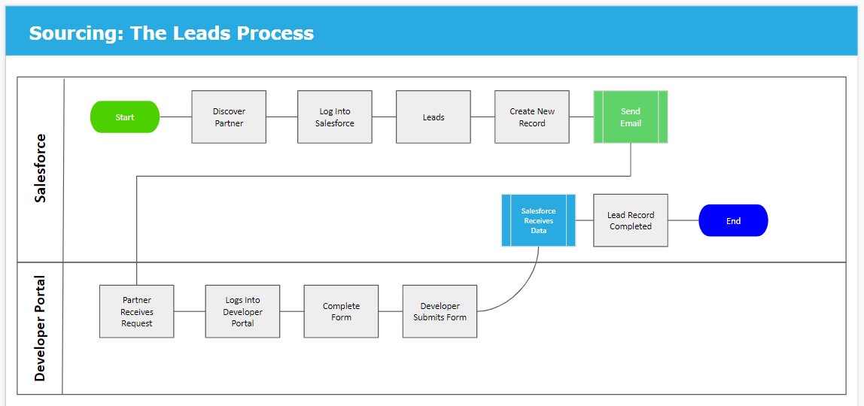

How do I use Leads?

Log into Salesforce

Navigate to “Oculus Leads” Tab at the top of the page

Click “New”

A new screen should pop up > enter minimum required information > Developer Name and Email

An email will be automatically sent to the Lead Email address in 30 mins. The Lead’s Partner Invitation Status will read “Awaiting Partner Info”

Screenshot 1: Searching for Existing or Creating New Leads

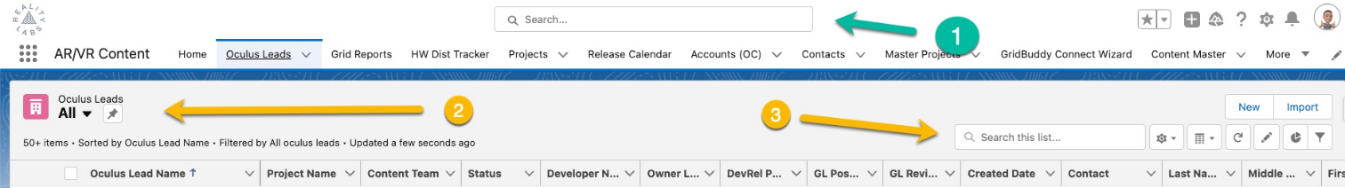

Screenshot 2: Inviting Partners ​

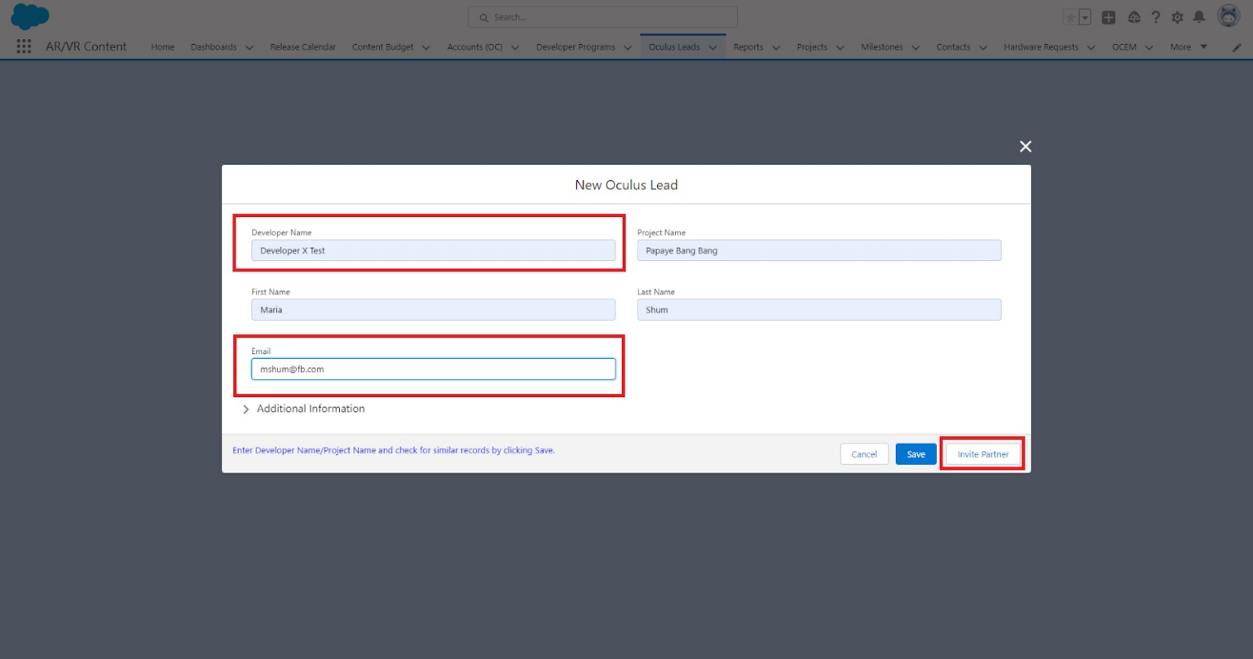

​ Screenshot 3: Email to Partners ​

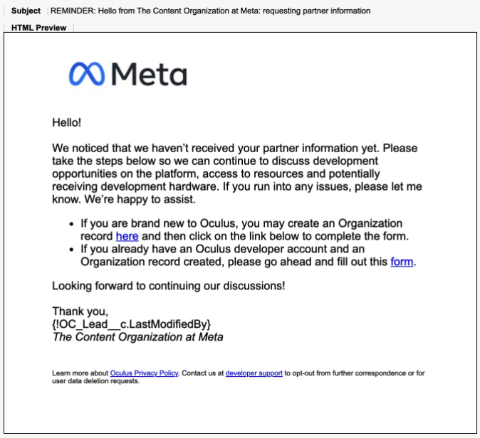

​ You can also check out the video here:

What's Next?

My partners have successfully submitted their information! Now what?

It’s time to engage with your partners and determine if their app should be funded, be handed off to one of our programs, or worked on later be released on the platform.

If you have deteremined that they are ready to move to the next steps such as the Start, Growth, Launch Pad, App Lab reach out to the necessary parties for assistance go here for Greenlight.

Can I still send an email if a lead already exists?

Yes, you can! Navigate to any existing Lead (using Search or to “Oculus Leads” Tab at the top of the page) Ensure the Email field is populated with a valid email address Click Invite Partner Button An email will be automatically sent to the Lead Email address in 30 mins The Lead’s Partner Invitation Status will read “Awaiting Partner Info”

Email Reminder Workflow

“Awaiting Partner Info” means your partner has not entered or submitted their information.

10 days after the first email sends a reminder email will be sent automatically

30 days after the first invite email sent the invite will automatically expire (which means the form link will no longer work and the Lead’s Partner Invitation Status will update to “Partner Invitation Expired”)

If they have still have not received it, you can resend it by clicking the Invite Partner button at any time

What happens if I need to cancel?

A user can manually cancel the invitation at any time by clicking the Cancel Invite button, this will expire form link and the Lead’s Partner Invitation Status will read “Partner Invitation Canceled”

Greenlight

After completing a variety of leads for various content categories, we potentially fund to help build the content. You can learn more about the process here.

Development

QA

The QA team supports various content producing programs across the RL organization. From our VRC program to our 1st Party Studios, we have a program for all content released on the Oculus Store If you have any questions about Content QA, please don’t hesitate to visit our wiki for more information.

Launch Readiness

Release

Post Release

Frequently Asked Questions

My partners have successfully submitted their information! Now what?

It’s time to engage with your partners and determine if their app should be funded, be handed off to one of our programs, or worked on later be released on the platform.

Can I still send an email if a lead already exists?

Yes, you can! Navigate to any existing Lead (using Search or to “Oculus Leads” Tab at the top of the page) Ensure the Email field is populated with a valid email address Click Invite Partner Button An email will be automatically sent to the Lead Email address in 30 mins The Lead’s Partner Invitation Status will read “Awaiting Partner Info”

Status Information:

“Awaiting Partner Info” means your partner has not entered or submitted their information.

10 days after the first email sends a reminder email will be sent automatically

30 days after the first invite email sent the invite will automatically expire (which means the form link will no longer work and the Lead’s Partner Invitation Status will update to “Partner Invitation Expired”)

If they have still have not received it, you can resend it by clicking the Invite Partner button at any time

What happens if I need to cancel?

A user can manually cancel the invitation at any time by clicking the Cancel Invite button, this will expire form link and the Lead’s Partner Invitation Status will read “Partner Invitation Canceled”