Project Development Phase
Model Performance Test

Date | 29 September 2026
Team ID | SWTID-2026-4940
Project Name | Streamlining IT Procurement: Automating Standard Laptop Orders with Flow Designer
Maximum Marks | 10 Marks

Model Performance Testing:
Project team shall fill the following information in model performance testing template.
S.No. | Parameter | Values | Screenshot
 | Model Summary | ServiceNow Flow Designer automation for standard laptop orders: request submitted, manager approval, IT fulfilment task creation and requester notification.  Note : Flow runs only when the standard laptop catalog item is requested; if approval is rejected, the request is closed and the requester is notified. | 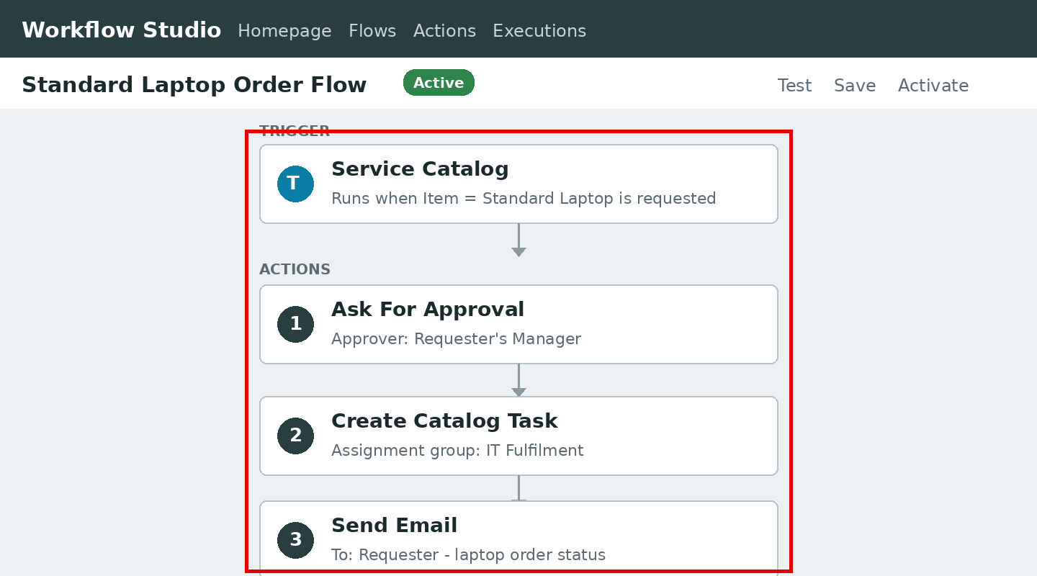
 | Flow Test Results | Flow Execution Success Rate - 100%  Test Cases Passed - 5 / 5 | - 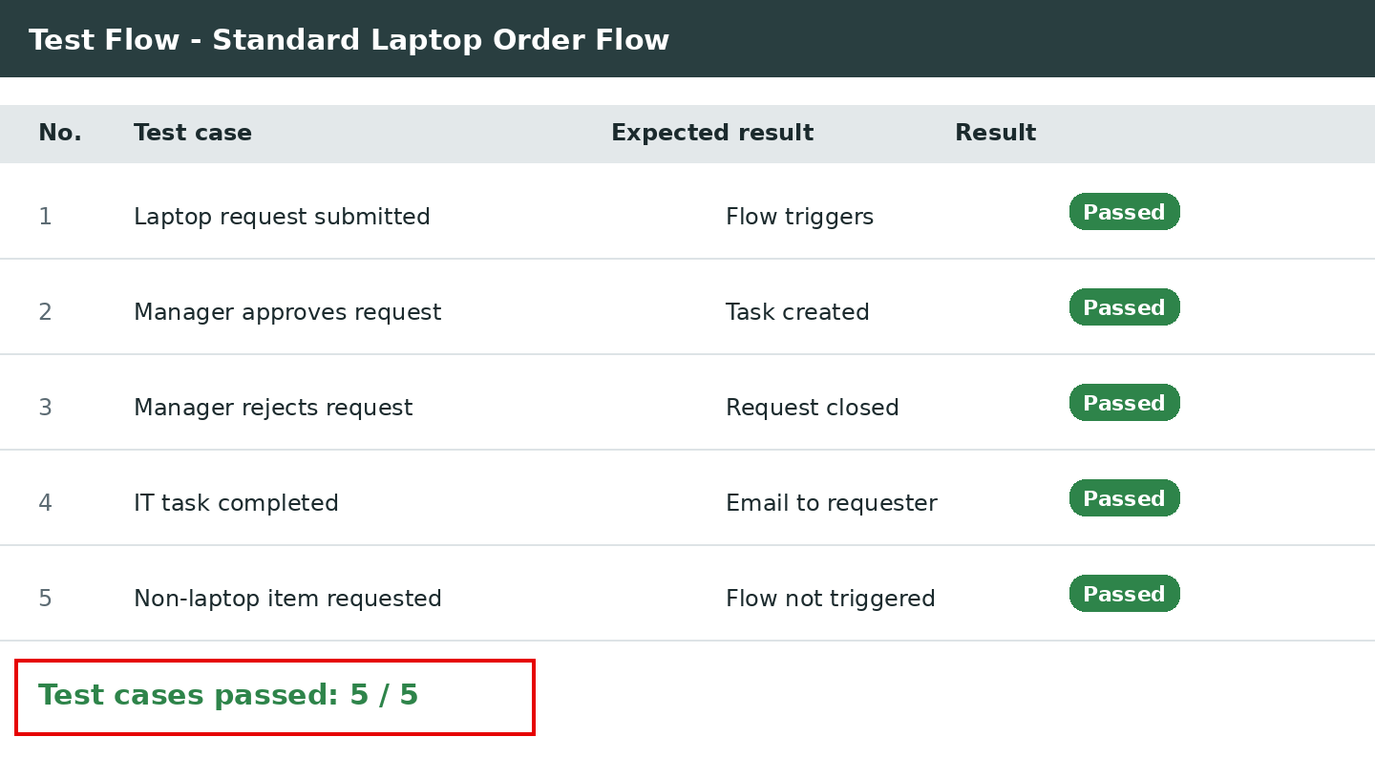
3. | Flow Execution Status (Trigger and Actions) | Trigger Detected - Service Catalog request for Standard Laptop; Actions - Ask for Approval, Create Task, Send Email  Execution Status - Completed (all actions ran without error) | 

