Fatima Jinnah Women University, Rawalpindi
Assignment #1 : Git, Gitea, GitHub, Git LFS, and GitHub Pages



Name:
Muneeza Amber Ejaz
Registration Number:
2024-BSE-10
Course Code:
SE-665
Section:
B
GitHub Username:
muneezaamber

Department of Software Engineering(BSE-5)

1. Introduction
The objective of this assignment is to demonstrate practical proficiency in version control systems and repository management. The tasks encompass setting up a self-hosted Git server (Gitea), configuring multiple remote repositories (GitHub), managing large files via Git LFS, and deploying a static portfolio website using GitHub Pages.

2. Task 1: Self-Hosted Git Service (Gitea) Configuration
In this task, a local self-hosted Git environment was established using Gitea. A local repository was initialized, and Gitea was configured as the remote server. The source files were successfully committed and pushed to the self-hosted Gitea repository.
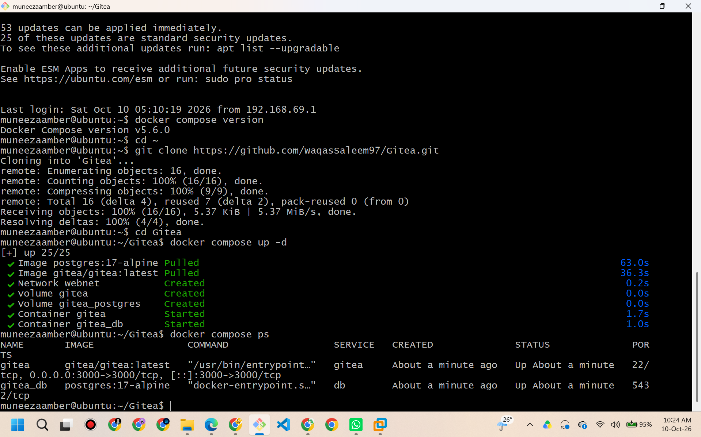
Figure 1: Verification of the Gitea service running in the local environment.
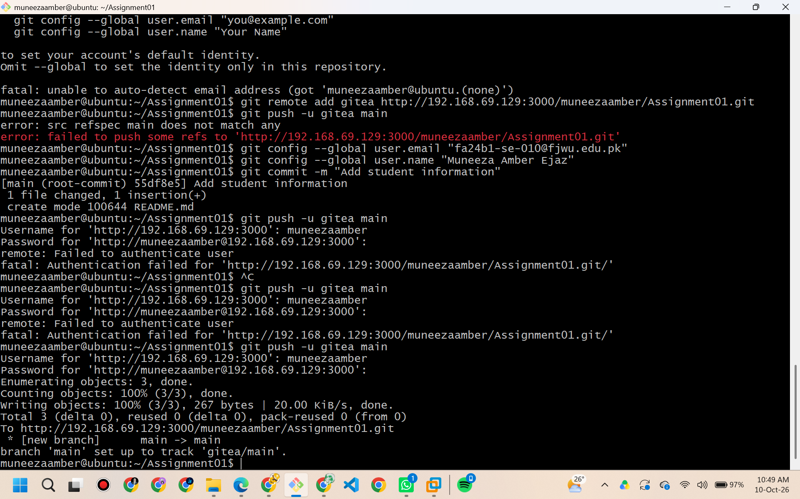
Figure 2: Execution of the Git push command to the self-hosted Gitea remote.
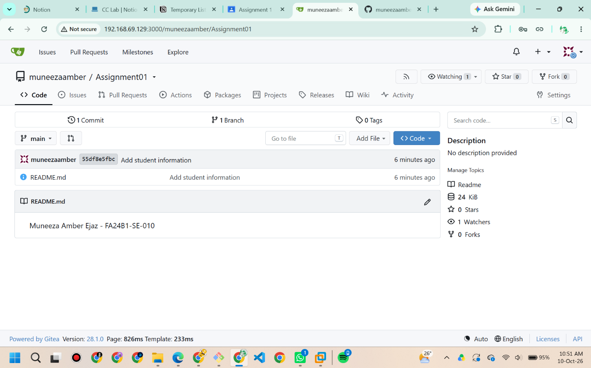
Figure 3: The uploaded repository files as viewed on the Gitea web interface.

3. Task 2: GitHub Remote Configuration
To maintain a secondary backup and utilize external version control, GitHub was added as an additional remote repository. The existing local codebase was pushed to the GitHub remote without disrupting the Gitea configuration.
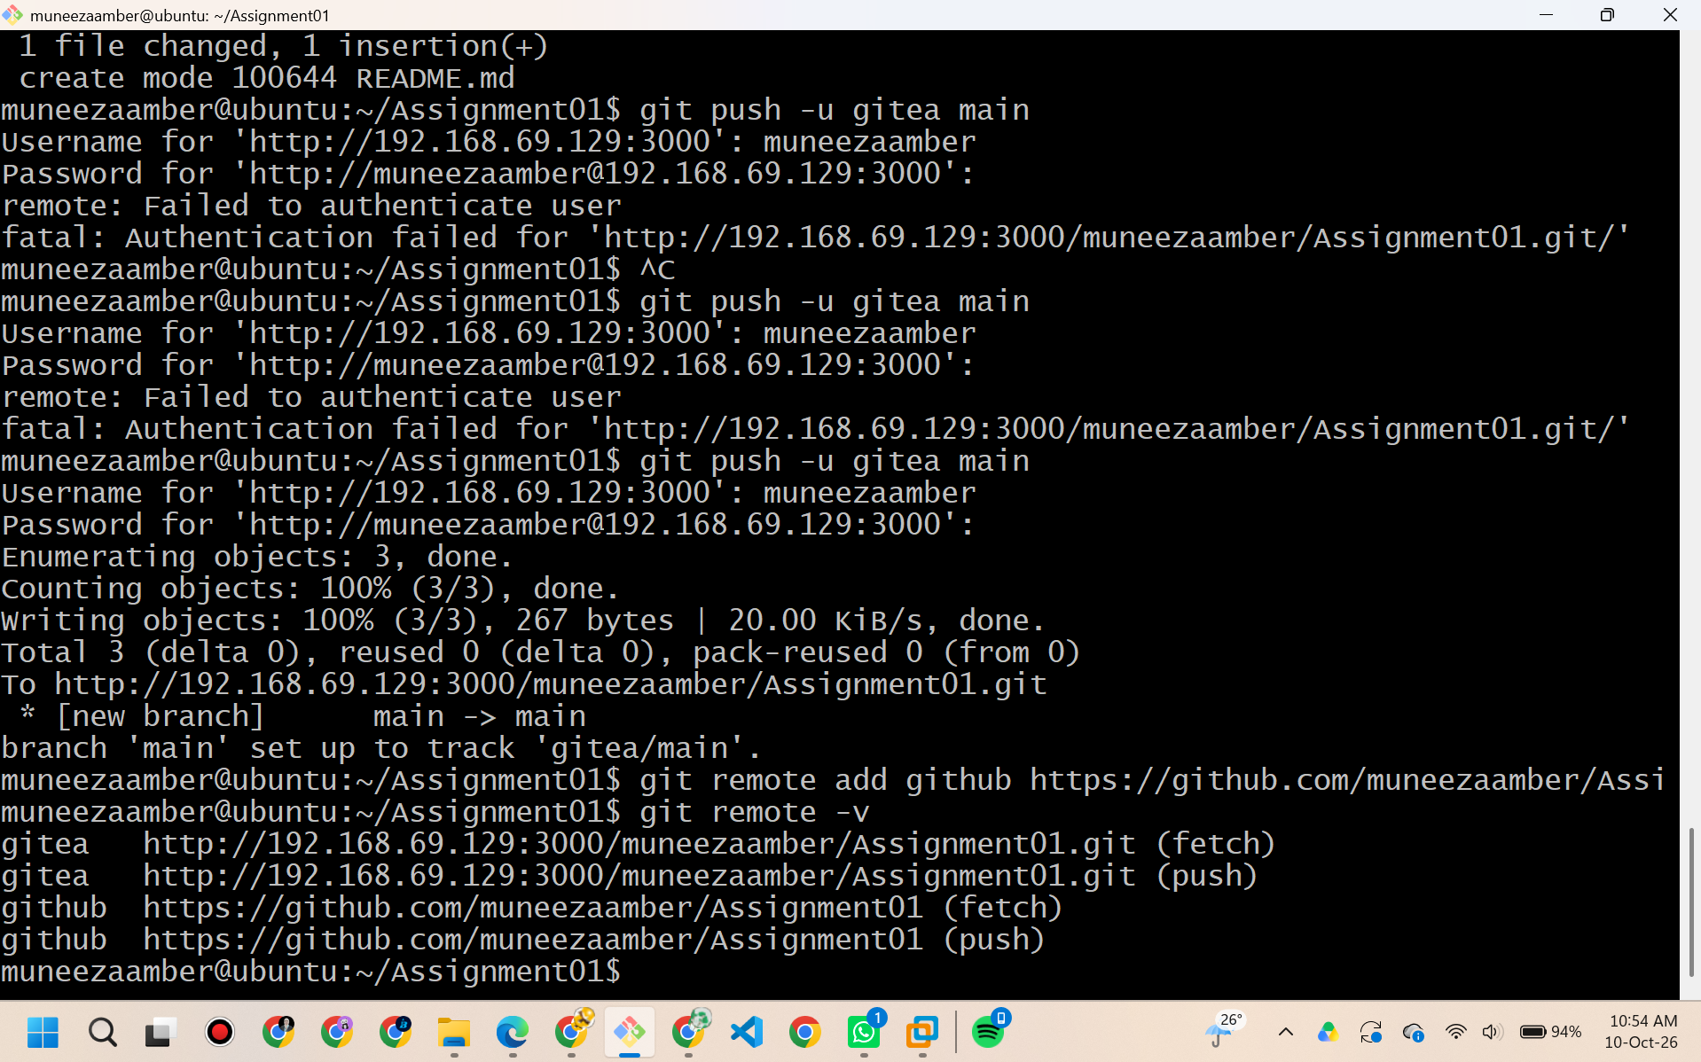
Figure 4: Terminal output displaying the configuration of both Gitea and GitHub remotes.
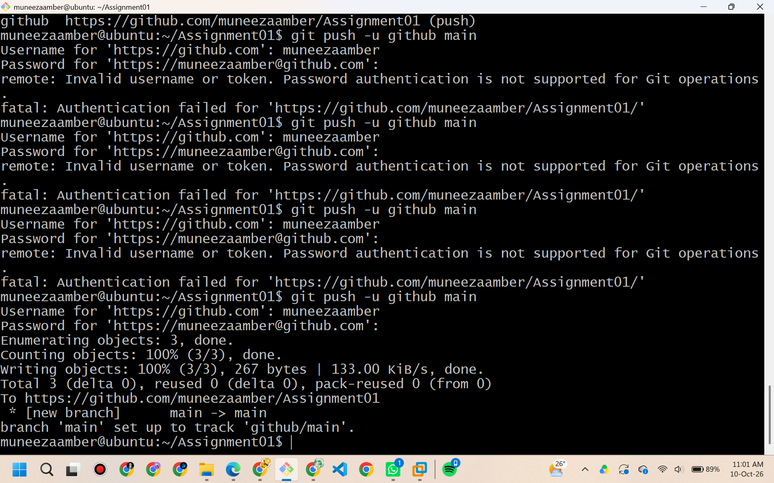
Figure 5: Execution of the Git push command targeting the GitHub remote repository.
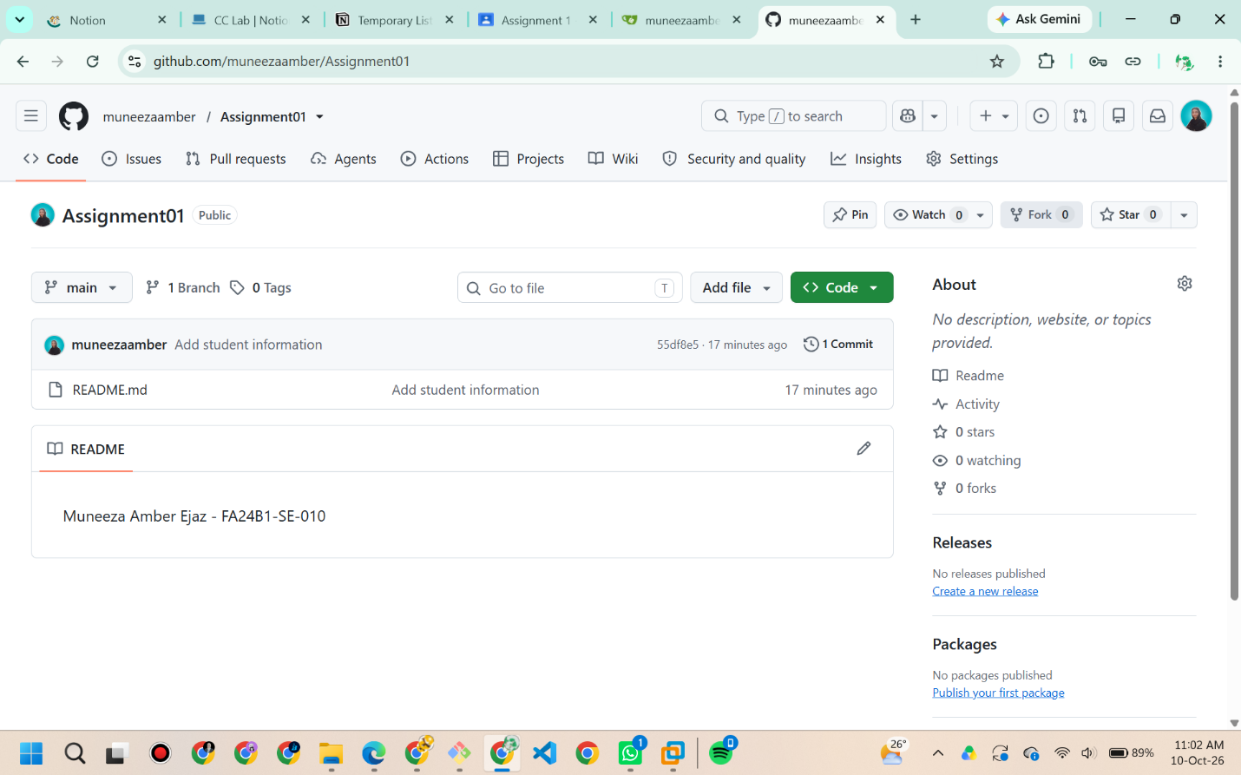
Figure 6: The successful upload of repository files viewed on the GitHub web interface.

4. Task 3: Git Large File Storage (LFS) Setup
Standard Git is not optimized for large binary files. To resolve this, Git Large File Storage (LFS) was initialized. Dummy binary files exceeding 100MB were generated, tracked using .gitattributes, committed, and successfully pushed to the repository using the LFS protocol.
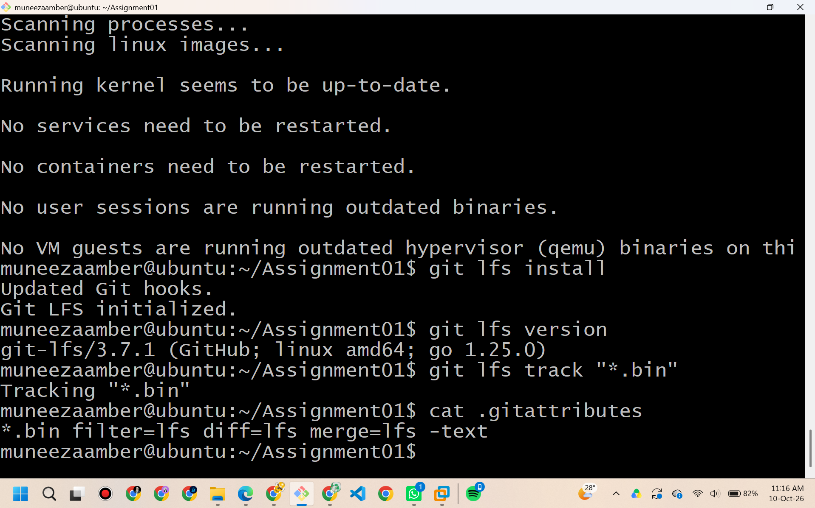
Figure 7: Installation and initialization of Git LFS in the repository.
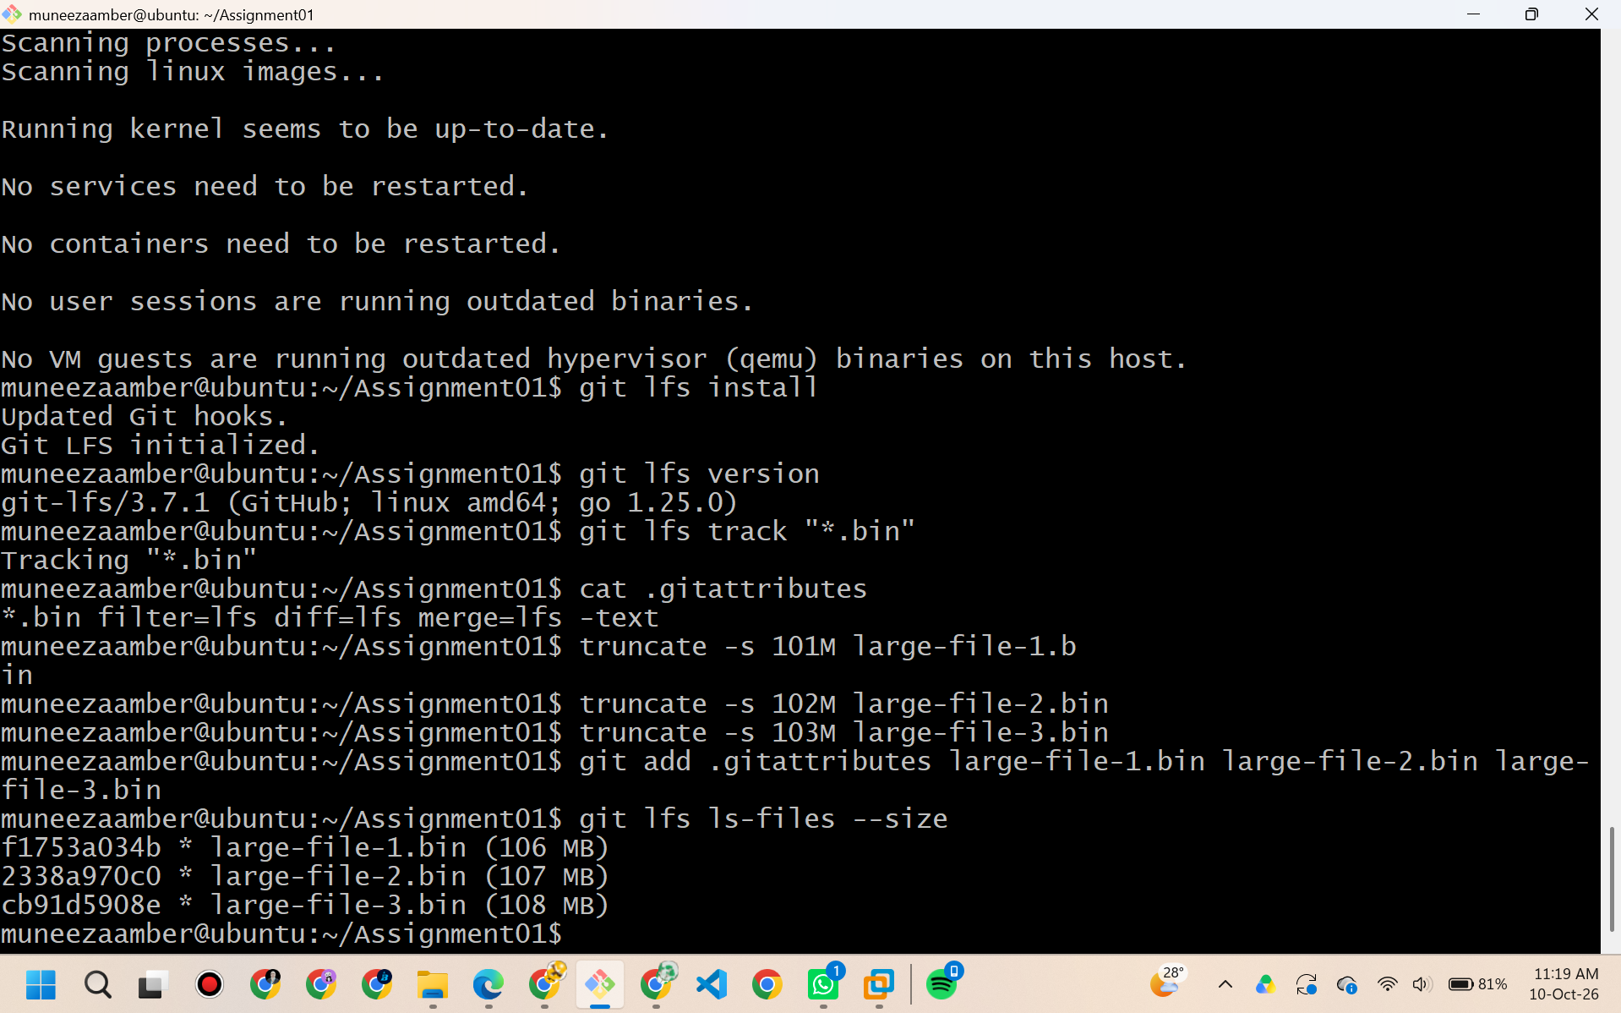
Figure 8: Tracking configuration for large binary files using Git LFS.
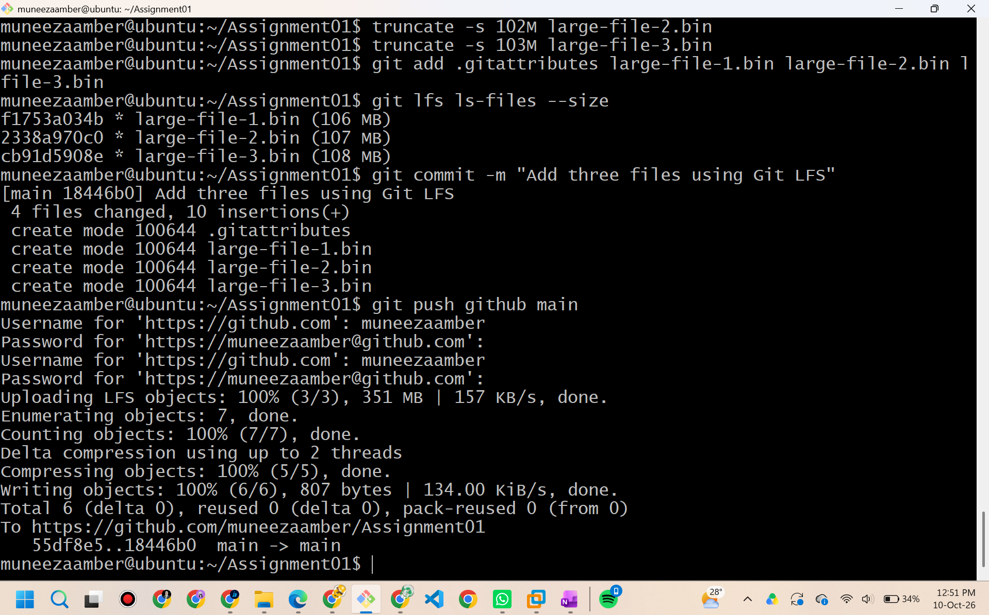
Figure 9: Successful push operation of the large binary files using Git LFS to the remote repository.

5. Task 4: GitHub Pages Deployment
A static UI/UX Portfolio website was developed using HTML and CSS. The portfolio includes professional sections such as About Me, Experience, Education, Skills, and Projects. The source code was uploaded to a specifically named repository (muneezaamber.github.io) and hosted live via the GitHub Pages deployment feature.
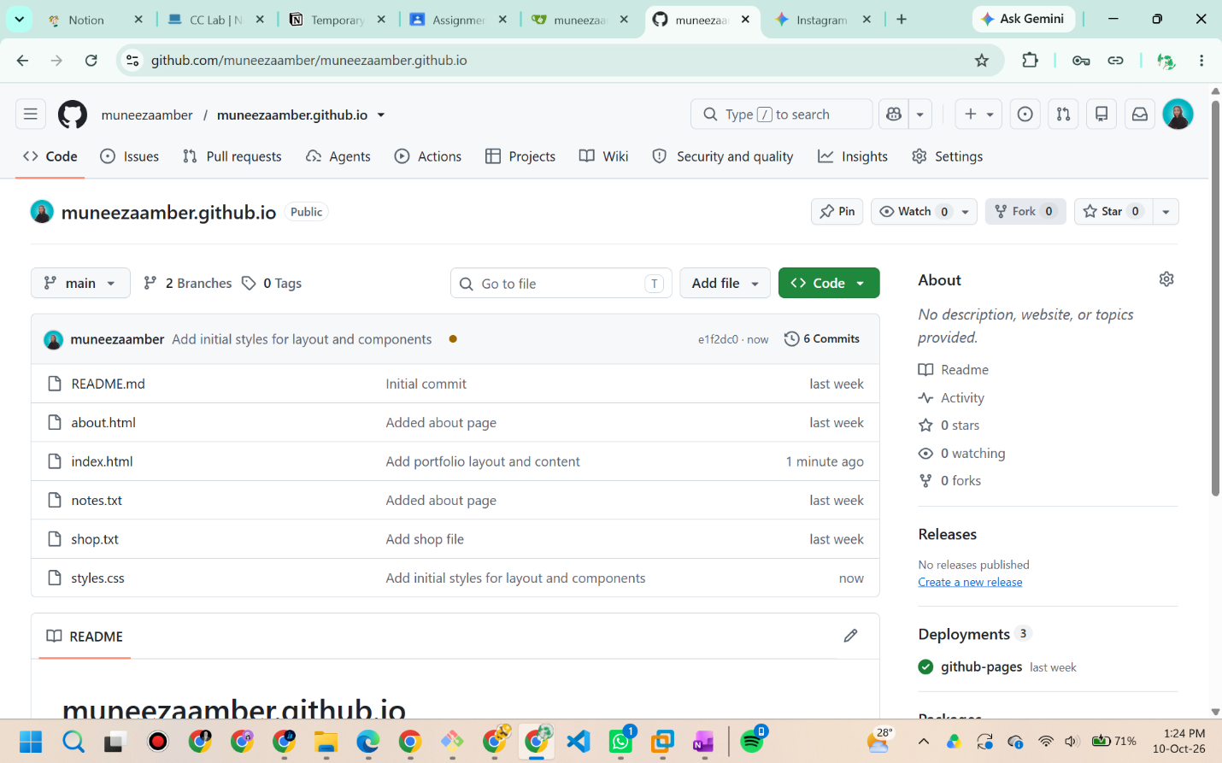
Figure 10: The repository containing the index.html and styles.css files for the portfolio.
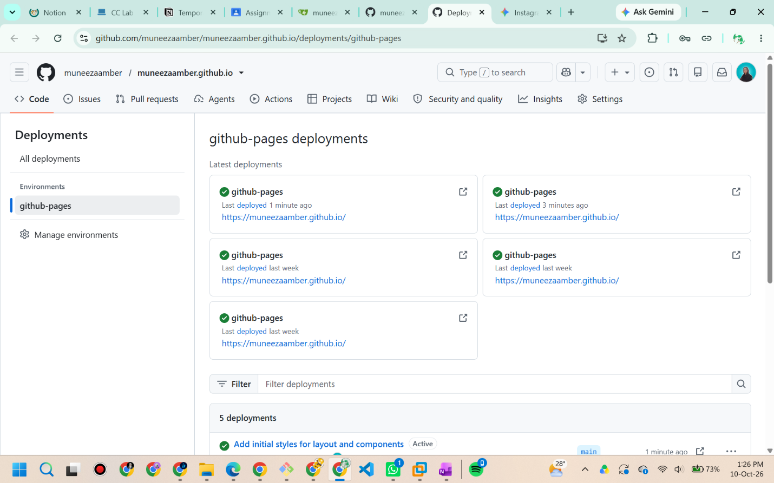
Figure 11: Verification of the successful GitHub Pages deployment process.
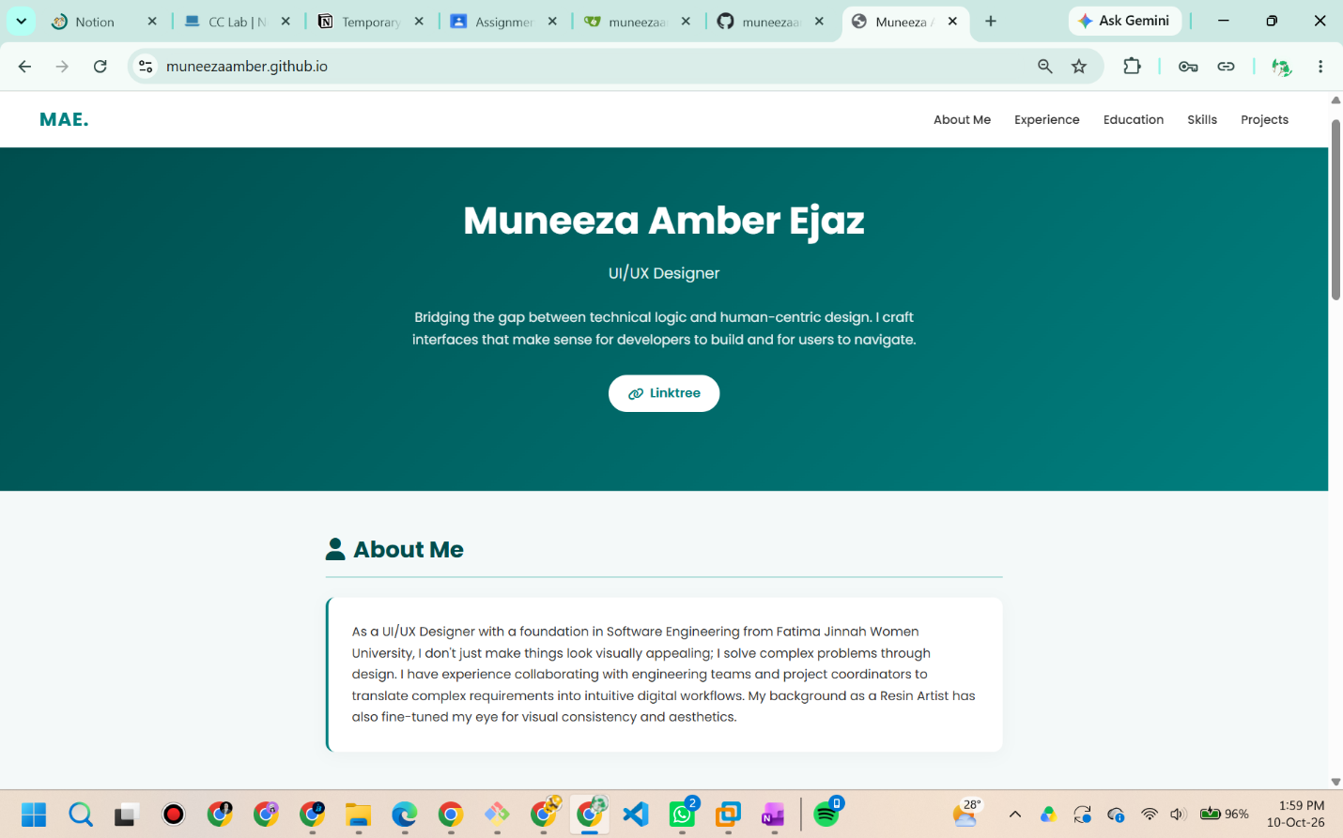
Figure 12: The live UI/UX designer portfolio website accessed via the GitHub Pages URL.

6. Conclusion
All requirements of the assignment have been successfully fulfilled. The practical implementation of Gitea, GitHub, Git LFS, and GitHub Pages demonstrates a comprehensive understanding of standard version control practices, large file management, and web deployment pipelines.

