Fit.ly Customer Churn Analysis
Author: Munem Shahriar Shams

1. Project Overview
Fit.ly is a digital fitness platform that provides users with tools to track workouts, access health content, and engage with fitness activities such as watching training videos, reading fitness articles, tracking workouts, and sharing progress. The platform operates under a subscription model offering several tiers including Free, Basic, Pro, and Enterprise.
For subscription-based services, retaining customers is critical for long‑term growth. Customer churn can indicate issues with engagement, product value, or customer experience. This project analyzes customer behavior and platform usage patterns to identify factors that contribute to churn and recommend strategies to improve retention.

2. Data Sources
Three datasets were used in this analysis:
Account Information – customer profile details including subscription plan and churn status.
Customer Support – records of support tickets, resolution times, and interaction channels.
User Activity – platform engagement events such as watching videos or tracking workouts.

3. Data Preparation
Customer IDs were converted into numeric user IDs so that records could be joined across datasets. Missing churn values were treated as non‑churned users. User activity events were aggregated to measure engagement levels, while support tickets were counted to evaluate customer support intensity.

4. Feature Engineering
Several analytical features were created to support the analysis:
Event Count – total number of engagement events performed by each user.
Engagement Bucket – grouped users into 0 events, 1 event, 2 events, and 3+ events.
Ticket Count – total number of support tickets submitted by each user.
Ticket Group – categorized as 0 tickets, 1 ticket, 2–3 tickets, or 4+ tickets.

5. Exploratory Analysis

5.1 Plan Distribution
This visualization illustrates the number of customers in each subscription tier. It helps understand how the user base is distributed between free and paid plans.

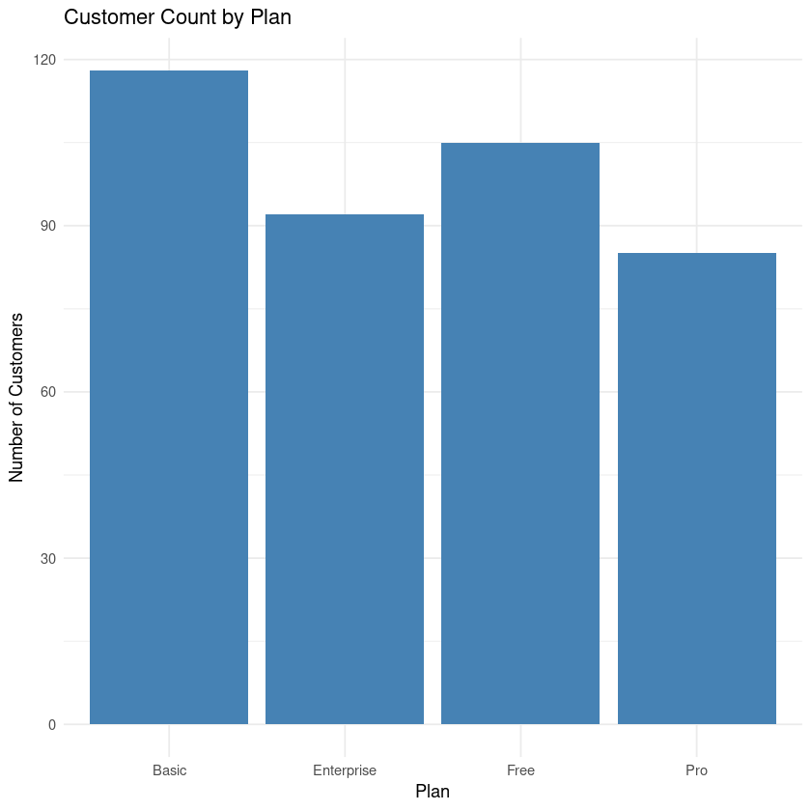

5.2 Support Resolution Time
A histogram of support resolution time shows how quickly customer issues are resolved. Most tickets are resolved within a moderate time frame, though a longer tail of extended resolution times is observed.

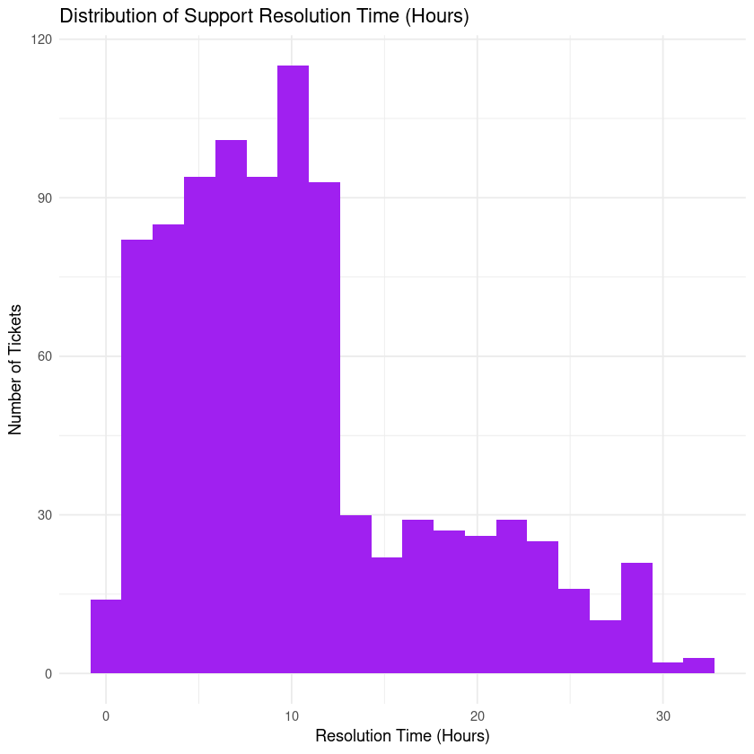

5.3 Churn by Engagement Bucket
This visualization compares churn rates across engagement levels. It highlights the strong relationship between product usage and customer retention.

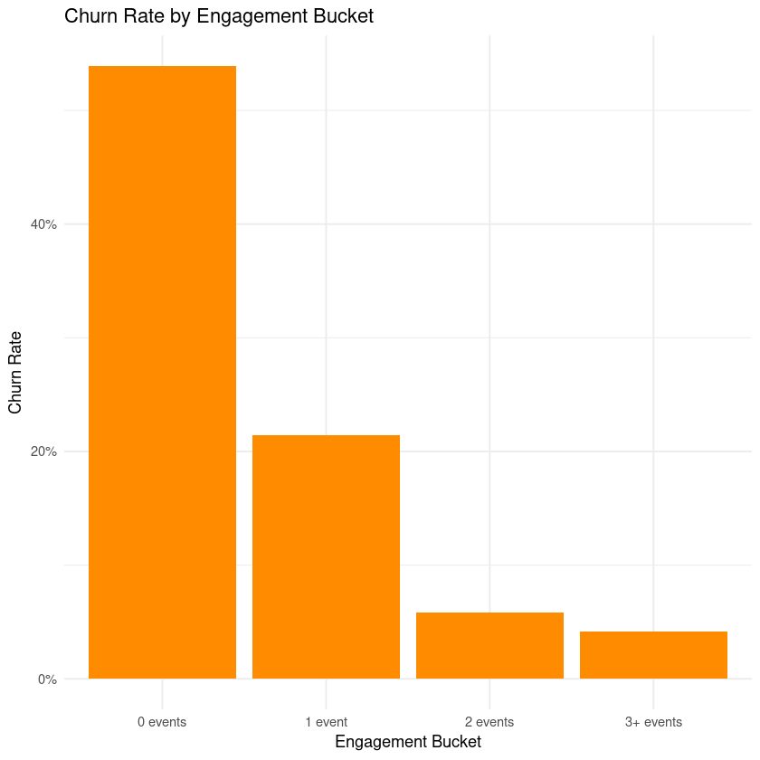

6. Key Findings
• Overall churn rate is approximately 28.5%.
• Free plan users churn at higher rates compared to paid plans.
• Customer engagement strongly correlates with retention.
• Users with little or no activity are far more likely to churn.
• Customers who contact support churn at roughly twice the rate of those who do not.

7. Recommended Business Metric
The recommended metric for monitoring retention is Monthly Churn Rate. This metric measures the proportion of customers who cancel or stop using the platform within a given month relative to the number of active customers at the beginning of that month.

8. Business Recommendations
• Improve onboarding to encourage early engagement with the platform.
• Encourage users to perform at least two meaningful platform activities early in their lifecycle.
• Provide proactive support to users with low engagement levels.
• Reduce long support resolution times to improve customer satisfaction.
• Track churn monthly across plan types and engagement segments.

9. Conclusion
This analysis demonstrates that user engagement and customer support interactions are strong indicators of churn risk. Improving early engagement and reducing friction in customer support can significantly improve retention rates. By monitoring churn and focusing on proactive engagement strategies, Fit.ly can improve long‑term customer value and platform growth.

