Untitled
2026-02-22
###############################
# Hypothesis Testing: Goals in Men's vs Women's World Cup Matches
# Best Combined Script
###############################
library(tidyverse)
## ── Attaching core tidyverse packages ──────────────────────── tidyverse 2.0.0 ──
## ✔ dplyr 1.1.4 ✔ readr 2.1.6
## ✔ forcats 1.0.1 ✔ stringr 1.6.0
## ✔ ggplot2 4.0.1 ✔ tibble 3.3.0
## ✔ lubridate 1.9.5 ✔ tidyr 1.3.1
## ✔ purrr 1.2.0
## ── Conflicts ────────────────────────────────────────── tidyverse_conflicts() ──
## ✖ dplyr::filter() masks stats::filter()
## ✖ dplyr::lag() masks stats::lag()
## ℹ Use the conflicted package (<http://conflicted.r-lib.org/>) to force all conflicts to become errors
library(gridExtra)
##
## Attaching package: 'gridExtra'
##
## The following object is masked from 'package:dplyr':
##
## combine
# -------------------------------------------------------------
# 1. Load Data
# -------------------------------------------------------------
women <- read_csv("women_results.csv")
## New names:
## Rows: 4884 Columns: 7
## ── Column specification
## ──────────────────────────────────────────────────────── Delimiter: "," chr
## (3): home_team, away_team, tournament dbl (3): ...1, home_score, away_score
## date (1): date
## ℹ Use `spec()` to retrieve the full column specification for this data. ℹ
## Specify the column types or set `show_col_types = FALSE` to quiet this message.
## • `` -> `...1`
men <- read_csv("men_results.csv")
## New names:
## Rows: 44353 Columns: 7
## ── Column specification
## ──────────────────────────────────────────────────────── Delimiter: "," chr
## (3): home_team, away_team, tournament dbl (3): ...1, home_score, away_score
## date (1): date
## ℹ Use `spec()` to retrieve the full column specification for this data. ℹ
## Specify the column types or set `show_col_types = FALSE` to quiet this message.
## • `` -> `...1`
# -------------------------------------------------------------
# 2. Filter Only FIFA World Cup Matches After 2002-01-01
# -------------------------------------------------------------
women_wc <- women %>%
filter(tournament == "FIFA World Cup",
date > "2002-01-01") %>%
mutate(goals_scored = home_score + away_score)
men_wc <- men %>%
filter(tournament == "FIFA World Cup",
date > "2002-01-01") %>%
mutate(goals_scored = home_score + away_score)
# -------------------------------------------------------------
# 3. Visual Check of Distribution (Normality Check)
# -------------------------------------------------------------
p1 <- ggplot(men_wc, aes(x = goals_scored)) +
geom_histogram(fill = "red", bins = 30, alpha = 0.75) +
labs(title = "Goals Scored - Men's World Cup Matches",
x = "Goals Scored", y = "Frequency")
p2 <- ggplot(women_wc, aes(x = goals_scored)) +
geom_histogram(fill = "blue", bins = 30, alpha = 0.75) +
labs(title = "Goals Scored - Women's World Cup Matches",
x = "Goals Scored", y = "Frequency")
grid.arrange(p1, p2, nrow = 1)
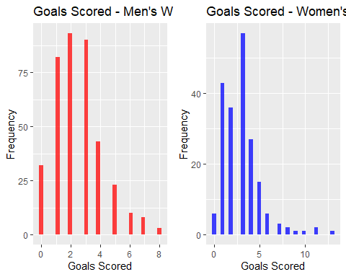
# Comment:
# Both distributions are skewed → t-test assumptions fail.
# Appropriate test: Mann-Whitney U (Wilcoxon rank-sum test)
# -------------------------------------------------------------
# 4. Hypothesis Test (One-sided)
#
# H0: women's mean goals == men's mean goals
# HA: women's mean goals > men's mean goals
# α = 0.10
# -------------------------------------------------------------
test_results <- wilcox.test(
x = women_wc$goals_scored,
y = men_wc$goals_scored,
alternative = "greater"
)
p_val <- as.numeric(test_results$p.value)
# Decision at 10% significance level
decision <- ifelse(p_val < 0.10, "reject", "fail to reject")
# -------------------------------------------------------------
# 5. Store Final Results in Required Format
# -------------------------------------------------------------
result_df <- data.frame(
p_val = p_val,
result = decision
)
print(result_df)
## p_val result
## 1 0.00510661 reject

