Stack Overflow Programming Language Trends Analysis
Munem Shahriar Shams
#Loading Libraries
library(readr)
library(dplyr)
##
## Attaching package: 'dplyr'
## The following objects are masked from 'package:stats':
##
## filter, lag
## The following objects are masked from 'package:base':
##
## intersect, setdiff, setequal, union
library(ggplot2)
library(scales)
##
## Attaching package: 'scales'
## The following object is masked from 'package:readr':
##
## col_factor
#Loading the dataset
data <- read_csv("stack_overflow_data.csv")
## Rows: 420066 Columns: 4
## ── Column specification ────────────────────────────────────────────────────────
## Delimiter: ","
## chr (1): tag
## dbl (3): year, num_questions, year_total
##
## ℹ Use `spec()` to retrieve the full column specification for this data.
## ℹ Specify the column types or set `show_col_types = FALSE` to quiet this message.
head(data)
## # A tibble: 6 × 4
## year tag num_questions year_total
## <dbl> <chr> <dbl> <dbl>
## 1 2008 treeview 69 168541
## 2 2008 scheduled-tasks 30 168541
## 3 2008 specifications 21 168541
## 4 2008 rendering 35 168541
## 5 2008 http-post 6 168541
## 6 2008 static-assert 1 168541

Data Preparation
To compare languages across years, we calculate the percentage of total questions associated with each tag. This allows us to measure relative popularity rather than raw counts.
data_percentage <- data %>%
mutate(
percentage = (num_questions / year_total) * 100
)

Trend Analysis: R Programming Language
We first examine how the popularity of the R programming language has evolved over time.
r_over_time <- data_percentage %>%
filter(tag == "r")

Visualization: R Popularity Over Time
The following chart shows how the percentage of Stack Overflow questions tagged with R has changed over time.
ggplot(r_over_time, aes(x = year, y = percentage)) +
geom_line(color = "steelblue", linewidth = 1) +
geom_point(color = "steelblue") +
labs(
title = "Popularity of R on Stack Overflow",
x = "Year",
y = "Percentage of Questions"
) +
theme_minimal()
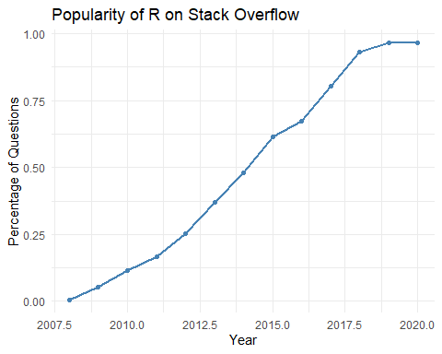

R Popularity in 2020
Next we extract the statistics for the year 2020 to determine the share of Stack Overflow questions related to R.
r_2020 <- r_over_time %>%
filter(year == 2020)
r_2020
## # A tibble: 1 × 5
## year tag num_questions year_total percentage
## <dbl> <chr> <dbl> <dbl> <dbl>
## 1 2020 r 52662 5452545 0.966

Identify Most Popular Programming Languages
Next we determine which programming languages received the highest number of questions between 2015 and 2020.
sorted_tags <- data %>%
filter(year >= 2015 & year <= 2020) %>%
group_by(tag) %>%
summarise(tag_total = sum(num_questions), .groups = "drop") %>%
arrange(desc(tag_total))
highest_tags <- sorted_tags %>%
slice_head(n = 5)
highest_tags
## # A tibble: 5 × 2
## tag tag_total
## <chr> <dbl>
## 1 javascript 1373634
## 2 python 1187838
## 3 java 982747
## 4 android 737330
## 5 c# 730045

Visualization: Popular Programming Languages
Finally, we visualize how the most popular programming languages have evolved over time.
top_tags <- highest_tags$tag
data_subset <- data_percentage %>%
filter(tag %in% top_tags, year >= 2015)
ggplot(data_subset, aes(x = year, y = percentage, color = tag)) +
geom_line(linewidth = 1) +
geom_point() +
labs(
title = "Popularity Trends of Top Programming Languages (2015–2020)",
x = "Year",
y = "Percentage of Questions",
color = "Language"
) +
theme_minimal()
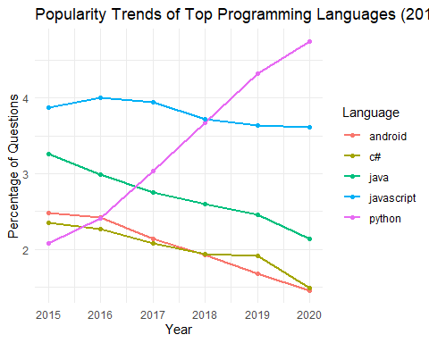

Key Insights
Several insights emerge from this analysis:
- Stack Overflow question data provides a strong indicator of developer interest in programming languages.
- R shows steady growth due to its importance in data science and analytics.
- A small group of programming languages dominates most Stack Overflow discussions.
- Observing trends over time helps identify emerging technologies and declining tools.

Conclusion
Stack Overflow question data offers a valuable perspective on programming language popularity. By analyzing tagged questions over time, we can observe how developer interest evolves across technologies.
These insights can help developers and organizations decide which programming languages to focus on learning and adopting.

