Digi Skills-AI-Course(DSTP3.0-Batch-03_AIP301)
Exercies-03:
- import libraries, understand data, handle missing & split data into training & testing
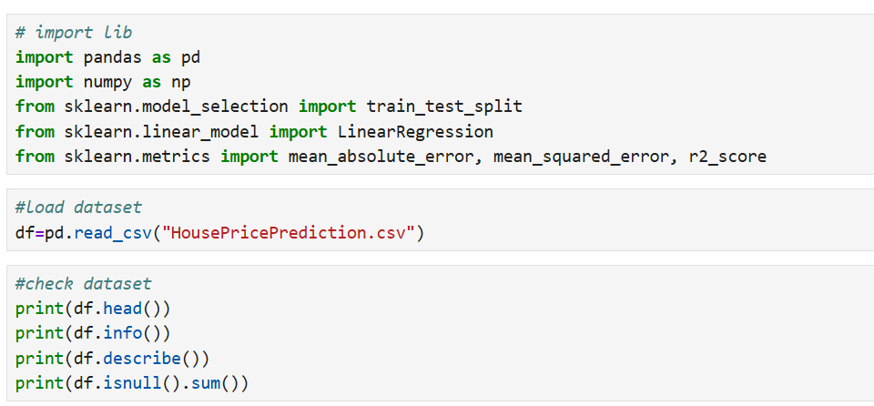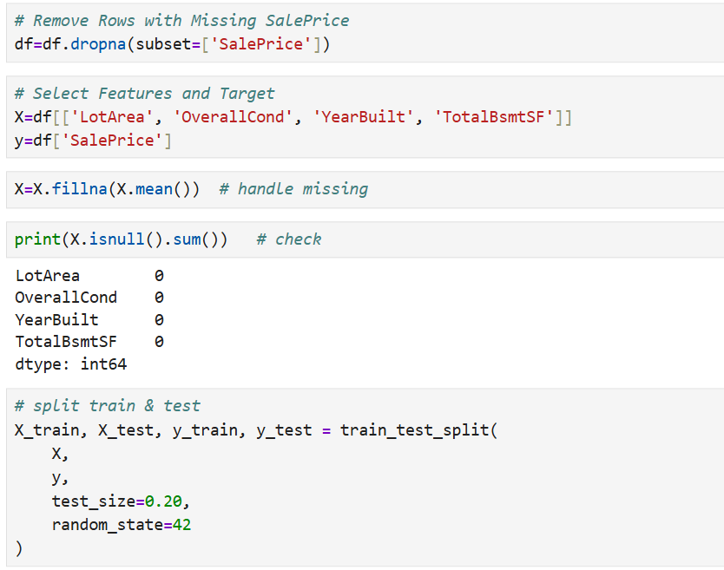
- Train model

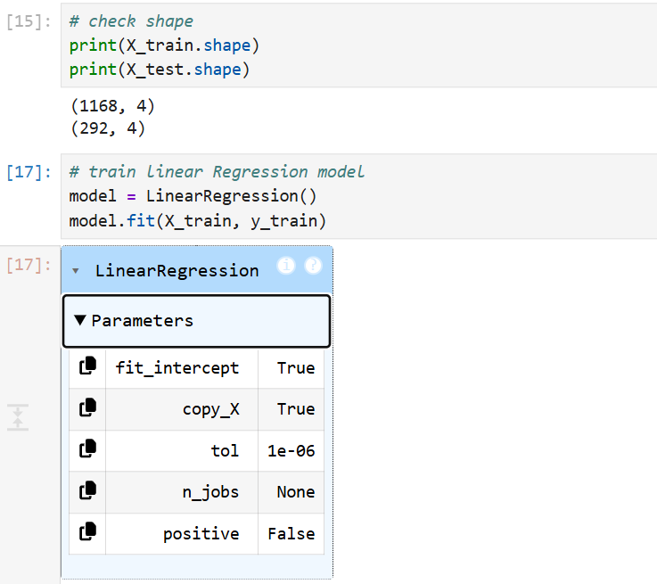

- Model Prediction
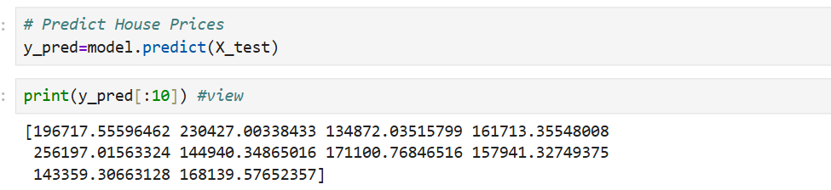
- Model Evaluation
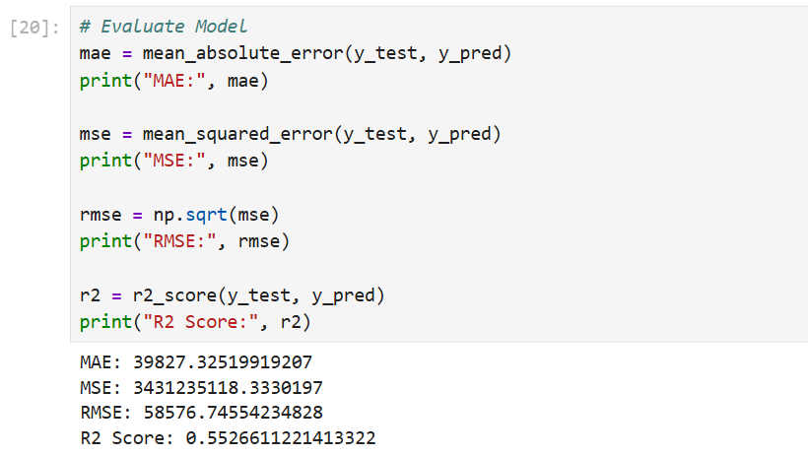

- interpretation
Interpretation:
- MAE shows the average prediction error.
- MSE measures squared prediction error.
- RMSE shows prediction error in the same unit as house price.
- R² Score indicates how well the model explains house price variation.
Conclusion:
- If R² is close to 1, the model performs well.
- If MAE, MSE, and RMSE are low, predictions are more accurate.
- Otherwise, the model may need improvement

