Digi Skills-AI-Course(DSTP3.0-Batch-03_AIP301)
Exercies-01:
1.
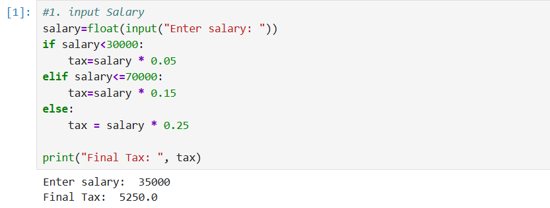

2.
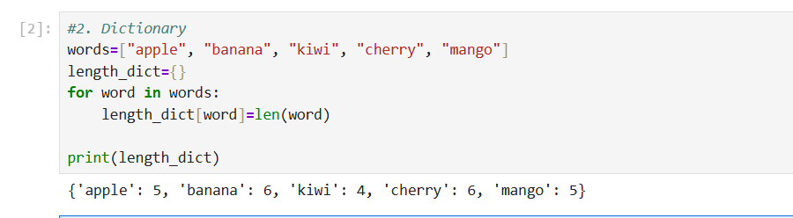

3.
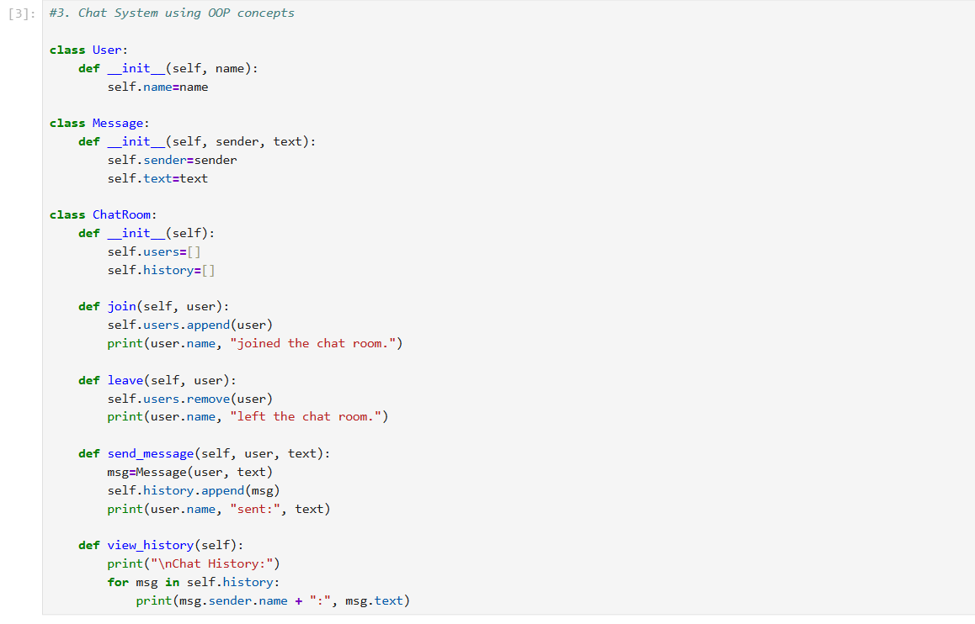

Example check methods:
