SYSTEM DEVELOPMENT PROCESS
Input and output specification
Database design
Front end design
Logic handing
Testing and deployment

FLOWCHART

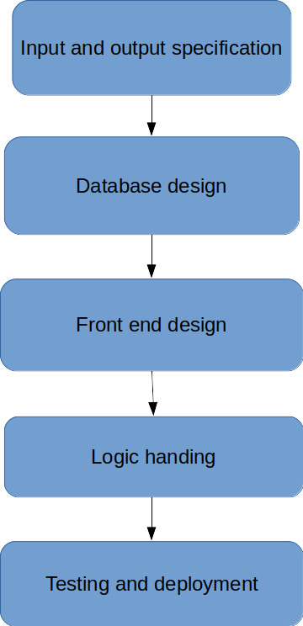
input and output specification:
define and analyze the input variables required for both parties involved i.e between the importers and exporters.
- These will be laid out in a meeting between you and the developers.
- Establish relationships between the inputs and the outputs.
- Sort the inputs with respect to data requirements; I.e a given input falls into a particular set of inputs in the project
- Specify the methods of data collection~ ways and sources of extracting the data.

Database design:
Design and develop a database for for storing the inputs specified in the input.
- Data types
- API’s to use (REST,)
- Frameworks (Django)
- Database architecture(SQL)
specification stage:

Front End Design:
- GUI design (HTML, JavaScript, React, CSS)

Logic Handling:
- How to handle database calls, interconnecting the front end and the back-end.
- Programming(Python back-end, Django API)
- Block-chain integration between processes.

Testing and deployment:
- The project will be hosted locally for testing and debugging purposes
- We will later deploy to amazon web hosting services.

