**Njoroge John Mungai**

**Reg No: C026-0718/2012**

**Assignment: Compiler Construction for MiniJava grammar**

Compile lexer

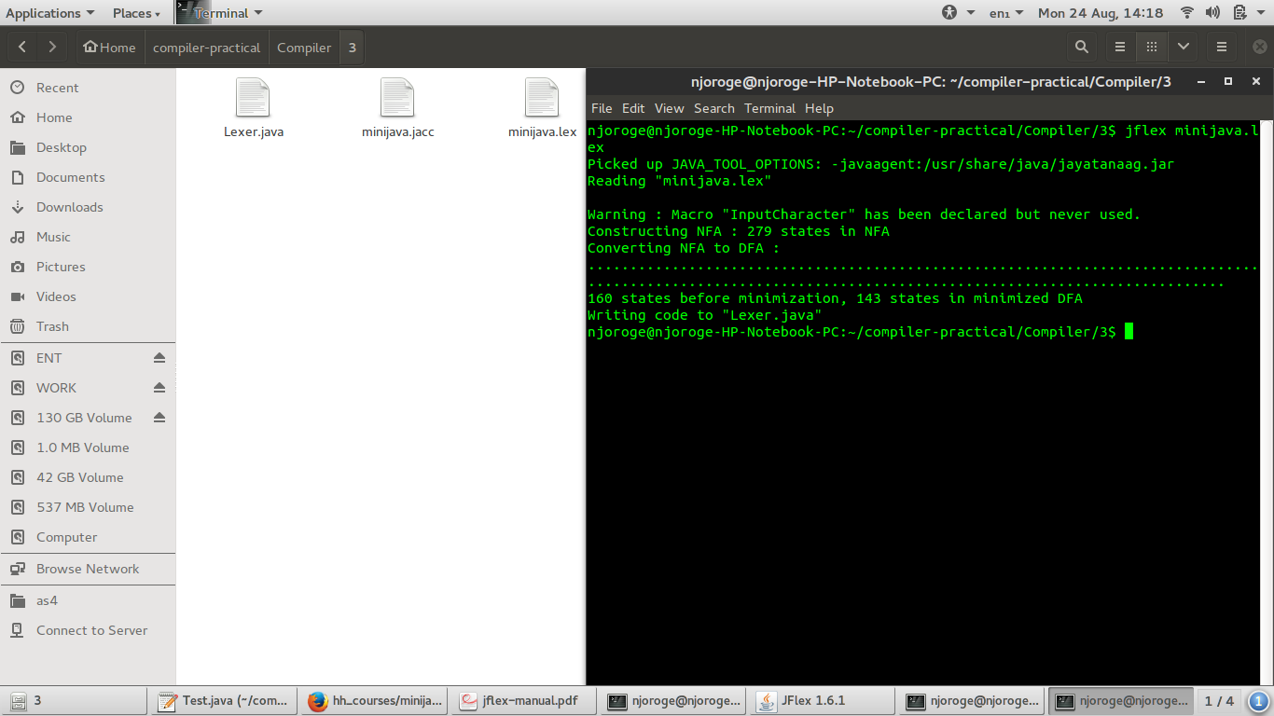

**Create parser**

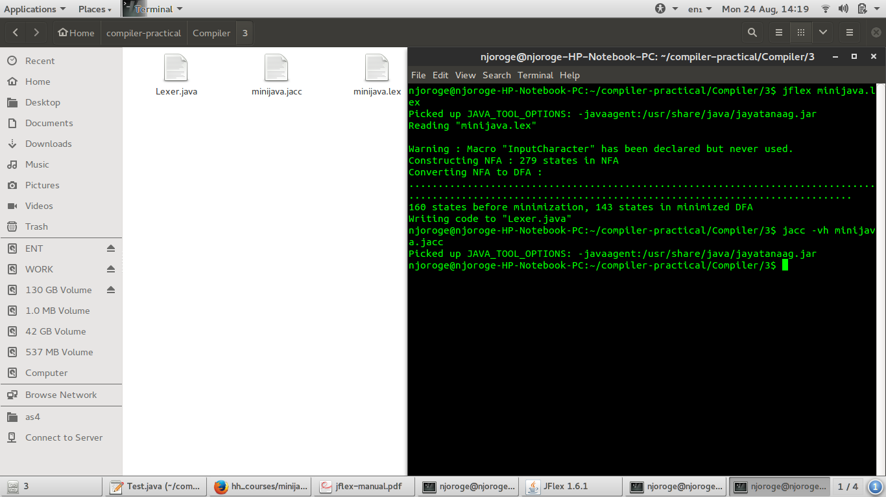

**Compile parser and scanner**

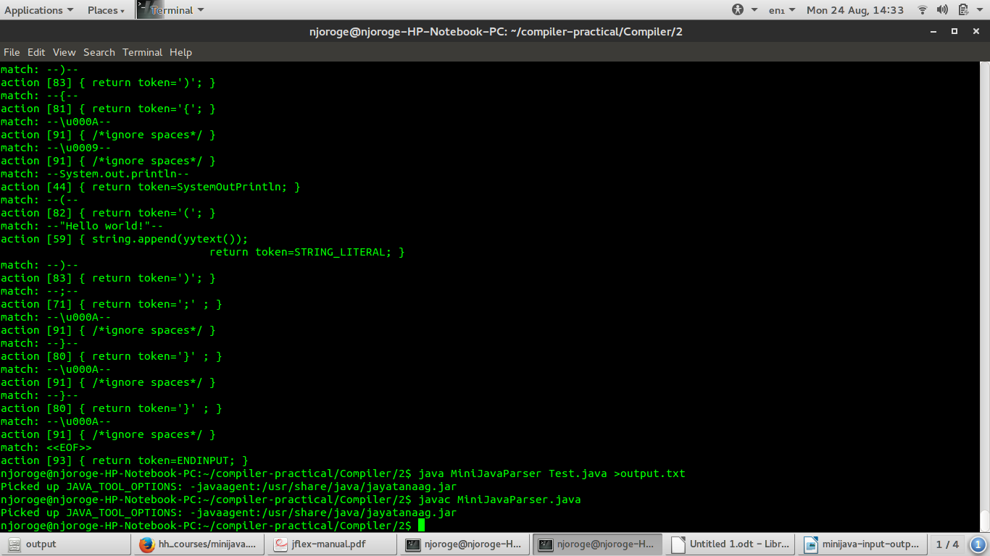

**Input file(Test.java):**

public class Test{

public static void main(String [] args){

System.out.println("Hello world!");

}

}

**Scanner output**

