Njoroge John Mungai
Reg No: C026-0718/2012
Assignment: Compiler Construction for MiniJava grammar

Compile lexer
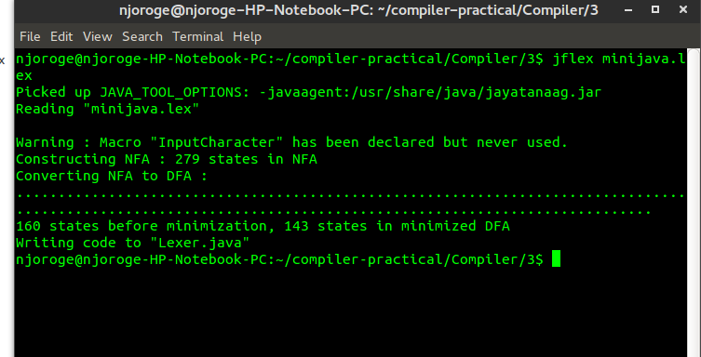

Create parser
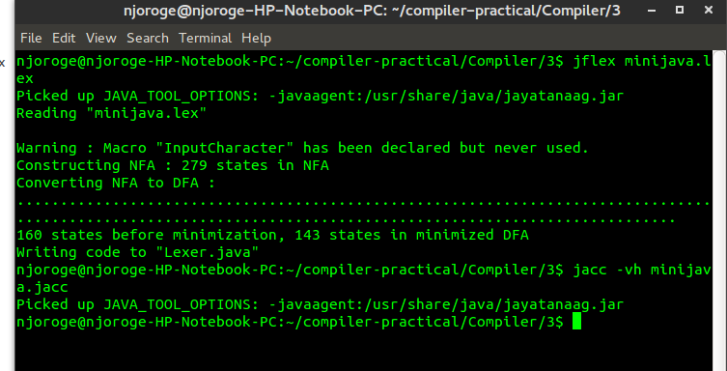

Compile parser and scanner
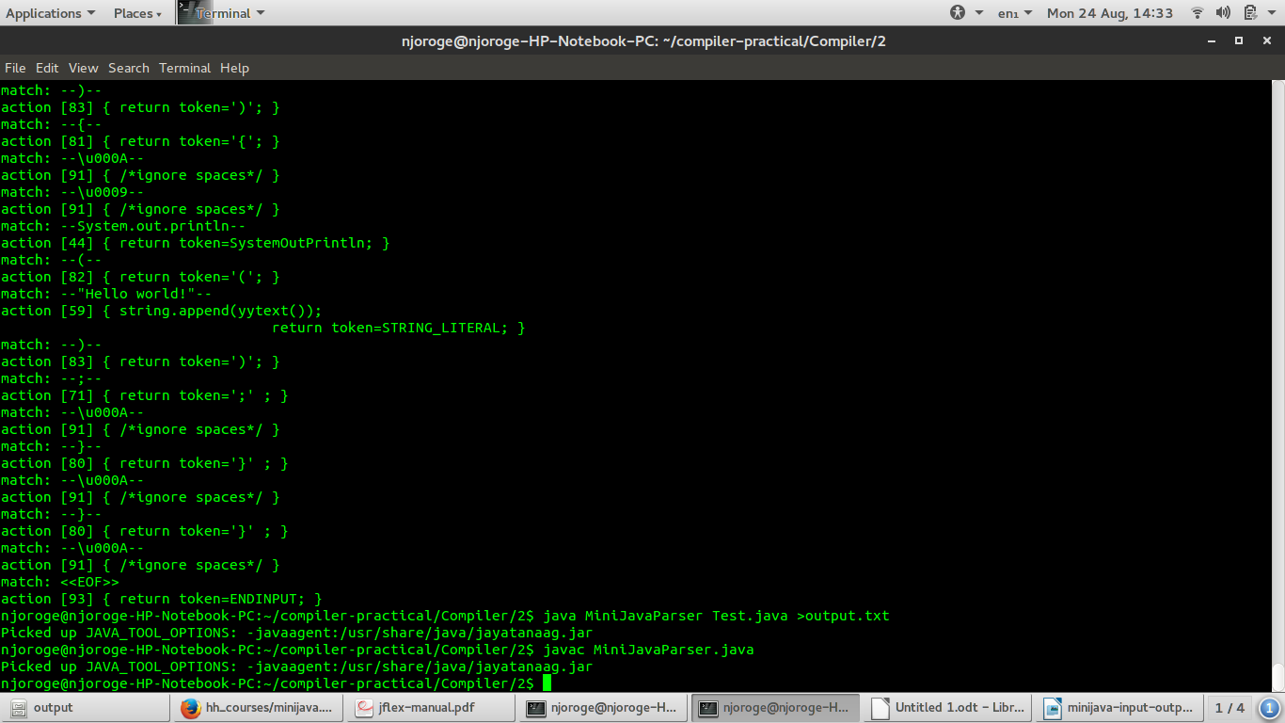

Input file(Test.java):

public class Test{
public static void main(String [] args){
System.out.println("Hello world!");
}
}
Scanner output
