Model: "model"

_________________________________________________________________

Layer (type) Output Shape Param #

=================================================================

input_1 (InputLayer) [(None, 224, 224, 3)] 0

_________________________________________________________________

block1_conv1 (Conv2D) (None, 224, 224, 64) 1792

_________________________________________________________________

block1_conv2 (Conv2D) (None, 224, 224, 64) 36928

_________________________________________________________________

block1_pool (MaxPooling2D) (None, 112, 112, 64) 0

_________________________________________________________________

block2_conv1 (Conv2D) (None, 112, 112, 128) 73856

_________________________________________________________________

block2_conv2 (Conv2D) (None, 112, 112, 128) 147584

_________________________________________________________________

block2_pool (MaxPooling2D) (None, 56, 56, 128) 0

_________________________________________________________________

block3_conv1 (Conv2D) (None, 56, 56, 256) 295168

_________________________________________________________________

block3_conv2 (Conv2D) (None, 56, 56, 256) 590080

_________________________________________________________________

block3_conv3 (Conv2D) (None, 56, 56, 256) 590080

_________________________________________________________________

block3_conv4 (Conv2D) (None, 56, 56, 256) 590080

_________________________________________________________________

block3_pool (MaxPooling2D) (None, 28, 28, 256) 0

_________________________________________________________________

block4_conv1 (Conv2D) (None, 28, 28, 512) 1180160

_________________________________________________________________

block4_conv2 (Conv2D) (None, 28, 28, 512) 2359808

_________________________________________________________________

block4_conv3 (Conv2D) (None, 28, 28, 512) 2359808

_________________________________________________________________

block4_conv4 (Conv2D) (None, 28, 28, 512) 2359808

_________________________________________________________________

block4_pool (MaxPooling2D) (None, 14, 14, 512) 0

_________________________________________________________________

block5_conv1 (Conv2D) (None, 14, 14, 512) 2359808

_________________________________________________________________

block5_conv2 (Conv2D) (None, 14, 14, 512) 2359808

_________________________________________________________________

block5_conv3 (Conv2D) (None, 14, 14, 512) 2359808

_________________________________________________________________

block5_conv4 (Conv2D) (None, 14, 14, 512) 2359808

_________________________________________________________________

block5_pool (MaxPooling2D) (None, 7, 7, 512) 0

_________________________________________________________________

flatten (Flatten) (None, 25088) 0

_________________________________________________________________

dense (Dense) (None, 6) 150534

=================================================================

Total params: 20,174,918

Trainable params: 150,534

Non-trainable params: 20,024,384

_________________________________________________________________

Found 899 images belonging to 6 classes.

Found 222 images belonging to 6 classes.

/usr/local/lib/python3.7/dist-packages/tensorflow/python/keras/engine/training.py:1940: UserWarning: `Model.fit_generator` is deprecated and will be removed in a future version. Please use `Model.fit`, which supports generators.

warnings.warn('`Model.fit_generator` is deprecated and '

Epoch 1/20

8/8 [==============================] - 711s 90s/step - loss: 2.8744 - accuracy: 0.3259 - val_loss: 1.1085 - val_accuracy: 0.5856

Epoch 2/20

8/8 [==============================] - 705s 89s/step - loss: 1.1975 - accuracy: 0.6440 - val_loss: 0.8361 - val_accuracy: 0.7027

Epoch 3/20

8/8 [==============================] - 702s 89s/step - loss: 0.7582 - accuracy: 0.7319 - val_loss: 0.7914 - val_accuracy: 0.7342

Epoch 4/20

8/8 [==============================] - 700s 88s/step - loss: 0.6804 - accuracy: 0.7653 - val_loss: 0.7501 - val_accuracy: 0.7117

Epoch 5/20

8/8 [==============================] - 701s 89s/step - loss: 0.5437 - accuracy: 0.8087 - val_loss: 0.6610 - val_accuracy: 0.7658

Epoch 6/20

8/8 [==============================] - 702s 89s/step - loss: 0.4772 - accuracy: 0.8309 - val_loss: 0.6246 - val_accuracy: 0.7568

Epoch 7/20

8/8 [==============================] - 700s 88s/step - loss: 0.3992 - accuracy: 0.8676 - val_loss: 0.4834 - val_accuracy: 0.7793

Epoch 8/20

8/8 [==============================] - 702s 89s/step - loss: 0.3255 - accuracy: 0.8899 - val_loss: 0.5547 - val_accuracy: 0.8108

Epoch 9/20

8/8 [==============================] - 699s 100s/step - loss: 0.2971 - accuracy: 0.8888 - val_loss: 0.3881 - val_accuracy: 0.8559

Epoch 10/20

8/8 [==============================] - 702s 89s/step - loss: 0.2282 - accuracy: 0.9388 - val_loss: 0.4034 - val_accuracy: 0.8153

Epoch 11/20

8/8 [==============================] - 699s 88s/step - loss: 0.2096 - accuracy: 0.9388 - val_loss: 0.3123 - val_accuracy: 0.8874

Epoch 12/20

8/8 [==============================] - 697s 88s/step - loss: 0.1564 - accuracy: 0.9666 - val_loss: 0.3003 - val_accuracy: 0.8874

Epoch 13/20

8/8 [==============================] - 703s 89s/step - loss: 0.1993 - accuracy: 0.9422 - val_loss: 0.3494 - val_accuracy: 0.8649

Epoch 14/20

8/8 [==============================] - 706s 89s/step - loss: 0.1520 - accuracy: 0.9633 - val_loss: 0.2771 - val_accuracy: 0.9099

Epoch 15/20

8/8 [==============================] - 703s 89s/step - loss: 0.1102 - accuracy: 0.9878 - val_loss: 0.2393 - val_accuracy: 0.9144

Epoch 16/20

8/8 [==============================] - 706s 89s/step - loss: 0.1038 - accuracy: 0.9855 - val_loss: 0.2407 - val_accuracy: 0.9369

Epoch 17/20

8/8 [==============================] - 708s 89s/step - loss: 0.0894 - accuracy: 0.9933 - val_loss: 0.2263 - val_accuracy: 0.9234

Epoch 18/20

8/8 [==============================] - 713s 90s/step - loss: 0.0828 - accuracy: 0.9967 - val_loss: 0.2236 - val_accuracy: 0.9369

Epoch 19/20

8/8 [==============================] - 711s 90s/step - loss: 0.1039 - accuracy: 0.9833 - val_loss: 0.2302 - val_accuracy: 0.9144

Epoch 20/20

8/8 [==============================] - 707s 90s/step - loss: 0.0871 - accuracy: 0.9855 - val_loss: 0.2160 - val_accuracy: 0.9234

Time: 14648.75 sec.

Time to run all : 4:04:08.745226

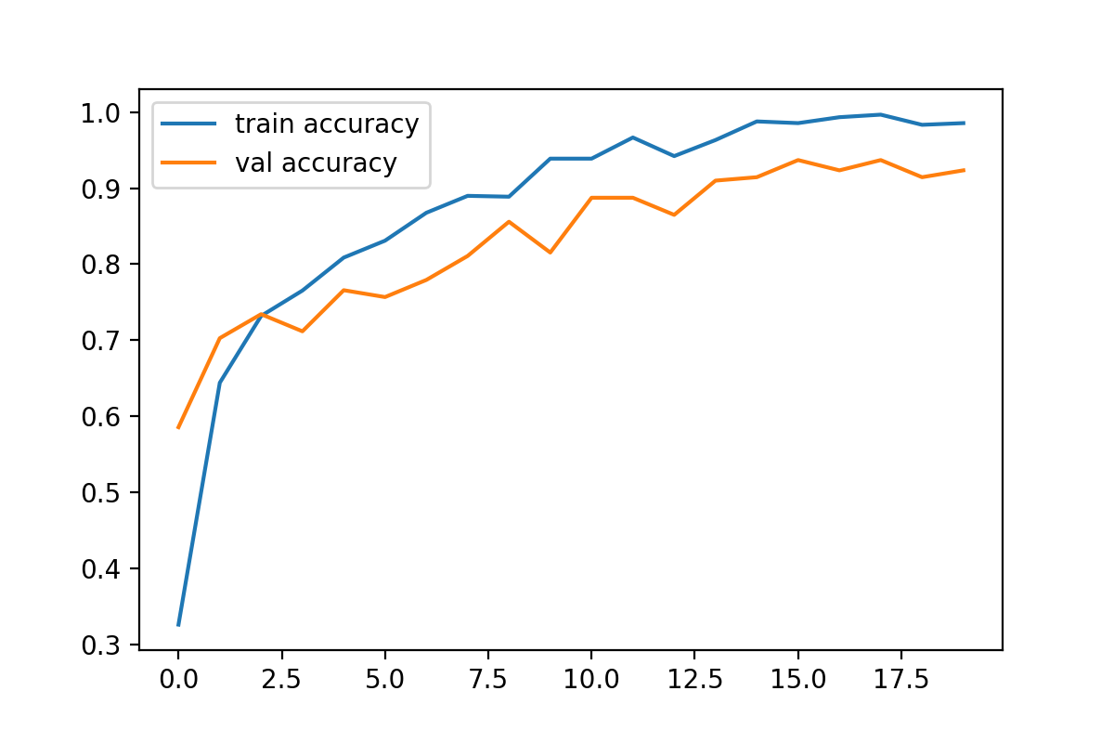

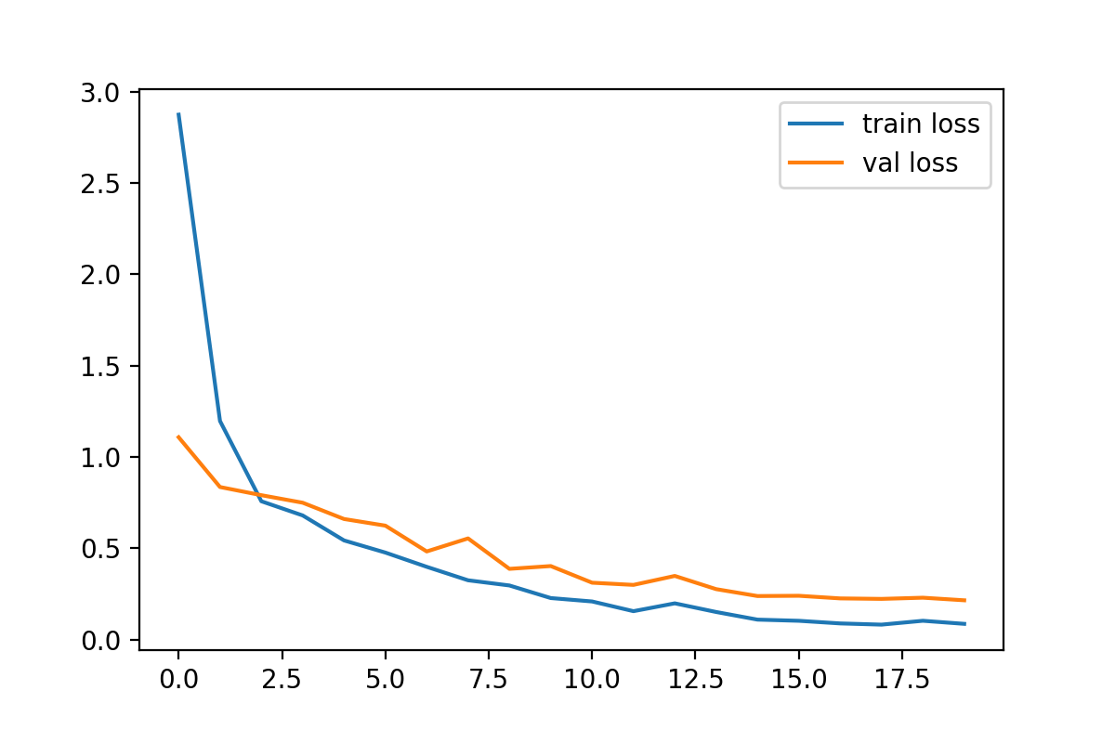

[[ 94 45 2 4 4 0]

[ 23 124 3 0 0 0]

[ 11 12 122 0 5 0]

[ 3 43 0 102 2 0]

[ 24 62 0 0 64 0]

[ 0 79 0 0 0 71]]

Accuracy: 0.641824

Error rate: 0.358176

classification_report

precision recall f1-score support

0 0.61 0.63 0.62 149

1 0.34 0.83 0.48 150

2 0.96 0.81 0.88 150

3 0.96 0.68 0.80 150

4 0.85 0.43 0.57 150

5 1.00 0.47 0.64 150

accuracy 0.64 899

macro avg 0.79 0.64 0.66 899

weighted avg 0.79 0.64 0.66 899

Cohens kappa: 0.570192