# **Appendice A – UML Activity Diagrams.**

Edit class details UML Activity Diagram.

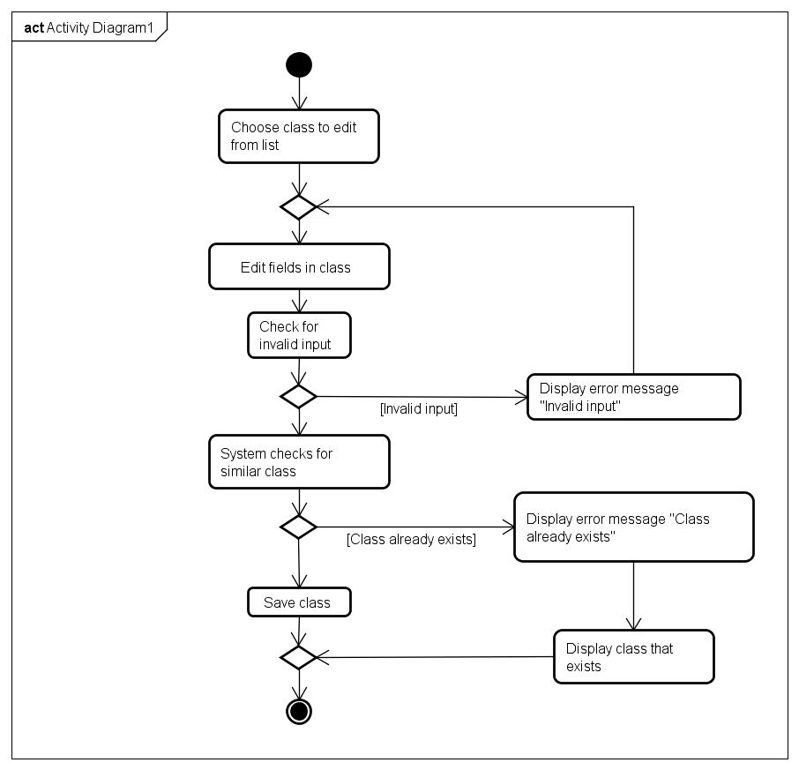

Edit instructors details activity diagram.

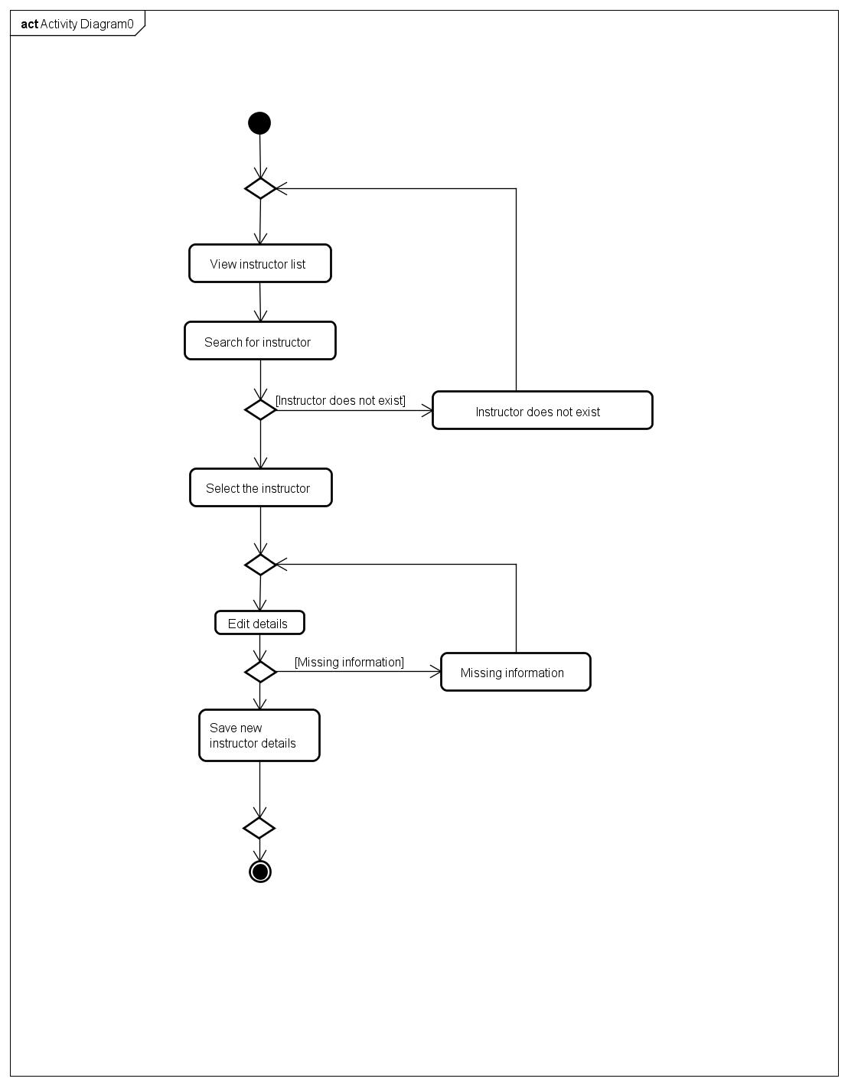

Registrer new class activity diagram.

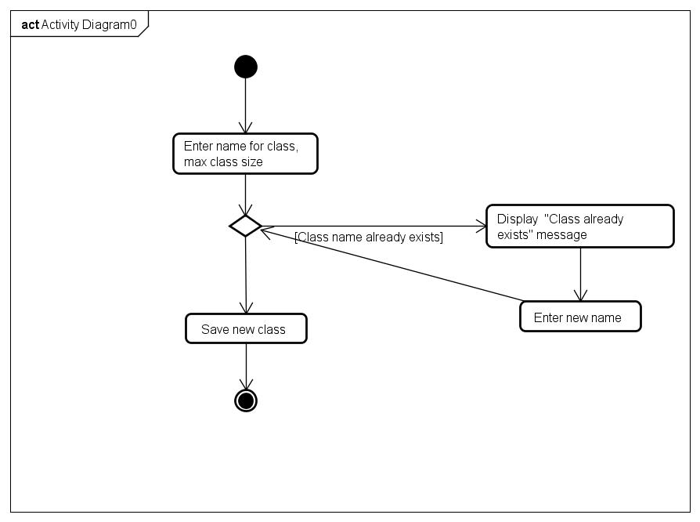

Registrer a new customer activty diagram.

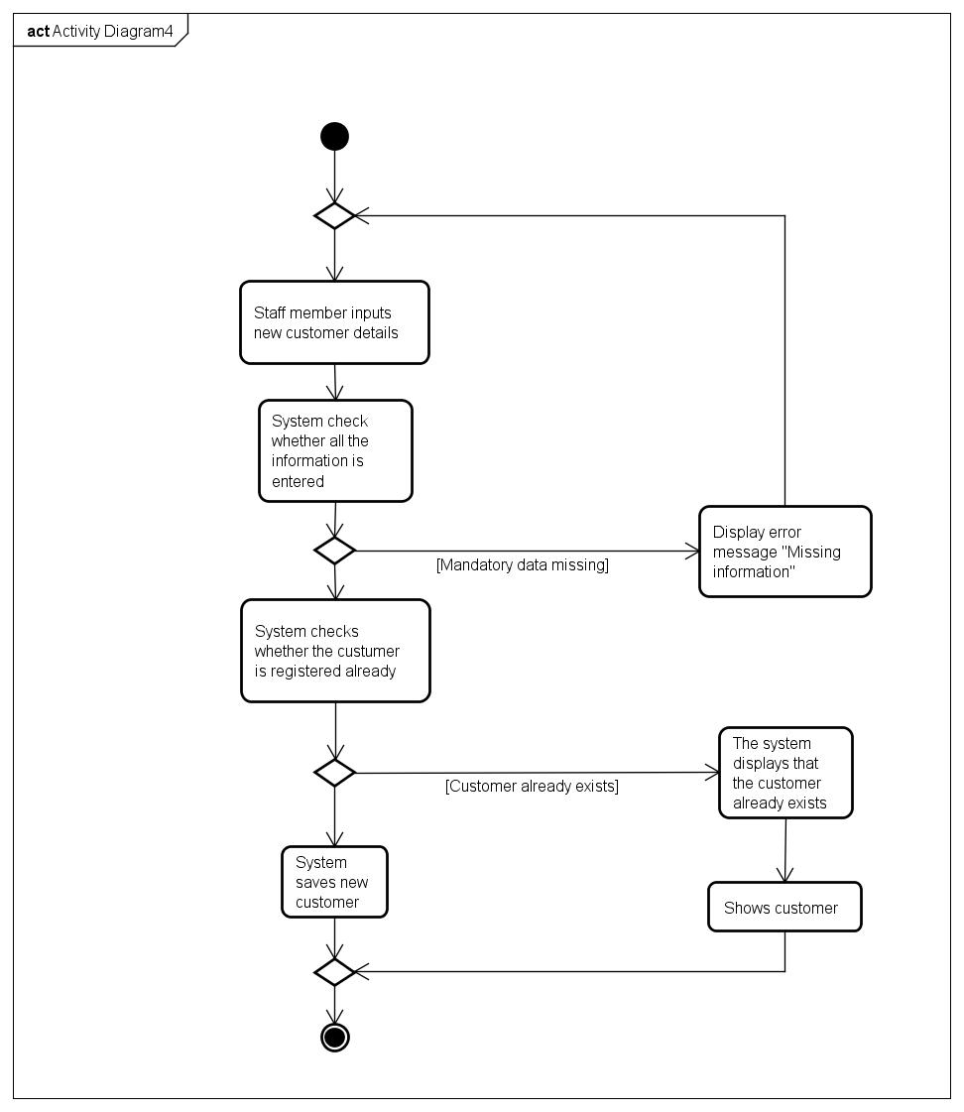

Registrer a new instructor activity diagram.

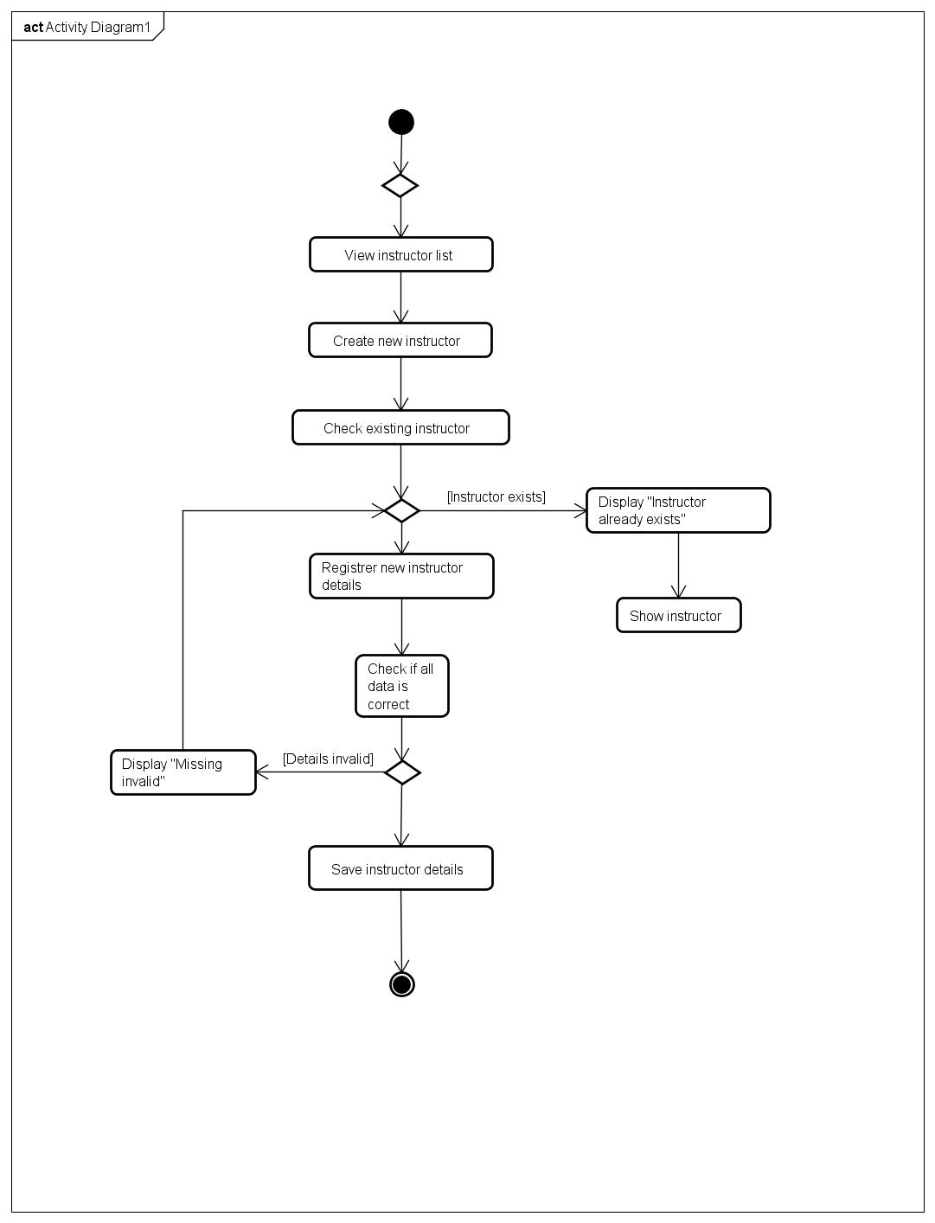

Schedule a class activity diagram.

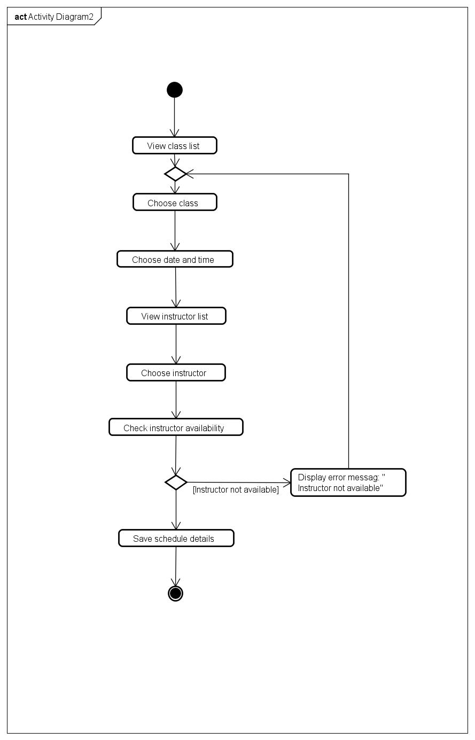

Search member activity diagram.

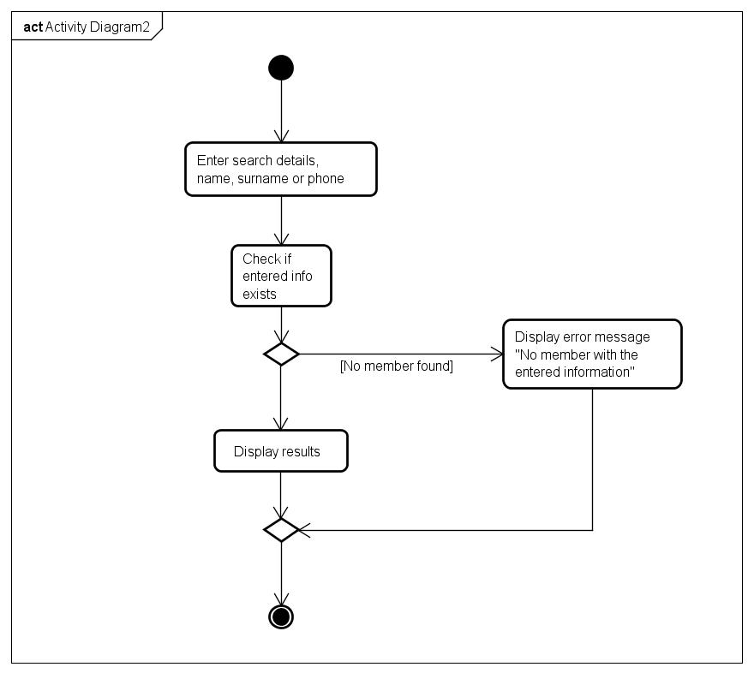

Subscribe member to class activity diagram.

