# **Appendice A – UML Sequence Diagram**

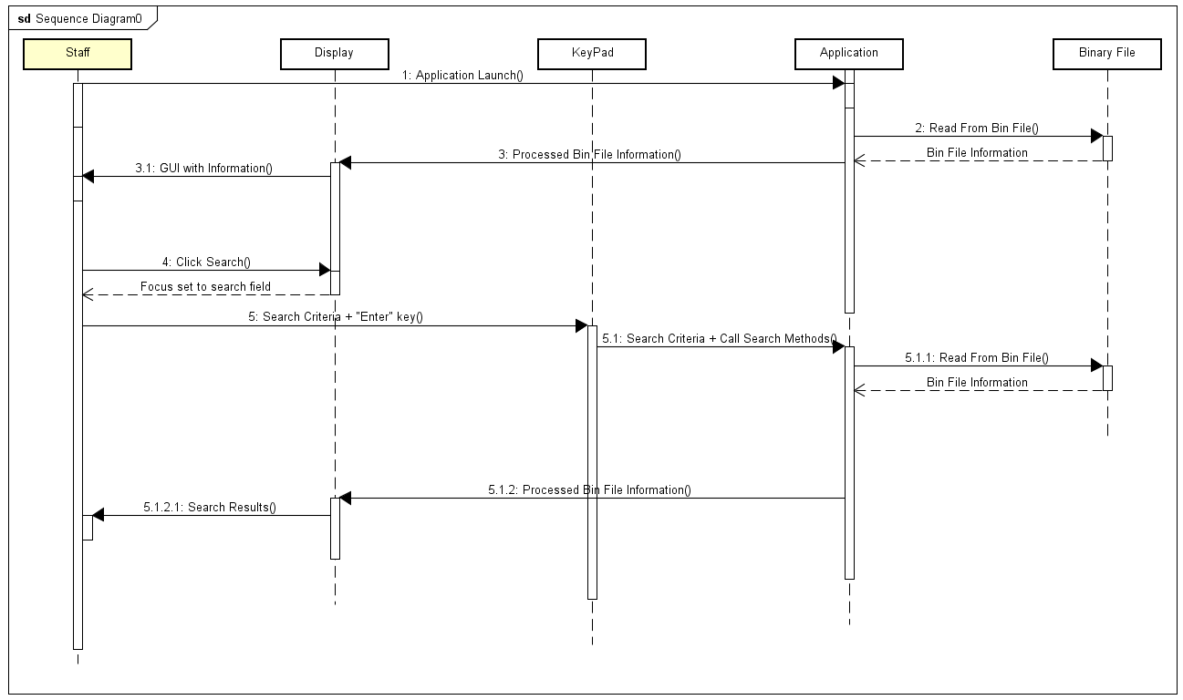Searching for information