# GROUP CONTRACT

As a part of this group, I agree to fulfill the tasks I was assigned.

# Participation:

All meetings are planned to fit the schedule of every group member. Therefore, all meetings are mandatory to attend. Only urgent or very serious conditions is considered as a valid reason for the absence. **Thursday** is a mandatory project day and will as a default be the day for group meetings.

Doing all homework and asking questions if homework can not be done is mandatory for keeping track of team progress. Attending 80% of the classes in mandatory, unless the person is fluent on the subject.

# Communication:

If I cannot complete the task, I will contact the Co-Ordinator within the group. Furthermore, I take the responsibility to meet all deadlines, if I don’t reach 50% of the task within 50% of the time frame, I will contact the Co-Ordinator. Communication takes place in group chats on various platforms such as Skype, Messenger, Discord, Trello etc. Tasks are to be updated on Trello whenever progress is made. Work in progress is not to be interrupted by other group members before they are marked as “Done”, hereafter the finished task can be discussed on the following group meeting. Java, HTML etc. Will be shared via GitHub.

# Meetings:

All meetings are planned to fit the schedule of every group member. Therefore all meetings are mandatory to attend. Meetings start with each member presenting the task they are working on and asking for feedback.

# Conduct:

Criticism is only accepted by a constructive explanation and a proper solution. Criticism can only be about code that does not compile or does not follow the structure of the UML diagram. The visual appearance of the code does not matter if it's accepted by the teacher. If a group member helps you on your code, they have the right to fully modify the code if they know how to make it work.

**§4. Breach of contract**

4.1 A personal disagreement between members shall be settled at a general meeting by all members, mediated by the third member or an impartial third-party.

4.2 A member can be excluded permanently from the group after 3 warnings and a notice to the team members and lecturers with a 3 days’ notice.

4.3 Each warning must be documented and discussed during the following group meeting.

ETC.

I hereby confirm my acceptance and enforcement of the above stated!

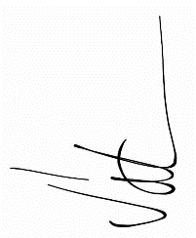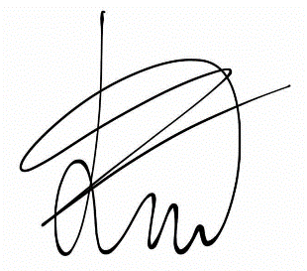

_______________________ _______________________

Mihai Draghiciu, 238971 Eric Volmer, 273448

Student 1st semester, Student 1st semester,

ICT Engineering ICT Engineering

VIA University College, Horsens VIA University College, Horsens

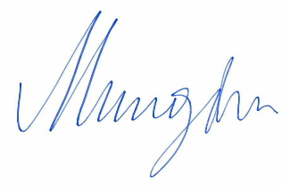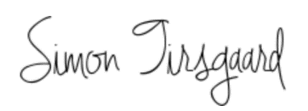

_______________________ _______________________

Andrei Mungiu, 273473 Simon Tirsgaard, 237434

Student 1st semester, Student 1st semester,

ICT Engineering ICT Engineering

VIA University College, Horsens VIA University College, Horsens



_______________________

Ronalds Andris Kalnins, 260506

Student 1st semester,

ICT Engineering

VIA University College, Horsens