# Exercise – Convert CD to MVC

This exercise is to convert an already existing application (the program from the previous exercise) to a Model-View-Controller version exactly as shown in the class diagram below

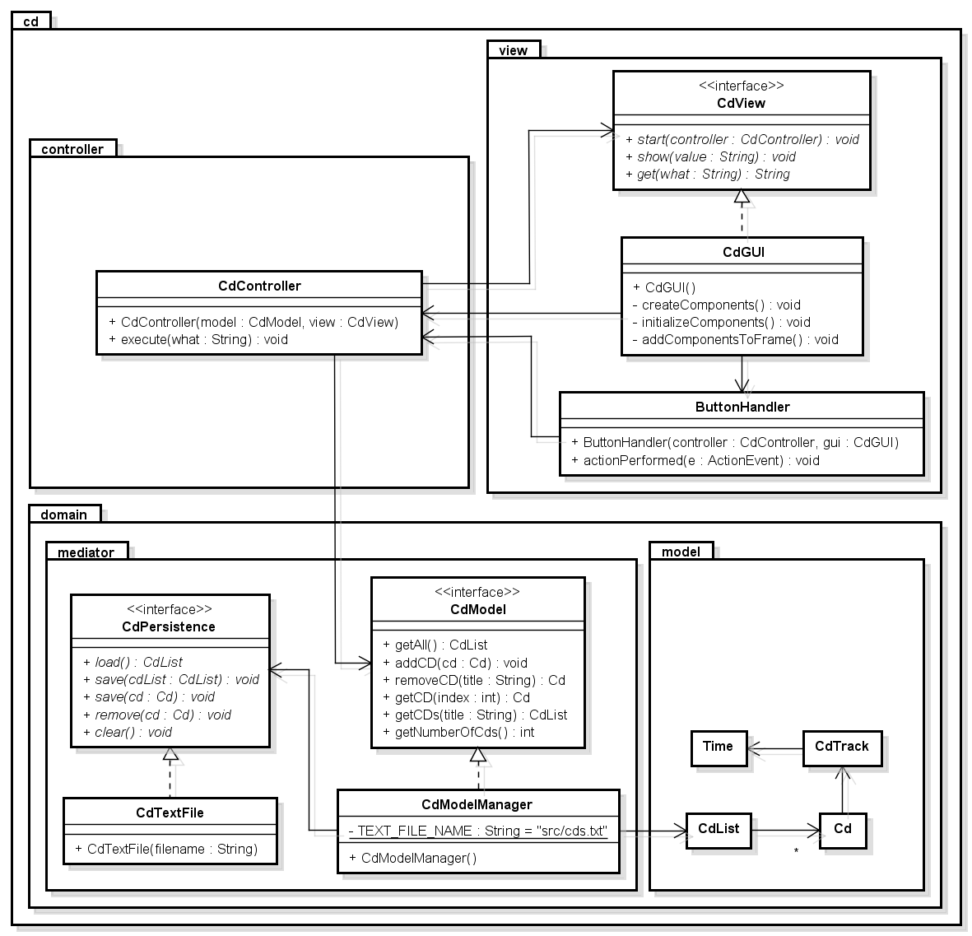

You have to do the following:

* Packages
  + Move CdList, Cd, CdTrack and Time into package cd.domain.model
  + CdPersistence and CDTextFile in class cd.domain.mediator
  + CdView, ButtonHandler and CdGUI in package cd.view
* Create interface CdModel (in cd.domain.meditor package) with the following methods:

public CdList getAll();

public void addCd(Cd cd);

public Cd removeCd(String title);

public Cd getCd(int index);

public CdList getCds(String title);

public int getNumberOfCds();

* Create class CdModelManager (in cd.domain.meditor package) The Model Manager keeps the Model’s state – in this case only a CdList instance variable. The second instance variable is a CdPersistence.
  + The constructor is loading the model/CdList from file (and this part is then deleted from class Main)
  + All methods are simply delegating the work to CdList and could each be implemented with a single statement.
* Class CdController (in package cd.controller) has
  + A constructor taking the model and the view
  + A method with the logic from the ButtonHandler’s method actionPerformed.
* Class CdGUI has no longer a reference to the model (to class CdList) and method start() is changed to include a CdController as argument.
* Class ButtonHandler has now a CdContoller as instance variable and actionPerformed calls method execute(…) in class CdController (and do not include any actions).
* Change Main to the following

import cd.domain.mediator.*;

import cd.view.*;

import cd.controller.*;

public class Main

{

public static void main(String args[])

{

CdModel model = new CdModelManager();

CdView view = new CdGUI();

CdController controller = new CdController(model, view);

view.start(controller);

}

}

# Exercise – CD TUI

The Exercise is to convert an already existing application (the application from CD-Console.zip) to a Model-View-Controller version exactly as shown in the class diagram below

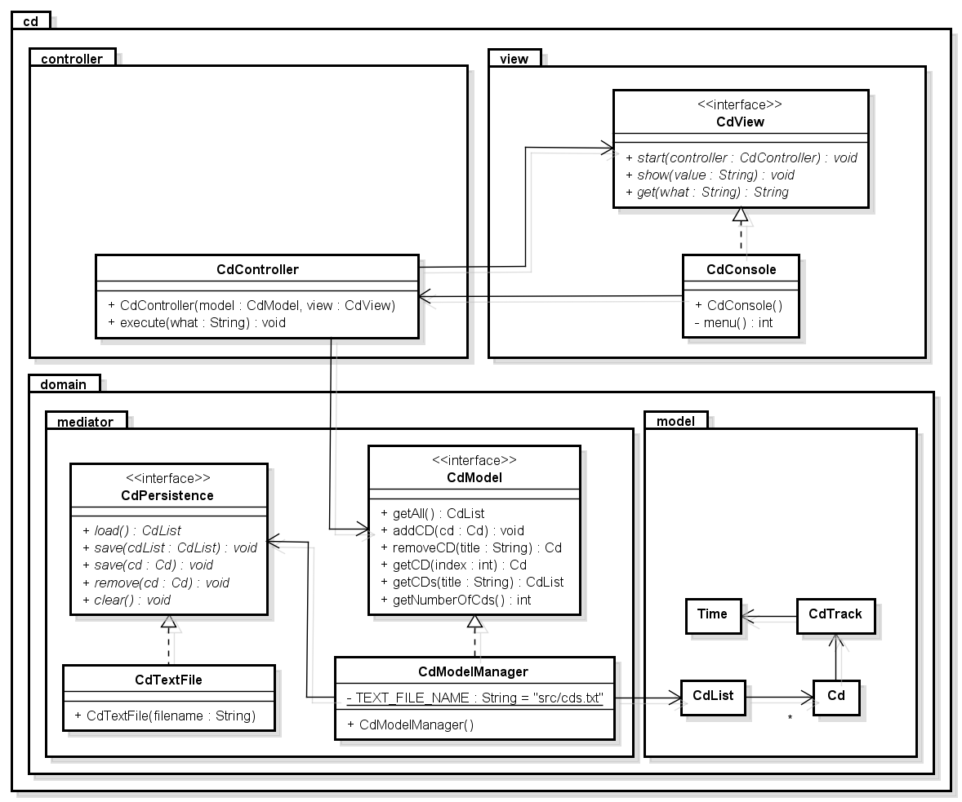

Use the previous exercise as basis because this will give you less work.

A few notes:

* The model is unchanged (Model package with all classes and class CdModelManager). The same goes for interfaces CdModel, CdPersistence, CdView and class CdTextFile.
* Class CdController
  + Method execute(…) takes a String as argument. This is either "List", "Add", "Remove", "Search" or "Quit". Use e.g. a switch to act upon this input. The logic is the same as in the CdConsole method start(…).
* Change Main to the following

**import** cd.controller.CdController;

**import** cd.domain.mediator.CdModel;

**import** cd.domain.mediator.CdModelManager;

**import** cd.view.CdView;

**import** cd.view.CdConsole;

**public** **class** Main

{

**public** **static** **void** main(String args[])

{

**try**

{

CdModel model = **new** CdModelManager();

CdView view = **new** CdConsole();

CdController controller =**new** CdController(model, view);

view.start(controller);

}

**catch** (Exception e)

{

e.printStackTrace();

}

}

}