The MARSE Project

Managing the daily financial operations of a cryptocurrency mine.

**Group Members:**

Mihai Dranghinciu

Eric Volmer

Ron Hill

Simon Tirsgaard

Andrei Mungiu

Project Description Table of Contents

1.1 BACKGROUND DESCRIPTION. **1**

**1.2 DEFINITION OF PURPOSE. 2**

1.3 PROBLEM STATEMENT. 2

1.4 DELIMITATION. **2**

**1.5 CHOICE OF MODELS AND METHODS. 3**

1.6 RISK ASSESSMENT. 4

1.7 SOURCES OF INFORMATION. 5

Project Description.

* 1. Background Description

It is very important that the reader understands, the complexity of running a cryptocurrency mining farm has many hardware implications which inevitably change the way the entire operation runs. However, a solution for more stable activities such as inventory management and financial reports is required to allow focus on the more unstable part of the project, which involves constant market research and fast hardware adjustment according to market prices. It is therefore crucial that inventory and finance management have a very solid base for fast data view and editing.

In 2009 Bitcoin became the first established cryptocurrency. Although there have been other attempts at creating other cryptocurrencies, they mostly copied Bitcoin. The decentralization of such technology that provides data integrity, partial anonymization, and data immutability, relies heavily on difficult mathematical algorithms, randomization, and simply a way of storing data as a chain link known as blockchain technology.

In other words, cryptocurrencies are the children of old technologies combined in a new way.

As a service, the cryptocurrency is based on the idea of having a very wide network of servers from which one is picked ever 10 minutes to execute an encryption task that the network requires. This encryption process combined with a randomly picked server from a big network running the software produces a high level of anonymization. Furthermore, the network later uses other randomly picked servers to check the reliability for each of the previously executed tasks on the network. These are called “confirmations”, the more confirmations a task (know as transaction) has, the higher its reliability. Theoretically, you can never be 100% sure, practically it is almost impossible to not be sure after 6 confirmations, which accumulate as time passes.

From a hardware perspective, due to the increased collective work required to support the cryptocurrency network, a mining farm requires expensive hardware to make a profit, the profits being the system's algorithm that rewards hardware connected to the network with Bitcoin to their address. To afford such a server and coordinate the actions of contributors connected the the cryptonetwork, the current daily task of a cryptocurrency mine is keeping track of each members contribution. This is done using hardware purchase history, with details about who purchased, at what price, from where, when, its delivery status and its current LIVE activity. The group eventually uses those details to correctly split among its members the costs, the profits, and the associated risks such as warranty claims and hardware depreciation.

On the financial side, a cryptocurrency mining operation must also be good at keeping track of its financial performance and monitor its worth in real life currency and cryptocurrency in parallel. Consequently recording exchange rates at the time of profit and cost allocation per member, correctly reflecting the hardware depreciation and transferred cryptocurrency to each member as well as their contribution to the group costs is a very important task which must be executed flawlessly.

Fast forward to 2018, we have a mining farm as our customer, they are formed from 17 people that coordinate their action to mine the cryptocurrency. The project group has the name: JMP – Javelin Mining Project.

While the number of people has been relatively small the above-mentioned requirements where easily met. Now, the number of members is starting to grow and this makes the management become cumbersome, time-consuming and open to errors. The customer is the one that takes care of recording the information about the mined cryptocurrency value and keeps track of the inventory in terms of GPUs, motherboards, locations, date of purchase, etc. and using excel is starting to become more of a bother than it’s worth.

Furthermore, due to the number of increasing members and not being in the same country, these group members would like to have a secure chat system for meeting discussions while viewing the relevant data at the same time.

Therefore, the customer has decided to invest in a software to reorganize all their information into an online database which can make their daily duties easier to manage.

Upon our client’s wish, the system requires an online chat that can work at the same time as the data review itself so that better communication can be achieved.

1.2 Definition of Purpose.

The purpose is to optimize the inventory management and have a way to improve the communication between the members in order to make project management easier.

1.3 Problem Statement.

* Communication is currently very difficult when the discussed data is not being displayed to group members that participate in the monthly group meetings. Data visualization is a current major drawback.
* Access and security (user separate access required, data editing access for administrators only)
* Users should have the possibility to access the available financial and inventory information from the project.
* Data visualization should be intuitive and easy to refer to in words.

1.4 Delimitation.

* Use other tools to record LIVE hardware (server) performance and keep this information separate.
* It is not possible to display relevant market updates as that is a subjective matter.
* Do not display graphical representations of data in an attempt to make the data more readable.
* There is not enough time to work on automatic data inputs from external sources.

1.5 Choice of models and methods.

|  |  |  |
| --- | --- | --- |
| What  Partial problem | Why  Study the problem | Which  Methods/Models/Theories |
| Communicating and investigating the data at the same time | Not all group members have the same application to communicate. Understanding the excel format, and editing data in excel is inconvenient.  Excel does not allow for live user communication. | Categorize the viewed data into customer predefined data categories. |
| How secure should each user account be | A negative third party should not be able to irreversibly destroy or edit the data. | Allow only one administrator data editing access at a time and enforce very long administrator password with no option for it to be remembered. Give all group members except the group administrator data view access only. |
| How to ensure the regular user know he is looking at the raw unfiltered data when required. | To increase trust among group members. | Ensure the raw data is stored according the group requirements by looking at their data storage examples. |

1.6 Project Timeline

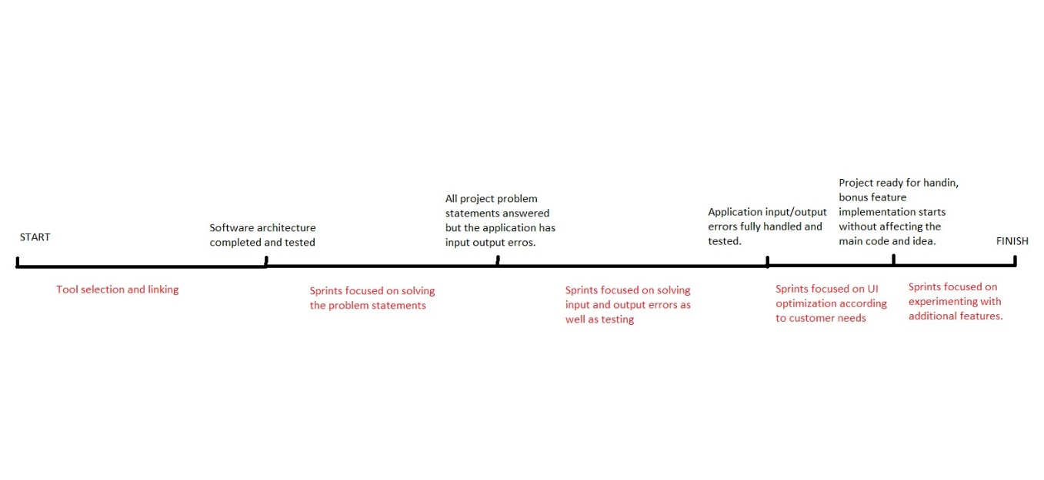

1.6 Risk Assessment.

|  |  |  |  |  |  |  |
| --- | --- | --- | --- | --- | --- | --- |
| Risks | Description | Likelihood Scale  1-5 | Severity Scale  1-5 | Risk Mitigation Preemptive and responsive actions | Identifiers | Responsible |
| Lack of  knowledge | One or more members don’t have the knowledge required to fulfill the requests. | 1 | 5 | Monitor each group member homework completion. | Member does not understand what the teacher is speaking about during classes. | Andrei |
| Setting unreachable goals | The group will try to implement features that require more knowledge than what the course offers. | 3 | 1 | Keep track of the predefined group tasks while they are fulfilled in order to maintain the set goal. | The teacher explains that you will not study the required materials to implement that feature. | Simon and Andrei |
| Group members not attending | One or more group members attendance negatively affects the performance of the project development. | 2 | 3 | Actively engage with and question the non-attending group member. | Group tasks take longer than expected to complete, not all group members understand what the next step of the project development is. | Andrei |
| Database architecture is irrelevant | The created database structure does not represent data groups correctly and is hard to or can not be used with Java. | 3 | 2 | Ensure that at least one group member fully attends every Database lesson. | The database structure is not finalized before the deadline and consistently fails to meet requirements of each sprint. | Simon and Andrei |

1.7 Sources of Information.

***Structure:***

***Last name, First initial. and Last name, First initial. (Year published). Title. City: Publisher, Page(s). – to be removed at project handing***

***Last name, First initial. (Year published). Article Title. Journal, [online] Volume(Issue), pages. Available at: URL [Accessed Day Mo. Year]. – to be removed at project handing***

[Marr](https://www.forbes.com/sites/bernardmarr/) B. (2017), A Short History Of Bitcoin And Crypto Currency Everyone Should Read

Available at: <https://www.forbes.com/sites/bernardmarr/2017/12/06/a-short-history-of-bitcoin-and-crypto-currency-everyone-should-read/#3bab870a3f27> [15 Sep 2018]