A mineralogical mystery
Name(s): _________________________________________________
The curriculum lists the following minerals: quartz, calcite, magnetite, mica, pyrite, galena, gypsum, talc, feldspar, and hematite (10).

Materials: minerals to observe, and a mineral identification from the Mineralogical Association of Canada kit containing:
- An unpolished porcelain tile
- a magnifying glass
- a magnet
- a hardness kit (copper, glass plate, stainless steel nail and drill bit)
Process:
- Work in groups. Observe the minerals and complete the observation table.
- To describe the brightness, use the words:
  - Metallic: looks like a metal
  - Vitreous: reflects light like glass
  - Matte: does not reflect light
- To observe a streak, rub the mineral on the porcelain plate. Note the colour of the steak. Wipe the porcelain plate clean to remove the mark.
- To determine the hardness, scratch the mineral against various objects from your hardness kit. See screenshot from Mineralogical Association of Canada’s kit:
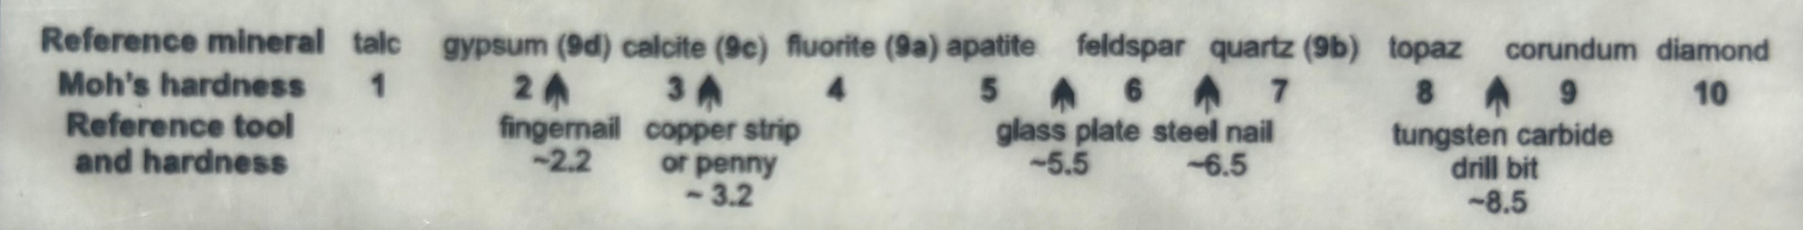
- Compare your observations with the table on page 323 of your book to identify the minerals. If you are not certain, write down all the possibilities.

Questions :
- Which mineral observed by your group is the least hard?

- Which mineral observed by your group is the hardest?

- Consider the streak and colour of the minerals. Which minerals had a streak of a different colour than the mineral itself, and which had a streak of the same colour?
Mineral Number | Color | Trace | Same or different?
- Which property was most useful for identifying minerals? Explain your answer.

- Which property or properties were less useful for identifying minerals? Explain why.

Observation Table:
Mineral Number | Colour | Lustre | Streak | Hardness | Other properties | Mineral Name
1

2
3
4
5
6

Mineral Number | Colour | Lustre | Streak | Hardness | Other properties | Mineral Name
7

8

9

10

