Science 7
Unit 4: Earth’s Crust

STSE: Seeing the big picture

Table of Contents:

- The article was revamped to include more connections to Canadian scientists and to use simpler language.
  - Original STSE from 2012.
  - Student Version of Article with all activities at the end.

- Comprehension questions in short answer format.
  - Teacher version with an answer key.

- Comprehension Questions in multiple-choice format.
  - Teacher Answer key with explanation in Google Docs.
  - Google Form with the same questions for easy correcting.
    - To make your own copy of this form, click on Google Form and “Make a Copy” from this folder.

- Edpuzzle with multiple choice and short answers that explain Alfred Wegener’s Continental Drift.

- Research Project in a variety of formats based on the unique geological history of Newfoundland and the development of Plate Tectonic Theory.

- Extension Activity #1- Convection Current Demo - showing how convection currents work using water, rice, and a hotplate, from the 2012 STSE.

- Extension Activity #2 - The Nature of Science with Alfred Wegener’s Continental Drift - preventing personal biases, how new evidence of theories is presented, the need to think outside the box, and how science is a cumulative process.

Please note: anything in burgundy is for Teacher use only, including instructions and answer keys.

The Great Earth Puzzle: Seeing the Big Picture

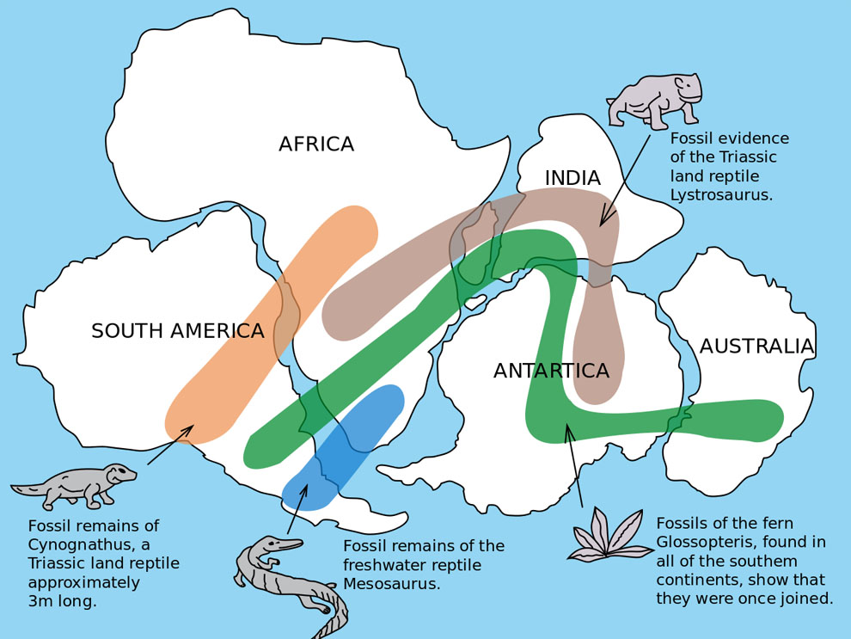
For most of human history, people had a limited view of our planet. Less than 600 years ago, many still worried the Earth might be flat. As explorers sailed across the Atlantic, new maps forced people to rethink their old ideas.

A Big Idea

Over 100 years ago, Alfred Wegener noticed that the coastlines of South America and Africa looked like they could fit together like puzzle pieces. He found amazing evidence: fossils of the same plants and animals on opposite sides of the ocean (see figure to the right for examples of matching fossils on different continents), and minerals that form only in tropical places found in icy polar regions. In 1912, he proposed the idea of Continental Drift, the idea that landmasses have shifted over time.

The Human Side of Science

The story of plate tectonics shows the "human side" of science. Scientists are regular people who can have egos, be competitive, and find it difficult to change their minds. Many ignored Wegener's evidence simply because it was new and challenging. To keep things fair, science follows strict rules: scientists must keep clear records so others can repeat their experiments. Wegener kept excellent records and notes, which kept his ideas alive and encouraged more scientists to search for evidence, including whether they could find additional evidence to support his theory of Continental Drift further.

Solving the Mystery: A Team of Global Scientists

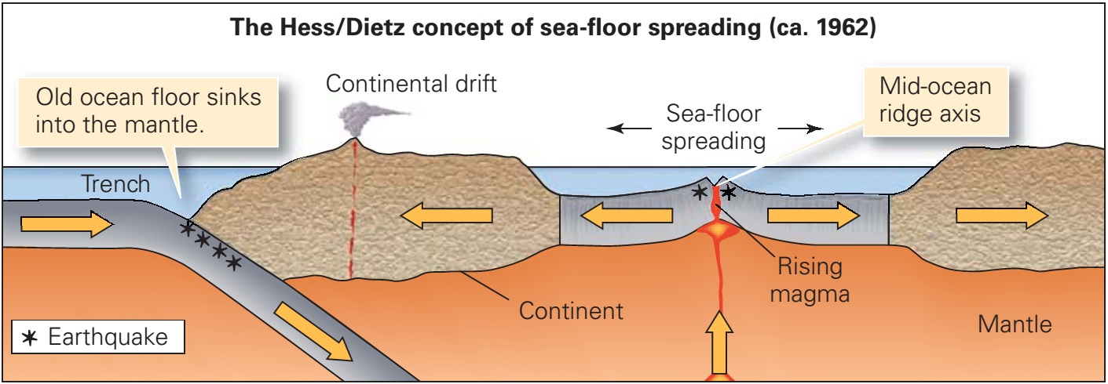
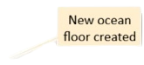
Wegener couldn't explain how continents moved in 1912. In 1960, Harry Hess used sonar to map the ocean floor and discovered underwater mountain chains. Sonar uses sound waves and calculates how far away something is based on when its signal returns to the machine. He found that the rocks were youngest at these ridges and got older as they moved further away.

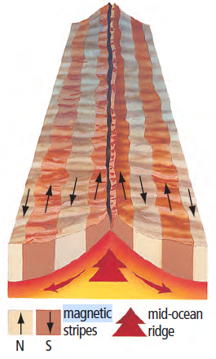
Magnetometers were used to locate submarines during World War II. When ships carrying magnetometers crossed the Atlantic Ocean, the magnetometers usually pointed north, but sometimes they pointed south unexpectedly. The scientists noticed a pattern resembling stripes of magnetic reversals traveling along paths parallel to the Mid-Atlantic Ridge on both sides of the ridge. A Canadian geophysicist, Lawrence Morley, was one of the first to have the “eureka” moment that put all the pieces of evidence together when he found "magnetic reversals" frozen in the rock. The first geophysics professor at Memorial University, Ernst Deutsch published data connecting magnetic reversals and continental drift in 1963. The mystery of magnetic reversals is solved by looking at how igneous rock solidifies. When magma cools at mid-ocean ridges, minerals like magnetite act as tiny compass needles, locking into place to match the Earth's current magnetic orientation. Because we see alternating 'stripes' of magnetic polarity that mirror each other on both sides of a ridge, this provides undeniable evidence of seafloor spreading. Essentially, the ocean floor acts as a geological timeline, recording millions of years of the Earth’s shifting magnetic history as new crust is created and pushed outward.
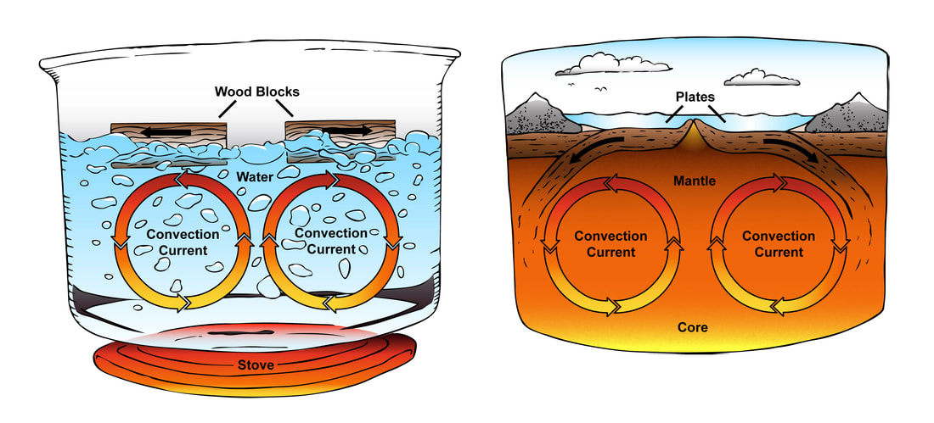
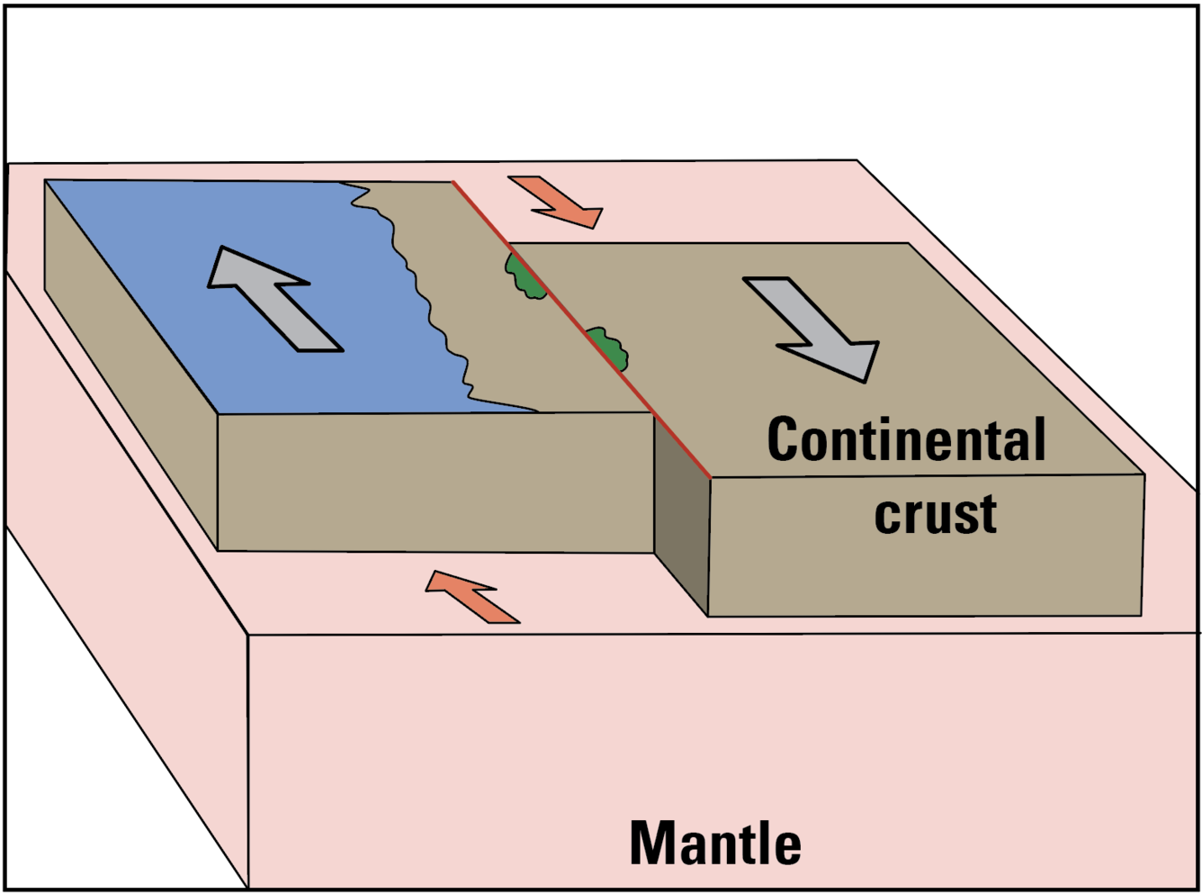
In other words, magnetic reversals show that the continents don't just sail through the ocean; they move because the entire ocean floor is moving. Scientists have found that these giant plates move because of convection currents. Like a pot of boiling soup, heat from the Earth’s core causes the mantle to move in a cycle, pushing the plates along like a conveyor belt.
Transform Boundary
Mantle

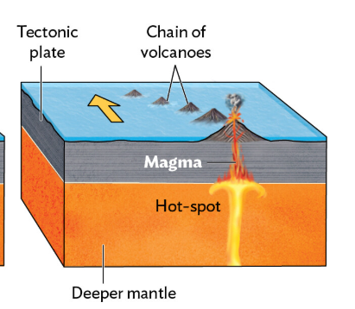
A famous Canadian scientist, J. Tuzo Wilson, made three major discoveries that helped complete the theory of Plate Tectonics during the 1960s. He was the first to propose that the Earth’s outer shell is actually broken into giant, rigid pieces called "plates". Beyond identifying these pieces, he discovered transform boundaries, which are special areas where plates grind and slide past one another. He also explained the existence of "hotspots" — stationary plumes of hot magma that act like torches under the Earth, creating island chains like Hawaii as the plates slowly move over them.

Newfoundland: A Global Collision

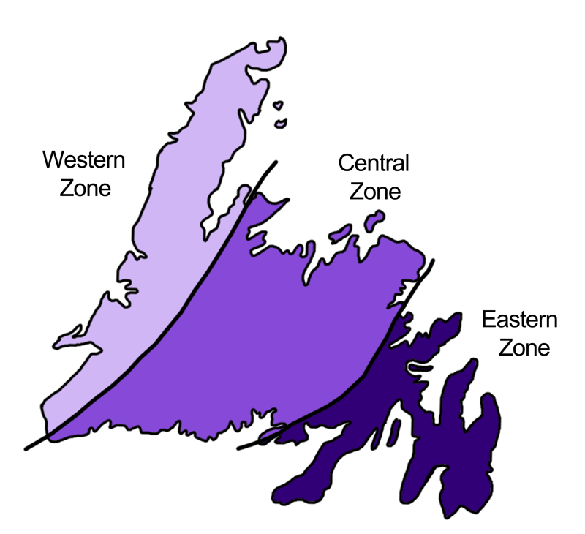
While Wilson was mapping the theory of plate tectonics, Harold “Hank” Williams, a Newfoundlander, was focused on mapping geology. He used what he learned in Tuzo Wilson’s lab to create a famous map showing that Newfoundland is made of three different geological zones.

Our province is a perfect example of these moving plates, as seen in the Appalachian Mountains in Newfoundland, where the history of their movement is recorded in Newfoundland's geology. Long before the Atlantic Ocean existed, there was an older ocean called Iapetus. About 500 million years ago, the plates squeezed together, causing a massive crash. The Western Zone of Newfoundland was the edge of ancient North America, while the Eastern Zone (the Avalon Peninsula) was actually part of Africa.

How Science Builds the Future

By working together and sharing results, scientists like Wegener, Hess, Wilson, and Williams continue to solve the mysteries of our planet. Today, we know that our continents are still moving at a speed of about 3 centimeters a year—about as fast as your fingernails grow. This slow but powerful movement is what causes the earthquakes and volcanoes that continue to shape our world.

Sources Cited:

- University of California Museum of Paleontology. "Alfred Wegener (1880-1930)," Online Historical Resource.
- National Geographic. "Continental Drift Diagram," Educational Diagram.
- Learning Geology. "Seafloor Spreading Theory Diagram," Educational Diagram.
- Geological Survey of Canada. "Seafloor Spreading Theory (1963)," Historical Record of the Morley-Vine-Matthews Hypothesis.
- SEPM Society of Sedimentary Geology. “Polar Wandering and Continental Drift.” Ernst Deutsch, Memorial University, 1963.
- Ludman, A. & Marshak, S. "Hotspot Volcanism Diagram," Laboratory Manual for Introductory Geology (5th ed.), W. W. Norton & Company, Figure 2.12.
- US Geological Survey. “Transform Boundary Diagram”
- Memorial University. "A Man for All Seasons: Hank Williams – Innovator," Online Biographical Resource.
- Ryan, A. B. "Geology of the West Coast of Newfoundland (1983)," Newfoundland Journal of Geological Education, 7(2).
- Shreeve, J. "The Greatest Journey (2006)," National Geographic, 209(3), 60-69.
- Heritage Newfoundland and Labrador. "Geological Map of Newfoundland," a resource showing Geological Subdivisions.

Comprehension questions:
Suggested point values and answer key.

1. What are the three pieces of evidence that support Wegener’s theory of continental drift? (3 points)
1 pt. Matching fossils on different continents
1pt. Fit of the continents
1pt. Minerals that only form in specific climates

2. What was the missing piece of the puzzle that Wegener needed to support his theory? (1 point)
1pt. Alfred Wegener could not explain HOW the plates moved.
3. Does a discovery always change the way we “see the big picture,” considering the human aspect of science? Why or why not? (2 points)
1pt. No
1pt. Scientists are human and can struggle with changing their way of thinking about the world
4. There were three Canadian Scientists discussed in this article. List the geoscientists and include their contribution to the Plate Tectonic Theory. (3 points)
1pt. Tuzo Wilson - discovered (1 of the 3) transform plate boundaries, hot spot volcanism, or the idea of “plates.”
1pt. Lawrence Morley - used magnetometers to discover magnetic reversals and the theory of sea floor spreading
1 pt Hank Williams - mapped the island of Newfoundland and discovered that Newfoundland had 3 distinct geological zones from its plate tectonic history
3. Newfoundland is approximately 4000 km away from Africa. If the Earth’s crust is moving at a rate of 3 cm per year, how long ago would we have been joined together? Do you think that this is possible? Explain your answer. (2 points)
0.5 pt. Conversion: 3cm = 0.000 03 km
0.5pt. Calculation: 4000km / 0.00003km = 133,333,333 years or 133 million years
0.5 pt. Yes
0.5 pt. From the text: “The plates squeezed together 500 million years ago.”

4. What is a “convection current”? How do convection currents cause crustal plates to move? (2 points)
1pt. Convection currents are circular movements of material. When material is heated, it becomes less dense and rises; as it cools, it becomes denser and sinks, creating a continuous, rotating cycle.
1pt. From the text: “Like a pot of boiling soup, heat from the Earth’s core causes the mantle to move in a cycle, pushing the plates along like a conveyor belt.”
5. Based on the story of Alfred Wegener, how can a scientist’s ego or their old beliefs stop a new scientific theory from being accepted? (1 point)
1pt. From the text, “Scientists are regular people who can have egos, be competitive, and find it difficult to change their minds. Many ignored Wegener's evidence simply because it was new and challenging.”
6. What are two 'rules' or habits scientists use today to make sure their personal feelings don't stop new evidence from being heard? (1 point)
0.5 pt. Per reason (1 pt. total). From the text: “To keep things fair, science follows strict rules: scientists must keep clear records so others can repeat their experiments.”
Comprehension Multiple Choice Questions:
1. Alfred Wegener first noticed that South America and Africa looked like they could fit together like puzzle pieces by looking at:
A) Satellite photos
B) Map coastlines
C) Deep-sea sonar records
D) Volcanic rock patterns

Answer: B. Wegener noticed this while looking at the coastlines on maps.

2. Which analogy is used in the article to explain how convection currents move Earth's plates?
A) A giant jigsaw puzzle
B) A tape recorder playing music
C) A pot of boiling soup
D) A growing fingernail

Answer: C. The article compares the rising and cooling of hot liquid in the mantle to a pot of boiling soup.

3. Why did many scientists in the early 1900s ignore Alfred Wegener’s evidence for Continental Drift?
A) Wegener did not have any fossils to show them.
B) They believed the Earth was flat at that time.
C) Wegener could not explain how the continents actually moved.
D) He lived in a polar region and could not send his books to other countries.

Answer: C. Although he had evidence, he lacked a mechanism to explain how continents moved through solid rock.

4. When Harry Hess mapped the ocean floor, what did he discover about the age of the rocks?
A) The rocks were the same age everywhere.
B) The rocks got younger the further they were from the ridge.
C) The rocks were the oldest at the center of the mountain ridge.
D) The rocks got older as they moved further away from the ridge.

Answer: D. Drilling showed that the crust was younger at the ridge and older as you moved away.

5. Which Canadian scientist is famous for proposing that the Earth's shell is broken into giant, rigid pieces called "plates"?
A) Harry Hess
B) Alfred Wegener
C) J. Tuzo Wilson
D) Harold "Hank" Williams

Answer: C. J. Tuzo Wilson was the first to propose the idea of rigid "plates".

6. How did J. Tuzo Wilson explain that some volcanoes, like those in Hawaii, form in the middle of plates?
A) Continental drift
B) Hotspots
C) Transform faults
D) Iapetus Ocean currents

Answer: B. Wilson discovered that stationary plumes of magma called "hotspots" create these volcanoes.

7. According to the "Human Side of Science," why is it sometimes hard for new scientific theories to be accepted?
A) Scientists are not allowed to use their imagination.
B) Scientists can have egos or find it hard to change their minds.
C) Science has no strict rules for keeping records.
D) New evidence is always thrown away completely.

Answer: B. The article explains that because scientists are human, they can be competitive or stuck in their old beliefs.

8. Newfoundland’s Avalon Peninsula (the Eastern Zone) was once physically attached to which continent?
A) North America
B) Antarctica
C) Africa
D) Europe

Answer: C. Scientific evidence shows the Eastern Zone was once attached to Africa before the plates collided.

9. What does it mean when the article describes science as a "cumulative process"?
A) Science always stays the same and never changes.
B) New ideas are accepted only if the scientist is famous.
C) Scientists throw away old ideas every time they find something new.
D) Science builds over time by updating or modifying old theories with new information.

Answer: D. Science is described as building upon previous knowledge through modification.

10. Canadian geophysicist Lawrence Morley used tools called magnetometers to find "magnetic reversals" frozen in the rock of the ocean floor. This evidence acted like a "giant tape recorder" to help prove which concept?
A) The Earth is a solid, unmoving sphere.
B) The seafloor is spreading apart.
C) Continents move by floating on top of the ocean water.
D) All mountains were once underwater.

Answer: B. These "frozen records" of magnetic reversals act as evidence that new crust is being created at the ridge and pushed outward as the ocean floor grows

Digital Extension:

Edpuzzle created for: Continental Drift - 100 Greatest Discoveries - Science Channel
Research Project: This project explores the unique geological history of Newfoundland and the development of Plate Tectonic Theory. Students may choose one of the following research tracks and one presentation format to showcase their findings.

Project Title: Newfoundland – The Global Puzzle Piece

Part 1: Choose Your Research Track
Track A: The African Connection
- Focus Question: Can you find fossils that link the Avalon Peninsula to Northern Africa?
- Key Concepts: Investigate the Eastern Zone of Newfoundland. Explain how fossil and mineral evidence prove that the Avalon Peninsula was once physically attached to the western edge of Africa. Identify the types of fossils found on both sides of the Atlantic that could not have traveled across an ocean.
Track B: The Western Anchor
- Focus Question: What geological feature links western Newfoundland to the rest of the old North American continent?
- Key Concepts: Research the Western Zone of Newfoundland. Explain how this area represents the eastern edge of the ancient North American continent. Focus on the Appalachian Mountains and how they were uplifted when tectonic plates collided 500 million years ago.
Track C: The Volcanic Core
- Focus Question: What rock types would you expect to make up most of central Newfoundland?
- Key Concepts: Explore the Central Zone, which contains the remains of the ancient Iapetus Ocean. Based on the sources, describe why you would find volcanic rocks (like basalt) and marine fossils in this region. Explain the role of volcanic islands in forming this part of the province.
Track D: The Tech Revolution
- Focus Question: What are the various technologies scientists used to discover the Plate Tectonic Theory?
- Key Concepts: Research the "missing pieces" that proved Wegener's theory. Focus on sonar used by Harry Hess to map the ocean floor, and magnetometers used by Lawrence Morley to discover "magnetic reversals" frozen in the rock. Mention how deep-ocean drilling provided further proof of seafloor spreading.

Part 2: Choose Your Presentation Format

- The "Big Picture" Poster: Create a visual display or brochure representing the evidence for your chosen track. Include maps and illustrations of fossils or technology.

- A Scientific Song or Rap: Write and perform a song that outlines the evidence for your research track, such as the "frozen records" in the rock or the collision of Africa and North America.

- The Evidence Foldable: Create a 3D "foldable" organizer that outlines the different pieces of evidence supporting your research (e.g., fit of continents, fossil correlation, or technological tools).

- A Geological Reporter Presentation: Act as a reporter from the geological past. Create a video or live news report forecasting the collision of the plates that formed Newfoundland.

Project Tips for Students:
- The "Human Side": In your project, mention how scientists like Alfred Wegener were initially ignored because they lacked a mechanism for movement, showing that science is a human process involving both intellect and imagination, as well as sometimes resistance to accepting new ideas.

- Canadian Contributions: If you choose Track D, be sure to highlight the work of Canadian scientists like J. Tuzo Wilson, Lawrence Morley,, Ernst Deutsch, and Hank Williams.

- The Power of Convection: Regardless of your track, remember that the "engine" moving these plates is convection currents in the Earth's mantle.

Extension Activities:

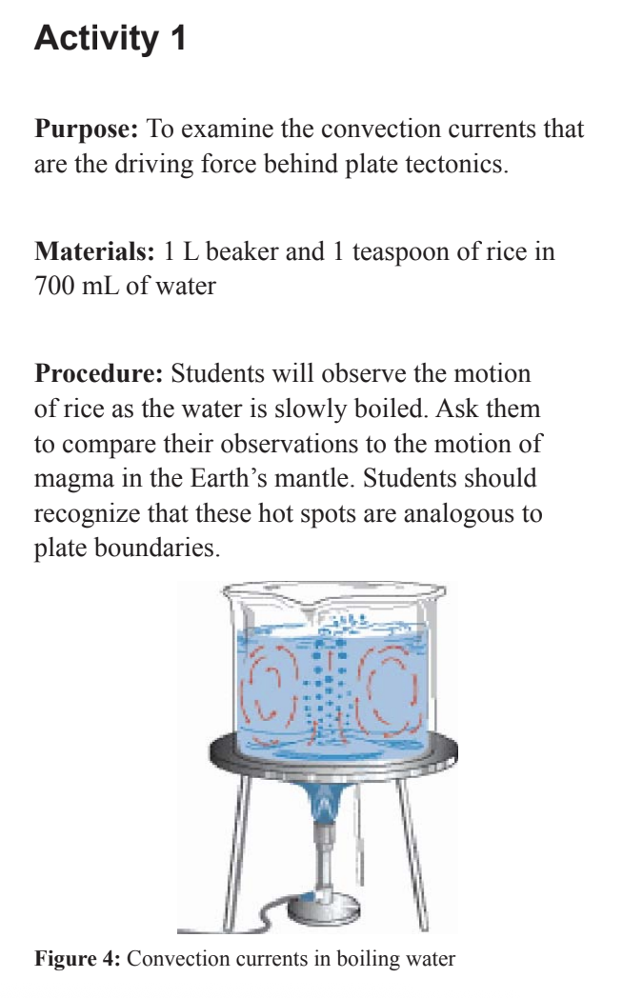
Activity 1:
To examine the convection currents that are the driving force behind plate tectonics.

Materials:
1 L beaker
1 teaspoon of rice in 700 mL of water

Procedure:
Students will observe the motion of rice as the water is slowly brought to a boil. Ask them to compare their observations to the motion of magma in the Earth’s mantle. Students should recognize that these hot spots are analogous to plate boundaries.

Activity 2:
Have students learn more about “the Nature of Science” from Project 2061: A long-term research initiative focused on improving scientific literacy from the American Association for the Advancement of Science.

Guiding questions:
- Many scientists ignored Alfred Wegener’s ideas for decades. Based on what you know about the 'human side' of science, why might a senior scientist with a long career refuse to accept a young scientist’s new theory, even if the evidence seems 'plainly obvious' today?

- Explain how the transition from the theory of Continental Drift to the theory of Plate Tectonics is an example of science being a 'cumulative process.' Did Harry Hess prove Wegener wrong, or did he provide the 'missing piece' that allowed the theory to be modified and improved?

- Wegener looked at maps, fossils, and minerals to propose his theory. How did he use his imagination to connect a fossil in Africa to a fossil in South America? Why is imagination just as important as logic in the systematic study of our planet?

- To prevent personal bias or 'cheating' from affecting scientific decisions, what are some major expectations scientists have of each other when sharing new conclusions? How do these rules help ensure that the whole community accepts a discovery like Harry Hess’s sonar mapping?

