WAVES OF DISASTER:
The 1929 Grand Banks Earthquake & Burin Peninsula Tsunami
Grade 7 Science | Unit 4, Ch. 11: Earth's Crust | STSE Activity

Name: ________________________________ Date: _______________ Class: ____________

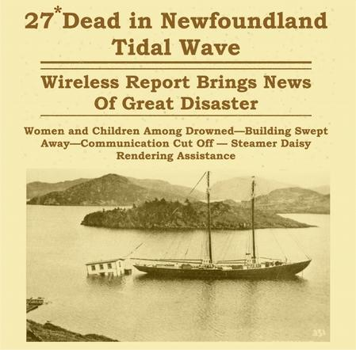
The 1929 Magnitude 7.2 "Grand Banks" earthquake and tsunami (Government of Canada)
https://www.earthquakescanada.nrcan.gc.ca/historic-historique/events/19291118-en.php

Part 1: The Story - November 18, 1929
Background Reading
On November 18, 1929, at 5:02 PM, a massive earthquake with a magnitude of approximately 7.2 struck under the Atlantic Ocean, 250 km south of Newfoundland on the Grand Banks. The shaking was felt as far away as New York City and Montreal.

Most earthquakes occur along plate boundaries, places where plate tectonics meet, grind, or pull apart beneath the Earth’s surface. However, the 1929 Grand Banks earthquake was unusual because it actually occurred within the North American plate itself, along ancient buried fault lines deep beneath the ocean floor.

The earthquake triggered a huge underwater landslide; millions of tonnes of seafloor sediment suddenly collapsed down the continental slope. The sediment broke loose and slid down a steep underwater slope near where the earthquake started. This created what scientists called a turbidity current or turbidite, which is basically an underwater avalanche of mud and sediment moving at incredible speed and force.

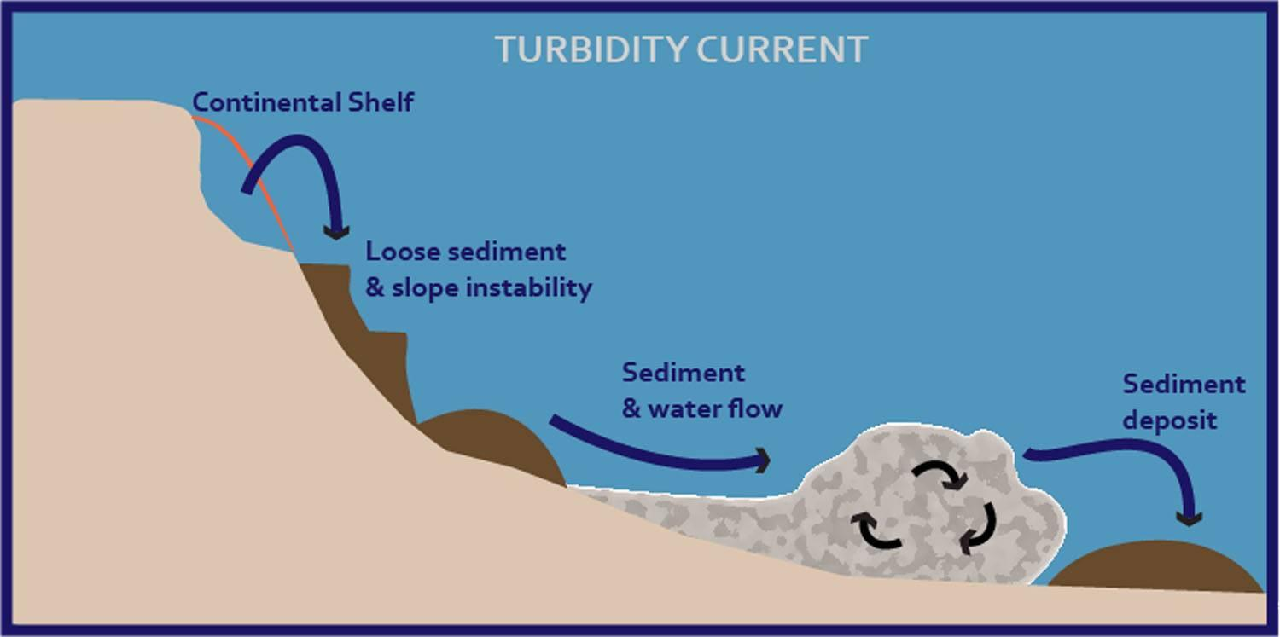
Image courtesy OceaniQ

As the sediment rushed downward, it snapped twelve transatlantic telegraph cables in sequence. These cables were thick, heavy lines running along the ocean floor that carried communication signals between continents, connecting places like Canada and Europe before the age of satellites and the internet. Scientists later used the timing of those cable breaks to calculate exactly how fast the underwater avalanche was moving.

But the worst was yet to come. The landslide displaced enormous amounts of ocean water and generated a tsunami, a series of large waves. About two and a half hours after the earthquake, the waves struck the Burin Peninsula on the south coast of Newfoundland. Some waves reached over 7 metres high.

Twenty-eight people were killed. Homes, fishing stages, boats, and supplies were swept away. Entire communities were devastated. In the days that followed, survivors had no food, shelter, or communication with the outside world… the telegraph cables that might have warned them had already been cut by the landslide.

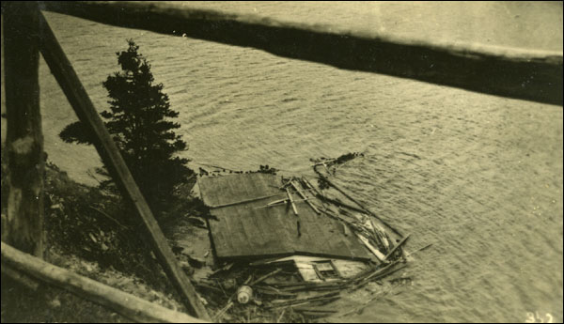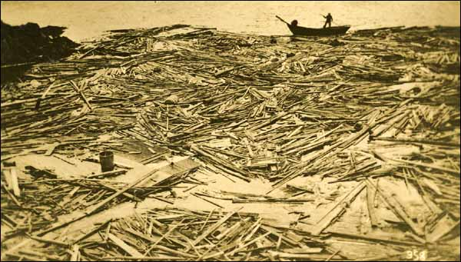
Image courtesy Heritage Newfoundland & Labrador

Part 2: Geophysics Questions
Use the background reading and your knowledge of Earth's crust to answer the following questions.

1. Explain what happens at a plate boundary to cause an earthquake. Why do you think the 1929 earthquake was considered unusual?
2. In your own words, describe what a turbidity current is, and explain what triggered one during the 1929 earthquake?

3. Explain in your own words how a submarine (underwater) landslide can produce a tsunami. What transfers the energy from the landslide to the ocean water?

4. Direct evidence is when scientists observe or measure something firsthand. Indirect evidence is when scientists use clues left behind to figure out something they couldn’t directly observe.
Scientists used the broken telegraph cables to figure out how fast the underwater landslide was moving. The cables broke in order, and the distance and timing between breaks were recorded. What type of scientific reasoning is this- direct evidence or indirect evidence? Explain.

Part 3: Data Analysis
The table below shows the times at which six undersea telegraph cables were snapped by the Grand Banks landslide on November 18, 1929. The cables are numbered roughly in the order they were cut, moving away from the earthquake's epicentre.

Cable # | Time of Break | Distance from Epicentre (km) | Minutes After Earthquake
1 | 5:02 PM | 0 | 0 (earthquake)
2 | 5:15 PM | 60 | 13
3 | 5:18 PM | 80 | 16
4 | 5:33 PM | 150 | 31
5 | 5:47 PM | 225 | 45
6 | 6:12 PM | 330 | 70

5. Using the data in the table, calculate the approximate average speed of the landslide between Cable 2 and Cable 6. Show your work. (Speed = Distance / Time)

6. Look at the pattern of cable breaks. Does the landslide appear to speed up, slow down, or stay constant as it moves farther from the epicentre? Use the data to support your answer.

Part 4: STSE - Science, Technology, Society & Environment
The 1929 tsunami struck the Burin Peninsula with almost no warning. Today, Canada is part of a Pacific Tsunami Warning System, but there is no equivalent system for the Atlantic Ocean, as tsunamis in the Atlantic are much rarer.

Consider This
The 2004 Indian Ocean tsunami killed over 200,000 people. A warning system that was activated 10 years later has since prevented many deaths.
Atlantic tsunamis are rare but not impossible; the 1929 event here proves it. The cost of building and maintaining an Atlantic warning network is estimated at hundreds of millions of dollars.
Many Newfoundland and Labrador communities are coastal and rely on the ocean for fishing and transportation.

7. Do you think the Canadian government should invest in an Atlantic Tsunami Early Warning System? Use evidence from this activity and your own reasoning. Consider the costs, benefits, and who would be affected.

8. In 1929, the people of the Burin Peninsula had no warning before the tsunami hit. Imagine you are a scientist advising the community TODAY. Name TWO specific actions they could take to be better prepared for a future tsunami, without relying on a warning system.

9. The 1929 event is a famous example in the history of geophysics because it was one of the first times scientists could calculate landslide speed using cable breaks. How does this story show that science can advance even from tragic events?

Excellent work, geoscientist! 🌊🪨

