Sedimentary Rock Demonstration:
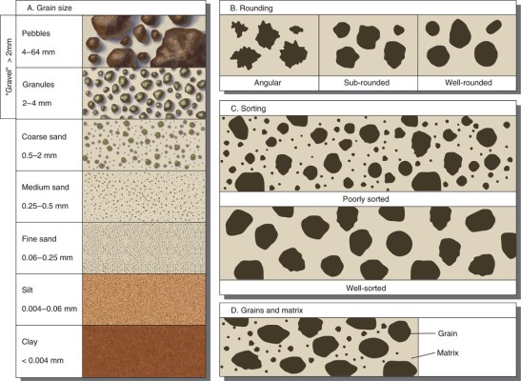
This demonstration plan is designed for a 19-minute classroom session to show how sediments are transported, deposited, and eventually form sedimentary rock using a sedimentator tube (a large, clear tube containing water, gravel, sand, and mud).

Source: National Park Service

Part 1: Introduction and Erosion (3 Minutes)
Start by defining erosion as the process that loosens and moves weathered rock particles, known as sediment, over the Earth's surface. You can choose to do the mechanical and chemical erosion activity alongside this demonstration. Explain that the shaking of the tube represents water in motion—the most powerful geological force for moving these materials.
- Activity: Shake the sedimentator tube vigorously to mix all sediment sizes.

Part 2: Deposition and Grain Size Sorting (5 Minutes)
Set the tube upright on a flat surface and watch the sediments settle into visible layers called beds.
- Key Observation: Sediments settle according to grain size. The largest, heaviest particles (gravel) will hit the bottom first, followed by medium sand, and finally the smallest particles (silt or mud).
- Teacher Note: This demonstrates how our physical world operates in consistent, understandable patterns.

Part 3: Classifying the Results (5 Minutes)
Use the settled layers to teach students how sedimentary rocks are classified by particle size.
- Conglomerate: Formed from the large gravel layer.
- Sandstone: Formed from the medium sand particles that are large enough to "roll between your fingers".
- Shale: Formed from the smallest silt or mud-sized particles.
- Snowbank Analogy: You can explain that these layers are like a vertical cross-section of a snowbank, where each snowfall event creates a distinct, visible layer.

Part 4: Lithification—From Sediment to Rock (6 Minutes)
Explain that for these layers to become rock, they must undergo two final processes:
- Compaction: As new layers settle on top, the weight increases pressure, causing the pore spaces (the empty spaces between particles) to become smaller and smaller.
  - Optional Quick Visual: You can have students squeeze three different colored balls of Play-Doh together to simulate this pressure.
- Cementation: Dissolved minerals in the water act as glue, binding sediments together. The colour of these minerals often determines the final colour of the rock.
Total Time: ~20 Minutes

