Please watch this TED Talk from Rosemary Knight - Freshwater Geophysicist, before reading the article.

Securing Freshwater with Geophysics
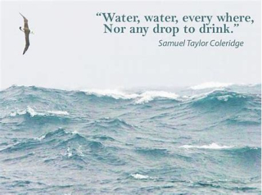
Water is essential for everything we do, from growing food and making products to drinking and washing. Today, the supply of clean freshwater is becoming a global concern due to population growth and climate change. Experts warn that a water shortage could spark conflicts between countries and force millions of people to leave their homes over the next five years. To prevent this, we must more effectively find and manage our planet's hidden water reserves.

Did you know? The UN aims to provide 20 litres of water a day to refugees. In Canada, on average we use 224 litre of water a day, 10x what is allotted to refugees. Can you reduce your water usage?
Source: UN Refugee Agency and Statistics Canada

Where does your drinking water come from? Source: Cathy LeFeuvre

In Newfoundland and Labrador, about 85% of people get their water from public town systems. Most of this water (78%) comes from surface water like lakes and ponds, while only 7% comes from public underground wells. The remaining 15% of the population uses private wells dug into the ground.
Local communities are already struggling to access clean drinking water. For example, during a severe dry spell in Eastern Newfoundland, the Town of Torbay nearly had to shut off the water to residents because water levels fell dangerously low. On top of that, toxic chemicals called PFAS from the St. John’s Airport washed into the local environment. This pollution affected up to 700 homes and contaminated the town’s backup water supply.

Did you know? Humans generally can only survive for three days without water. According to the Government of Canada, access to freshwater in Canada is mainly affecting First Nation reserves, with 37 long-term water advisories on First Nation reserves in 2025.
Source: Government of Canada

From guessing to science:
For hundreds of years, people used traditional, non-scientific methods to find water underground. The most famous method is "dowsing" or "water witching." A person would walk across the land holding a forked stick or metal rods. If the stick moved or twitched, they believed water was directly below. While some people still do this today, science shows it does not actually work. Success with dowsing is just a matter of good luck.
In contrast, geophysics uses scientific methods to survey the Earth and locate resources such as oil, minerals, and water. Geophysicists use special tools to look beneath the ground, similar to how a doctor uses an ultrasound to see inside the human body. These tools show the hidden layers of rock and soil that hold water.

Did you know? In Malawi, the use of traditional dowsing to look for groundwater only had a success rate of 25% requiring a lot of unnecessary digging. In 2000, canadian Paul Bauman used geophysics to locate groundwater by digging wells with a success rate of 93%. His work gave enough water to support 105 communities and 60,000 people.

Geophysics can change the world!
How Geophysics Finds Water
Geophysicists use a few main techniques to scan the ground:
- Electrical Methods (ERI): Scientists push a small electric current into the ground using metal stakes. Water conducts electricity much better than dry rock. By measuring how easily the electricity flows, scientists can map out exactly where the wet, water-bearing zones are.
- Sound Wave Methods (Seismic Refraction): Scientists hit the ground with a heavy hammer or a small explosive to send sound waves deep into the earth. These waves travel at different speeds through different materials. When a wave hits a layer of water, it bends and bounces back. Scientists measure the time it takes for the wave to return to find out how Source: Discover APEGA
deep the water is.
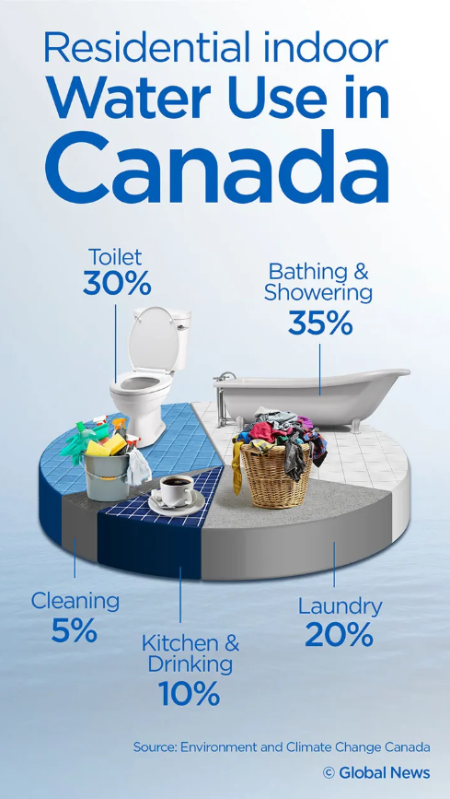
- Radar and Electromagnetic Waves: Tools send radio waves into the ground. Just like the other methods, these waves change when they hit dry soil versus wet soil, giving scientists a clear picture of the shallow subsurface.

Canada's role in freshwater geophysics
Canada is home to about 7% of the world’s renewable freshwater, but has less than 0.5% of the world's population. However, most of this water flows north toward the Arctic Ocean. It is far away from the southern border, where 85% of Canadians actually live. This means our accessible water is under significant pressure from human activity, and we must protect it.
Canada is a leader in water research. Government agencies use geophysics not only to find new water but also to monitor how climate change affects our current supply. For example, a recent major project called Canada1Water created a massive computer model of Canada's entire water system. This model helps scientists predict how climate change will affect our groundwater and surface water until the end of this century.
Do your own part! Be water-wise

You can do your own part to reduce your personal water usage! From the David Suzuki Foundation:
- In the bathroom: Turn off the tap while brushing your teeth, take shorter showers, and reuse your towels.
- In the kitchen: Only run the dishwasher when it is completely full, and keep a pitcher of drinking water in the fridge so you don't have to run the tap to chill it.

Dive Deeper Questions
- The Ethic Challenge: A small community is running out of water. They strongly believe in traditional dowsing but have very little money for a modern scientific survey. As a scientist, how can you respectfully explain the benefits of geophysics without disrespecting their cultural traditions?
- The Global Impact: Research how geophysicists use these tools for humanitarian work (such as finding water in refugee camps or developing nations). What are the social and economic benefits of their work?
- Your Opinion: Using the data in the graph below, should individual Canadians worry about their personal use of water? Why or why not? Give 2 examples to support your answer.
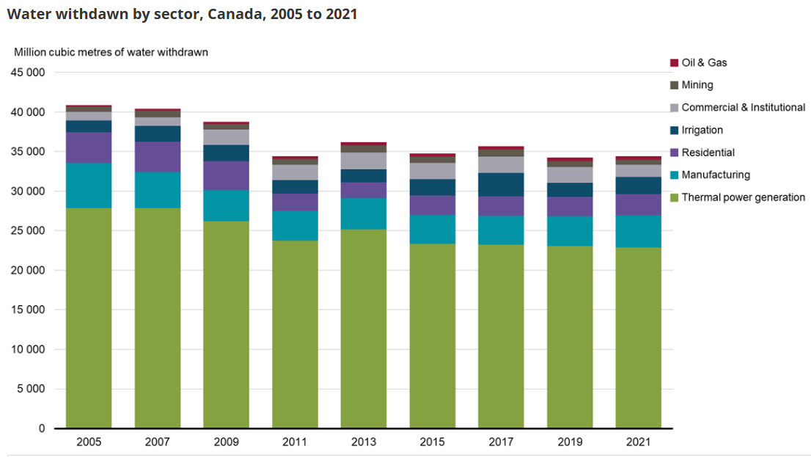
Source: Government of Canada

