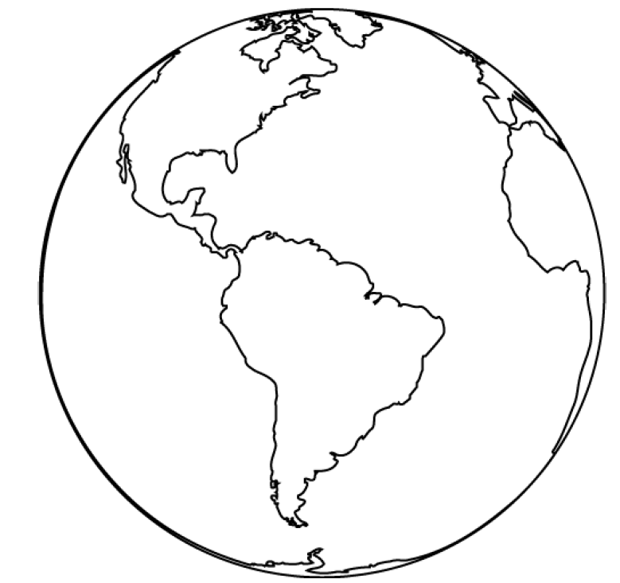
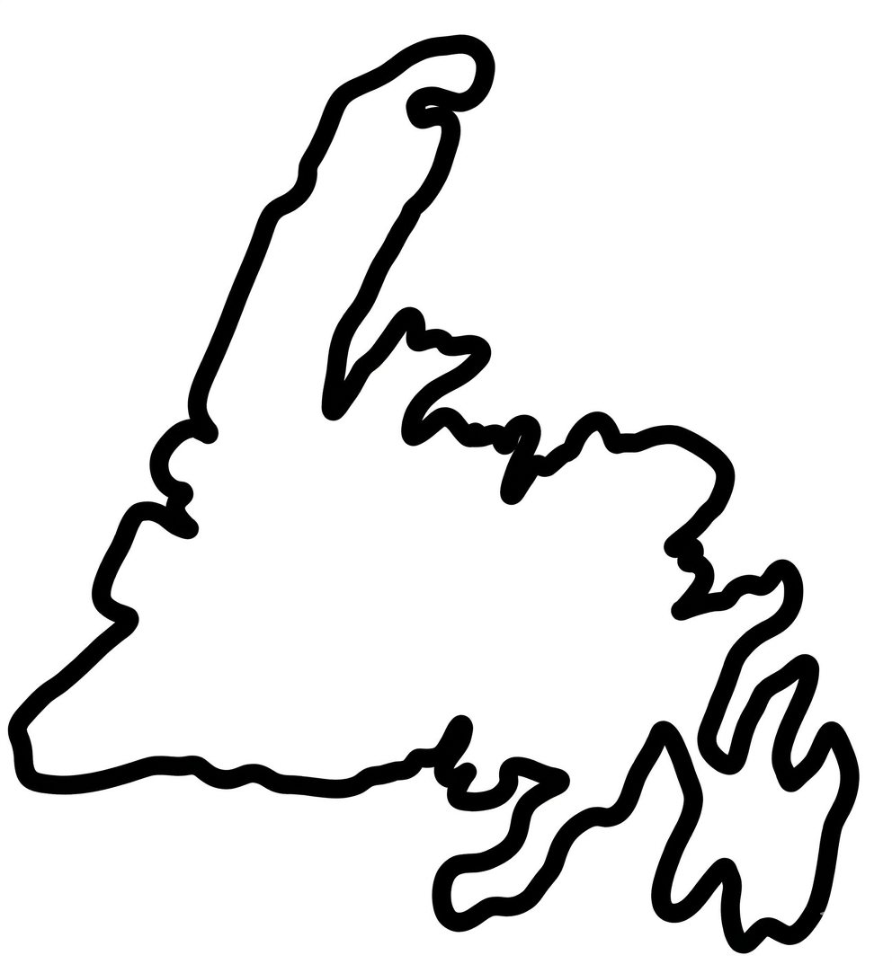
This sheet contains 2 world maps, photocopy on white paper.




This sheet contains 6 outer cores, photocopy on one color of paper.

Earth’s outer core is 15% of it’s volume.

Earth’s outer core is 15% of it’s volume.

Earth’s outer core is 15% of it’s volume.

Earth’s outer core is 15% of it’s volume.

Earth’s outer core is 15% of it’s volume.

Earth’s outer core is 15% of it’s volume.

This sheet contains 2 mantles, photocopy on one color of paper.

Earth’s mantle is 84% of the Earth’s volume.

Earth’s mantle is 84% of the Earth’s volume.

This sheet contains 2 crusts, photocopy on one color of paper.

Earth’s Crust is less than 1% of it’s volume.

Earth’s Crust is less than 1% of it’s volume.

This sheet contains 24 inner cores, photocopy on one color of paper.

The Earth’s inner core is <1% of it’s volume.

The Earth’s inner core is <1% of it’s volume.

The Earth’s inner core is <1% of it’s volume.

The Earth’s inner core is <1% of it’s volume.

The Earth’s inner core is <1% of it’s volume.

The Earth’s inner core is <1% of it’s volume.

The Earth’s inner core is <1% of it’s volume.

The Earth’s inner core is <1% of it’s volume.

The Earth’s inner core is <1% of it’s volume.

The Earth’s inner core is <1% of it’s volume.

The Earth’s inner core is <1% of it’s volume.

The Earth’s inner core is <1% of it’s volume.

The Earth’s inner core is <1% of it’s volume.

The Earth’s inner core is <1% of it’s volume.

The Earth’s inner core is <1% of it’s volume.

The Earth’s inner core is <1% of it’s volume.

The Earth’s inner core is <1% of it’s volume.

The Earth’s inner core is <1% of it’s volume.

The Earth’s inner core is <1% of it’s volume.

The Earth’s inner core is <1% of it’s volume.

The Earth’s inner core is <1% of it’s volume.

The Earth’s inner core is <1% of it’s volume.

The Earth’s inner core is <1% of it’s volume.

The Earth’s inner core is <1% of it’s volume.
Rubric - Earth’s Model: Name:________________________

Section: | Criteria: | Marks:
Crafting: | The physical construction, neatness, and creative effort of the model:  1pt. satisfactory 4pts. great  2pts. fair 5pts. exceptional  3pts. good | / 5
Layers’ Titles: | All four layers must have a clear, distinct title to receive the mark. | / 1
Layer 1 Description: | Provide a description for the first layer’s composition. | / 1
Layer 2 Description | Provide a description for the second layer’s composition. | / 1
Layer 3 Description | Provide a description for the third layer’s composition. | / 1
Layer 4 Description | Provide a description for the fourth layer’s composition. | / 1
TOTAL |  | / 10

Rubric - Earth’s Model: Name:________________________

Section: | Criteria: | Marks:
Crafting: | The physical construction, neatness, and creative effort of the model:  1pt. satisfactory 4pts. great  2pts. fair 5pts. exceptional  3pts. good | / 5
Layers’ Titles: | All four layers must have a clear, distinct title to receive the mark. | / 1
Layer 1 Description: | Provide a description for the first layer’s composition. | / 1
Layer 2 Description | Provide a description for the second layer’s composition. | / 1
Layer 3 Description | Provide a description for the third layer’s composition. | / 1
Layer 4 Description | Provide a description for the fourth layer’s composition. | / 1
TOTAL |  | / 10

