How to Make a Model of Earth’s Layers:

Materials:  - Four colours of construction paper (or colour each layer a different colour)  - crayons or colored pencils  - scissors  - Glue  Step 1: Cut out and colour the Earth colouring page.  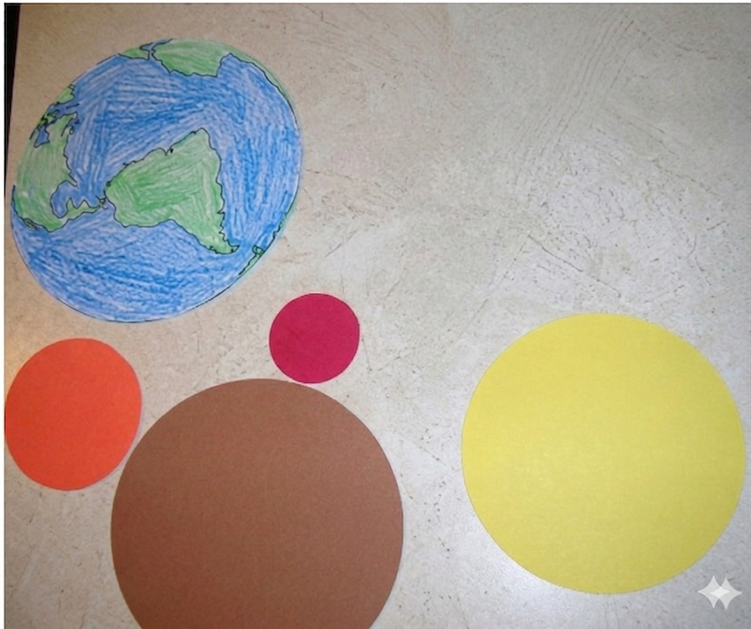  Step 2: Cut out the largest circle using one colour. Then, cut out three progressively smaller circles using three different colours, for a total of four layers. | Step 3: Glue the largest shape to the back of the Earth sheet. Then glue the next-largest shape, and so on until they’re all glued.  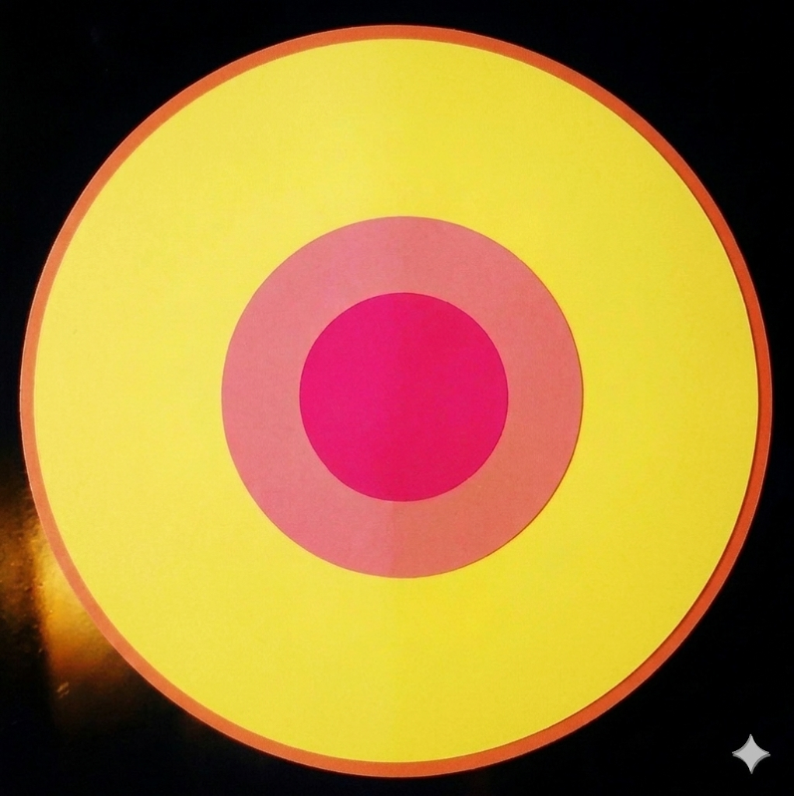  Step 4: Label each layer. Make sure to include a description of each layer’s composition. If needed, use a small white paper box to write out the layer’s description and glue directly on that layer, including an arrow!

Rubric:

Section: | Criteria: | Marks:
Crafting: | The physical construction, neatness, and creative effort of the model:  1pt. satisfactory 4pts. great  2pts. fair 5pts. exceptional  3pts. good | / 5
Layers’ Titles: | All four layers must have a clear, distinct title to receive the mark. | / 1
Layer 1 Description: | Provide a description for the first layer’s composition. | / 1
Layer 2 Description | Provide a description for the second layer’s composition. | / 1
Layer 3 Description | Provide a description for the third layer’s composition. | / 1
Layer 4 Description | Provide a description for the fourth layer’s composition. | / 1
TOTAL |  | / 10

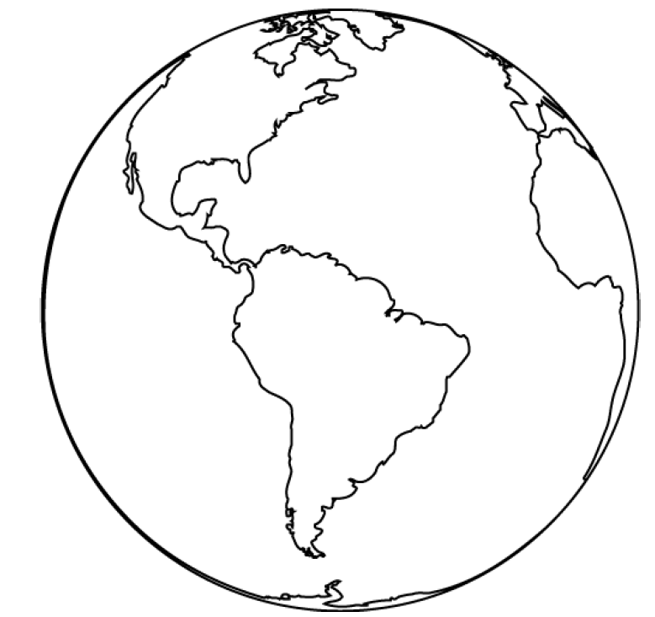
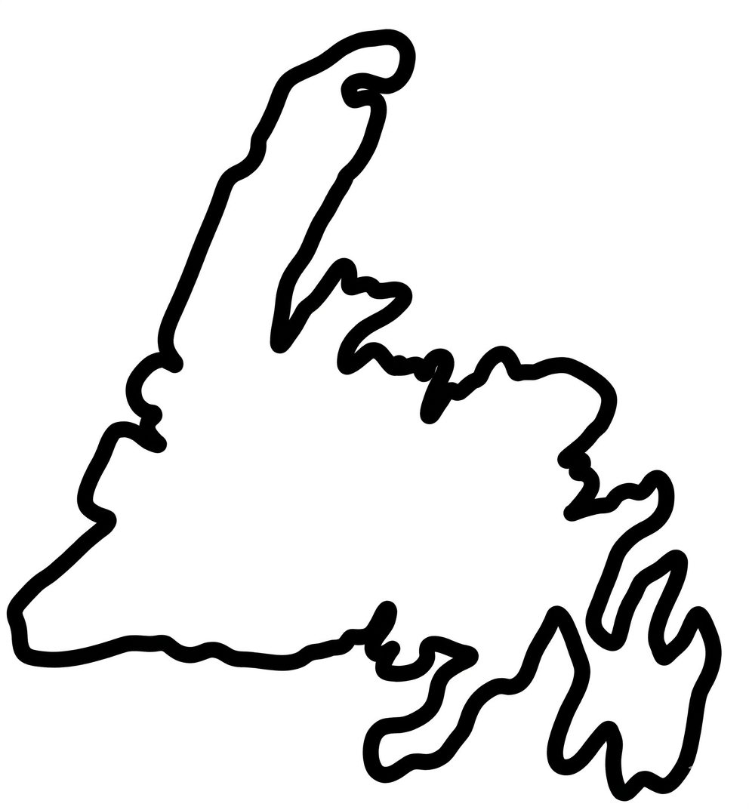

Earth’s outer core is 15% of it’s volume.

The Earth’s inner core is <1% of it’s volume.

Earth’s Crust is less than 1% of it’s volume.

Earth’s mantle is 84% of the Earth’s volume.

