Teacher's version of "Make your own Earth's layers model"

The original source for this activity is here. It’s been changed to better represent the relative scales of the different layers. The colouring page also did not include the island of Newfoundland, so it was added.

Quick notes:
- If you do not have access to coloured paper, have students colour each layer a different colour.
- This is a version of the sheets designed for photocopying, including rubrics.
- Description of each layer is on page 144 of the curriculum guide, but it states:
  - Students should know the relative position and qualitative size of the layers. The description of each layer should be limited to the following: the crust is solid and varies in depth; the mantle is partly molten; the outer core is liquid and is made mostly of nickel and iron; the inner core is solid and is made mostly of nickel and iron.
    - Students are not required to know depth or volume quantitatively, only to understand their qualitative size and position.

Rubric - Earth’s Model: Name:________________________

Section: | Criteria: | Marks:
Crafting: | The physical construction, neatness, and creative effort of the model:  1pt. satisfactory 4pts. great  2pts. fair 5pts. exceptional  3pts. good | / 5
Layers’ Titles: | All four layers must have a clear, distinct title to receive the mark. | / 1
Layer 1 Description: | Provide a description for the first layer’s composition.  Answer Key: the crust is solid and varies in depth; | / 1
Layer 2 Description | Provide a description for the second layer’s composition.  Answer Key: The mantle is partly molten | / 1
Layer 3 Description | Provide a description for the third layer’s composition.  Answer Key: The outer core is liquid and is made mostly of nickel and iron | / 1
Layer 4 Description | Provide a description for the fourth layer’s composition.  Answer Key: The inner core is solid and is made mostly of nickel and iron. | / 1
TOTAL |  | / 10

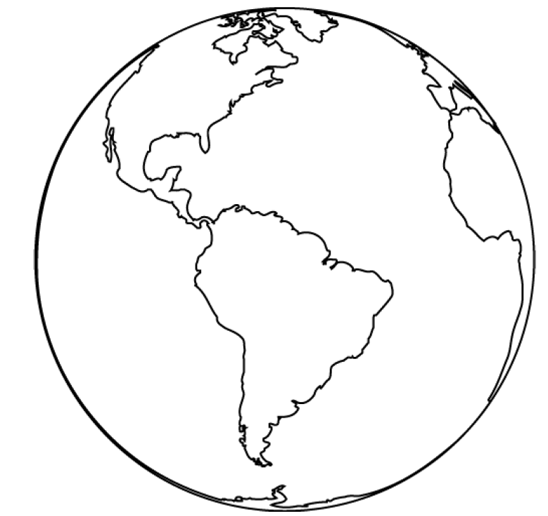
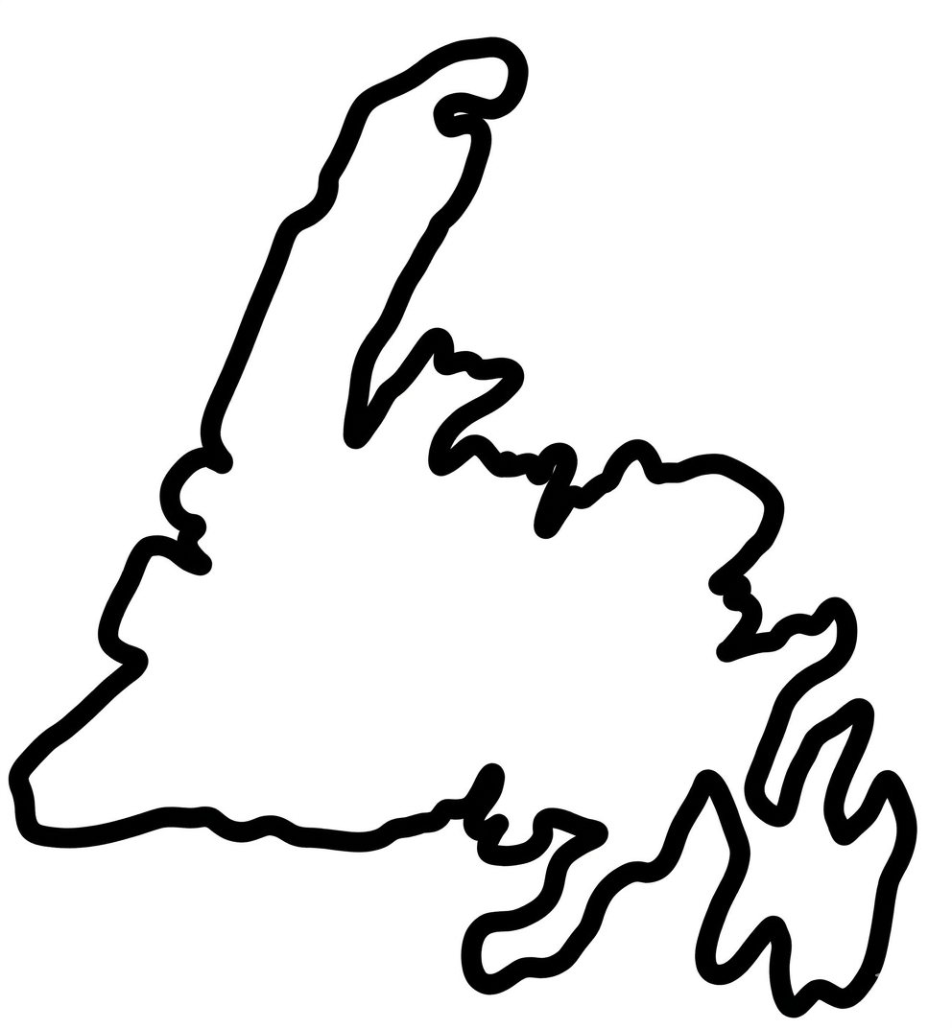

Earth’s outer core is 15% of it’s volume.

The Earth’s inner core is <1% of it’s volume.

Earth’s Crust is less than 1% of it’s volume.

Earth’s mantle is 84% of the Earth’s volume.

