🌍 Finding an Earthquake Epicenter
How do scientists figure out where an earthquake started?
Name: ______________________________ Class: __________ Date: __________

Part 1 - What Happens When the Earth Shakes?
When an earthquake happens, it releases energy that travels outward from the source in all directions, like ripples spreading across a pond. These travelling pulses of energy are called seismic waves.

The place underground where the earthquake starts is called the focus. Directly above it, on Earth's surface, is the epicenter. This is the point where shaking is usually felt most strongly.

There are two types of seismic waves you need to know about for this activity:

P-waves (Primary waves) | S-waves (Secondary waves)
- Arrive first  - Travel faster  - Can travel through anything (rock, liquid, etc.)  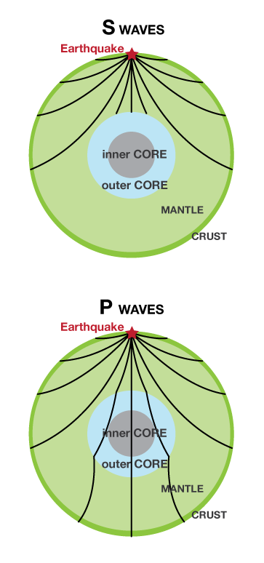 | - Arrive second  - Travel slower  - Can only travel through solid rock  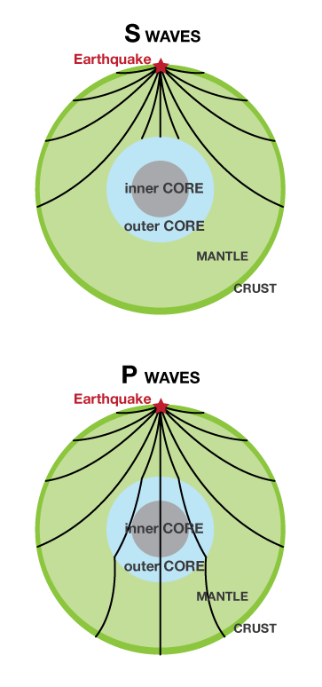
Image Source: https://www.usgs.gov/media/images/p-wave-and-s-wave-paths-through-earth
🔑 Key Idea:
Think of two runners leaving at the same time, a sprinter and a jogger. After a short distance, they're still close together. After a long distance, the sprinter is way ahead. The same is true for P-waves and S-waves!

Because P-waves are faster, they arrive at a seismometer (an earthquake detector) before S-waves.

The bigger the distance from the earthquake, the bigger the gap between their arrivals.

Part 2 - Reading a Seismogram
A seismogram is the recording made by a seismometer over time. It shows when seismic waves arrived at that station. Below is an example:
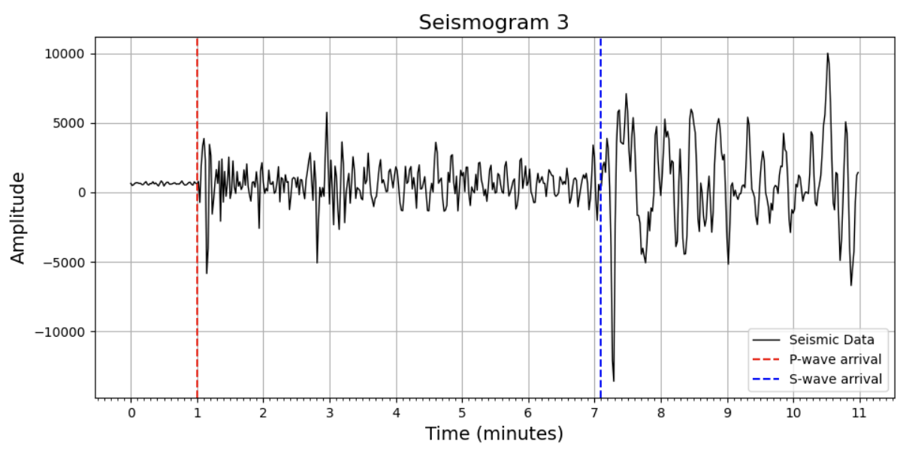

On a seismogram, time runs left to right. You can see two places where the line suddenly gets bigger:
- The first jump = the P-wave arriving
- The second (bigger) jump = the S-wave arriving

The gap between the two arrivals is called the P-S time interval. The bigger the gap, the farther away the earthquake was.

📌 Example:
If the P-wave arrives at 1.0 min and the S-wave arrives at 3.5 min, the P-S interval:

3.5 − 1.0 = 2.5 minutes.

In seconds: 2.5 min × 60 sec = 150 seconds.

Check Your Understanding
Q1. Look at the example seismogram above. At approximately what time (in minutes) does the P-wave arrive?

Answer: _______________

Q2. At approximately what time does the S-wave arrive?

Answer: _______________

Q3. What is the P-S time interval? (Subtract P-wave arrival from S-wave arrival.)

Answer: _______________ minutes × 60 = _______________ seconds

Part 3 - Finding the Epicenter
An earthquake has occurred! We have recordings from three seismic stations. Your job is to use those recordings to find the epicenter, which is the location on the surface directly above where the earthquake started.

Here is where the three stations are located:

Station | Latitude | Longitude
Station 1 | 64.77° | -146.89°
Station 2 | 38.06° | -91.24°
Station 3 | 42.51° | -71.56°

Step 1 - Measure the P-S Time Interval
Below are the three seismograms (from the three stations) for this earthquake. The graphs have been marked with dashed lines to help you. Read off the arrival times as carefully as you can.

Station 1:

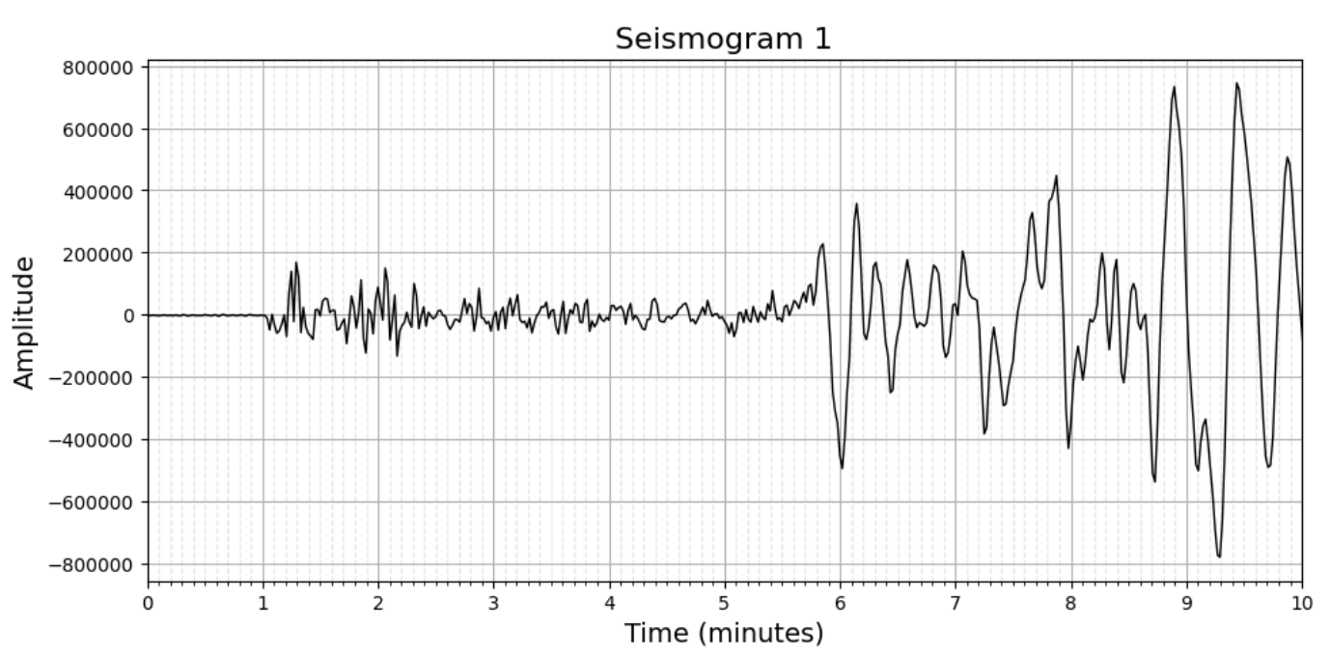

Station 2:
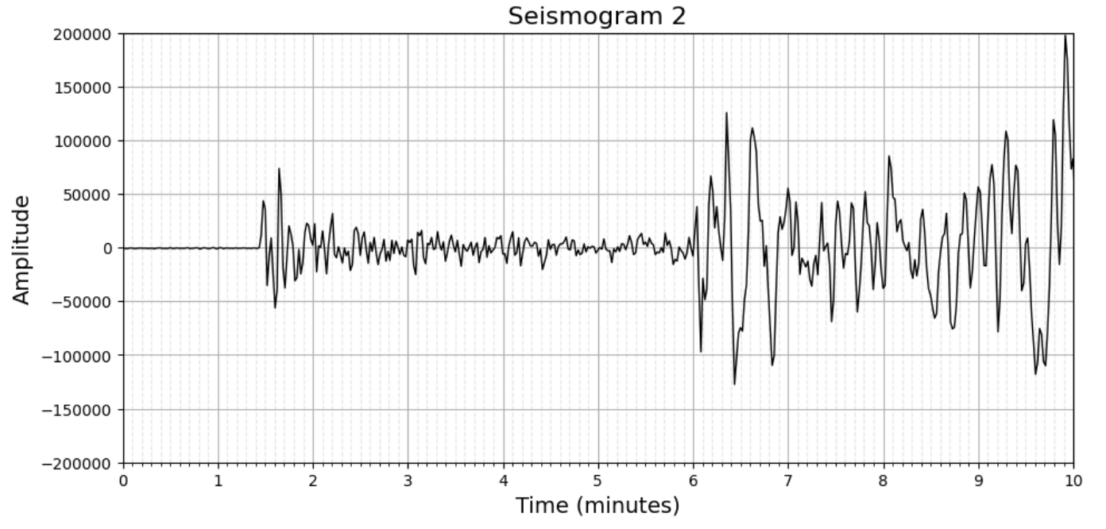

Station 3:

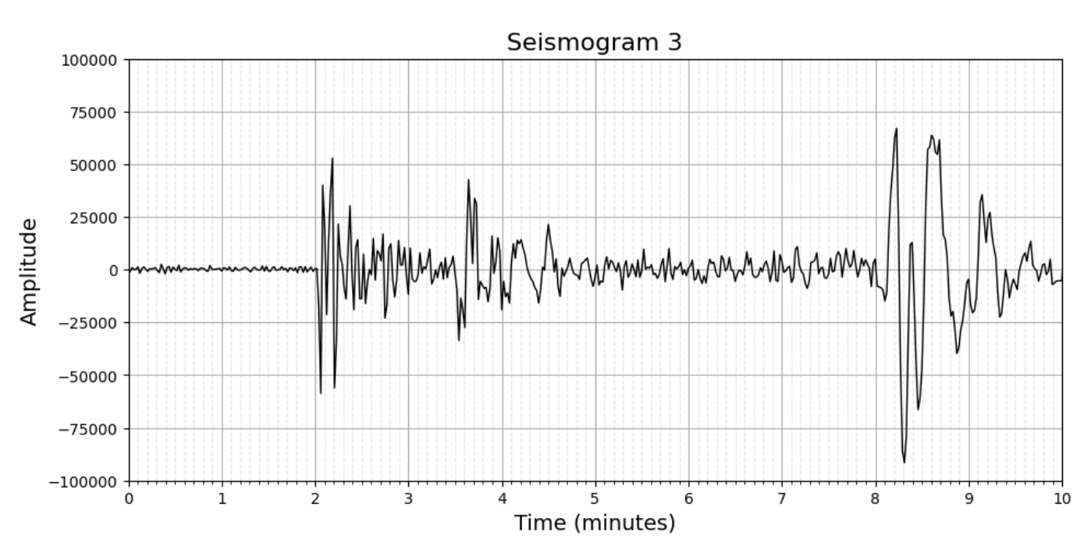

💡 Tip:
To convert minutes to seconds, just multiply by 60. For example, 2.5 minutes × 60 = 150 seconds.
Fill in your measurements in the table below:

 | Seismogram 1 | Seismogram 2 | Seismogram 3
P-wave arrives at (min)
S-wave arrives at (min)
P-S interval (min)
P-S interval × 60 (seconds)

Step 2 - Look up the Distance
Now use the P-S Interval Distance Table below to find the approximate distance between each station and the earthquake epicenter. Find the row that matches your P-S interval (in seconds), and read off the distance.
P-S Interval → Distance Table
P-S Interval | Distance from Epicenter | P-S Interval | Distance from Epicenter
10 s | ~86 km | 170 s | ~1462 km
20 s | ~172 km | 180 s | ~1410 km
30 s | ~258 km | 200 s | ~1750 km
40 s | ~344 km | 220 s | ~2090 km
50 s | ~430 km | 240 s | ~2430 km
60 s | ~516 km | 260 s | ~2770 km
70 s | ~602 km | 280 s | ~3110 km
80 s | ~688 km | 300 s | ~3450 km
90 s | ~774 km | 320 s | ~3790 km
100 s | ~860 km | 340 s | ~4130 km
110 s | ~946 km | 360 s | ~4470 km
120 s | ~1032 km | 400 s | ~4870 km
130 s | ~1118 km | 450 s | ~5420 km
140 s | ~1204 km | 500 s | ~5970 km
150 s | ~1290 km | 550 s | ~6520 km
160 s | ~1376 km | 600 s | ~7070 km

Write the distances you looked up in the table below:

Station 1 | Station 2 | Station 3

Step 3 - Draw Circles on the Map
Now it's time to locate the epicenter! Go to the IRIS Earthquake Triangulation website:

https://www.iris.edu/app/triangulation/

Follow these steps on the website:
- Add the three stations. Click the  button (top right). Click on the triangle on the map to select it. In the bar at the bottom, type in the name and coordinates from the table above. Repeat for all three stations.
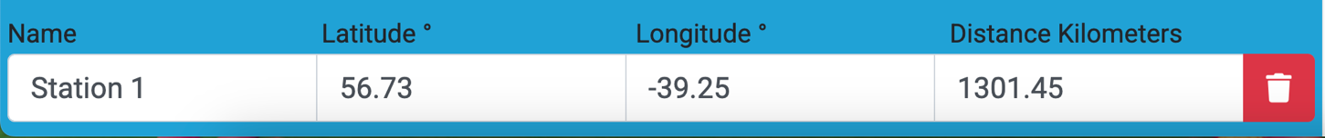

- Enter the distances. Click each station, then type your calculated distance (from Step 2) into the "Distance Kilometers" box at the bottom. A circle will appear around each station.

- Find the epicenter. Look at where all three circles meet. That point is the epicenter! (The circles won't line up perfectly, that's okay.)

- Place the star marker. Click the  button (left side menu) and check off . Drag the star to where the circles meet. Note the latitude and longitude displayed.

Example: 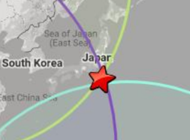

- Take a screenshot. Use the Snipping Tool to capture your map showing the three stations, the three circles, and the star at the epicenter. Insert it below.

Record the epicenter coordinates:

Latitude | Longitude
Insert your screenshot below:

[ Paste screenshot here ]

Part 4 - Think About It
Now that you've found the epicenter, answer the questions below. Write in full sentences where you can.

- Look at your epicenter on the map. What do you notice about where this earthquake happened? Is it near a plate boundary?

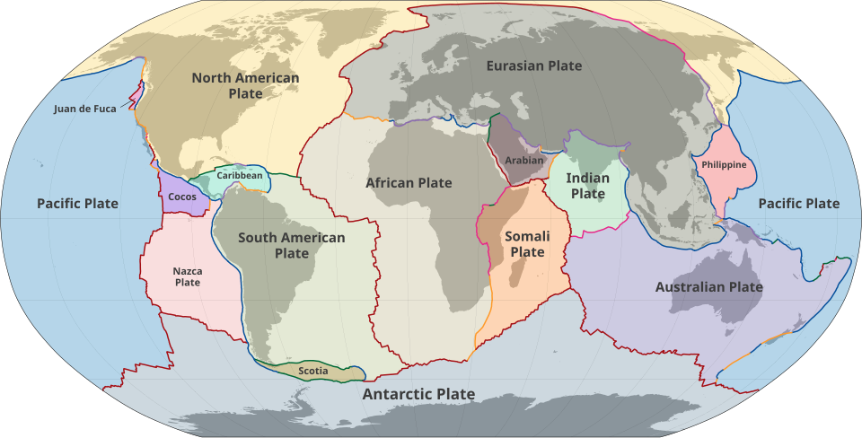

Image Source: https://en.wikipedia.org/wiki/List_of_tectonic_plates

2. Why did scientists need recordings from three different stations? What would happen if they only used one?

3. Station 3 had a bigger P-S time interval than Station 2. What does that tell you about which station was closer to the epicenter?

4. Real seismologists use this same triangulation method. Where in the world do you think there might be many seismic stations close together? Why?

⭐ Bonus Challenge
Can you find a real earthquake that happened recently using the USGS Earthquake Hazards website? Look it up and try to figure out which tectonic plates were involved. Share with your class!
earthquake.usgs.gov/earthquakes/map

