🌍 Finding an Earthquake Epicenter
Teacher Version – Answer Key

📌 Example:
If the P-wave arrives at 1.0 min and the S-wave arrives at 3.5 min, the P-S interval:

3.5 − 1.0 = 2.5 minutes.

In seconds: 2.5 min × 60 sec = 150 seconds.

Check Your Understanding
Q1. Look at the example seismogram above. At approximately what time (in minutes) does the P-wave arrive?
1 minute
Answer: _______________

Q2. At approximately what time does the S-wave arrive?
7.1 minutes
Answer: _______________

Q3. What is the P-S time interval? (Subtract P-wave arrival from S-wave arrival.)
366
6.1
Answer: _______________ minutes × 60 = _______________ seconds

 | Seismogram 1 | Seismogram 2 | Seismogram 3
P-wave arrives at (min) | 1 | 1.4 | 2
S-wave arrives at (min) | 5.8 | 6 | 8.1
P-S interval (min) | 4.8 | 4.6 | 5.9
P-S interval × 60 (seconds) | 288 | 276 | 354

Write the distances you looked up in the table below:

Station 1 | Station 2 | Station 3
3110 km | 2770 km | 4470 km

Record the epicenter coordinates:

Latitude | Longitude
~36.88° | ~124.45°

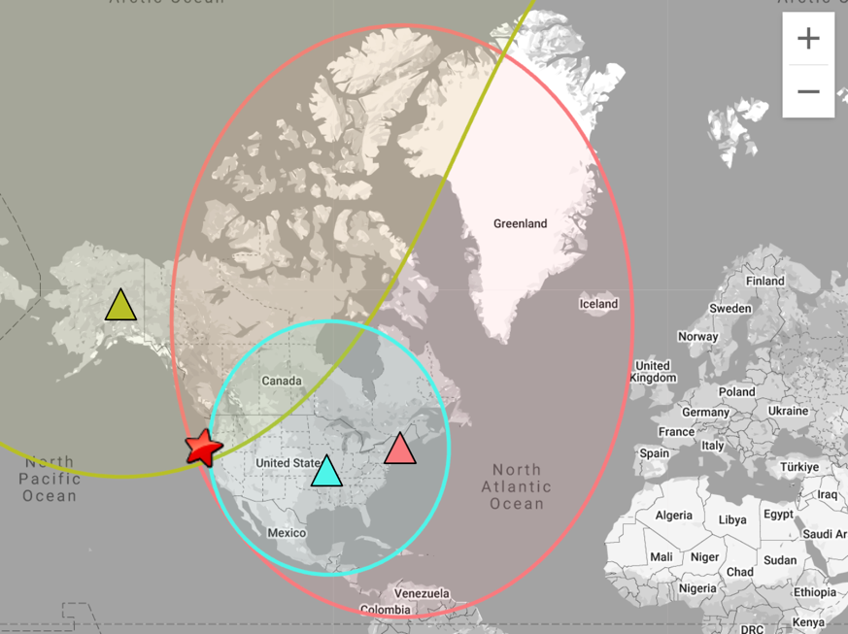

Part 4 - Think About It
Now that you've found the epicenter, answer the questions below. Write in full sentences where you can.

- Look at your epicenter on the map. What do you notice about where this earthquake happened? Is it near a plate boundary?

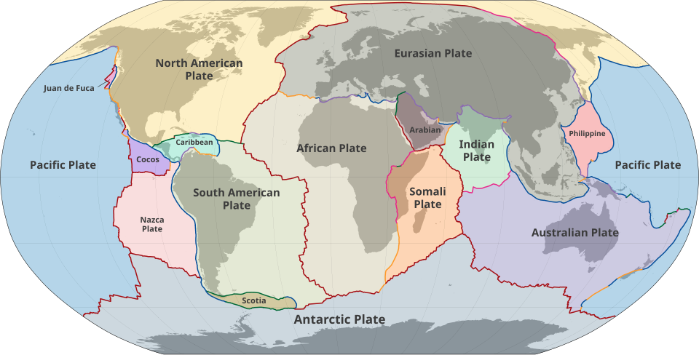

Image Source: https://en.wikipedia.org/wiki/List_of_tectonic_plates
- The earthquake is near a plate boundary.
- It is part of the boundary between the Pacific Plate and the North American plate.

2. Why did scientists need recordings from three different stations? What would happen if they only used one?
- Scientists need at least three stations to find the exact location of the epicentre using triangulation.
- Each station gives a distance from the earthquake.
- One station = a circle of possible locations
- Two stations = two possible intersection points
- Three stations = one exact point
- If only one station were used, scientists wouldn’t know the exact location, only how far away the earthquake is.

3. Station 3 had a bigger P-S time interval than Station 2. What does that tell you about which station was closer to the epicenter?
- A larger P-S interval means the station is farther from the epicenter.
- Since Station 3 has a bigger interval than Station 2, Station 2 is closer to the epicenter.

4. Real seismologists use this same triangulation method. Where in the world do you think there might be many seismic stations close together? Why?
- There might be many seismic stations close together along plate boundaries because these areas have more seismic activity.
- Scientists would need more stations to detect earthquakes quickly, accurately locate epicenters, monitor hazards, improve safety, etc.

