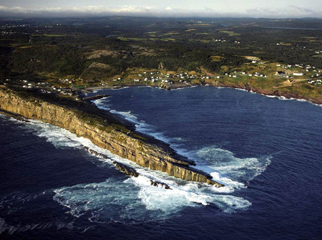
A New Era for The Rock: Critical Minerals
Flatrock, NL

Newfoundland and Labrador, or "The Rock," is known for its beautiful landscapes, with striking cliffs and rocky beaches. Beneath your feet, the rocks contain important elements for Canada's future: critical minerals. These aren't just any minerals: they're the building blocks for our high-tech world. From the cell phone in your bag to the electric car you might one day drive, critical minerals are required!

What are Critical Minerals?

A critical mineral is a mineral that's essential to modern technology. Canada's government has a list of over 30 minerals considered “critical”, and many of them are in Newfoundland and Labrador. For example, antimony, cobalt, and nickel are crucial for making the batteries that store energy from wind turbines and solar panels. These minerals are so important that countries around the world are trying to secure their own supplies. The demand for them is increasing as new technologies, like touch screens, require critical minerals.
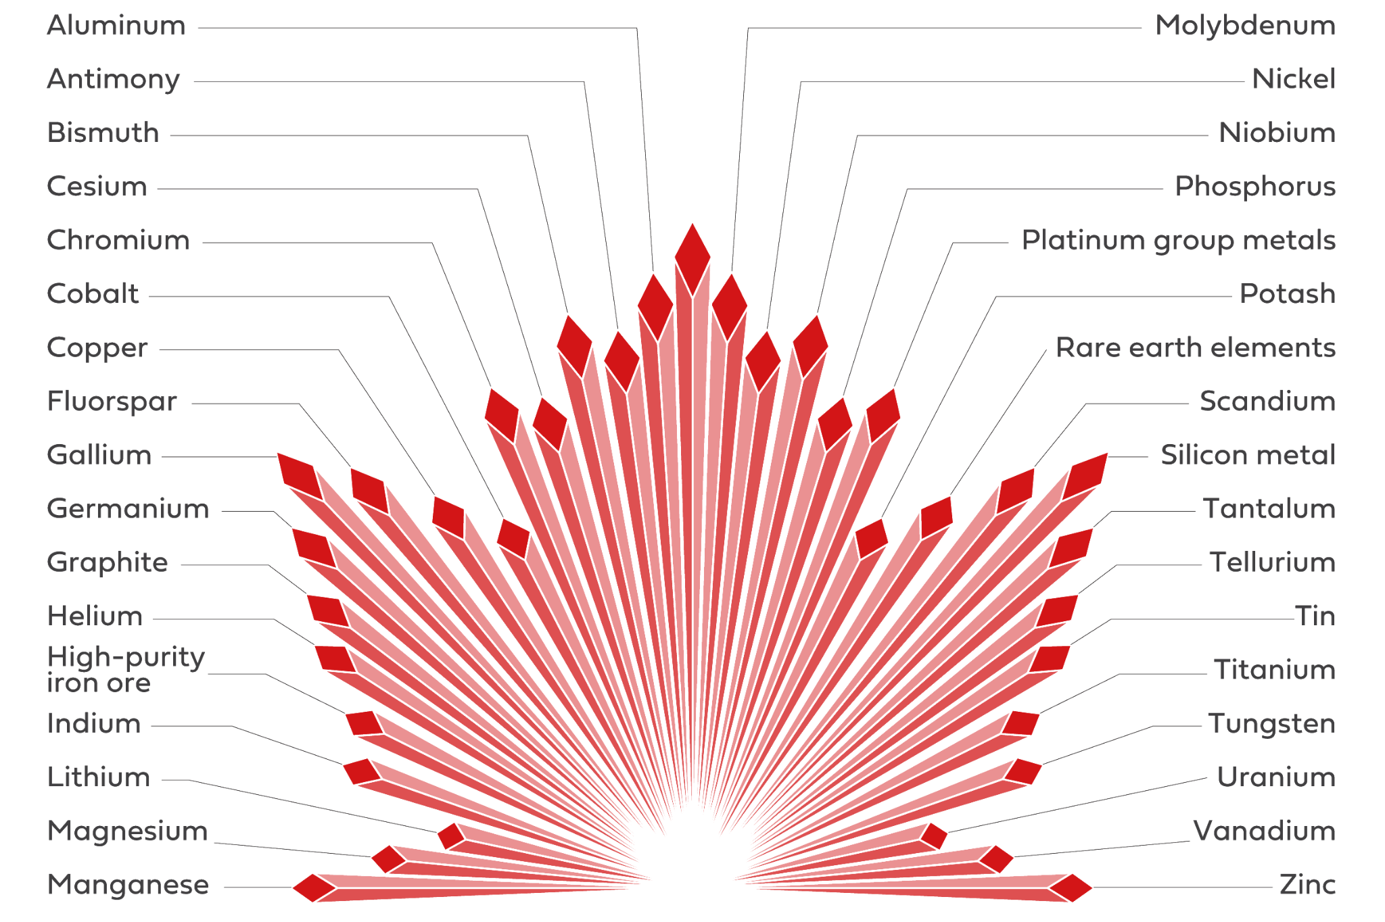

Why are they so important for Newfoundland and Labrador?

Our province could be a leader, as we have many of these minerals, including one of the world’s largest nickel deposits at Voisey's Bay in Labrador and undeveloped rare earth element deposits in Labrador. On the Burin Peninsula, we have one of the largest fluorspar deposits in North America. The recent lithium discoveries in the province have generated widespread excitement as they demonstrate that "The Rock" still holds many more hidden treasures!

Mining these critical minerals can create new jobs, boost our economy, and help Canada secure a reliable supply for new technology. It also helps us move towards a more sustainable economy by providing the materials needed for green technology. For example, our high-quality, low-impurity iron ore in Labrador is in high demand for making "green steel," a key part of creating a low-carbon future.

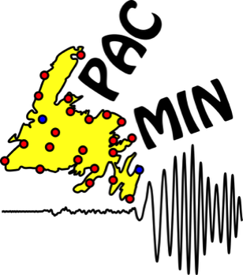
Finding the Treasure: How Do We Locate Critical Minerals?

In July 2025, Dr. Kim Welford from Memorial University launched “Passive Array for Critical Minerals on the Island of Newfoundland” or PACMIN contains a network of 22
seismographs (machines that passively observe earth vibrations from earthquakes) which will allow for the internal structure of the Earth beneath Newfoundland to be studied, which has never been done at this scale before. Understanding more about how Newfoundland was created from plate tectonic movement will allow geophysicists to know where to look for critical minerals.

Finding critical minerals is a bit like being a detective. It starts by looking for clues in the province's geology. Geoscientists use a variety of tools to explore for minerals. Starting by studying geological maps to identify areas with the right kind of rock formations. Then, using geophysical surveys with specialized equipment to search for magnetic fields or radiation, which can indicate the presence of certain minerals, or seismic exploration for critical minerals like graphite. The exploration team collects rock and soil samples from the field to analyze with chemistry lab tests. All this information is put together to understand what lies beneath the surface, helping them pinpoint the best places to drill for samples and hopefully, critical minerals!

Careers in a Critical Minerals Future

The critical minerals industry offers a wide range of career opportunities, from hands-on work in the field to technical roles in labs or offices. Currently, there is a hiring crisis, with too little new talent entering the mining industry. These careers are more than just mining; it's a whole chain of events, from finding the mineral to processing it and turning it into a final product.

- Geoscientists use their knowledge of rocks and Earth's history to find new mineral deposits.
- Mining engineers design and manage the extraction of minerals from the ground.
- Heavy equipment operators and technicians are essential for running the machinery used in exploration and mining.
- The industry needs people with technological skills, such as data scientists who analyze geophysical data and environmental specialists who ensure operations are as sustainable as possible.

These jobs are crucial for an innovative economy in Newfoundland and Labrador.

Dive Deeper Questions:
- Based on what you've learned, explain in your own words what makes a mineral "critical." Using a smartphone as an example, describe at least three critical minerals within and their purpose.

- Choose a career connected to mining and look into education requirements, day-to-day responsibilities and job opportunities. Create a summary to sell your classmates on your chosen career.

- Do you think the development of critical minerals is a good thing for Newfoundland and Labrador? Take a stance and use evidence from the article and your own reasoned opinion to support your view. Consider economic, environmental and societal impacts.

