Metamorphic Rocks:

Modelling Foliation with Play-Doh and Pennies
Objective: To demonstrate how pressure aligns structures within a matrix to model the formation of a metamorphic rock.
Materials:
- ½ container of Play-Doh.
- A handful of copper pennies (acting as your "crystals").
- Twine

Instructions:
- Prepare the Matrix: Soften the Play-Doh by squeezing it in your hands.
- Random Orientation: Mix the pennies into the play-dough. Fold and pull the material together until the pennies are thoroughly mixed and randomly oriented (pointing in various directions).
- Apply One-Dimensional Pressure: Place the dough on a flat surface and press the top with your hand.
  - Observation: Pressure from one dimension compresses the "rock" and begins to align the pennies in one dimension, forming parallel layers.
- Apply Two-Dimensional Pressure: Pick up the dough and press from a different direction, squeezing it into a tube. Continue applying pressure from alternating sides. If the tube grows too long, pull it in two, stack them, and join them back together. This simulates the intense pressure found during mountain formation, where pressure comes from the rocks above and from the sides.
- Examine the Results: Use the twine to cut the tube lengthwise to see the internal orientation of the pennies.

What This Shows
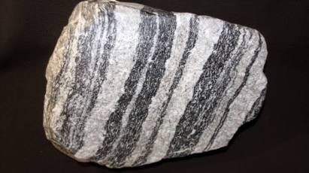
By the end of the activity, the randomly scattered pennies should now be aligned parallel to one another. This modelled "rock" represents a foliated metamorphic rock, such as schist.
Note on Materials: Using pennies is an excellent way to show how flat minerals respond to pressure. In nature, minerals like mica are flat (like pennies) and align under heat and pressure to create the distinct layers or "foliation" seen in metamorphic rocks.

- Making Sense of Metamorphic Rocks
- Does foliation help to identify metamorphic rock?
- What to Do
- 1. Take the plasticine and roll it between your hands until it is soft and easy to shape. Roll it
- into a ball shape.
- 2. Insert 5 pennies into the plasticine in different and random oriented directions. In the
- chart below, draw and label a picture of the plasticine ball before pressure is applied.
- 3. Place the ball on the table and carefully flatten the plasticine. In the chart below, draw
- and label a picture of the plasticine ball after pressure has been applied.

- 4. Compare the granite (IGNEOUS)
- and gneiss (METAMORPHIC) rock
- samples. Record your observations.

- Distinct layering defined by aligned
- minerals (banded, foliation)
- Crystalline, coarse or fine (sparkly)
- Wavy, irregular layering
- Very hard

