Exploring Newfoundland Geology in
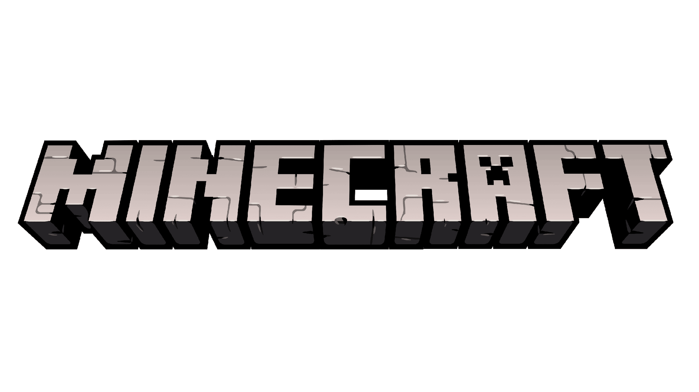

Activity
Newfoundland is a great place to study geology! Our island has so many different rock types, alongside super important fossils and ore deposits. But it would take a week to do a field trip to all the geologically significant places in Newfoundland in real life. So, we brought Newfoundland to Minecraft, and we’ll explore in there instead!
On your computers, you have access to the NL Minecraft world. This world contains the simplified bedrock (deep rock, not bedrock as in the block type in Minecraft) geology of Newfoundland! We’ve also added beacons around the world to mark significant landmarks on the island, such as fossil sites and structural features. Some of these landmarks have links to additional information about these places. When you spawn into the world, you’ll start at a platform with some info to help get you started.
For this activity, you’re going to open up this Minecraft world and use it to learn about the geology of Newfoundland and some geologic concepts. Before you load up the world, have a look at the questions below, so you know what to look for. Your goal here is to explore the island and to try to answer the questions below as best you can. And in case you get lost, check out the map for places to visit! Make sure to visit each landmark, add them to your digital portfolio using the camera, quill and book and check out the additional info at the links.
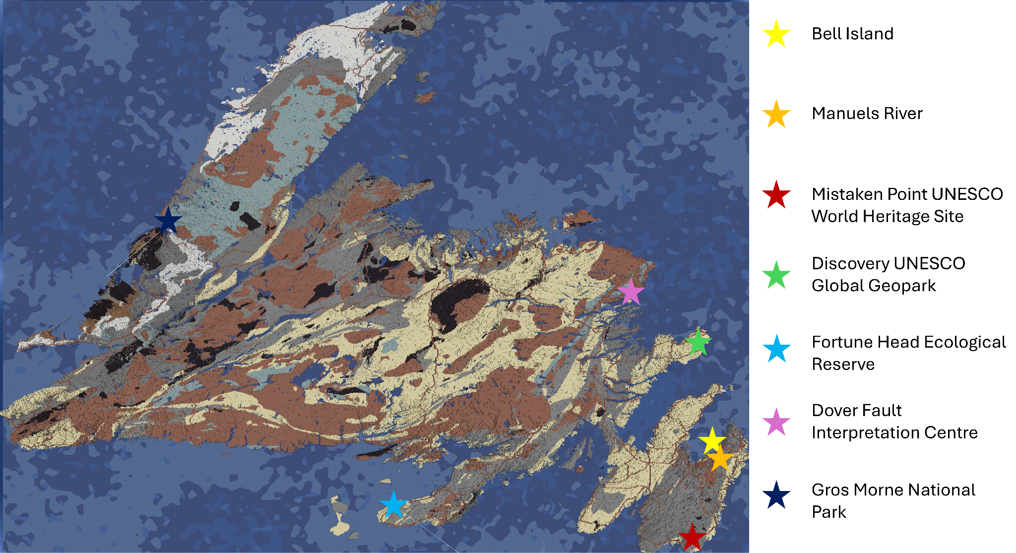
Figure 1: Geologic map of Newfoundland in Minecraft, with stars marking locations of geologic landmarks.
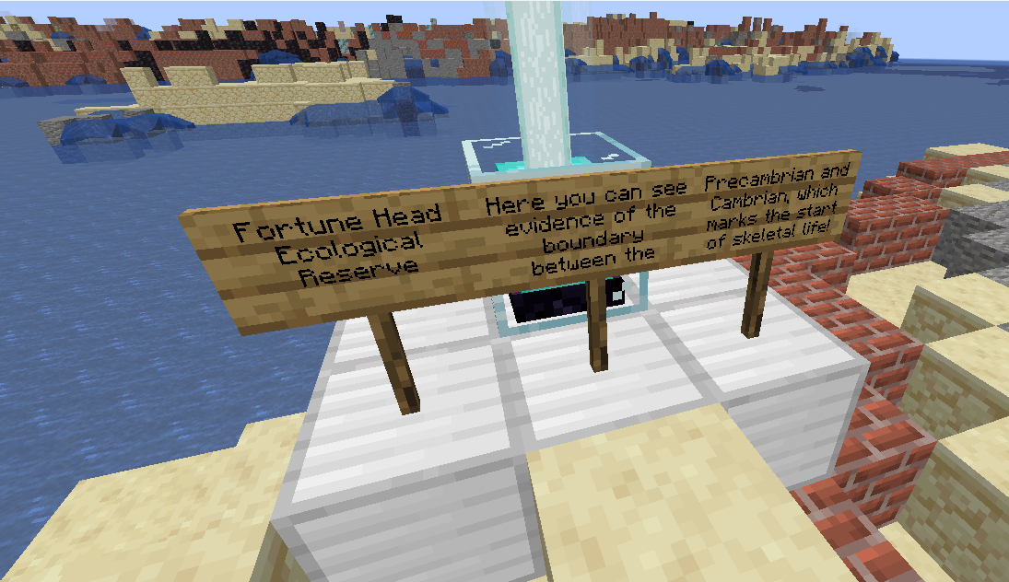
Figure 2: Example of a geologic landmark in Minecraft.

Questions:
- What are some examples of the three main rock types you can find in Newfoundland?
  - Igneous:

  - Sedimentary:

  - Metamorphic:

- How could one of these rocks from one rock type eventually form into another rock within a different rock type? (think of the rock cycle)

- What are some minerals you can find in Newfoundland?

- What are the three geologic zones of Newfoundland?

- There are some really important fossil sites in Newfoundland. Name two of these fossil sites, and describe some details about them (ex. how old are the fossils, what kind of fossils are they, why are they important)
  - Name: _______________
Description:

  - Name: _______________
Description:

- What’s an important geologic structure in Newfoundland, and why is it important?

- What’s special about the geology in Gros Morne National Park?

- Do you think Newfoundland would be a good place to mine ore? Why or why not?

Answer Key:
- What are some examples of the three main rock types you can find in Newfoundland?
  - Igneous:
  - Sedimentary:
  - Metamorphic:
- How could one of these rocks from one rock type eventually form into another rock within a different rock type? (think of the rock cycle)
  - Variable answers, ex, an igneous rock (ex. Granite) could erode, and the sediments from the granite could lithify and become a sandstone
- What are some minerals you can find in Newfoundland?
  - Gold, iron, copper
- What are the three geologic zones of Newfoundland?
  - Western/Humber Zone
  - Central/Dunnage Zone
  - Eastern/Avalon Zone
- There are some really important fossil sites in Newfoundland. Name two of these fossil sites, and describe some details about them (ex. how old are the fossils, what kind of fossils are they, why are they important)
  - Fortune Head Ecological Reserve
    - Marks the boundary between the Precambrian and the Cambrian (the Cambrian explosion). These are the best-preserved fossils from the start of the Cambrian in the world, marking the emergence of skeletal and bioturbating (sediment-mixing) life. The marker fossil for the start of the Cambrian is the Treptichnus
  - Mistaken Point
    - Ediacaran fossils (580-541MYA). Best place in the world to view a 565-million-year-old seafloor. The age and abundance of these fossils are unique to this site. These fossils are some of the first complex lifeforms on Earth
- What’s an important geologic structure in Newfoundland, and why is it important?
  - The Dover Fault
  - This fault is important because it is where two old continents came together during the formation of Pangaea
- What’s special about the geology in Gros Morne National Park?
  - In Gros Morne, we have the Tablelands. The Tablelands are composed of mantle rock. Exposed mantle rock is very rare
- Do you think Newfoundland would be a good place to mine ore? Why or why not?
  - Yes, because many valuable minerals like copper and gold can be seen on/near the surface

