Mining like a Pro in Minecraft!
Using Geophysical Data

Resource Outline:
- Advanced version of Mining like a Pro!
- Junior High version of Mining like a Pro!
- Junior High version Answer Key
- High School version of Mining like a Pro!
- High School version Answer Key

Mining in Minecraft: Advanced

Background

The Earth has many natural materials that are very valuable to us. We mine minerals from the Earth to use for building, energy, electronics, and more. Minecraft includes some of these natural resources, such as coal, iron, gold, diamond, and copper. In Minecraft, we can explore open caves to look for these resources, but in real life, finding ores is more complicated. We often don’t have these big open caves to explore, so we can’t see the ores directly. So, we need to sense the ores, and this is done with a branch of geology called geophysics.

Geophysicists use physical properties of the Earth and its materials to learn about the Earth below us. We can measure various properties of the Earth to determine what materials are in the ground. Common properties geophysicists use include density, magnetism, conductivity, and stiffness. Different materials on Earth have different physical properties. Geophysical surveys use sensing equipment to collect data about these properties. Geophysicists can then map these data and use knowledge of the physical properties of different natural materials to determine what kinds of materials are underground and where they are. Geophysical methods such as gravity and magnetic surveys are commonly used to locate ores underground.

Gravity surveys measure the gravitational pull along the survey area. The data are corrected to highlight any anomalies caused by changes in materials in the shallow subsurface. Gravity data measure the density of materials in the ground. Where gravity data values are higher, the material in that area is denser. Where the gravity data values are lower, the material in that area is less dense. Gravity surveys are used to locate ores in the ground. Ores such as gold and iron are very dense relative to the surrounding rock, causing them to appear as strong gravity anomalies in gravity data. An example of a map of gravity data is shown below:
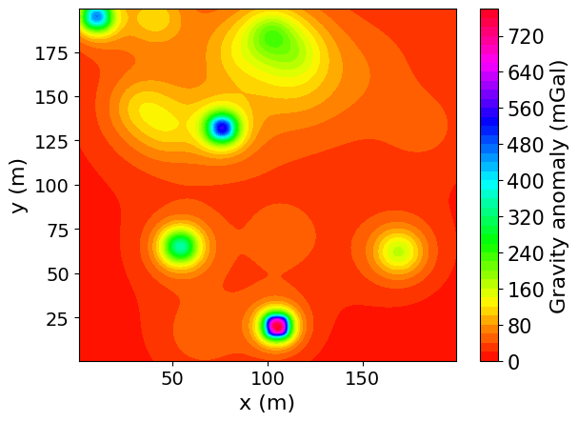
This gravity map shows gravitational anomalies where dense material lies beneath the surface. Anomalies of high gravity are seen in the cool colours (blue and purple). The anomalies highlight locations of dense materials. These dense materials could potentially be ore bodies.

Magnetics surveys measure the magnetic field along the survey area. The data are corrected to highlight the magnetic response of the shallow subsurface. Most materials in the Earth’s crust are not magnetic. But metals such as iron are often very magnetic. Strong magnetic anomalies in the data indicate the presence of magnetic material underground at that location. So, magnetic surveys are used to locate ore deposits such as iron and gold. An example of a map of magnetic data is shown below:
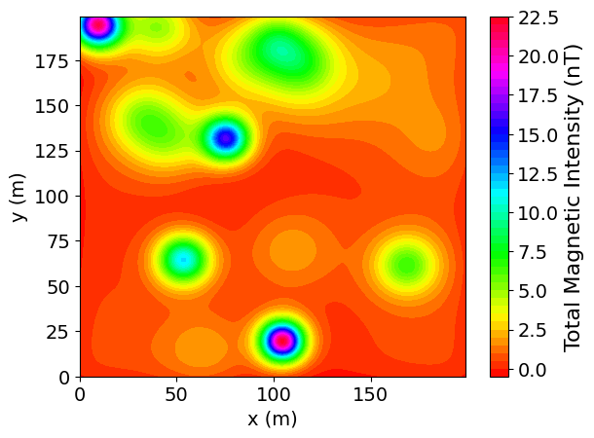
This magnetic map shows magnetic anomalies where there is magnetic material underground. Anomalies of high magnetism are seen in the cool colours (blue and purple). The anomalies highlight locations of magnetic materials. These magnetic materials could potentially be ore bodies.

Activity

In Minecraft, there’s plenty of ore you may miss because not all of it can be seen along the walls of caves. So, we can use gravity and magnetic data from Minecraft worlds to help us find ores. In this exercise, we will explore Minecraft worlds with gravity and magnetism maps and use them to mine for ores. You will have a set time to explore these worlds to try to mine as much ore as you can, and you can only use these maps to look for the ores. There are two identical worlds, one with a gravity map and one with a magnetic map. In both of these worlds, the map is located up in the sky above the play area where the ore bodies are located. You should try to explore both worlds to make sure you are using gravity and magnetic data to help you find ores, as they may reveal different targets. You can only use the tools given in your inventory when you first enter the world. Keep any materials you break/collect (ores, dirt, stone) in your inventory so you can keep track of how much of each material you find, as well as how much ground you need to dig through to get to any ores.

Questions

- How much ore did you find?

Gold:
Iron:
Diamond:

- How much of the other materials (dirt, stone) did you dig up?

Dirt:
Stone:

- If gold is worth $200 per block, iron is worth $100 per block, and diamond is worth $400 per block, how much money would you make if you sold all the ore you found?

- If dirt costs $20 to dig per block, and stone costs $35 to dig per block, how much did it cost to dig for ores?

- You had 5 pickaxes originally. How many pickaxes did you use to dig? Include any that you broke and any that are damaged. If each pickaxe costs $50, how much did your tools cost?

- Based on questions 1-5, what would your net profits be? Your net profit is your profit (the money you made selling ores) minus the money you spent on the project (the cost of tools and digging).

- Were the gravity and magnetics maps helpful? Was one more helpful than the other?

- Did you notice a difference in the ore bodies you found from really strong (purple, blue) anomalies and from medium (green, yellow) anomalies?

- Based on the previous questions and your experience using the maps, explain why using data like gravity and magnetics is beneficial compared to unthinkingly digging for ores.
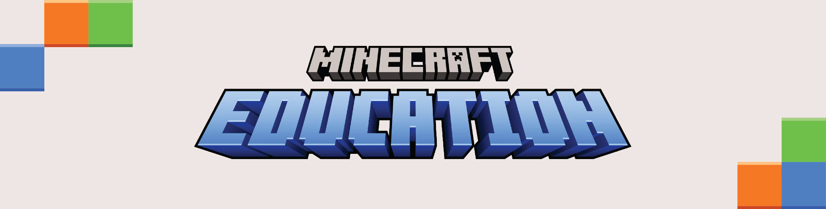
Version 1: For Junior High

Mining Like a Pro:
Using Science to Find Treasure in Minecraft!

Source: Minecraft Education

How do we find stuff?
In Minecraft, we usually just run through caves looking for shiny blocks on the walls. But in the real world, big open caves are rare! Geologists use a special science called geophysics to "sense" what is hidden deep underground without having to dig first.

Gravity Map:
The Science of Sensing
Geophysicists use special tools to measure how heavy or magnetic a rock is, kind of like using a metal detector at the beach.

- Gravity Power: Ores like gold and iron are much heavier than normal stone. Gravity maps help us find these heavy areas. In this activity, look for cool colours on the map. The higher the gravity, the more likely there's heavy ore underneath.
Magnetic Map:
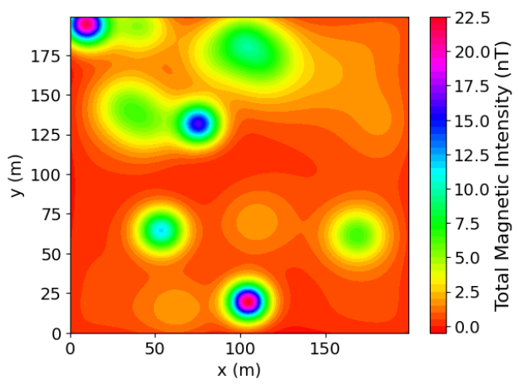
- Magnet Magic: Most rocks aren't magnetic, but metals like iron are. Magnetic maps help us find 'anomalies,' or places where the magnetic pull changes. On these maps, look for cool colours like blue and purple to spot hidden metal.

Reading Your Treasure Map
Look at the maps on the right. You'll see these in the sky in your Minecraft world. On these maps, search for cool colours like blue and purple. The bright 'bullseye' circles show physical anomalies. If you dig under those purple spots, you're more likely to find iron or gold ore.

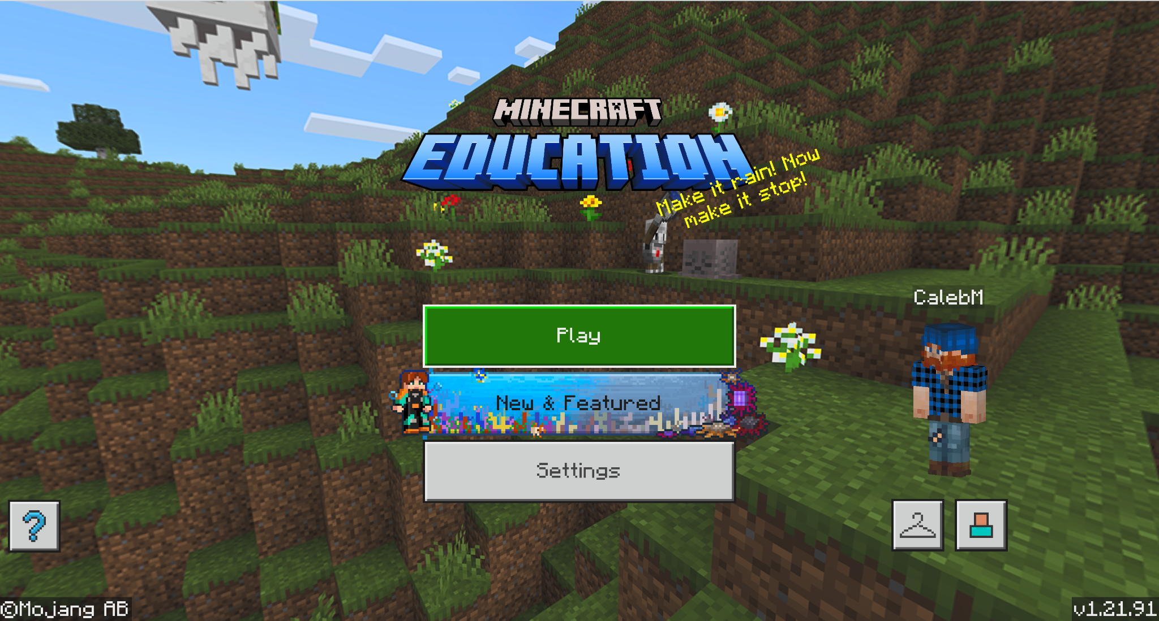
The Minecraft Challenge

You'll explore two Minecraft worlds. One has a Gravity Map, and the other has a Magnetic Map floating above the play area.
1. Your Goal: Mine as much ore as you can using only the maps to guide you.
2. The Rules: Use only the tools you start with. Keep everything you dig up, including dirt and stone, so that you can count it later. Don’t place any blocks you dig! Make sure you keep everything.

Your Mining Report. After your adventure, check your inventory and answer these:

- a) How much Gold, Iron, and Diamond did you find in grams if each block contains 1000g?

b) Look up the current price per gram for Gold, Iron, and Diamond. Trading Economics is a good source for Gold and Iron prices. Diamond prices change by quality so you can ask AI for an average price today. Make sure to use the same unit of mass as your Minecraft data. If you need to, use Google to convert units.

c) Calculate your gross profit in Canadian Dollars (CDN) by multiplying the cost by the mass collected.

- How much 'junk' (dirt and stone) did you dig up to reach the valuable ores (Diamond, Gold, and Iron)? Remember, each block is 1000g.

3. The Big Question: Did using the maps help you save time? Was it better than just digging randomly and hoping to find ore?

Case Study:  The Iron Ore Company of Canada (IOC) in Labrador City employs over 2000 employees in our province. IOC hires people to design, maintain, and operate the massive machinery used in mining, as well as office support roles and geoscientists to serve as the "detectives" of the mine, using 3D modelling, rock sampling, and sensors to find high-grade iron ore and map out the safest places to dig. Current projections estimate the Labrador City operation will continue until 2079. | 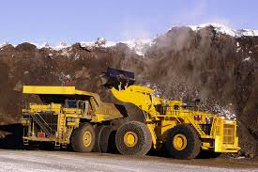Labrador Iron Ore Royalty Corporation
They have mineral resources of approximately 2.8 billion tonnes with an average grade of 38% iron.
  - In 2022, IOC produced 17.9 million tonnes of iron ore concentrate and pellets.

  - In March 2022, the average price of Canada’s iron ore exports was CA$155.39 per tonne.

  - The production costs at this time were CA$82 per tonne.

Questions:
1. Using the information above, calculate the net profit.

(Hint: 1. Determine the profit per tonne and 2. multiply the profit per tonne by the total production.)

2. If only 38% of the rock at the IOC mine is actually iron, that means a huge part of the 2.8 billion tonnes is just 'junk' rock. Why is it important for the IOC 'detectives' to map the ground before they start digging?

(Hint: Think about your Minecraft inventory—what happens to your Net Profit if you spend all your money digging up regular stone instead of iron?)

3. If a company fails to target anomalies, how would the cost of excavating low-grade impact their ability to remain profitable until their goal of 2079?

4. Give 4 suggestions for why it costs CA$82 to produce concentrated iron.

Teacher Answer Key:

Answer Key: Mining Like a Pro

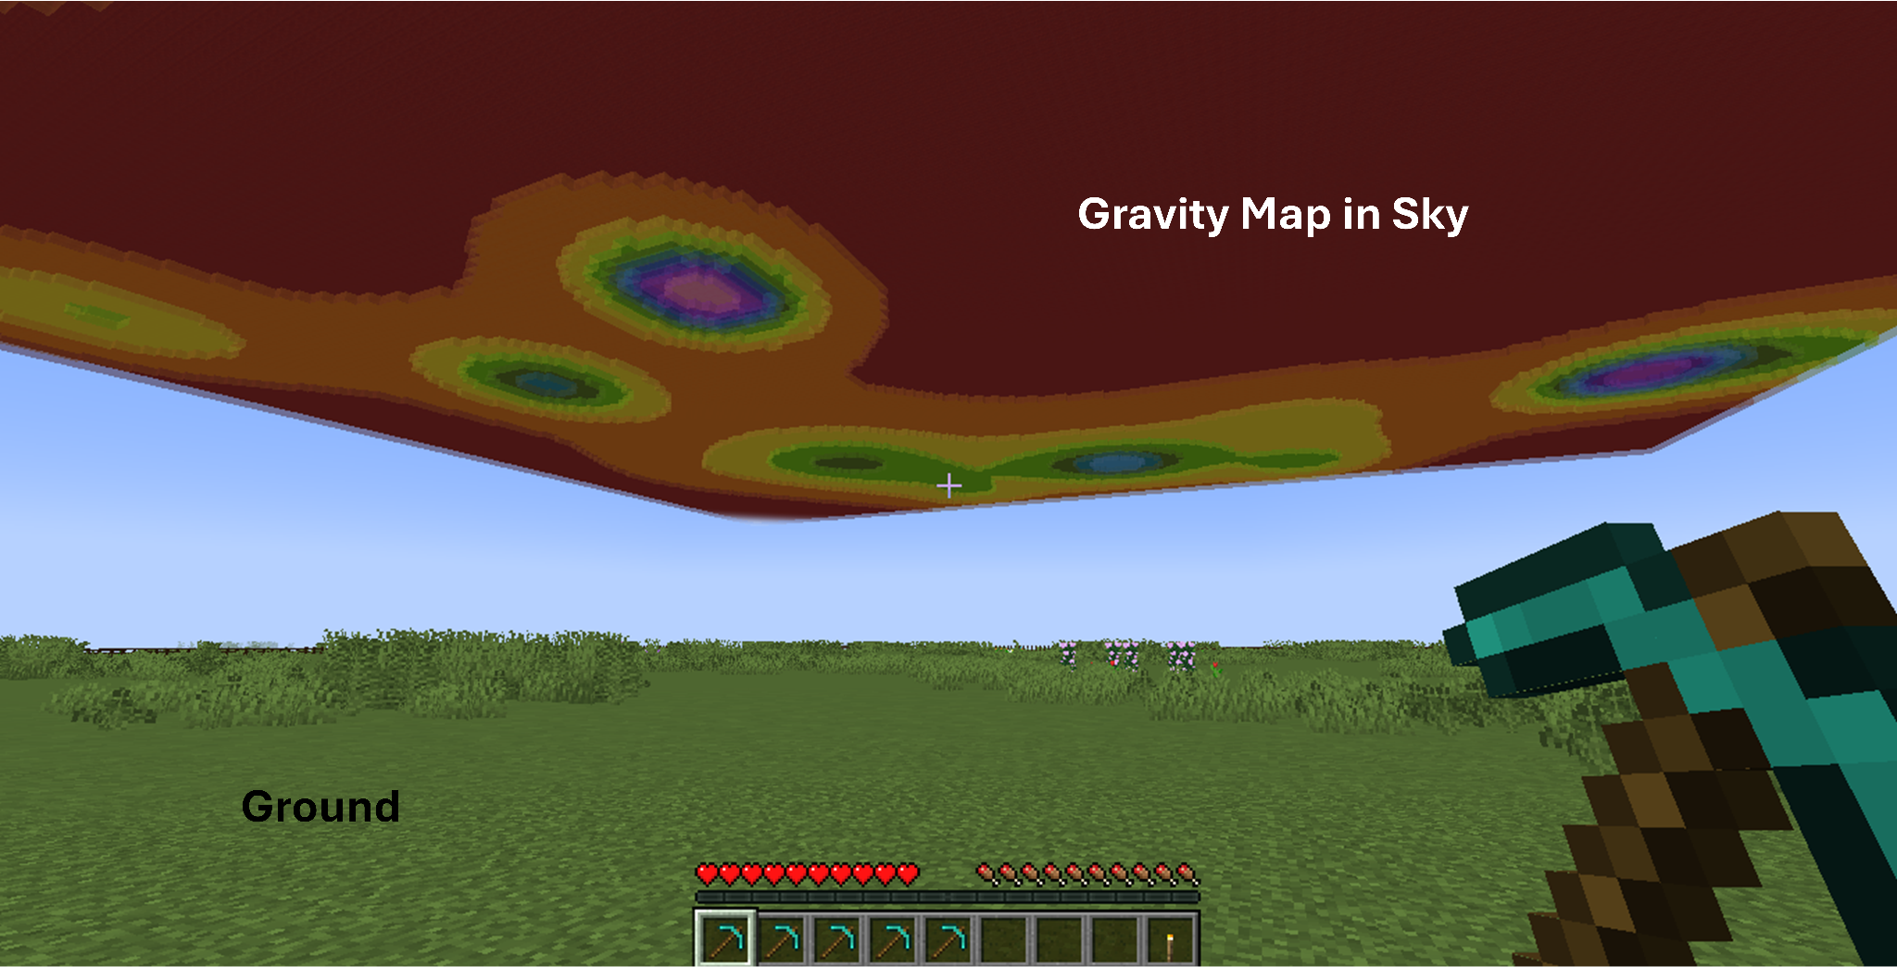
Here’s what the Minecraft worlds look like, including some of the key features related to this exercise:

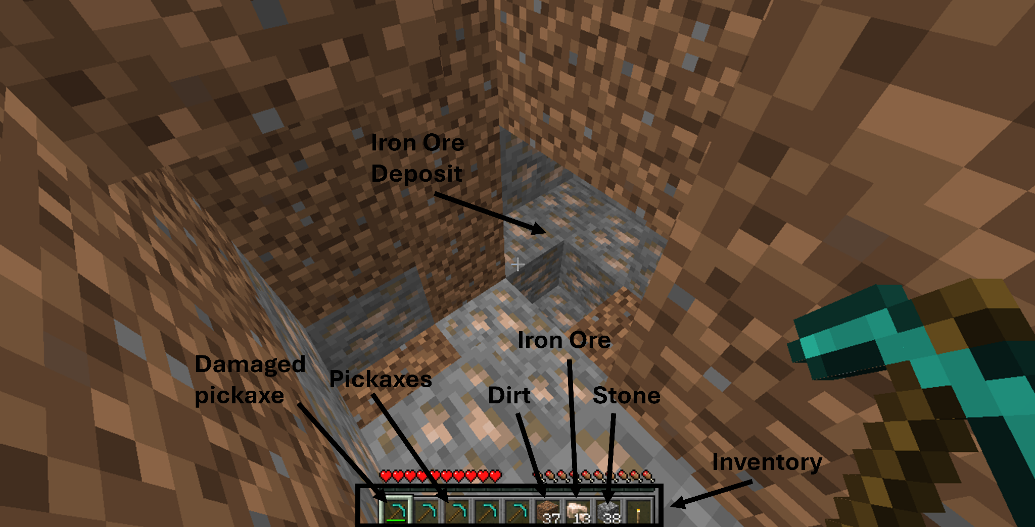
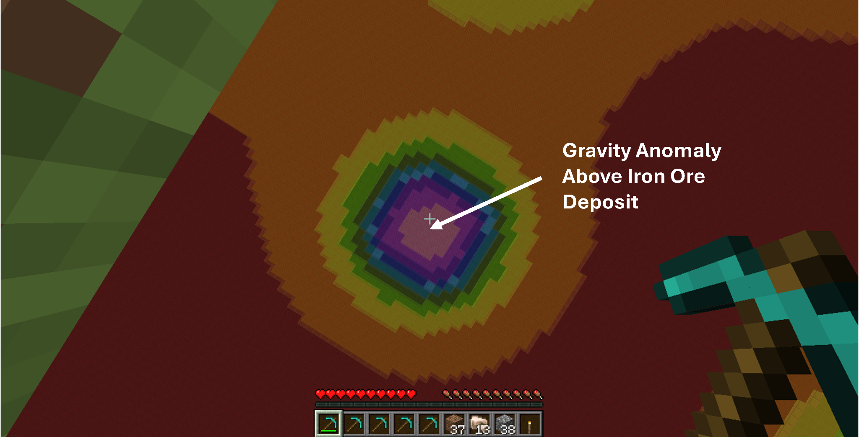
- a) How much Gold, Iron, and Diamond did you find in grams?
Answer: This depends on the student’s individual results. Students should list the number of blocks or the converted mass (in grams) for each ore type in their inventory.
b) Search the current cost of Gold, Iron and Diamond per mass for today.
Answer: This requires an external search by the student. Guidance: Students should ensure the unit of mass (e.g., grams or tonnes) matches their Minecraft data before calculating.
c) Calculate your gross profit in Canadian Dollars (CDN) by multiplying the cost by the mass collected.
Answer: (Mass of Gold × Current Price) + (Mass of Iron × Current Price) + (Mass of Diamond × Current Price). Note: This represents Revenue before any expenses are subtracted.

- How much "junk" (dirt and stone) did you have to dig through to get the economic ore?
Answer: This is recorded from the student’s inventory.
  - Scientific Context: In geophysics, this is known as waste rock or the "host rock" that surrounds the target anomaly. Measuring this is critical because every block of dirt or stone dug represents a cost in both time and tool durability.

3. The Big Question: Did the maps save you time? Was it better than just digging holes and hoping for the best?
Answer: Yes, using the maps is significantly more efficient than "blindly digging".
Explanation:
  - Targeting: The Gravity Map identifies dense materials (gold/iron/diamond) and the Magnetic Map identifies metals (iron) using "cool colours" (blue and purple) to mark anomalies.
  - Efficiency: Digging directly under these anomalies saves time because players do not waste their limited resources (pickaxes) or expend effort excavating large volumes of "junk" material that yield nothing.
  - Profitability: Students maximize their Net Profit by reducing waste rock, which is their revenue minus the costs of tools and digging. Just like real-world geophysicists, you can make "smart decisions" that deliver a better return on investment than guessing.

Answer Key: IOC Case Study Analysis

1. Quantitative Financial Analysis. Using the 2022 data provided in the case study:
- Step 1: Determine the Profit per Tonne
  - $155.39 (Sale Price) - 82.00 (Production Cost) = CA $73.39 per tonne
- Step 2: Calculate Total Net Profit
  - 73.39 (Profit per Tonne) × 17,900,000 (Total Production) = CA $1,313,681,000
- Net Profit is defined as the money earned from selling ore minus the money spent on the project, including the cost of tools and digging.
2. Why is it important for the IOC "detectives" to map the ground before digging?
- Answer: Mapping is essential because real-world ores are hidden deep underground and cannot be seen directly. If a company engages in "blind digging" without maps, they waste significant money excavating "junk rock" (dirt and stone).
- Minecraft Connection: Just as your Minecraft inventory fills up with dirt and stone that costs money to dig, mapping allows the company to target only the valuable areas, maximizing Net Profit by minimizing the costs of moving non-profitable material.
3. How would failing to target anomalies impact profitability?
- Answer: Magnetic and Gravity maps show anomalies in cool colours, which highlight the most likely locations for ore bodies. If a company mines low-grade sections (like 20% iron) instead of their targets, they must excavate much more "host rock" to find the same amount of iron.
- Impact: Because the production cost (CA$82) remains the same regardless of rock quality, mining low-grade areas reduces the profit margin and could make the mine economically unviable before its 2079 goal, as investors would not see a high enough return on the expensive machinery and labour required.
4. Based on the case study and geophysical principles, the CA$82 cost likely covers:
- Specialized Labour: Wages for over 2,000 employees, including geoscientists who act as "detectives" to analyze data.
- Advanced Technology: The expense of 3D modelling, rock sampling, and high-tech geophysical sensing equipment used for gravity and magnetic surveys.
- Machinery and Maintenance: Designing, fixing, and running the massive machinery required to move millions of tonnes of rock.
- Operational Excavation: The direct cost of digging and processing waste material (dirt, stone, and gravel) to extract the 38% of usable iron.

Version 2: For High School

Geophysical Prospection: Data-Driven Exploration in Minecraft

Introduction to Geophysics
In the mining industry, success is determined by data rather than chance. Whereas Minecraft players may rely on visual cues in caves, real-world ore deposits are generally located deep underground. Geophysicists identify these deposits by measuring the Earth's physical properties to create maps.

Methods of Exploration

- Gravity surveys measure the gravitational pull within an area, which results from the density of the rock below. Ores such as iron and gold result in gravitational anomalies.

- Magnetic surveys detect variations in the Gravity Map:
Earth's magnetic field. Certain metals have strong magnetic properties. Magnetic maps highlight these materials. In the simulation, anomalies in the blue and purple spectral bands indicate areas of high magnetism and potential ore bodies.

Data Interpretation:
Magnetic Map:

The Magnetic Map to the right is the geophysical data for your exploration area. When analyzing this data, focus on the Total Magnetic Intensity (nT) scale on the right.
- Cool colours (Purple/Blue): These represent strong magnetic anomalies and are your primary targets for magnetic ore bodies.
- Warm colours (Red/Orange): These represent the standard "host rock" or background noise where ore is unlikely to be found.


The Field Exercise

You will be placed in two identical Minecraft worlds, each featuring a data map (Gravity or Magnetics) displayed in the sky above the play area. Your objective is to use these data sets to maximize your resource extraction.

Steps:
1. First, examine the data maps above your world to identify areas where the maps suggest valuable ore might be found.

2. Next, as a team, choose specific locations where you want to start digging based on your analysis of the magnetic and gravity anomalies.

3. Then, mine in your chosen areas, collect all materials you find, and record your findings (type and amount of resources, waste rock, and tool durability).

4. Finally, use this data to calculate and discuss which exploration strategies led to the most efficient and profitable mining.

In your Minecraft activity, you will take on the roles of both investors and geophysicists. As 'investors,' you must decide how to allocate your resources (such as tools and time) to achieve the best return. As 'geophysicists,' you'll use the magnetic and gravity data provided to pinpoint the most promising locations, helping your team make smart decisions and maximize your mining profits—just like real professionals do in the industry.

Data Collection:

Each team should write down the following data after each mining round:
- Number and type of valuable ores collected (e.g., iron, gold, diamonds)
- Amount of waste material collected (dirt, stone, gravel)
- Number of tools used or the amount of tool durability used
- Number of mining attempts or locations dug
- Total time spent mining
Documenting this information enables comparison of strategies and identification of the most effective methods for achieving successful outcomes.

Analysis and Results

To determine the success of your survey, calculate your Net Profit:
- Revenue: Total value of all Gold, Iron, and Diamonds collected.

- Expenses: The cost of digging (per block of dirt/stone - assume one block is one tonne) plus the cost of your pickaxes.

- Net Profit: Revenue minus Expenses.

4. Without Geophysics: Compare your results to a hypothetical 'blind digging' scenario. How would the lack of geophysical data affect your profit margins?

Discussion Questions

- How did the strength of the anomalies (e.g., purple vs. yellow) correlate to the size or type of ore body you found?

- Based on your net profit, explain why geophysical sensing is a more sustainable and cost-effective method than "blind" exploration.

Case Study: Economic and Geophysical Analysis of the Iron Ore Company of Canada (IOC)
Source: Mining in Newfoundland and Labrador 2022 Report

The Iron Ore Company of Canada (IOC) in Labrador City employs over 2,000 individuals within the province. IOC recruits personnel to design, maintain, and operate mining machinery, provide office support, and hire geoscientists. Geoscientists act as the "detectives" of the mine, using 3D modelling, rock sampling, and sensors to locate high-grade iron ore and identify the safest excavation sites. Current projections indicate that the Labrador City Mine operation will continue until 2079. |   Labrador Iron Ore Royalty Corporation
IOC has mineral resources of approximately 2.8 billion tonnes with an average grade of 38% iron. To put this into perspective, 2.8 billion tonnes of iron is enough to build over 350,000 Eiffel Towers or nearly 400 million full-sized cars. This massive amount of high-quality iron ore makes IOC one of the most important mining sites in the country.

- In 2022, IOC produced 17.9 million tonnes of iron ore concentrate and pellets.
- In March 2022, the average price of iron ore exports was CA$155.39 per tonne.
- The production costs at this time were CA$82 per tonne.

Net Profitability is the money left after you subtract all project costs from what you earn by selling resources. In mining, these costs include digging through worthless dirt or stone. Just like in Minecraft, your net profit is what you make from ores minus what you spend on tools. If you manage your resources well, you can earn more.

Investors, whether individuals or companies, provide the funds for tools and specialized sensing equipment, hoping the project will turn a profit. Geophysicists use magnetic and gravity maps to help mines find valuable ore and reduce risk. Using data like this makes mining investments more attractive by helping maximize profits.

The Iron Ore Company of Canada (IOC) in Labrador City employs over 2,000 individuals within the province. IOC recruits personnel to design, maintain, and operate mining machinery, provide office support, and hire geoscientists. Geoscientists act as the "detectives" of the mine, utilizing 3D modelling, rock sampling, and sensors to locate high-grade iron ore. Current projections indicate that the Labrador City Mine operation will continue until 2079.

Quantitative Financial Analysis

Using the provided 2022 IOC data, perform a fiscal analysis of their operations. Fiscal analysis provides investors with the information they need to make informed decisions.

Calculate the Net Profit Margin per tonne of iron ore.

Calculate the total Annualized Net Profit based on the production guidance of 17.9 million tonnes.

Considering the net profit, explain why the "cost of digging" (production costs) is a critical variable in determining whether a mineral deposit is considered an "ore" or just common rock.

The Geoscience of Efficiency: Managing the Waste-to-Ore Ratio

​The IOC mine has an average grade of 38% iron, meaning 62% of the extracted material is non-profitable "host rock." As 38% is an average, finding rock containing more or less iron is possible.

Drawing on the text, explain how geophysicists can ensure the maximum amount of iron is mined.

How does the use of magnetic intensity maps act as a financial safeguard against the high costs of "blind digging"?

Long-term Sustainability and Resource Targeting

IOC aims to remain operational until 2079. This goal will create employment for future generations, while encouraging the economy in Western Labrador. Additionally, IOC benefits the entire province by contributing to the provincial gross domestic product and generating tax revenue.

If the company fails to target concentrated iron sections and instead mines lower-grade sections (e.g., 20% iron), describe the impact on their investors.

Operational Expenditure (OPEX) Inquiry: The case study notes that IOC employs over 2,000 people and uses large machinery, 3D modelling, and sensors.

Suggest four specific operational factors that contribute to the CA$82 per tonne production cost.

Teacher Answer Key

Minecraft Activity:

Here’s what the Minecraft worlds look like, including key features related to this exercise:





1. Revenue: Calculate by multiplying the total quantity of Gold, Iron, and Diamond collected by their respective market values.
2. Expenses: Sum the operational costs of digging (total blocks of dirt/stone excavated multiplied by the cost per block) and the total cost of pickaxes used or broken during the simulation, multiplied by that cost.
3. Net Profit: Subtract the total Expenses from the total Revenue.
4. Comparative Analysis: Blind Digging Scenario
- Tool Durability: Without geophysical data, tool durability would decrease much faster. Players would break more pickaxes digging through random "host rock".
- Volume of "Junk" Material: In a "blind digging" scenario, the volume of excavated waste rock would be higher. Because the player lacks data to pinpoint anomalies, they have to dig a larger area to find ore, leading to a low waste-to-ore ratio.
- Profit Margins: The lack of data would likely lead to lower profit margins. The high cost of digging and replacing broken tools would likely outweigh the value of the small amount of ore found by chance.
Discussion Questions

1. How did the strength of the anomalies correlate with the size or type of ore body you found?
Answer: Stronger anomalies indicate areas of high magnetic intensity. Students should find that these locations contain larger ore bodies or more concentrated deposits of magnetic metals like iron. Medium anomalies typically indicate smaller deposits. Stronger anomalies are also closer to the surface.
2. Based on your net profit, explain why geophysical sensing is a more sustainable and cost-effective method than "blind" exploration.
Answer: Geophysical sensing is more cost-effective as companies allocate resources only where there is a high probability of finding value. By targeting specific gravity or magnetic anomalies, the mine avoids the expense of processing "junk" rock. It is more sustainable because it achieves a higher return.
Iron Ore Company of Canada - Case Study - Answer Key

1. Quantitative Financial Analysis
Calculate the Net Profit Margin per tonne of iron ore.
Answer: CA$73.39. Calculation: $155.39 (Sale Price) - $82.00 (Production Cost) = $73.39
Calculate the total Annualized Net Profit based on production of 17.9 million tonnes.
Answer: CA$1,313,681,000. Calculation: 17,900,000 tonnes×$73.39 profit per tonne.

Explain why the "cost of digging" is a critical variable in determining whether a deposit is "ore" or "common rock."
Answer: Net profit is the money made from selling ores minus the cost of digging. If the cost of extracting the rock is greater than the value of the minerals it contains, the deposit is not economically viable.

2. Managing the Waste-to-Ore Ratio
Explain how geophysicists use physical properties to differentiate iron from "junk rock" before excavation.
Answer: Geoscientists use properties like density and magnetism. Iron is much denser than the surrounding host rock, creating strong anomalies in gravity surveys. Additionally, while most crustal materials are not magnetic, iron is highly magnetic, allowing it to be detected by magnetic sensors as a high-intensity anomaly.

How do magnetic intensity maps act as a financial safeguard against "blind digging"?
- Answer: Magnetic maps highlight anomalies, which mark potential ore bodies. By using this data, companies avoid the expense of "blindly digging" through "junk rock" (dirt and stone) that has no magnetic intensity or no valuable iron.

3. Long-term Sustainability and Resource Targeting
Analyze the impact on investors if the company mines lower-grade sections (e.g., 20% iron).
Answer: Since investors provide upfront money expecting a profit, mining lower-grade sections increases their risk. If the grade drops, the company extracts less iron per tonne of rock moved, thereby lowering net profit.

Explain why geophysical "detective work" is essential for long-term profitability.
Answer: “Detective work" using sensors and modelling ensures they are targeting the highest-grade ore, maximizing revenue. Maximizing efficiency will sustain the mine until 2079.

4. Operational Expenditure (OPEX) Inquiry
Suggest four specific operational factors that contribute to the CA$82 per tonne production cost.
Possible Answers:
- Labour Costs: Wages for over 2,000 employees.
- Maintenance: Fixing and running massive mining machinery.
- Technology: Upfront and operational costs for sensing equipment or 3D modelling.
- Excavation: The physical cost of digging and moving "junk rock" to reach the iron.

