The Great Earth Puzzle: Seeing the Big Picture

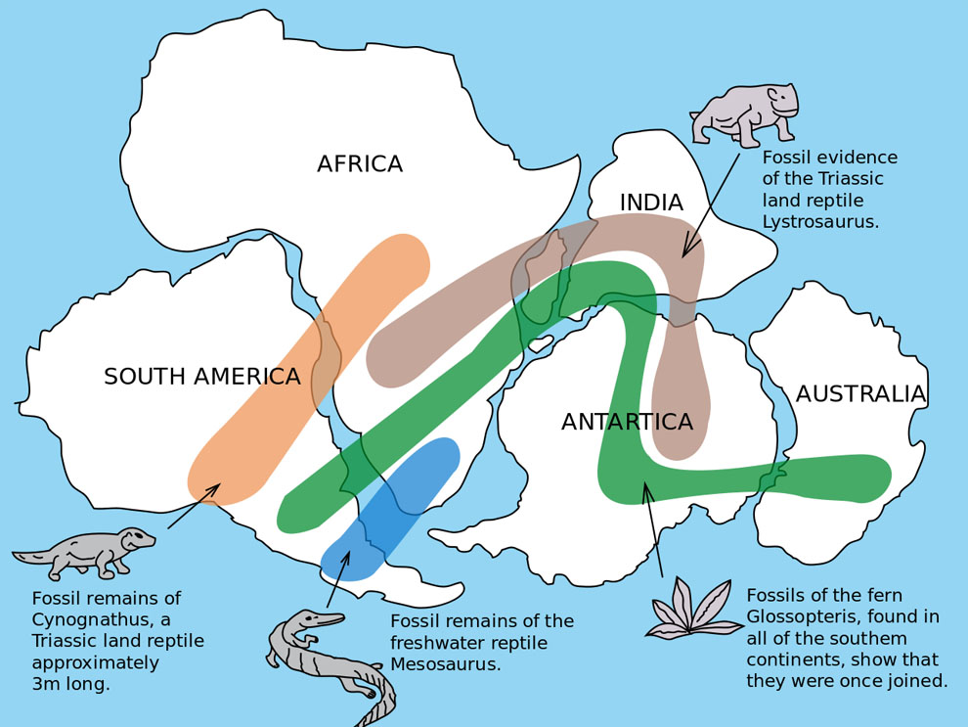
For most of human history, people had a limited view of our planet. Less than 600 years ago, many still worried the Earth might be flat. As explorers sailed across the Atlantic, new maps forced people to rethink their old ideas.

A Big Idea

Over 100 years ago, Alfred Wegener noticed that the coastlines of South America and Africa looked like they could fit together like puzzle pieces. He found amazing evidence: fossils of the same plants and animals on opposite sides of the ocean (see figure to the right for examples of matching fossils on different continents), and minerals that form only in tropical places found in icy polar regions. In 1912, he proposed the idea of Continental Drift, the idea that landmasses have shifted over time.

The Human Side of Science

The story of plate tectonics shows the "human side" of science. Scientists are regular people who can have egos, be competitive, and find it difficult to change their minds. Many ignored Wegener's evidence simply because it was new and challenging. To keep things fair, science follows strict rules: scientists must keep clear records so others can repeat their experiments. Wegener kept excellent records and notes, which kept his ideas alive and encouraged more scientists to search for evidence, including whether they could find additional evidence to support his theory of Continental Drift further.

Solving the Mystery: A Team of Global Scientists

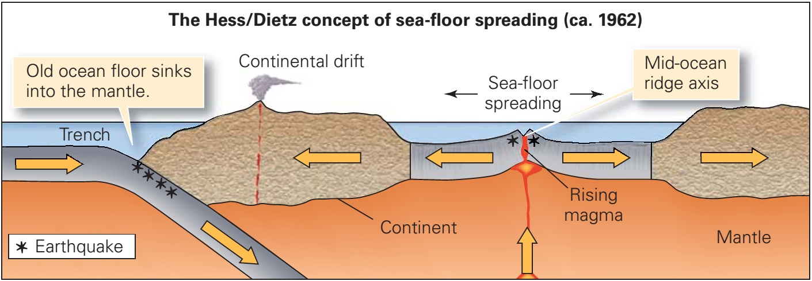
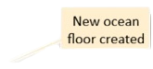
Wegener couldn't explain how continents moved in 1912. In 1960, Harry Hess used sonar to map the ocean floor and discovered underwater mountain chains. Sonar uses sound waves and calculates how far away something is based on when its signal returns to the machine. He found that the rocks were youngest at these ridges and got older as they moved further away.

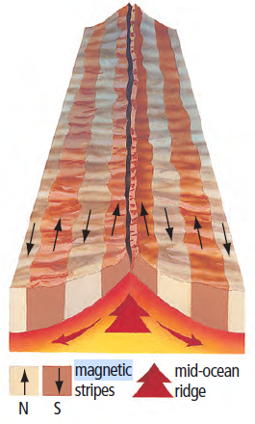
Magnetometers were used to locate submarines during World War II. When ships carrying magnetometers crossed the Atlantic Ocean, the magnetometers usually pointed north, but sometimes they pointed south unexpectedly. The scientists noticed a pattern resembling stripes of magnetic reversals travelling along paths parallel to the Mid-Atlantic Ridge on both sides of the ridge. A Canadian geophysicist, Lawrence Morley, was one of the first to have the “eureka” moment that put all the pieces of evidence together when he found "magnetic reversals" frozen in the rock. The first geophysics professor at Memorial University, Ernst Deutsch, published data connecting magnetic reversals and continental drift in 1963. The mystery of magnetic reversals was solved by looking at how igneous rock solidifies. When magma cools at mid-ocean ridges, minerals like magnetite act as tiny compass needles, locking into place to match the Earth's current magnetic orientation. Because we see alternating 'stripes' of magnetic polarity that mirror each other on both sides of a ridge, this provided credible evidence of seafloor spreading. The ocean floor acts as a geological timeline, recording millions of years of shifting magnetic history as new crust is created and pushed outward.
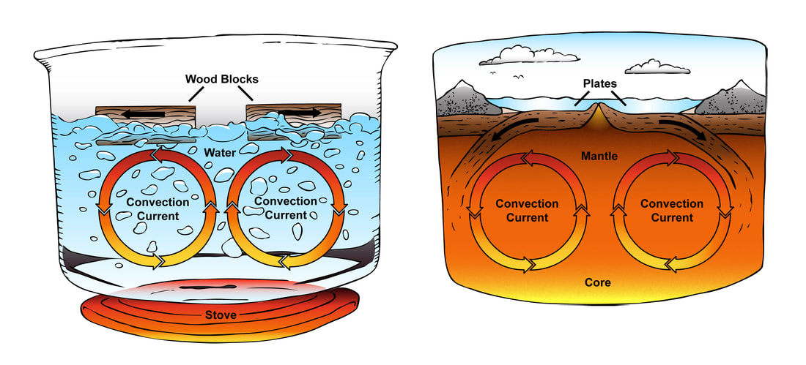
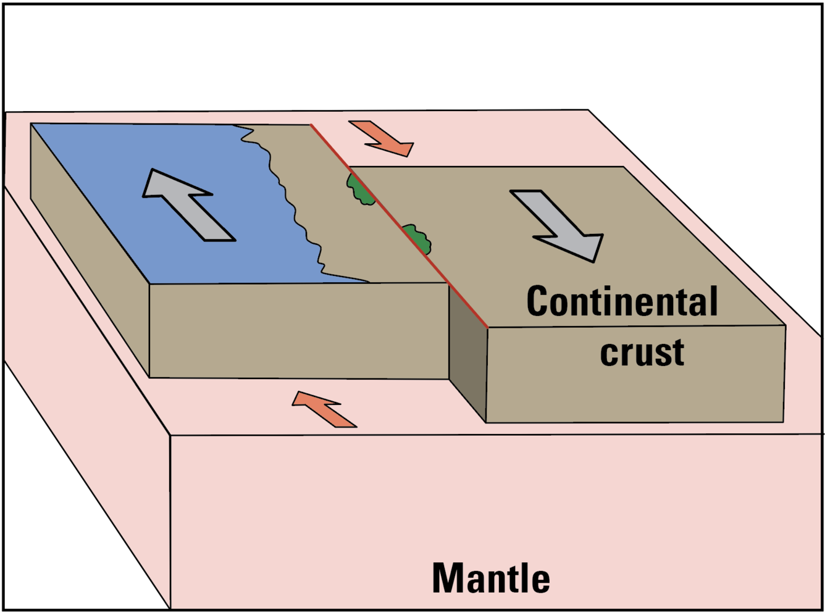
In other words, magnetic reversals show that the continents don't just sail through the ocean; they move because the entire ocean floor is moving. Scientists around the world have found that these giant plates move because of convection currents. Like a pot of boiling soup, heat from the Earth’s core causes the mantle to move in a cycle, pushing the plates along like a conveyor belt.
Transform Boundary
Mantle

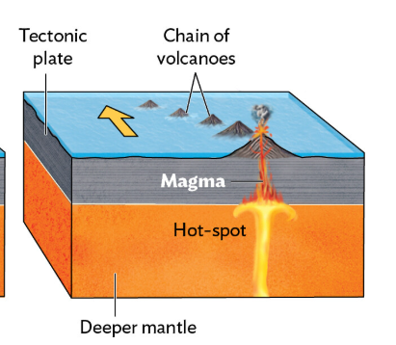
A famous Canadian scientist, J. Tuzo Wilson, made three major discoveries that helped complete the theory of Plate Tectonics during the 1960s. He was the first to propose that the Earth’s outer shell is broken into giant, rigid pieces called "plates". Beyond identifying these pieces, he discovered transform boundaries, which are special areas where plates grind and slide past one another. He also explained the existence of "hotspots" — stationary plumes of hot magma that act like torches under the Earth, creating island chains like Hawaii as the plates slowly move over them.

Newfoundland: A Global Collision

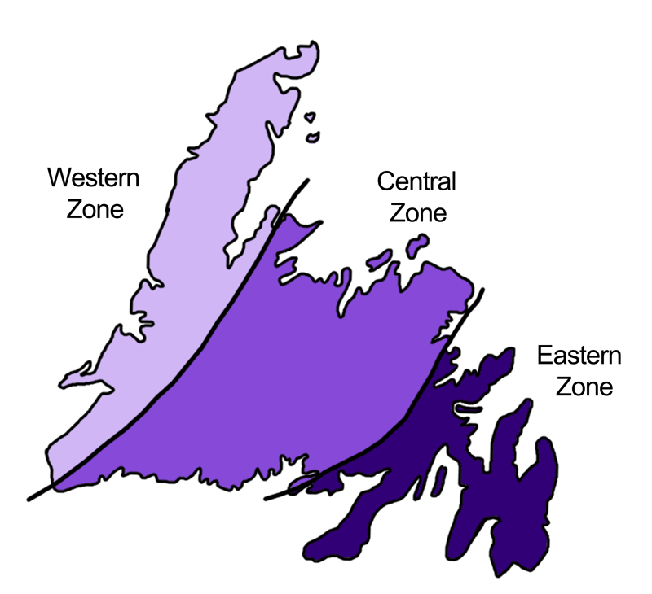
While Wilson was mapping the theory of plate tectonics, Harold “Hank” Williams, a Newfoundlander, was focused on mapping geology. He used what he learned in Tuzo Wilson’s lab to create a famous map showing that Newfoundland is made of three different geological zones.

Our province is a perfect example of these moving plates, as seen in the Appalachian Mountains of Newfoundland, where the history of their movement is recorded in the province's geology. Long before the Atlantic Ocean existed, there was an older ocean called Iapetus. About 500 million years ago, the plates squeezed together, causing a massive crash. The Western Zone of Newfoundland was the edge of ancient North America, while the Eastern Zone (the Avalon Peninsula) was actually part of Africa.

How Science Builds the Future

By working together and sharing results, scientists like Wegener, Hess, Wilson, and Williams continue to solve the mysteries of our planet. Today, we know that our continents are still moving at a speed of about 3 centimetres a year—about as fast as your fingernails grow. This slow but powerful movement is what causes the earthquakes and volcanoes that continue to shape our world.

Sources Cited:

- University of California Museum of Paleontology. "Alfred Wegener (1880-1930)," Online Historical Resource.
- National Geographic. "Continental Drift Diagram," Educational Diagram.
- Learning Geology. "Seafloor Spreading Theory Diagram," Educational Diagram.
- Geological Survey of Canada. "Seafloor Spreading Theory (1963)," Historical Record of the Morley-Vine-Matthews Hypothesis.
- SEPM Society of Sedimentary Geology. “Polar Wandering and Continental Drift.” Ernst Deutsch, Memorial University, 1963.
- Ludman, A. & Marshak, S. "Hotspot Volcanism Diagram," Laboratory Manual for Introductory Geology (5th ed.), W. W. Norton & Company, Figure 2.12.
- US Geological Survey. “Transform Boundary Diagram”
- Memorial University. "A Man for All Seasons: Hank Williams – Innovator," Online Biographical Resource.
- Ryan, A. B. "Geology of the West Coast of Newfoundland (1983)," Newfoundland Journal of Geological Education, 7(2).
- Shreeve, J. "The Greatest Journey (2006)," National Geographic, 209(3), 60-69.
- Heritage Newfoundland and Labrador. "Geological Map of Newfoundland," a resource showing Geological Subdivisions.

Short answer comprehension questions:

1. What are the three pieces of evidence that support Wegener’s theory of continental drift?

2. What was the missing piece of the puzzle that Wegener needed to support his theory?

3. Does a discovery always change the way we “see the big picture”? Why or why not?

4. There were three Canadian Scientists discussed in this article. List the geoscientists and include their contribution to the Plate Tectonic Theory.

5. Newfoundland is approximately 4000 km away from Africa. If the Earth’s crust is moving at a rate of 3 cm per year, how long ago would we have been joined together? Do you think that this is possible? Explain your answer.

6. What is a “convection current”? How do convection currents cause crustal plates to move?

7. Based on the story of Alfred Wegener, how can a scientist’s ego or their old beliefs stop a new scientific theory from being accepted?"

8. What are two 'rules' or habits scientists use today to make sure their personal feelings don't stop new evidence from being heard?

Comprehension Multiple Choice:
1. Alfred Wegener first noticed that South America and Africa looked like they could fit together like puzzle pieces by looking at which?
A) Satellite photos
B) Map coastlines
C) Deep-sea sonar records
D) Volcanic rock patterns

2. Which analogy is used in the article to explain how convection currents move Earth's plates?
A) A giant jigsaw puzzle
B) A tape recorder playing music
C) A pot of boiling soup
D) A growing fingernail

3. Why did many scientists in the early 1900s ignore Alfred Wegener’s evidence for Continental Drift?
A) Wegener did not have any fossils to show them.
B) They believed the Earth was flat at that time.
C) Wegener could not explain how the continents actually moved.
D) He lived in a polar region and could not send his books to other countries.

4. When Harry Hess mapped the ocean floor, what did he discover about the age of the rocks?
A) The rocks were the same age everywhere.
B) The rocks got younger the further they were from the ridge.
C) The rocks were the oldest at the center of the mountain ridge.
D) The rocks got older as they moved further away from the ridge.

5. Which Canadian scientist is famous for proposing that the Earth's shell is broken into giant, rigid pieces called "plates"?
A) Harry Hess
B) Alfred Wegener
C) J. Tuzo Wilson
D) Harold "Hank" Williams
6. How did J. Tuzo Wilson explain that some volcanoes, like those in Hawaii, form in the middle of plates?
A) Continental drift
B) Hotspots
C) Transform faults
D) Iapetus Ocean currents

7. According to the "Human Side of Science," why is it sometimes hard for new scientific theories to be accepted?

A) Scientists are not allowed to use their imagination.
B) Scientists can have egos or find it hard to change their minds.
C) Science has no strict rules for keeping records.
D) New evidence is always thrown away completely.

8. Newfoundland’s Avalon Peninsula (the Eastern Zone) was once physically attached to which continent?
A) North America
B) Antarctica
C) Africa
D) Europe

9. What does it mean when the article describes science as a "cumulative process"?
A) Science always stays the same and never changes.
B) New ideas are accepted only if the scientist is famous.
C) Scientists throw away old ideas every time they find something new.
D) Science builds over time by updating or modifying old theories with new information.

10. Canadian geophysicist Lawrence Morley used tools called magnetometers to find "magnetic reversals" frozen in the rock of the ocean floor. This evidence acted like a "giant tape recorder" to help prove which concept?
A) The Earth is a solid, unmoving sphere.
B) The seafloor is spreading apart.
C) Continents move by floating on top of the ocean water.
D) All mountains were once underwater.

Digital Extension:

Edpuzzle created for: Continental Drift - 100 Greatest Discoveries - Science Channel

Research Ideas for Student Projects:

- Can you find fossils that link the Avalon Peninsula to Northern Africa?
- What geological feature links western Newfoundland to the rest of the old North American continent?
- What rock types would you expect to make up most of central Newfoundland?
- What are the various technologies scientists used to discover the Plate Tectonic Theory?

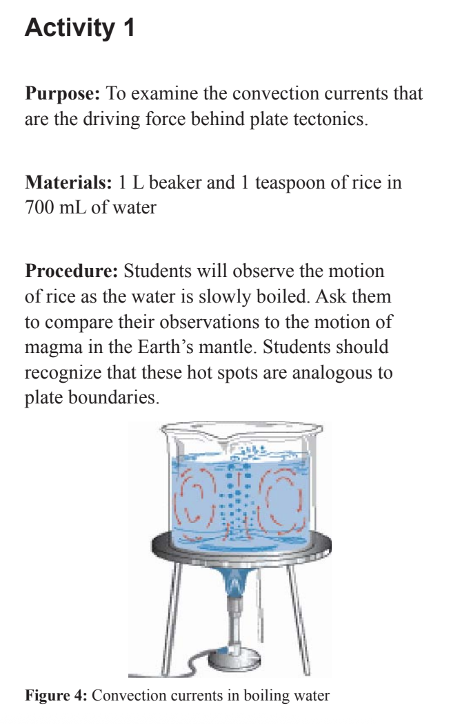
Extension Activities:

Activity 1:

Purpose: To examine the convection currents that are the driving force behind plate tectonics.

Materials:
1 L beaker
1 teaspoon of rice in 700 mL of water

Procedure:
Students will observe the motion of rice as the water is slowly boiled. Ask them to compare their observations to the motion of magma in the Earth’s mantle. Students should recognize that these hot spots are analogous to plate boundaries.

Activity 2:

Have students learn more about “the Nature of Science” from Project 2061: A long-term research initiative focused on improving scientific literacy from the American Association for the Advancement of Science.

Guiding questions:
- Many scientists ignored Alfred Wegener’s ideas for decades. Based on what you know about the 'human side' of science, why might a senior scientist with a long career refuse to accept a young scientist’s new theory, even if the evidence seems 'plainly obvious' today?
- Explain how the transition from the theory of Continental Drift to the theory of Plate Tectonics is an example of science being a 'cumulative process.' Did Harry Hess prove Wegener wrong, or did he provide the 'missing piece' that allowed the theory to be modified and improved?
- Wegener looked at maps, fossils, and minerals to propose his theory. How did he use his imagination to connect a fossil in Africa to a fossil in South America? Why is imagination just as important as logic in the systematic study of our planet?
- To prevent personal bias or 'cheating' from affecting scientific decisions, what are some major expectations scientists have of each other when sharing new conclusions? How do these rules help ensure that the whole community accepts a discovery like Harry Hess’s sonar mapping?

