Igneous Rocks: Cooling Rate and Crystal Size

Outline:
- Student lab with questions embedded in the scientific method
- Teacher Resource with additional explanations
- Suggested answer key

Teacher’s Guide: The "Magma to Mineral" Demo

Igneous Rocks: Cooling Rate and Crystal Size

This experiment demonstrates the relationship between cooling rate and crystal size when considering the formation of igneous rocks:

- Slow cooling (Intrusive/Plutonic): Occurs underground. Atoms have more time to find each other and build onto existing structures, resulting in large, visible crystals (e.g., Granite).

- Fast cooling (Extrusive/Volcanic): Occurs at the surface. Atoms are "locked" in place quickly, resulting in tiny or microscopic crystals (e.g., Basalt).

I. Observation and Questioning
Before starting, look at the dry Epsom salt and the boiling water. How do you think the salt will behave differently in hot water versus room-temperature water? (2 points)

We know igneous rocks have different textures. What specific question are we trying to answer by putting one jar in the fridge and one on the counter? (1 point)

II. Hypothesis Formation
Based on what you know about igneous rocks, which environment (warm or cold) do you hypothesize will produce the largest crystals? Explain. (2 points)

Can you frame your prediction as an "If/Then" statement? (e.g., "If the cooling rate is slower, then...") (1 point)

III. Identifying Variables
Independent Variable: In this experiment, what is the one factor that we are purposely changing between the two jars? (1 point)

Dependent Variable: What exactly are we measuring or observing to see if our change had an effect? (1 point)

Controlled Variables: List three controlled variables. (3 points)

Why is it important that both jars have the same amount of water and the same concentration of salt? What would happen to our data if one jar had more salt than the other? (1 point)

Materials:

- Epsom salt
- Water
- Two glass jars or beakers
- Food colouring (optional, for visibility)

Procedure:

- Boil roughly 1 cup of water; teachers will handle the hot water.
- Add Epsom salt 1/4 cup at a time, stirring until it no longer dissolves (you should see a few grains at the bottom).
- Pour the clear liquid into your two glass jars or beakers, making sure they have equal amounts.

The Experiment: Two Environments

To simulate different geological conditions, you will create two distinct cooling environments:

1. The "Volcanic" Environment or Fast Cooling: Place one jar in the refrigerator or an ice bath.

2. The "Plutonic" Environment or Slow Cooling: Place the second jar in a warm area (like a sunny windowsill) or wrap it in a towel to insulate it.

IV. Data Collection and Analysis
Qualitative vs. Quantitative: How would you describe the shape of the crystals (qualitative) versus the number or size of the crystals (quantitative)? (2 points)

Visual Evidence: How does the "volcanic" jar (fridge) look different from the "plutonic" jar (warm spot) after 24 hours? (2 points)

V. Observations to Record: (3 points)
Variable | Fridge or ice bath container | Warm Spot or insulated container
Crystal Size
(large or small)
Growth Speed
(fast or slow)
Rock Equivalent (plutonic or volcanic) and rock name.

Using a scale, please draw the crystals in the two different experimental conditions. (4 points)

Exemplar: | Slow Cooling Crystals: | Fast Cooling Crystals:
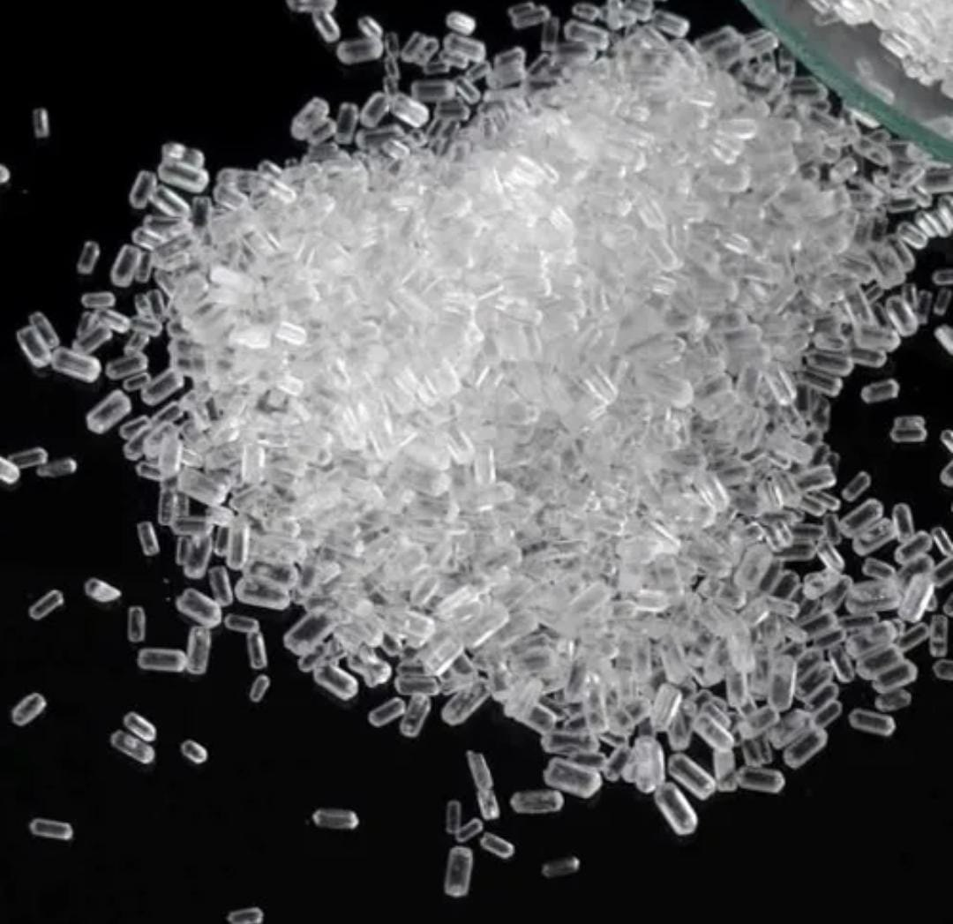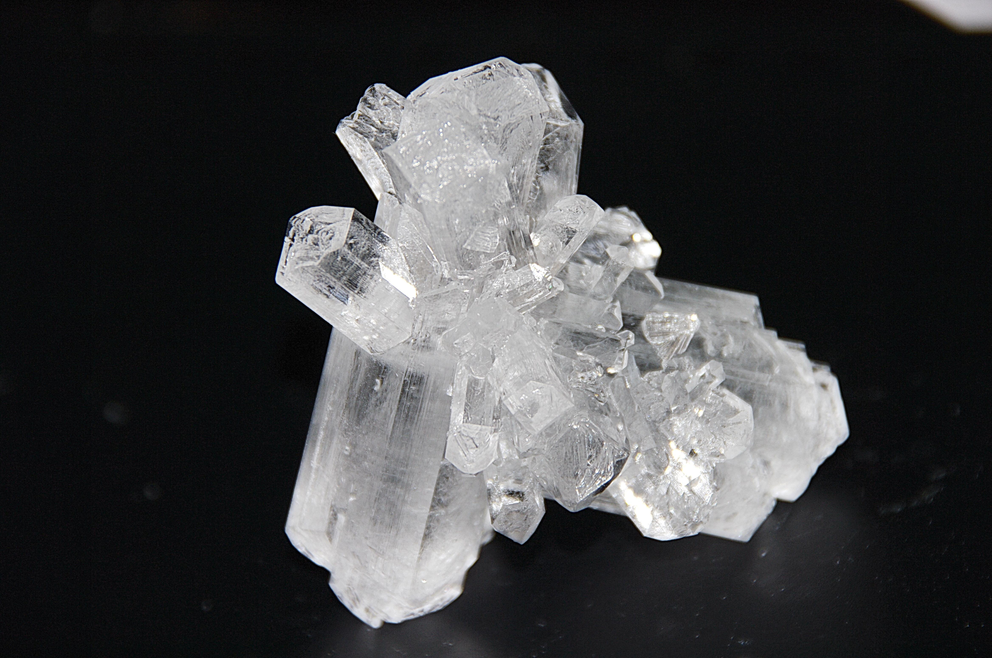
1 cm
5 cm
Small crystals
Large
crystals

VI. Drawing Conclusions
Did your actual results support or disprove your original hypothesis? (1 point)

If you found an igneous rock in nature with very large, chunky crystals, what can you conclude about how and where that rock was formed? (1 point)

Experimental Error: What are some factors that might have "messed up" our results? List at least three. (3 points)

VII. Taking it Further
If we did this experiment again and put one jar in the freezer (extremely fast cooling), how do you think that would change the results compared to the refrigerator? (1 point)

BONUS QUESTION: How might the results change if we used a different substance, like table sugar or Borax, instead of Epsom salt? (1 point)

Draw a diagram of igneous texture, cooling rate and location of cooling. Include the following:
- Volcano and magma chamber. (2 points)
- The crystal size and texture classification for two cooling rates. (2 points)
- Give 3 rock type examples of each texture. (3 points)

You should use this diagram to help with your study.

%

_______ =
40
Teacher Resource:

The Experiment: Two Environments

To simulate different geological conditions, you will create two distinct cooling environments:

1. The "Volcanic" Environment (Fast Cooling)
Place one jar in the refrigerator or an ice bath.
- The Process: The rapid drop in temperature causes the solution to become "supersaturated" quickly.
- The Result: A dense "forest" of very thin, needle-like crystals. Because they grew so quickly, they didn't have the time or space to form thick, distinct structures. Small crystals represent aphanitic (fine-grained) rock textures.

2. The "Plutonic" Environment (Slow Cooling)
Place the second jar in a warm area (like a sunny windowsill) or wrap it in a towel to insulate it.
- The Process: As the water evaporates and cools slowly, the magnesium sulphate molecules have time to align perfectly.
- The Result: Fewer, but significantly thicker and more defined crystals. Large crystals represent phaneritic (coarse-grained) rock textures.

Pro-Tip for Better Crystals

If you want the "slow" version to look truly impressive, drop a pebble, a piece of gravel, or some sand into the jar once it has cooled slightly. The addition gives the molecules a foundation to build upon, often resulting in much larger, singular structures rather than a clump of small ones.

Teacher Answer Key

I. Observation and Questioning
- Behaviour in Hot vs. Room-Temperature Water:
  - The jar that goes in the refrigerator will cool much faster, resulting in smaller crystals. (1 point)
  - The jar that stays in a warm location will cool more slowly, giving crystals more time to form. (1 point)
- The Specific Question:
  - How does the rate of cooling (the speed at which the temperature drops) affect the size and texture of the crystals that form? (1 point)

II. Hypothesis Formation
- The Prediction:
  - The warm environment will produce the largest crystals (1 point) as the crystals will have more time to grow. (1 point)
- "If/Then" Statement:
  - If the cooling rate is slower in a warm environment, then the resulting crystals will be larger and more defined. (1 point)

III. Identifying Variables
- Independent Variable:
  - The environmental temperature (the cooling rate). (1 point)

- Dependent Variable:
  - The size/shape/texture of the crystals. (1 point)

- Controlled Variables:
1. The volume of water used;
2. The amount of Epsom salt dissolved.
3. The type of container used. (1 point each)

- Importance of Consistency:
  - If one jar had more salt, it might crystallize faster or more densely regardless of temperature, making the data "noisy" (1 point).

IV. Data Collection and Analysis

- Qualitative vs. Quantitative:
  - Qualitative describes the appearance (e.g., "The crystals look like long needles" or "They look like chunky blocks"). (1 point)
  - Quantitative describes measurable data (e.g., "The crystals are 5mm long" or "There are approximately 50 crystals"). (1 point)

- Visual Evidence:
  - The "volcanic" jar will likely show a thick, messy slush of tiny, thin needles. (1 point)
  - The "plutonic" jar will show fewer, but much thicker and more distinct geometric shapes. (1 point)

V. Observations to Record (3 points - 0.5 point for each block completed)
Variable | Fridge or ice bath container | Warm Spot or insulated container
Crystal Size  (large or small) | Small, fine, or needle-like | Large, coarse, and blocky
Growth Speed  (fast or slow) | Fast (starts within minutes/hours) | Slow (takes hours or days)
Rock Equivalent (plutonic or volcanic) and rock name. | Volcanic (e.g., Basalt) | Plutonic (e.g., Granite)

Crystal Drawing:

Exemplar: | Slow Cooling Crystals: | Fast Cooling Crystals:
  1 cm  5 cm  Small crystals  Large  crystals | - 0.5 point for size  - 0.5 point for shape  - 0.5 point for tidiness  - 0.5 point for scale | - 0.5 point for size  - 0.5 point for shape  - 0.5 point for tidiness  - 0.5 point for scale

VI. Drawing Conclusions

- Hypothesis Support:
  - Student's answer based on result—usually, it supports the hypothesis that slow cooling creates larger crystals. (1 point)

- Geological Conclusion:
  - The rock was formed intrusively (underground), where the surrounding earth acted as insulation, allowing the magma to cool very slowly over a long period. (1 point)

- Experimental Error: (3 points - 1 for each)
  - 1. Moving/shaking the jars during growth;
  - 2. Contamination (dust in the jar);
  - 3. The "warm" spot is cooling down too quickly at night.

VII. Taking it Further

- Freezer vs. Refrigerator:
  - The freezer would likely produce even smaller crystals, or perhaps a solid mass with no visible individual crystals, similar to how obsidian (volcanic glass) forms from nearly instantaneous cooling. (1 point)

- Different Substances:
  - Borax usually produces larger, sturdier octahedral crystals compared to the needle-like Epsom salt, while sugar takes much longer to crystallize and forms "Rock Candy" structures. Answers that include crystal shape, ability to dissolve and crystal size should all be marked correct. (1 point)

Study Diagram: Grading Scheme

- Extrusive (Volcanic):
  - Volcano drawing (1 point)
  - Crystal Size and Texture: Aphanitic (Fine-grained). (1 point)
  - Examples: Basalt, Rhyolite, Obsidian (Glassy). (1.5 points)

- Intrusive (Plutonic):
  - Magma Chamber Drawing (1 point)
  - Crystal Size and Texture: Phaneritic (Coarse-grained). (1 point)
  - Examples: Granite, Gabbro, Diorite. (1.5 points)

Teacher’s Guide: The "Magma to Mineral" Demo

If you’re short on time, this could be a demo to introduce igneous rocks’ cooling rate and textures in 10 minutes in one class and 10-15 minutes in the next class.

1. Preparation & Safety
- The "Secret" to Success: Use distilled water if your tap water is hard. Mineral impurities in tap water can interfere with crystal clarity.
- Safety First: Since this involves boiling water, the heating should be done by the teacher using a hot plate or electric kettle.
- Labelling: Ensure you label your jars to encourage students to do the same while doing labs.
- Extension: Prepare four jars instead of two if you want to show "extreme" versions (Freezer vs. Insulated Box).

2. The Setup (The "Magma" Phase)
- Heat the Water: Bring 2 cups of water to a boil.
- Saturate the Solution: Slowly stir in Epsom salt. Continue adding until you see a thin layer of salt at the bottom that will not dissolve, no matter how much you stir. The solution mimics the high mineral concentration in molten magma.
  - Pro-Tip: This is a supersaturated solution, a term in the Mixtures and Solutions Unit later in this course.
- Colouring (Optional): Add 1–2 drops of food colouring. Use blue for the "Cold/Volcanic" jar and red for the "Warm/Plutonic" jar to help students associate the colours with temperature.

3. Creating the Environments

Divide the liquid equally into two glass jars (or four if you’re doing the extension activity).

Jar A: The "Volcanic" Surface (Extrusive)
- Action: Place this jar immediately in a bowl of ice or the back of a refrigerator.

- Analogy: Tell the students, "This represents lava erupting onto the cold surface of the Earth or into the ocean."

- Expected Observation: Crystals will start forming almost immediately. They will be thin, needle-like, and disorganized.

Jar B: The "Plutonic" Chamber (Intrusive)
- Action: Place this jar in a warm spot or an insulated container. To be even more accurate, wrap it in a thick towel or place it inside a small cooler (without ice).

- Analogy: Explain to students, "This represents magma underground, where the surrounding rock insulates the magma, keeping it warm for a long time."

- Expected Observation: It may take 12–24 hours to see results. The crystals will be much thicker and chunkier.

4. Classroom Discussion Points

As you set the jars aside, ask the students to predict the outcome using the Scientific Method:
- Cooling rates analogies:
  - Fast Cooling (No Time): "Imagine you have 10 seconds to build a LEGO tower. You’re going to be rushing, dropping pieces, and you'll end up with a tiny, messy pile. This rush is what happens in the fridge. The salt doesn't have time to build anything big, so it makes tiny, thin needles."

  - Slow Cooling (Lots of Time): "Now imagine you have all day to build that tower. You can snap every piece into place perfectly and build it as tall as you want. This is what happens in the warm spot. Because the 'magma' stays liquid longer, the salt has the time to find its partners and build big, chunky crystals."

- The Texture Connection: Show a piece of Granite (Large crystals) and a piece of Basalt (Tiny crystals that cannot be seen with the naked eye). Ask the students to guess which jar represents which rock.

Troubleshooting for Teachers

- No crystals forming? Your solution wasn't saturated enough. Reheat the water and add more salt until it no longer dissolves.

- Crystals look like a solid block? This outcome happens if the cooling is too fast. If the fridge is too cold, you get a "crystal slush" rather than individual needles.

- Hard to see? Once the crystals have grown, carefully pour off the excess liquid so the students can see the structures clearly without distortion from the water, then use a hand lens to magnify the crystals.

Timing:
- Set up: Setting up the demo should take around 10 minutes as you encourage students in a discussion to understand the connection between cooling rate and crystal size.

- Follow-Up: The next day, have students use a hand lens to examine the crystals. To save time, and if you have a document viewer, you could put the crystals on your Smart Board/TV.

