STEM Jobs
Geologist


What Is Geology?
Geology is all about studying the Earth. It focuses on Earth’s physical features in the past, present and sometimes into the future. Geology is a type of science that can help us in many ways. Some examples of these are:
• Finding out when natural disasters may happen, such as earthquakes and volcano eruptions.
• Finding important materials in the Earth’s surface, such as oil and gas.
• Understanding how our land changes and moves, for example, studying erosion.

Types of Geologists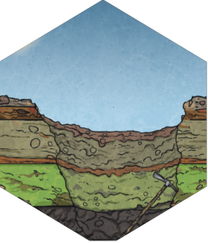
Geologists can focus on different types of sciences. Each geologist has special responsibilities. Here are some of the job titles geologists may have and the areas they may work in.
• Environmental geologist: Tries to find ways to prevent
or lessen the effects of natural disasters, such as flooding, bushfire, climate change and more.
• Planetary geologist: Studies the geology of other planets and space matter, such as meteorites and asteroids.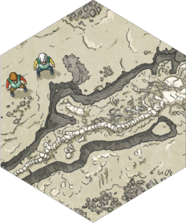
• Geomorphologist: Studies land, water and ice systems and their effects.
• Geophysicist: Uses special tools, like magnets and electricity, to study the internal features of Earth.
• Palaeontologist: Studies fossils from long ago to reveal information about the history of the Earth.
These are just some of the types of jobs that geologists do.

Page 1 of 2 visit twinkl.com.au

^{STEM Jobs} Geologist

Becoming a Geologist

People who are interested in becoming geologists need to have certain skills and study certain subjects. Geologists are usually great at solving problems. They also need to enjoy both working outdoors and within a lab. To become a geologist you need to go to university to earn a degree. Some of the subjects geologists need to study include biology, physics, chemistry, mathematics and computer science. So if you are interested in a career as a geologist, these are great subjects to think about studying.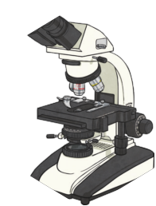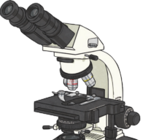
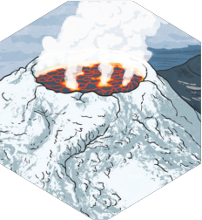
Want to Know More?
If this job sounds interesting to you, have a look at some of these great geological resources to learn more:

…

…

…

Page 2 of 2 visit twinkl.com.au

STEM Jobs
Geologist Comprehension Questions

1. Geology is the study of:
a. water b. Earth c. space
d. dinosaurs

2. Write down one way geology can help us.

3. Which type of geologist specialises in studying space matter? a. geophysicist
b. palaeontologist
c. geomorphologist
d. planetary geologist

4. Environmental geologists can help us to understand natural disasters. a. true
b. false

5. What does a palaeontologist do?

Page 1 of 2 visit twinkl.com.au

STEM Jobs
Geologist Comprehension Questions

6. List down two skills people need to become a geologist.

7. What subjects should you study if you want to become a geologist? Circle all that apply.
a. physics
b. art
c. business
d. mathematics e. biology

8. Geologists spend all of their time working outdoors. a. true
b. false

Page 2 of 2 visit twinkl.com.au

