Evil Plan (kill ladiesman461 with poisonous candies)
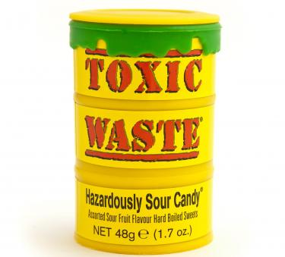
frame-col-ypos:0.247222in; bot-style:none; xpos:-0.156944in; wrap-mode:wrapped-both; frame-type:image; frame-page-xpos:0.843056in; ypos:0.062500in; top-style:none; frame-height:2.937500in; frame-pref-page:0; left-style:none; position-to:column-above-text; frame-col-xpos:-0.156944in; frame-pref-column:0; right-style:none; frame-width:3.250000in; frame-page-ypos:1.247222in
Obtain the toxic waste candy from a local store
- go to Chicago and come back by 8:00pm
Elephant's Candy | Chicago

Wrap it and leave it in front of ladiesman461‘s apt

leave town at 10pm

