Assignment 21.2

Aviation data analysis

The U.S. Department of Transportation’s (DOT) Bureau of Transportation Statistics (BTS) tracks the on-time performance of domestic flights operated by large air carriers. Summary information on the number of on-time, delayed, canceled, and diverted flights appears in DOT’s monthly Air Travel Consumer Report, published about 30 days after the month’s end, as well as in summary tables posted on this website. Summary statistics and raw data are made available to the public at the time the Air Travel Consumer Report is released.

Downloaded the dataset of DelayedFlights.csv and uploaded in the local file system /home/acadgild/Sumona

The dataset has 29 columns as follows :

Name 1

Description
Year 1987-2008

- Month 1-12

3 | DayofMonth | 1-31
4 | DayOfWeek | 1 (Monday) - 7 (Sunday)

- DepTime actual departure time (local, hhmm)

6 CRSDepTime scheduled departure time (local, hhmm)

- ArrTime actual arrival time (local, hhmm)

8 CRSArrTime scheduled arrival time (local, hhmm)

- UniqueCarrier unique carrier code

10 | FlightNum | flight number
11 | TailNum plane tail number
12 | ActualElapsedTime |  | in minutes

- CRSElapsedTime in minutes

- AirTime in minutes

15 ArrDelay arrival delay, in minutes

16 | DepDelay |  | departure delay, in minutes
17 | Origin | origin IATA airport code
18 | Dest | destination IATA airport code
19 | Distance |  | in miles

- TaxiIn taxi in time, in minutes

- TaxiOut taxi out time in minutes

22 | Cancelled | was the flight cancelled?
23 | CancellationCode |  | reason for cancellation (A = carrier, B =
weather, C = NAS, D = security)
24 | Diverted | 1 = yes, 0 = no

- CarrierDelay in minutes

- WeatherDelay in minutes

27 | NASDelay | in | minutes
28 | SecurityDelay | in | minutes
29 | LateAircraftDelayin minutes

Problem Statement 1:

Find out the top 5 most visited destinations.

First we will read the DelayedFlight.csv file and then split the columns and take the column 18.

After splitting, we will combine the occurrence of the value and take the top 5 values.

val delayed_flights = sc.textFile("/home/acadgild/sumona/DelayedFlights.csv")

val mapping = delayed_flights.map(x => x.split(",")).map(x => (x(18),1)).filter(x => x._1!=null).reduceByKey(_+_).map(x => (x._2,x._1)).sortByKey(false).map(x => (x._2,x._1)).take(5)

Output:

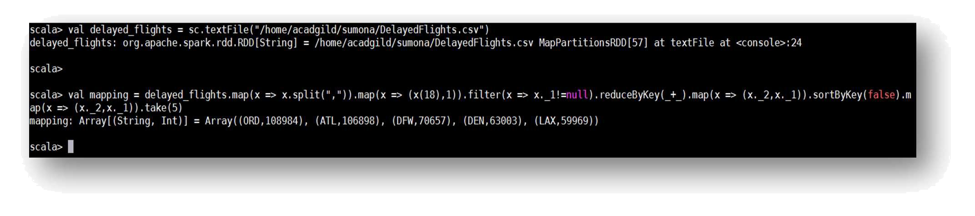

Problem Statement 2

Which month has seen the most number of cancellations due to bad weather?

Here we will split the columns to get the columns 22 and 23 and combine the occurrence values and get the output.

val canceled = delayed_flights.map(x => x.split(",")).filter(x =>

((x(22).equals("1"))&&(x(23).equals("B")))).map(x => (x(2),1)).reduceByKey(_+_).map(x => (x._2,x._1)).sortByKey(false).map(x => (x._2,x._1)).take(1)

Output:
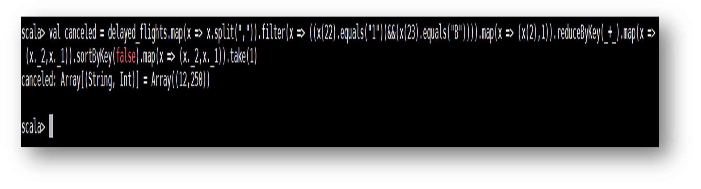

Problem Statement 3

Top ten origins with the highest AVG departure delay

We will split the RDD and select the column 16 and 17, by using the reduceByKey we will combine the occurrence of the value and using the case, we are getting the average value.

val avg = delayed_flights.map(x => x.split(",")(17),x.split(",")(16).toDouble).mapValues((_, 1)).reduceByKey((x, y) => (x._1 + y._1, x._2 + y._2)).mapValues{ case (sum, count) => (1.0 * sum)/count}.map(x => (x._2,x._1)).sortByKey(false).map(x => (x._2,x._1)).take(10)

Output:
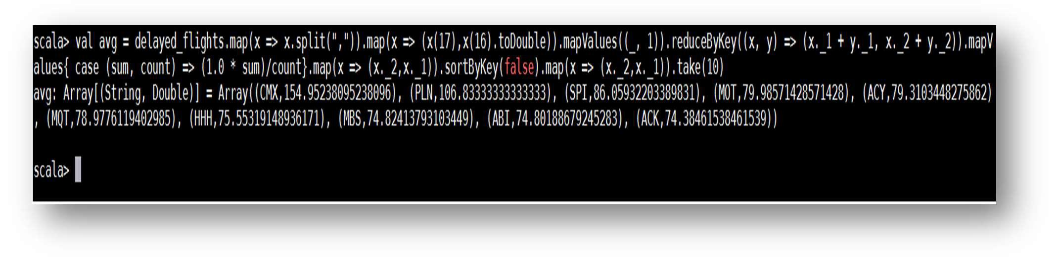

Problem Statement 4

Which route (origin & destination) has seen the maximum diversion?

We will split the RDD and select the column 24 and by using the reduceBykey we will combine the occurrence of the value and the add the numbers.

val diversion = delayed_flights.map(x => x.split(",")).filter(x => ((x(24).equals("1")))).map(x => ((x(17)+","+x(18)),1)).reduceByKey(_+_).map(x => (x._2,x._1)).sortByKey(false).map(x => (x._2,x._1)).take(10).foreach(println)
