**CodeCoverage-UI: Karma-angular**

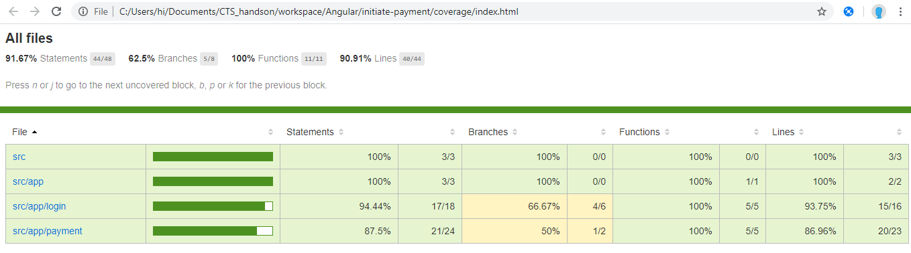

**CodeCoverage-Java: Sonar**

