MM Cleaning & Optimization Control

Material master rationalization & governance
Project Charter

Table of contents
No table of contents entries found.

01 Project purpose
Rationalize the SAP material master to retain only the articles genuinely required for business continuity, reduce duplicate and unnecessary material numbers, and establish controlled creation, extension, sourcing and phase-out practices across the relevant plants.
REDUCE  Unnecessary material numbers and duplicate variants | CONTROL  New creation and global / local extensions | STANDARDIZE  Plant, MRP and sourcing master data

02 Future-state creation & extension policy
Default position: do not create a new article number. Permit exceptions only when a documented business case confirms that existing articles, approved alternatives, and the Product Group (PG) mechanism cannot satisfy the requirement.
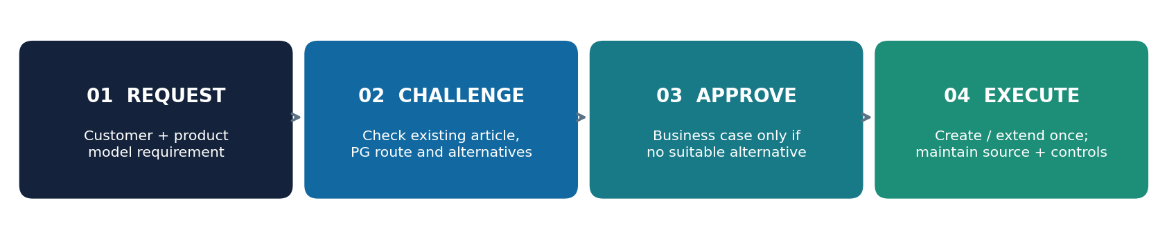
- All global material extensions and local creation requests must pass the standard PG-based review. PG article assignment should reflect the customer + product-model combination, subject to approved design and technical rules.
- Where a new article is justified and approved, extend it to the defined in-scope plants in one coordinated transaction/workflow, rather than repeated case-by-case extension.
- Where an ELC material is applicable, include its extension as part of the creation/extension workflow; verify the source-system and organizational prerequisites before release.
- Creation is not complete until source-of-supply information and the required purchasing info record are maintained or a documented exception is approved.

03 Phase-out decision flow
Every rationalized article is screened for open sales orders (SO), purchase orders (PO), and stock before any final phase-out action.
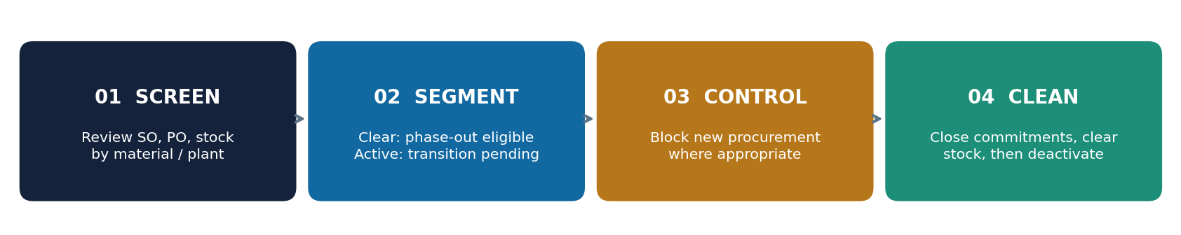
Condition | Required action
No open SO, no open PO, no stock | Eligible for controlled phase-out after dependency and master-data checks.
Open SO / PO or stock remains | Mark as “Phase-out pending”; prevent new procurement where feasible, while fulfilling or closing existing obligations and clearing stock.
Source of supply unknown | Flag for owner investigation; phase out if no valid source is established and no justified business requirement exists.
All closure conditions met | Complete rationalization cleanup, update material status/controls, and preserve an audit record.

04 Plant and process-category standardization
The following rules are project requirements to validate against SAP configuration and actual cross-plant procurement processes before mass updates.
Article / scenario | Standard control rule
5700 — PC01 / PC06 | Align the designated process category with dependent plants 5110 and 5120; avoid conflicting plant-level category assignments.
Service materials | Service plants may retain an independent process category where justified by their separate replenishment process.
5800 production — PC03 / PC04 / PC12 | Standardize the applicable production-customization category across 5800, 5700 and other relevant entities. Plant 5700 must not independently diverge.
PC01 vs PC06 | Use PC01 only where stock is available or approved safety stock is maintained; otherwise use PC06, subject to confirmation of the SAP process semantics.
Purchasing info records | Maintain a valid purchasing info record and confirmed source for every retained/procured article; investigate or phase out unsupported articles.
Plant extensions | Perform one-time standard extensions for rationalized retained articles to all defined applicable plants. Apply the same rule to approved new articles.

05 Operating control model
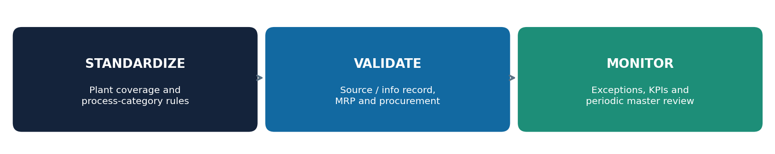
Control | Minimum evidence / output | Suggested owner
Creation challenge | Business case, existing-article check, PG/customer-model mapping, exception decision | Product Management / MDM
SAP data validation | Plant coverage, MRP/process category, source and info record | MDM + Planning + Procurement
Phase-out gate | SO/PO/stock snapshot, disposition and block decision | Planning + Customer Service + Procurement
Execution and audit | Change log, approval reference, before/after article status | MDM / SAP key user
Periodic review | Exception register, new creations, blocked materials, incomplete extensions | OPEX / process owner

06 Implementation workstreams
A — Baseline and classification Extract complete material master; map active plants, process categories, SO, PO, stock, sources, usage and duplicate candidates.
B — Rule validation and pilot Validate PC01/PC06 and PC03/PC04/PC12 logic with SAP process owners; pilot on representative plant/material groups.
C — Controlled cleanup Apply phase-out status or procurement restrictions where supported; clear legacy commitments; standardize retained master data.
D — Governance launch Enable request template, approval gate, bulk plant extension standard, exception log and recurring control reporting.

07 Suggested success measures
KPI | Working definition (baseline and target to agree)
Material rationalization rate | Retired / blocked-for-new-use articles as % of assessed candidates, with open commitments separately reported.
New article control | % of creations supported by approved business case and alternative/PG assessment.
Plant standardization | % of in-scope retained articles with complete applicable plant extension and aligned process category.
Source-data completeness | % of active procured articles with confirmed source and valid purchasing info record.
Exceptions and leakage | Unapproved creations, erroneous reactivations, category mismatches and new procurement on phase-out candidates.

08 Decisions needed before mass change
Confirm the in-scope plant list and service exceptions; the exact SAP meaning and allowed combinations of process categories; material-status/blocking mechanisms; PG customer-model uniqueness and reuse rules; owner/approval thresholds; treatment of historical demand and stock transfers; and whether bulk extension is technically and commercially appropriate for every material type.
Implementation note: Procurement blocking must not cancel valid open POs or interrupt contracted SO fulfillment. First validate operational and SAP dependencies, then apply controlled restrictions and obtain sign-off.

