Sales Approval
PROCESSES

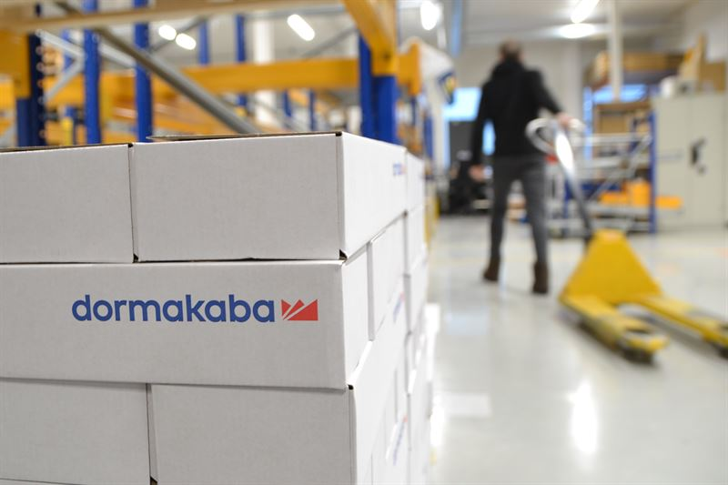

Table of Contents
Introduction 3
Scope 3
Benefits: 3
Material Inbound 4
Process flow chart ID: WL-M-IB-01 4
Material Quality Assurance & Control Check 5
QA/QC process flow chart ID: WL-S-QC-01 5
FRAGILE HANDLING 6
FRAGILE HANDELING flow chart ID: WL-S-FH-02 6
Material Pick and Pack 7
Process flow chart ID: WL-M-PP-01 7
Shipping Documentation 8
Process flow chart ID: WL-M-SP-01 8
Material Dispatch 9
Process flow chart ID: WL-M-OB-01 9
Inventory Audit 10
Process flow chart ID: WL-M-IA-01 10
Stock Correction 11
Process flow chart ID: WL-S-SC-01 11
Escalation Matrix and KPIs 12
Escalation Matrix 12

Introduction
Documenting the complete logistics process can have a significant positive impact on both the department and the organization as a whole. The scope of documenting the logistics process includes capturing all the steps, activities, and interactions involved in the movement of goods and services from the point of origin to the final destination. This can encompass various stages such as procurement, transportation, warehousing, inventory management, order fulfilment, and distribution.

Scope
This document encompasses the process brief and flowchart for key Logistics and Warehousing procedures, along with the inclusion of an Escalation Matrix and Key Performance Indicators (KPIs). It has been collaboratively developed with guidance from team members and Subject Matter Specialists. Through a thorough analysis of existing processes and the subsequent integration of enhancements, this document reflects an optimized approach to these operations.

Benefits:
- Clarity and Transparency:
To have a clear and transparent view of how materials and products flow through the supply chain. This will identify bottlenecks, inefficiencies, and areas for improvement.
- Standardization:
To ensures consistent practices, reducing complexity and errors.
- Training and Onboarding:
Staff members can quickly understand their roles, responsibilities, and the overall workflow, leading to faster integration, productivity, and resource allocation.
- Risk Management:
By identifying potential points of failure or disruption, the department can develop contingency plans to minimize the impact of unforeseen events.
- Performance Measurement:
This data-driven approach helps monitor efficiency (KPIs), track progress, and make informed decisions for process optimization.
- Continuous Improvement:
A benchmark for continuous improvement. The department can identify areas for enhancement and implement changes effectively.
- Compliance and Auditing:
Well-documented logistics processes aid compliance with regulations and industry standards, streamlining audits.
- Scalability:
Enabling efficient handling of increased workload and complexity.

Project Management Process
The project management process encompasses the assignment of projects by sales approved by country manager or values above a specified threshold, followed by kick-off meetings, execution, and ultimately, project closing.

Process flow chart ID: SA-M-PM-01
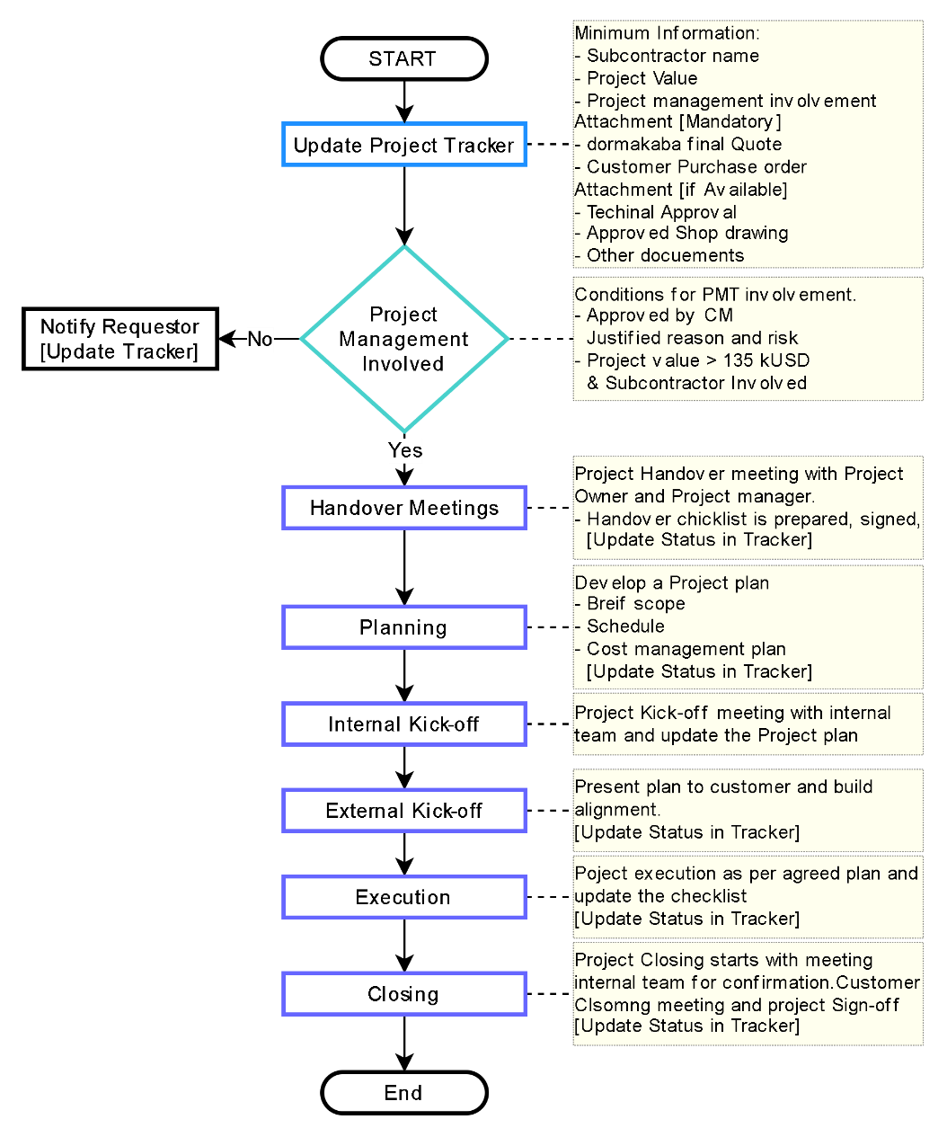
Responsible
■ Sales & Support Team
■ Country Manager
■ Project Management Team [PMT]

Document Ref.: PM-LOG-0100
Issue No.: 1
Rev.: 0
Issuance Date: 20/11/2023

Material Quality Assurance & Control Check
Material Quality Assurance (QA) and Quality Control (QC) are essential processes in manufacturing and supply chain management that ensure the materials used in production meet specific quality standards and requirements. While QA and QC are related, they have distinct roles within the overall quality management framework.

QA/QC process flow chart ID: WL-S-QC-01
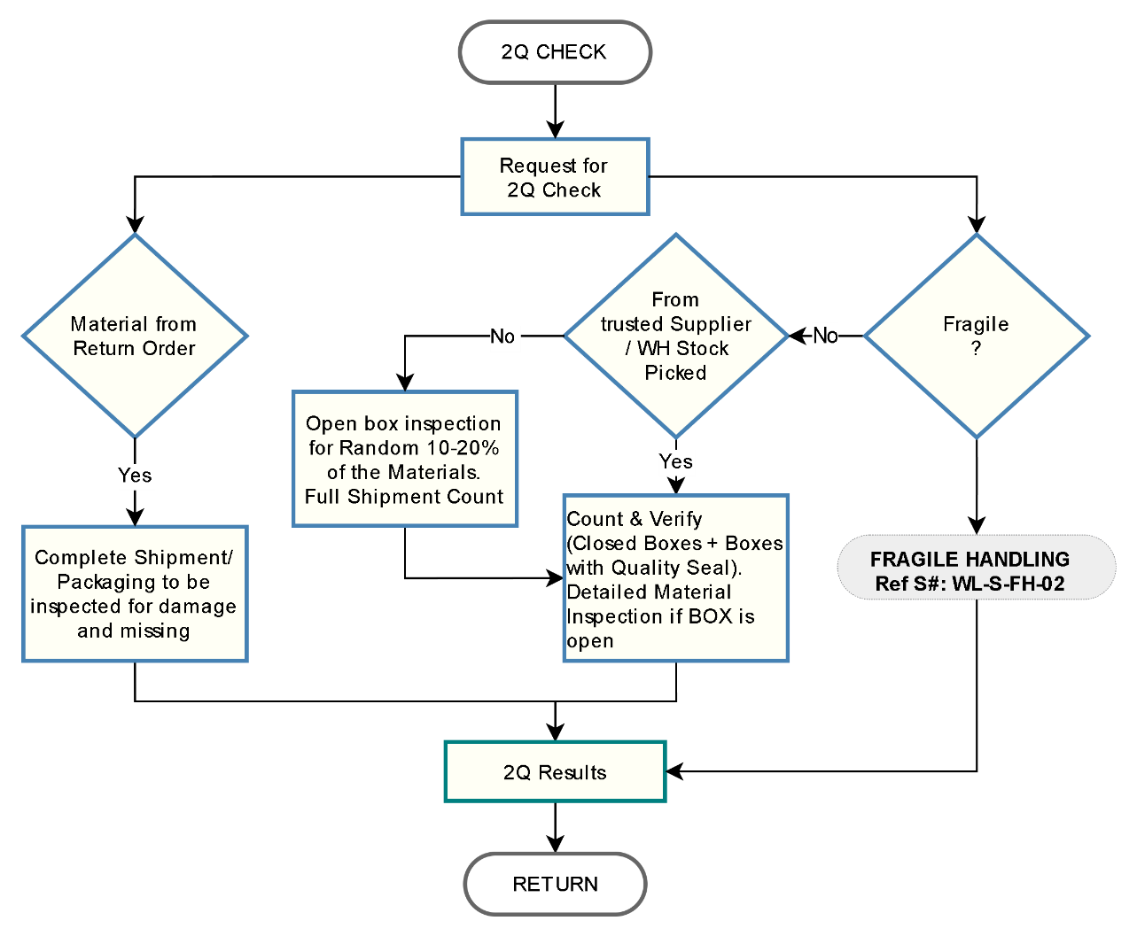
Document Ref.: PM-LOG -08
Issue No.: 1
Rev.: 2
Issuance Date: 10/10/2023
Departments Involved:
■ Logistics
■ Warehouse

FRAGILE HANDLING
Fragile material inspection involves the careful examination of delicate or easily breakable items to ensure they are undamaged and properly packaged. It aims to prevent any potential damage during transportation or handling by identifying and addressing any vulnerabilities in the items or their packaging.

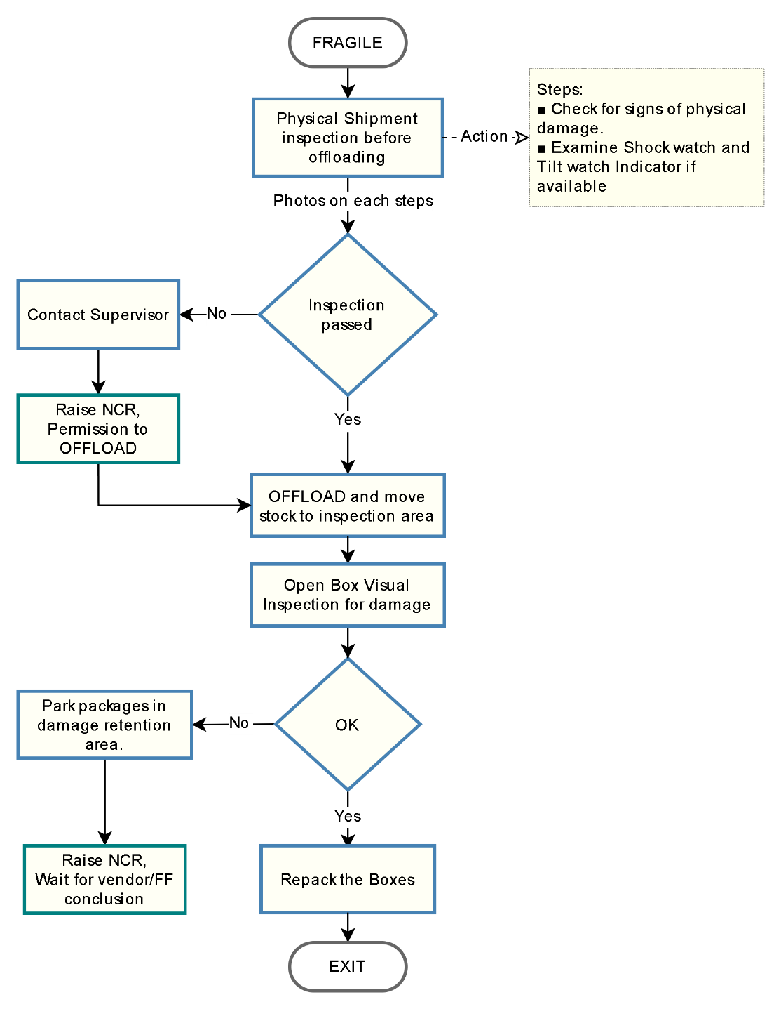
FRAGILE HANDELING flow chart ID: WL-S-FH-02
Departments Involved:
■ Logistics
■ Warehouse
Document Ref.: PM-LOG -14
Issue No.: 1
Rev.: 0
Issuance Date: 10/11/2023

Material Pick and Pack
The process involves selecting and gathering the required materials or products from a storage location and then packing them appropriately for shipment or use, ensuring accuracy, efficiency, and adhering to specified procedures or quality standards.

Process flow chart ID: WL-M-PP-01
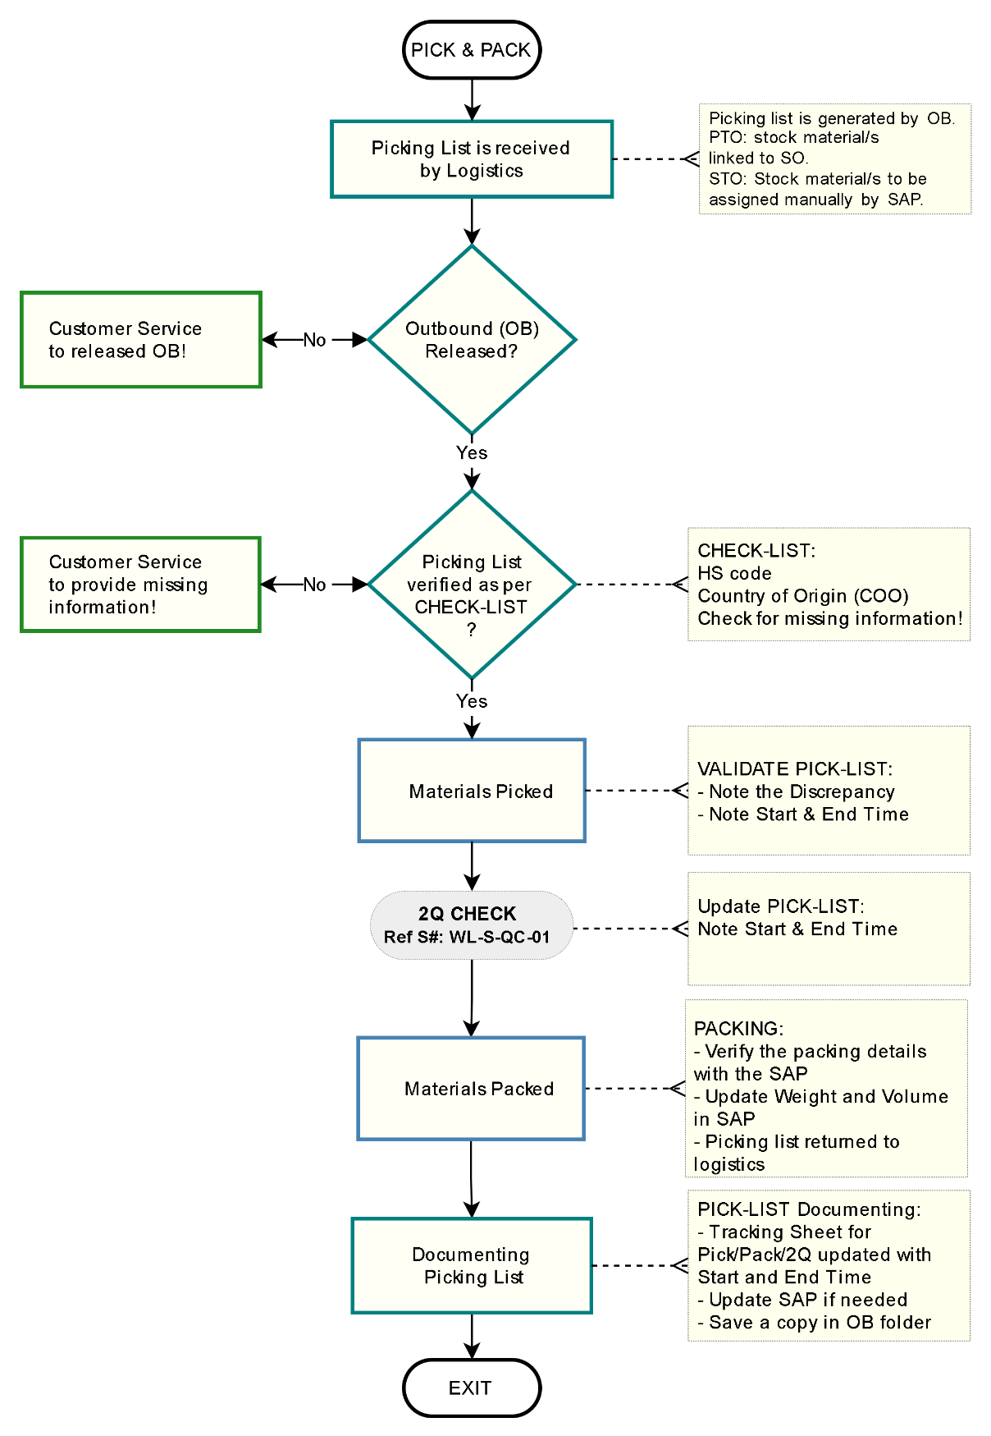
Document Ref.: PM-LOG -09
Issue No.: 1
Rev.: 0
Issuance Date: 10/10/2023
Departments Involved:
■ Logistics
■ Warehouse

Shipping Documentation
The shipping document process is a series of steps and documentation involved in preparing, organizing, and executing the shipment of goods from one location to another. This process is a critical component of logistics and supply chain management, as it ensures that goods are properly packaged, labelled, and documented for transportation and delivery.

Process flow chart ID: WL-M-SP-01
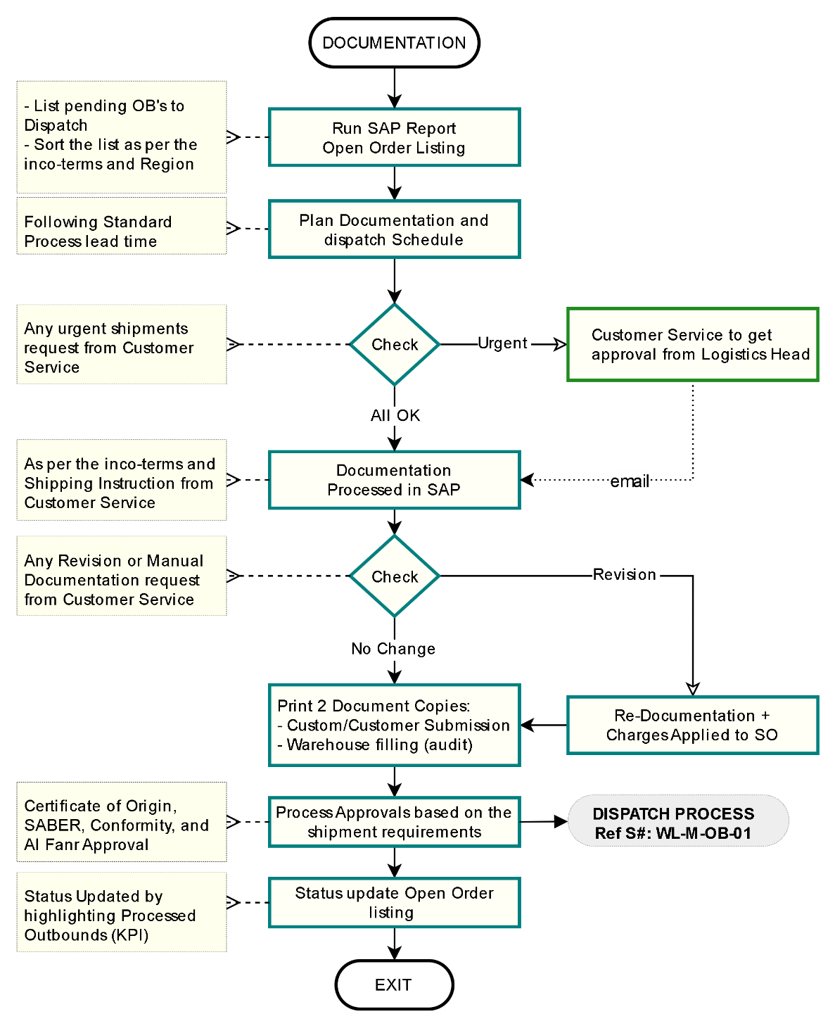
Departments Involved:
■ Customer Service
■ Logistics
■ Warehouse
Document Ref.: PM-LOG -10
Issue No.: 1
Rev.: 0
Issuance Date: 10/10/2023

Material Dispatch
The movement of goods, materials, or information from an organization's internal operations to external entities, such as customers, distributors, or other partners. In the context of logistics and supply chain management, outbound processes involve activities related to packaging, labelling, and delivering products to their intended recipients.

Process flow chart ID: WL-M-OB-01
Departments Involved:
■ Freight Forwarder
■ Customer
■ Customer Service
■ Logistics
■ Warehouse.
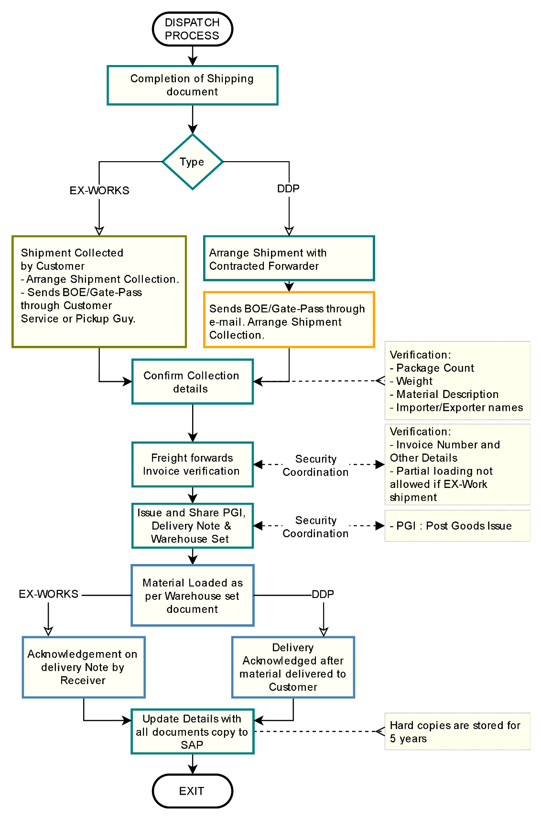

Document Ref.: PM-LOG -11
Issue No.: 1
Rev.: 0
Issuance Date: 10/10/2023

Inventory Audit
The annual inventory or stock audit is a routine procedure conducted by either internal or external auditors. Its primary objective is to verify and confirm the accuracy, comprehensiveness, and reliability of the stock levels and valuations as reported in the company's financial statements.

Process flow chart ID: WL-M-IA-01
Departments Involved:
■ Purchase
■ Customer Service
■ Logistics
■ Warehouse.
■ Financial Controller
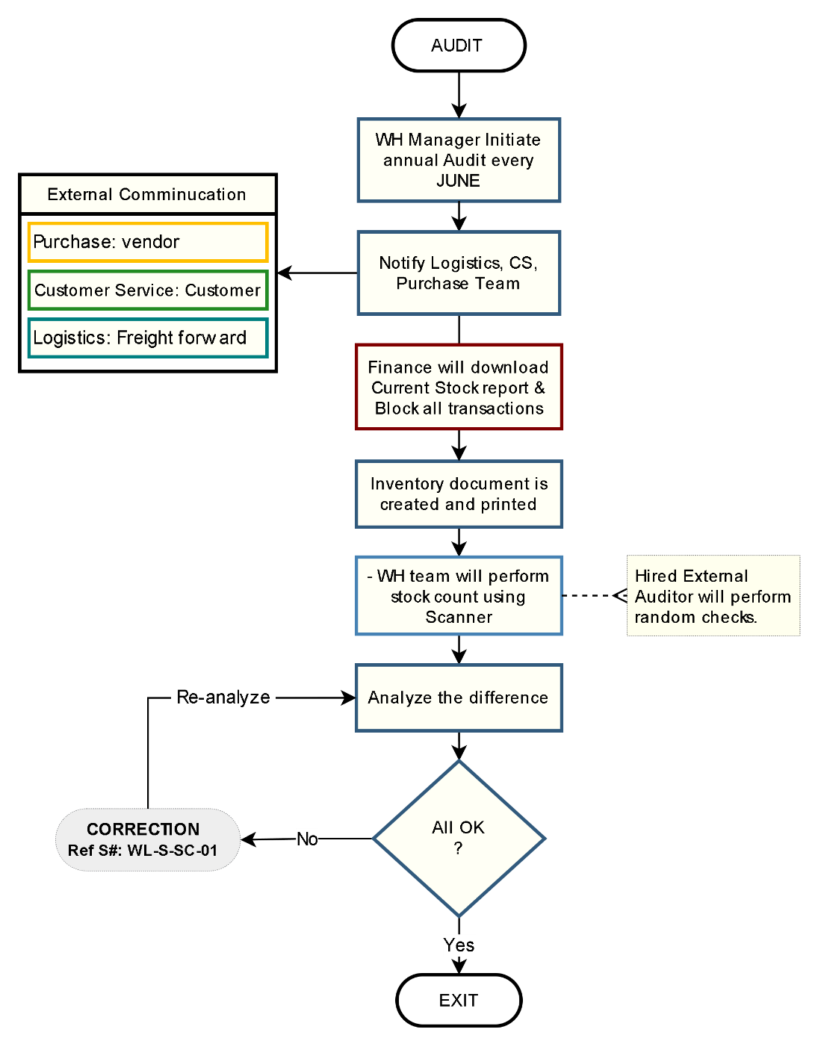

Document Ref.: PM-LOG -12
Issue No.: 1
Rev.: 0
Issuance Date: 10/10/2023

Stock Correction
Inspect the physical stock and ensure that SAP records are updated to accurately reflect the quantity and price in accordance with the approvals provided by the financial controller.

Process flow chart ID: WL-S-SC-01
Departments Involved:
■ Financial Controller
■ Warehouse.
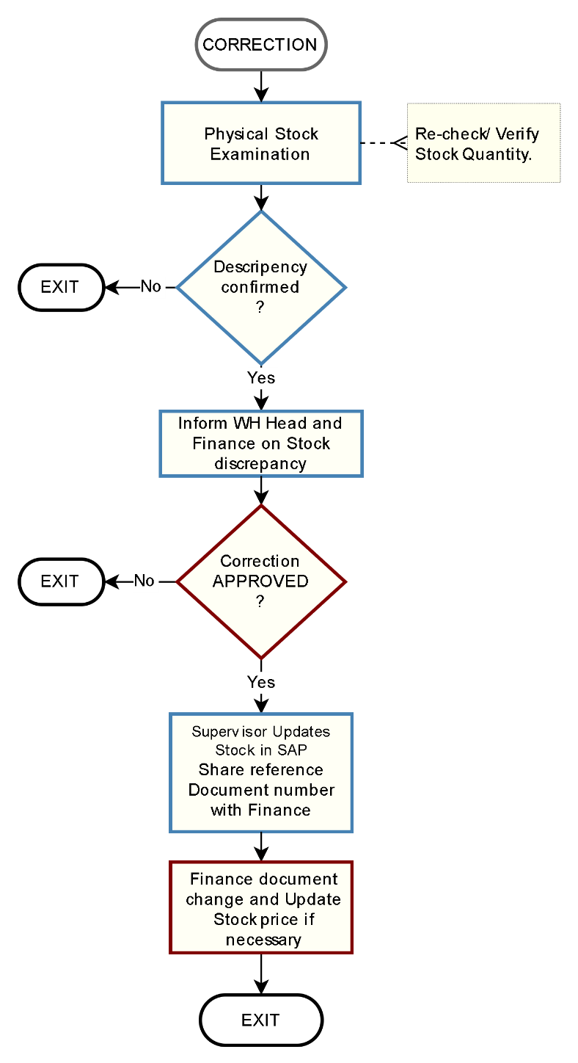

Document Ref.: PM-LOG -13
Issue No.: 1
Rev.: 0
Issuance Date: 10/10/2023


Escalation Matrix and KPIs

Escalation Matrix
Stage | Task / Reminder to | Time Period | Escalation (by Customer Service) | Previous SLA
Level 0 | PICK + PACK +  Labelling + Documentation + Dispatch. | Process Turn Around Time  2 days - UAE  3 days - OMN/BHR  4 days - EXP/KWT/QAT | No Escalation if done in time | UAE - 2 days  Exp/Kwt/ Qat, 4 days  - not incl. consolidations
Level 0 | Documentation revision | + 1 day  to be added to above TAT | No Escalation if done in time
Level 1 | Logistics Supervisor | +1 day  after the Process agreed TAT | - Reminder.  - Copy to Manager. | -
Level 2 | Logistics Manager | +1 day  after the Process agreed TAT | - Reminder.  - Copy-1 (Escalation) to Department Head.  - Copy-2 (For Information) concerned Sales and Sales support Manager. | -
Level 3 | Department Head | +1 day  after the Process agreed TAT | - Reminder.  - Copy-1 (Escalation) to SVP.  - Copy-2 (For Information) concerned Sales, Sales Support Manager, and Market Lead. | -

Note:
- Labelling 500+ will vary TAT as per agreed term between CS, WH & Logistics
- for KSA SABER process TAT will change and if not registered the TAT will extend (depending on availability of required documents).

KPIs (Line Manager to manage)
- Turn around time for each process:
  - Inbound: 1 day
  - PICK + PACK + Labelling + Documentation + Dispatch:
    - 2 days – UAE
    - 3 days – OMN/BHR
    - 4 days - EXP/KWT/QAT
- Keep Stock quantity updated in System.
- SAP Up-to date with Weight, COO and HS-code time of GR
- Rate of return.
- Picking Accuracy.
- Others as per line manager decision.

dormakaba Gulf FZE
Jebel Ali South,
Dubai, United Arab Emirates
T: +971 4 8020 000
www.dormakaba.com/mea

